**Table of Cantents:-**

**Basic of Java**

**Oops (Array&String)**

**Exception Handling**

**Serilization**

**I/O**

**Socket-Programming**

**Multithreading**

**Collection Framework**

**Variable length**:-The main purpose of variable-length arguments in Java is to allow methods to accept a flexible number of parameters of the same type.

**What is java?**

Java is simple, secure, platform independent , highly level , object oriented programming language. Which have capability to make various variety of s/w. Using java desktop app, web app, enterprises app, embedded app etc .

One person knowledge of java . He can develop any variety of s/w .

Mainly three types of s/w:-

* System s/w-O.s
* App s/w – fb, gmail
* Utility – Antivirus , driver

So java is one kind of programming language. Which uses all variety of areas.

**What is java use in website?**

Java is interact with server. Goes to the server. Goes to Database. Bring data from it.

**Programming Language:-** It Provides Syntax and Semantics to create computer program. OR A programming language is a vocabulary and set of grammatical rules for instructing a computer or computing device to perform specific tasks

**Types of Programming Languages: -**

* Low-Level e.g., (Machine and Assembly Language)
* Mid-Level e.g., (C Language)
* High-Level e.g., (COBOL, FORTAN, PASCAL, B, CPL, C++, JAVA, C# etc...)

**Low level:-**Low level programming language are those language whose program are directly interact with hardware. They can be easily understand by machine but cannot be easily understand by human.

**Mid level:-** Mid level language is called which have both features low level and high level language. OR It came between low level and high level in one time duration.

**High level : -** High level are those language that makes it easier for people to create computer program. It provides friendly environment for writing code , And usually is not link computer inner’s workings.

**Program:** A computer program may be defined as the set of instructions in static state OR we can say that it is a chain of steps OR a set of activities which combine together to perform a specific task.

**Process:** It’s the Active state of a program OR we can say that program in execution is called a process.

**Thread:** It’s a Sub-Process. Process Inside process or light weight process

**Translator:** A translator is a program that converts a computer program from one language to another (in general from High Level Language program to Machine Language Program). It takes a program written in source code and converts it into machine code.

There are three type of Translator:

1. **Compiler :**- It is entire program translate at a time.
2. **Interpreter :-** It is one statement translate at a time.
3. **Assembler :-** It is only used Assembly language , low language converts Assembly language and Assembly language converts low language.

Java is the compile as we as interpret programming language. Where as C and C++ is the only compile programming language.

**Embedded Programming** :-Software interact with hardware like-freeze ,cooler.

**What is Cmd ?**

Cmd is doc. When windows were not then command run in doc. Before, all those CUI and now all of these Gui, then environment of that is Cmd Where we write ,write. Windows’s cmd and Linux’s cmd is same. Cmd is software.

**Need to Program :-**

* Compiler
* Editor
* Library
* C:\Users\naeem-drive\folder\in folder
* **Cmd command**
* javac-(java compiler)-It is used to compile java program.
* java-(jvm)- It is responsible to run java (Run java program)
* javap-(java protype-De compile)- It is responsible to partially a java program.
* javadoc-It is responsible to general doc of java program.
* javaw-It is responsible to run java program with out windowing.
* javah - It is responsible to generate header file from java program.
* jar –(java archive)- It is responsible to create update and extract the any file in jar(for core java app),war (web app) and ear(inter prese archive) formal.
* Applet viewer-It is responsible to run the applet program.
* jdb – java debugger ,remic-RMI compiler
* rmirgistry-for rmi rmirgisty metntool
* jconsole-It is JVM montoring manage.
* **Linux:-** Linux is a Carnol . Carnol is the boss of O\S. Carnol is govern O\S Every O\S have own Carnol.
* Linux is popular Carnol is heart of O\S secure, opensource
* There are many operating systems available in the market today using linux.
* Linux Carnol operating system- Ubanto ,Vmware.
* **Linux command:_**

1. ls – This commands shows a list of all the files and directories in the current working directory of your machine, ls -ltr
2. cd -Change directory command. It is used to change current working directory
3. pwd -This command prints the current working directory
4. mkdir – This command prints the current working directory
5. touch – touch command is way to create empty files.
6. cat – print the content of a file

The cat command also allows us to some texts into a file.save(ctrl+d)

Combine files using cat command

1. mv command- Moves files from one directory to another directory used for renaming a file or directory
2. wc – Total number of lines ,total number of words , total number of character. Wc m1.txt, m2.txt (give total).
3. Sort command is used to sort a file [sort file.txt]
4. Uniq -command is used to tool the helps detect the adjacent lines and also deletes the duplicate lines, {uniq -d file.txt] only duplicate files.

* Sort command- alpha, beta char
* Uniq command- uniq value print
* Uniq -d -kitani value uniq hain

11.History -History command is used to view the previously excuted command

* hostname – display hostname
* hostname -i -display IP address of hostname.

12.head –

* Display top 10 lines
* tail – display last 10 lines
* tac – display in revers order

13.Remove –

* rm command is used to remove files.
* rmdir- command is used to remove a directory (directory should be empty)

14.chmod –

* Chmod command is used to change the acess permissions of files directories .
* User ,Groups. Others {r-read,x-execute,w-write}
* rw -,r--,r—
* Remove read permission from groups and others [chmod g-r,o-r hello.tx]

15.grep – (Global Regular Expression pattern)

This command is used to each txt and string a given file

1. grep “hello” file.txt
2. grep -i “maridul” file.txt ignore the case senstive
3. grep -c “Naeem” file.txt count
4. grep [ABCDEF] file.txt

16.cp -The cp command is used to copy a file or directory

Syntax :-

To copy in the same directory

17.mail – The mail command is used to send email from the command line mail -s “sub” recepint address

18.Date- The date command is used to display date, timezone , and more.

19.cal – The cal command is used to display the current months calendar with the current date highlight

20.exit – Linux exit command is used to from the current shell . It takes a parameter as a number and exists the shell with return of status number.

21clear- clear the terminal display

22.echo – The echo command displays defined text terminal .Its that simple.

23vi – organize way create files

24 Nano -Nano is a simple text editor . It is used creating files.

25.Who ami- get the active username

26.Uname-Linux command to get basic information about os.

27.vi Test.java

Insert- esc -:wq-enter-save

29.open terminal-doucment-new file-filesave-write code.

**Software:-** Software is a set of instructions, data or programs used to operate computers and execute specific tasks. Opposite of hardware, which describes the physical aspects of a computer, software is a generic term used to refer to applications, scripts and programs that run on a device.

From software development point of **a software is the combination of requirement specification (SRS) + Implementation + Documentation**

**Software Development Life Cycle (SDLC):**

Software Development Life Cycle (SDLC) is a process used by the software industry to design, develop and test high quality Software. The SDLC aims to produce a high-quality software that meets or exceeds customer expectations, reaches completion within times and cost estimates.

A typical Software Development Life Cycle has the following stages:

[1. Planning](https://arkbauer.com/blog/software-development-life-cycle-sdlc/#1planning)

[2. Requirement analysis](https://arkbauer.com/blog/software-development-life-cycle-sdlc/#2-requirement-analysis)

[3. Design](https://arkbauer.com/blog/software-development-life-cycle-sdlc/#3-design)

[4. Implementation](https://arkbauer.com/blog/software-development-life-cycle-sdlc/#4-implementation)

[5. Testing and Integration](https://arkbauer.com/blog/software-development-life-cycle-sdlc/#5-testing-and-integration)

[6. Maintenance](https://arkbauer.com/blog/software-development-life-cycle-sdlc/#6-maintenance)

### Graphical representation of the various stages of a typical SDLC.

### Software development life-cycle (SDLC) | Arkbauer

Sdlc models: There are quite a few software development life-cycle models out there that you can follow and use. Each model follows a series of unique steps, with the ultimate aim of ensuring the success of the software development.

**Here are some of the most popular SDLC models in industry:**

* Waterfall also known as Traditional model
* Agile
* Iterative
* Spiral
* Rapid Application Development
* Prototyping

Waterfall v/s agile (Quick Differences)

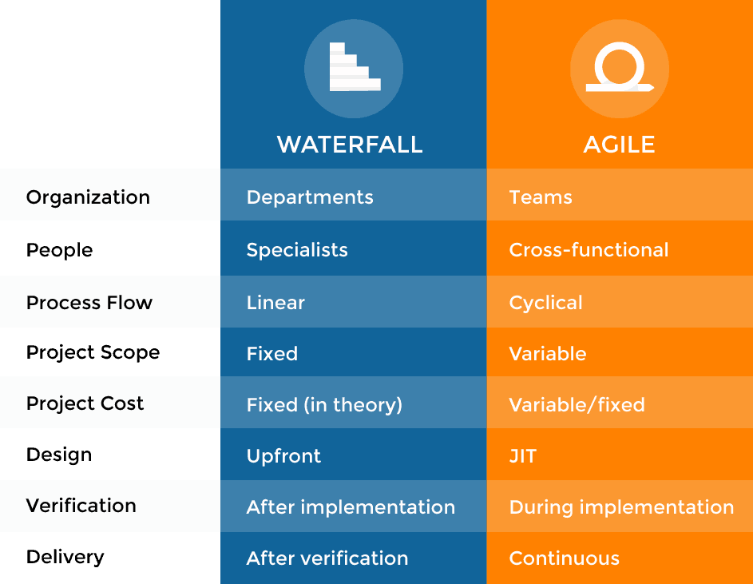

**What is an agile or agile methodology?**

Agile is an iterative approach of software development methodology using short iterations of 1 to 4 weeks. Due to the agile methodology, the development process is aligned to deliver the changing business requirement

**What are some quality strategies of agile?**

Some quality strategies of agile are:

* Iteration
* Re-factoring
* Dynamic code analysis
* Short feedback cycles
* Reviews and inspection
* Standards and guidelines
* Milestone reviews

**Is there any disadvantage of the agile model (SDLC)?**

Disadvantages of Agile SDLC:

1. The development team should be highly professional and client-oriented.
2. New requirement may be a conflict with the existing architecture.
3. With further correction and change, there may be chances that the project will cross the expected time.
4. There may be difficult to estimate the final coast of the project due to constant iteration.
5. A defined requirement is absent.

**What are the burn-up and burn-down chart?**

The burn-up chart depicts the amount of work done in the project, whereas the burn-down chart illustrates the amount of work remaining in the project. Thus, the burn-up and burn-down are used to describe the progress report of the project.

**What do you understand about Scrum?**

**Scrum is a framework** that helps agile teams work together to develop, deliver, and sustain the complex product in the shortest time. The product provides by scrum team in this shortest period is known as a **sprint**.

**What are the different roles in Scrum?**

There are three different roles in scrum. These are the *Scrum Master*, *Product Owner*, *Agile Development Team*:

* **Scrum Master:** The Scrum Master is a team leader and facility provider who help the team member to follow agile practices so that they can meet their commitments and customers requirements.
* **Product Owner:** The Product Owner is one who runs the product from a business perspective. He defines the requirements and prioritizes their values.
* **Agile Development Team:** Agile development team provides the judgment on the technical feasibilities or any dependencies.

**What are the responsibilities of the Scrum Master?**

The critical responsibility of Scrum Master includes:

* Tracking and monitoring project development.
* Understanding the user requirement correctly.
* Work to obtain the project properly.
* Improving the performance of the team.
* Organized meetings and resolve issues.
* Communicate and report to the customer and development team.

**What are different ceremonies and their importance in Scrum?**

To clearly express the Scrum planning, Scrum review, Scrum Daily stand up, and scrum retrospective is the purpose of the ceremony. The importance of these ceremonies is to use sprint as per your project.

**What do you know about Scrum ban?**

Scrum-ban is a Scrum and Kanban-based model for software development. This model is used in the project that needs continuous maintenance, various programming error, or some sudden changes.

**What do you understand by the term agile testing?**

The agile testing is the software testing process which is fully based on the principle of agile software development. It is the iterative approach where the user story becomes the output of the collaboration between the product owner and the development team.

**What are the major principles of agile testing?**

Some of the essential principles of agile testing are:

* Customer satisfaction
* Face to face communication
* Sustainable development
* Continuous feedback
* Quick respond to changes
* Successive improvement
* Self-organized
* Focus on essence
* Error-free clean node
* Collective work

**Name the agile frameworks**

Some of the agile frameworks are:

* Scrum
* Kanban
* Feature Driven Development
* Test Driven Development

**Name some methodologies and development where you have used the agile model.**

While answering this type of question, keep in mind to mention those methodologies from which you are familiar whit. Some of the methodologies where agile is used are:

* Crystal methodologies
* Lean software development
* Dynamic development
* Feature-driven development

**What is the difference between the agile & traditional way of working?**

The traditional way of development is that which follow the sequential where design -> development -> testing etc. is performed whereas, in agile development, all of this is done in every iteration/sprint.

**History of java:-**

The history of Java is very interesting. Java was originally designed for interactive television, but it was too advanced technology for the digital cable television industry at the time. The history of Java starts with the Green Team. Java team members (also known as Green Team), initiated this project to develop a language for digital devices such as set-top boxes, televisions, etc. However, it was best suited for internet programming. Later, Java technology was incorporated by Netscape.

**Programming methodology or programming paradigm or paradigm tachniqe**

A programming methodology deals with providing a way to consider and manage the development, design, implementation, and testing of a piece of software.

**OR**

A programming methodology is just a programming practice to help you plan and structure your code in a more defined way.

**Types of Programming Methodology:-**

1. **Procedural Oriented (Top to Bottom Approach) :-each step executed in a systematic manner so that the computer can understand what to do.**
2. **Object Oriented, Object Based, Pure Object Oriented. (Bottom to Top Approach**)

**Object Oriented –** Object oriented programming (OOPs) is a methodology that simplifies software development and maintenance by providing some rules.

Object oriented programming technology or programming methodology hain .Jo real world se li gayi hain.

**It is taken from the real world .This programming language says that whenever you go to do program, consider it as your objective and start your program by considering that objective as same that is called object oriented methodology**

.**Jo real world se li gayi hain why?**

**Java ek object oriented programming language hain. Aur object oriented programming language ye kahati hain ki jab bhi app progamming krnae jaye to uska apna objective man le. Aur usi objective man ke apna program start (orientation )kre.That is called object orientd approach hain**

Hum software kis liye banate hai real world ki problem ki solve krne ke liye. Jab hum s/w real world ki problem ko solve krne ke liye banate hai ,to approach bhi real world ka hona chaiye , isliye ye real world se le gayi.

**when we make software for solve the real word problem. Approach should from real world. so It taken from the real world**

**Ques-Is technique ka naam object oriented hi kyu pad gayaa aur bhi kuch ho sakta tha?**

**Ans-**.Or Sbase pahale hum yaha per objective decide karte hai ki mera Objective kya hai.Usi objective ko decide karke hum apna kaam karate hai.Isliye oops walo kuch aisa word doodah jise sabhi pe valid ho duniya koi bhi cheez ho sabke liye ek word ho jise kaam asaan ho jaye.Wo word Object hai jo duniya main koi bhi cheez hai wo object hai  **.**

**Java ek object oriented programming language hain. Aur object oriented programming language ye kahati hain ki jab bhi app progamming krnae jaye to uska apna objective man le. Aur usi objective man ke apna program start (orientation )kre.That is called object orientd approach hain**

**Objective-**Kisi

**Object oriented** :-aisi programming language jo oops ke sare characeterstics ki apne pass rakhate ho.

**A programming language that supports all the oops characteristics**

**Object base:-** aisi programming language jo oops ke sare characeterstics ki apne pass rakhate ho.like-Runtime polymorphisam, Inheritance

**A programming language except runtime and inheritance that supports all the oops characteristics**

**Pure object oriented**:-isme har cheez object ke form hai hoti hain

**It is the everything form of object**

**Bottom to top approach:-This approach which have everything Redimade like classes, Library ,packages using all of this create program.**

**Objective-**Kisi object ke liye sochate ho for example muje ye software banana hai wahi apka objective hai**.**

You plan to achieve.

Aspect Oriented (Bottom to Top Approach)

Example of POPL: C Language

Example of OOPL: Java, C++, Simula etc.

Example of AOPL: Spring.

**Java is better than pure because java have wrapper classes, primitive data type convert object &object convert primitive data type.**

**Problems with C language**

C is a procedural programming language and C++ is Object Oriented Programming Language.

1. No data hiding
2. It doesn’t support the concept of real world
3. No modularity
4. Complexity
5. Tight coupling
6. Platform Dependent

**Advantages of C++ (OOPs) over C**

1. Data Hiding 2. Modularity

3. Reusability 4. Simple

5. Loose Coupling 6. Because of OOPs it supports the concepts of real world

**Coupling in java :**

Coupling is nothing but dependency of one class on the other.

There are two types of coupling

**Loose coupling in java:-**

* When two classes have low dependencies on each other . It is called loose coupling.
* Loose coupling in java means that the classes are independent of each other
* The only knowledge one class has about the other class is what the other class has exposed through its interface in loose coupling

Class Test{

}

Public class Test1{

}

Interface food{

Class implements food Test

**Tight coupling –** when two classes are highly dependent on each other, is called tight coupling . for example an object (child object) for its usage. If the parent object knows more how the child object was implemented , we can say that the parent and child object are tightly coupled.

**Cohesion: har cheez bound rahana chaiye**

**Modularity:**- kisi bade part ko chote -2 part mai thodana.

Explors the creation of a program by using different modules than a single leguay architecture.

**Why do path set?**

* **Path is implicit environment variable hain. Jis per sari cheeze set hoti for example-tree command internal command hain-jo system 32 ke andar hain ya hume system32 ke andar jake usi locnper cmd chalana hoga yap hir path set kr denge jise tree command chal jayegi.**
* **Path isliy set karate hain jise hum apni internal and external command chala sake.**
* **Java path-ye external command hain aur tree external command hain.**
* **It is used to locate the jdk packages that are used to convert the java source code into the machine readable binary format.**
* **Real main OS 32 bit ka nahi hota hain , balki 32 bit ka processor hota hain jiski capability hoti hain 32**
* **Ctrl+c- Stop process**
* **Ctrl -o Hathi test-java -name change karna ho**
* **Kisi bhi language ka compiler bin folder ke andar hota hain.**
* **Java path isliye set krte hain kyuki java ka compiler jdk ke bin folder main pada hota hain. Run krana hain to jdk ke bin folder mai save krde program aur wahi se run kr sakate hain yap hir bin tak ka path set krde path set krne ke do tarike hote hain**

1. **Temporary:-cd C:\Program Files\Java\jdk1.8.0_202\bin**

* **set path=;-sare system ke path khatam ho jayenge**
* **set path=;-c** **C:\Program Files\Java\jdk1.8.0_202\bin;**

**ye tab tak valid hain. Jab tak cmd open hain**

1. **Parmanent:Environment main jaake set krna padata hain.**

**Without path-Run administrator-cmd-open-cd C:\Program Files\Java\jdk1.8.0_202\bin-enter**

**javac ,java**

* **javap-How to convert m-s. It is responsible to decompile.**
* **What is java vs javaw tool difference**

**1.java -Run program seen console**

**2.javaw -Run without seen console**

**Which situation use javaw command?**

**It is use GUI application.**

* **Environment variable ka main parpose unaki Internal &external command ko run krwan hain.**

**Difference bet ween java and C++:**

* Java is platform independent while C++ is platform dependent.
* Java has automatic garbage collection whereas C++ have destructor
* Java does not support the explicit use of pointers whereas C++ have pointers
* Java is very much used on internet while C++ is not suitable for internet programming
* Java is compiled as well as interpreted programming language while C++ is only compiled.

**Platform:-**

It is the place on which our program is going to be executed it could be a hardware or software or combination of both.

Any software and hardware and combination of both in which programing is execute is called platform.

**Type of Platform:-**

1. Software- O.S
2. Hardware-

* Micro controller: process ke sath data hold krna
* micro processor : only process

1. Software + Hardware

**What is Platform Independency: -**

Any programming language is called platform independent if Its program is compiling on one platform and same program can be executed on another platform without changing It’s object code. In other word we can say that CORA (compile once run anywhere)

**How C++ is Platform Dependent:**

**Jab C++ ka program compile hota . Compile time per compiler OS &Processor ko call lagata hain aur OS ki library ko call krta hain aur compiler processor se pochata hain Kaise process . Ek bar main kitane byte chaloge to compiler us type ki file banake rakh dega jise excutabale file kaha jata hain uske baad Run time per aur operating system mai load hoga aur os ki us library ko Khojega jo compile time per link hui thi.aur uske baad uske architecture ko dega agar architecture mil jayega to wha program chal jayega.**

In case of C or C++ (languages that are Platform dependent). The compiler generates an Executable file which is Operating System (OS) dependent. When we try to run this Executable file on other OS it does not run, as it is OS dependent hence it’s not compatible with the other OS.

How to create program in any programming language-

1. With IDE (Integrated development environment) e.g. eclipse. Net beans
2. Without IDE (editor + compiler + lib)

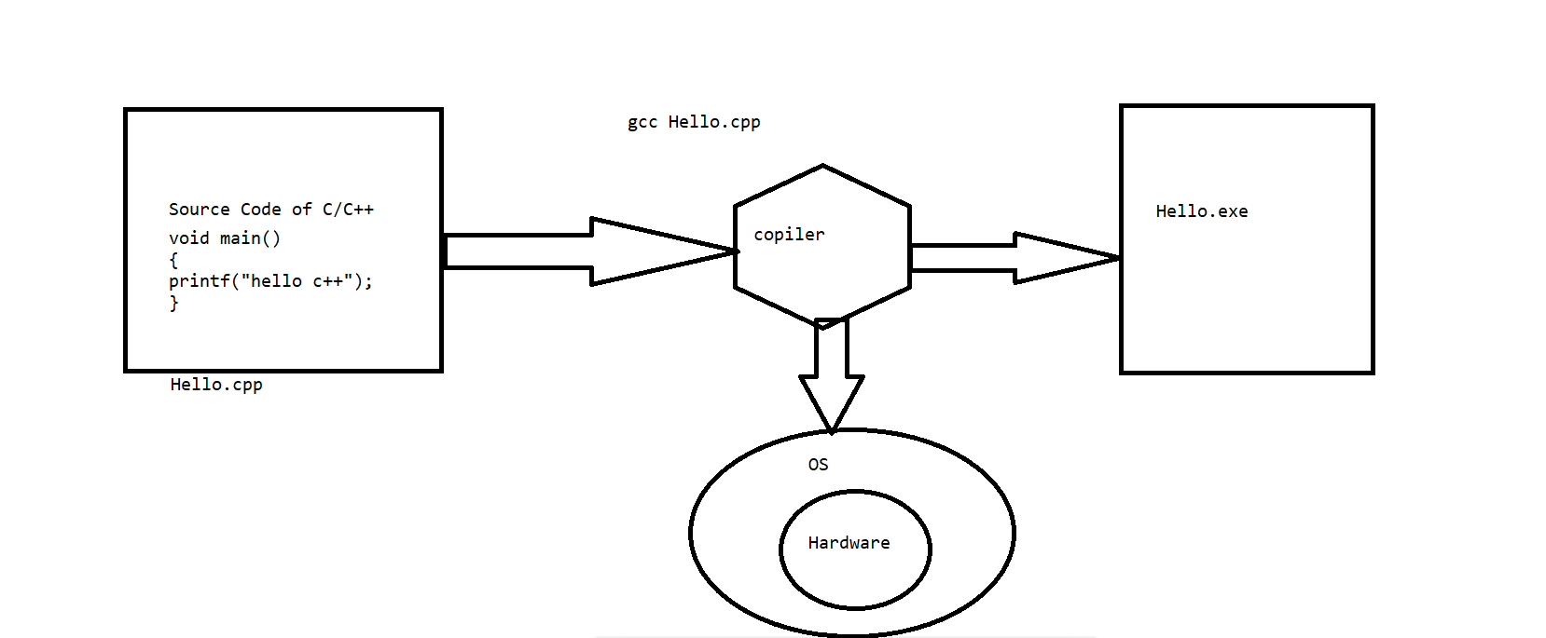

**How java is platform Independent:-**

* **Jab java ka program compile hota hain to complier compile time per JRE ko call lagata hain aur JRE O/S ko &H/W ko call lagata hain**
* **Why do compile do?**
* **Because computer can understand , computer cannot understand English language then computer can understand this code**
* **Inhone source code ke andar aane wale har ek charcter (public, static etc.) ke liye uniq symbol banaya hain aur jab ise memory main store krte hain to minmum ek byte ka space le leta hain.Isliye ise byte code kahan jata hain.**
* **Run time per java naam ka tool JRE ke andar hide JVM ko call krta hain aur ye JVM hamare program ko line by line chalata hain isi ko interpreter kaha jata hain.**
* **JVM-load -link-verify-excuetion engine ke pass gaya -process hoga -aur program run ho jayega .**
* **Byte code-ko Jre and Compiler do log hi janate hain.**
* **Jre is depedent kayuki jab tum window wala object codw linux per leke jaoge to JRE ki jaroorat hogi.Agar hum window wala JRE Linux per leke jayenge to JRE chalega hi nahi kyuki window and linux dono ka JRE alag -2 hota hain**
* **Iske baad object code ko linux per laaye aure linux wala jre bhi hain.To ab program Run ho jayega.**
* Whenever java program compile it does not directly interact with underlying operating system and hardware , It interact with own runtime environment called JRE, and create a JRE specific code called byte code and this byte code can be run on any machine, but in order to run this byte code you need JRE of particular platform.

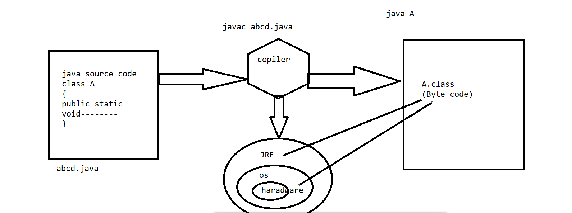

**What is API** (Application program interface): -

Set of inbuilt libraries or predefined functionality in any language whose form may varies from language to language.

In C and C++ API is present in the form of Header files, in .Net it’s in the form of namespace and DLL files whereas in Java it’s in the form of classes, interface and packages.

**What is Framework:** It is the set of API.

**Bytecode: -** Highly optimized, unique and universal code which is created by java compiler with the help of JRE which is runs by Java Virtual Machine (JVM).

**JVM:** It is abstract virtual machine which is responsible to run a java program . In other word s we can say that It is a S/W program which have no any physical existence, It is not single thing , but combination of following thing.

* JVM SRS( Requirement specification)
* JVM API
* JVM implementation(JRE)
* JVM Documentation

**JRE :- It combination of following things-**

* **The implementation of JVM+ It contain a set of libraries + other file+ that JVM uses at runtime.**

**JDK** : It is a complete s/w of java that contains JVM +JRE+ java source code (src.zip)+ many more tools (like-javac ,javah,javap, javaw).

**Features of Java in Details:**

**Simple**:

* Java is simple as it supports OOPs and we can say that OOPs supports the real world.so it’s simple to develop program in java by relating the problem with real world.
* It’s syntactically similar to C and C++.
* It doesn’t provide explicit use of pointers.
* It doesn’t have concept of Operator overloading.
* Its Automatic Garbage feature also makes it simpler.

**Secure:**

* It doesn’t has support of Explicit use of pointers which prevents someone to gain the direct access to a memory location .Hence making the program secure.
* It has the facility of bytecode verification using the concept of magic number. The magic number is the part of bytecode.
* Do trike se magic number gayab ho jata hain.

1. Save bytecode
2. Byte code se kuch nikala phir dal diya

Java also has Java Authentication and Authorization Service (JAAS) is API 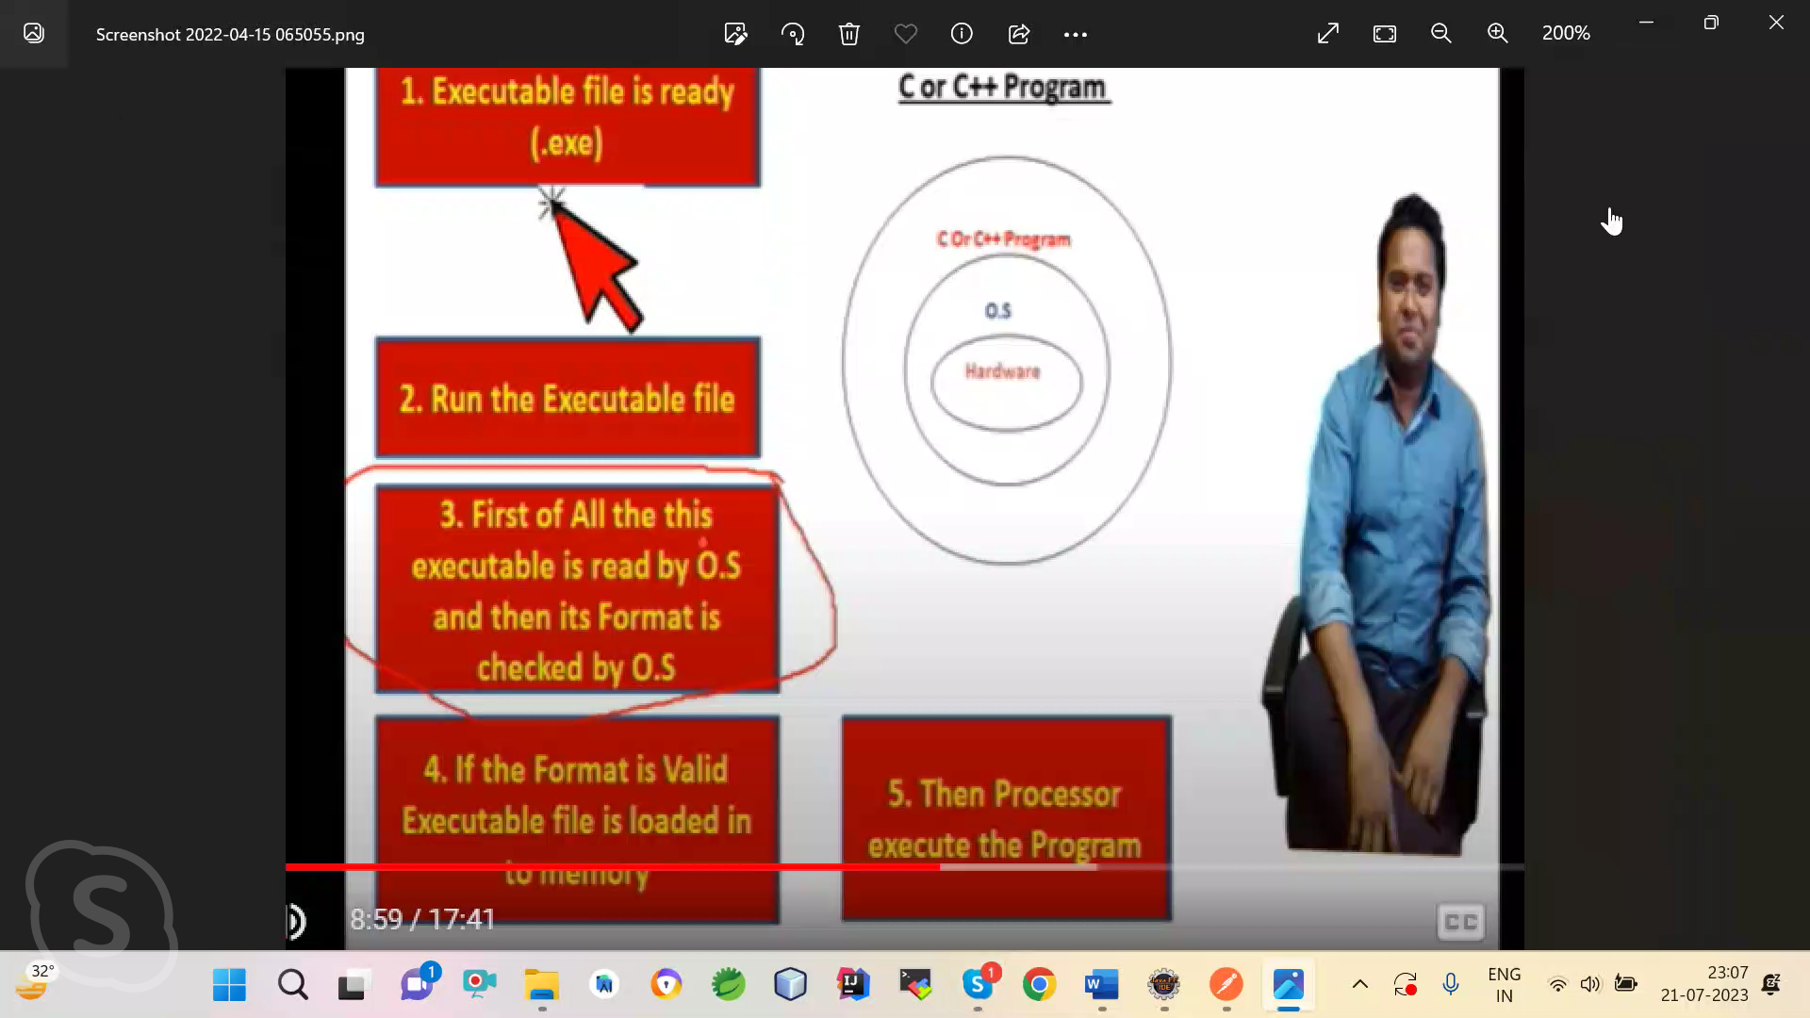for *authentication* of users, to reliably and securely determine who is currently executing Java code.

* 

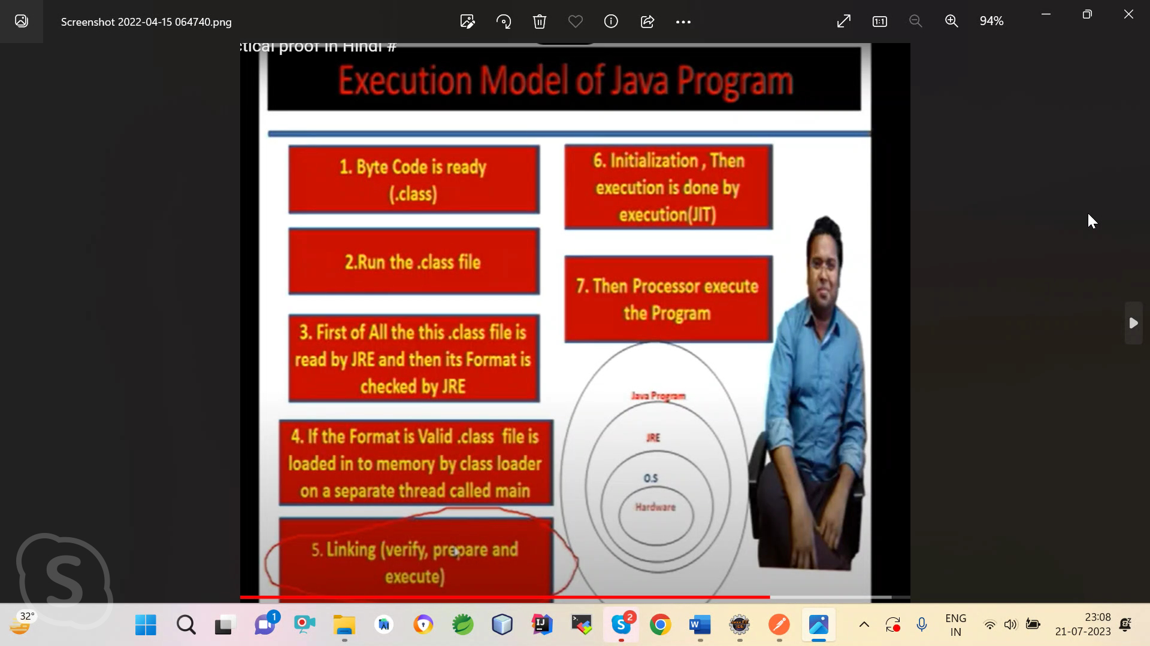

**4.Authentication : It is the process of identifying a user to provide access to a system.**

**5. Authorization: It is the process of giving permission to access to resources . Authorization permissions can not be changed by the user. The permissions are given to user by the owner/manger of the system and He can only change it.**

**For example- You are ordering any product from Flipkart. First you will enter your loction. After that you will make payment like debit, credit etc. Assuming you will pay with a credit card ,you will enter your credit card number on Flipkart .After that checking the credit card number you entered on a Flipkart matches before making in online purchase is called Authentication/validation.**

**After that Reciving a one time code your phone and entering it on the Flipkart to confirm your identity and complete the transection securely is called Authorization / Verification.**

* An executable file is generated only when we run the program and it’s automatically deleted by the JVM after the program execution.
* Java also has Java Authentication and Authorization Service (JAAS) is API for *authentication* of users, to reliably and securely determine who is currently executing Java code.
* Java also provides the application level security called encryption and decryption.
* Sandbox security checks the security concern on the network.

Garbage Collection -Algorithm mark &sweep

HDD-10 speed

RAM-matching JR-JVM---exe.

CPU-100 speed

Source file-src.zip(All javafile)

Compile file(.class file)-jre/lib/rt jar

**Platform Independent**: - Java is platform independent because it is different from other languages like C, C++, etc. which are compiled into platform specific machines while Java is a write once, run anywhere language.

**Architectural Neutral: -** Software that is designed without regard to the target platform are known as Architectural Neutral Software and the language which provide facility to develop such software is known as Architectural Neutral Language.

Java is architecture neutral because there are no implementation dependent features, for example, the size of primitive types is fixed.

**Here are the system requirments for windows:**

|  |  |  |
| --- | --- | --- |
| **Requirement** | **Minimum** | **Recomanded** |
| **O/S** | **64bit** | **Latest 64 bit** |
| **RAM** | **8GB** |  |

In C programming, int data type occupies 2 bytes of memory for 32-bit architecture and 4 bytes of memory for 64-bit architecture. However, it occupies 4 bytes of memory for both 32 and 64-bit architectures in Java.

**Portable: -** The literal meaning of portable is “Easy to carry”. (WORA)

Java is portable as we can carry the bytecode easily to various platform also it is platform independent while C and C++ are only portable they’re not platform independent.

**Robust: -** The literal meaning of robust is “Strong”.

**Java is robust because: -**

* It uses strong memory management. There is automatic garbage collection in java which runs on the Java Virtual Machine to get rid of objects which are not being used by a Java application anymore.
* There are exception handling and the type checking mechanism in Java.
* **Runtime exception , Garbage collection**
* **Robust ka matlab jab kisi leanuage ko wrong input mile use jhel jaye to wo Robust hain.**
* Any programming language is called Robust if the particular programming language .We are providing some wrong input and the wrong input accept by at without terminating the program giving some proper message the particular programming language called Robust.
* **rt -jar file is inbuilt API byte code**
* **All B/L logic >method &variable>class &interface packages >jar file (rt.jar) all built classes &interfaces byte code**
* **nextInt(); method user se input lena**
* **nextInt():;>scanner>import java util>jar file**

**Multithreaded: -** The Java platform is designed with multithreading capabilities built into the language. Thread is a process of executing the multiple tasks simultaneously at a time. Its implementation is provided by two sub-concepts.

1. **Process**
2. **Thread: -** It’s a light weight process of a sub-process. A thread is the smallest unit of a processing. It doesn’t have any memory address.

A thread is like a separate program, executing concurrently. We can write Java programs that deal with many tasks at once by defining multiple threads. This is called multithreaded The main advantage of multi-threading is that it doesn't occupy memory for each thread. It shares a common memory area.

**Interpreted: -**  Java has both Compiled and Interpreter Feature Program of java<http://ecomputernotes.com/java/what-is-java/what-is-java-explain-basic-features-of-java-language> is First Compiled and Then it is must to Interpret it .First of all The Program of java is Compiled then after Compilation it creates Bytes Codes rather than Machine Language.

Then After Bytes Codes are converted into the Machine Language with the help of the Interpreter so for executing the java Program First of all it is necessary to c

most of the programming languages which are either complied or interpreted, Java is both complied and interpreted The Java compiler translates a java source file to bytecodes and the Java interpreter executes the translated byte codes directly on the system that implements the Java Virtual Machine. These two steps of compilation and interpretation allow extensive code checking and improved security .

**Distributed:(Bata Hua) -** Distributed applications (distributed apps) are applications or software that runs on multiple computers within a network at the same time and can be stored on servers or with cloud computing. Unlike traditional applications that run on a single system, distributed applications run on multiple systems simultaneously for a single task or job.

Java is distributed because it facilitates users to create distributed applications in Java. RMI and EJB are used for creating distributed applications. This feature of Java makes us able to access files by calling the methods from any machine on the internet.

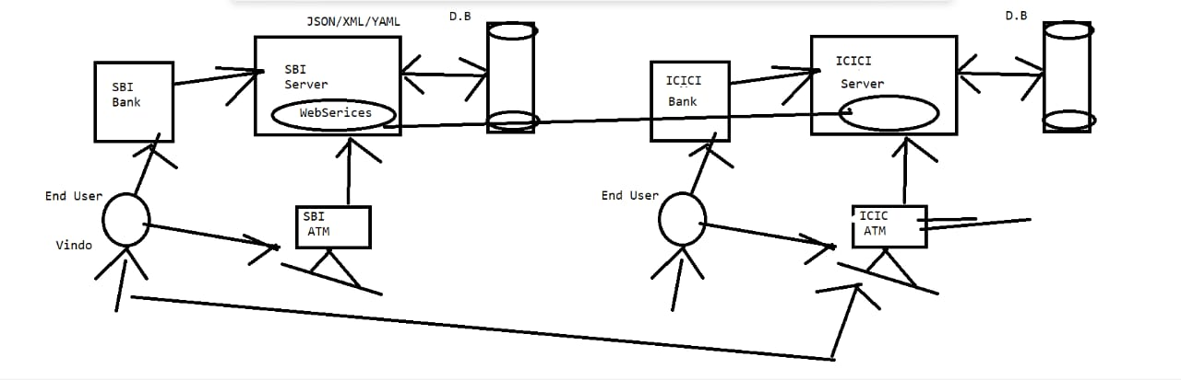

**Dynamic: -** “Dynamic” just means changing, which generally (in programming languages) means changing something at run time that isn’t explicitly coded in the source code.

Java is a dynamic language as it supports dynamic loading of classes. It means classes are loaded on demand it allocates memory at runtime for classes, methods and objects. This feature allows programmer to allocate memory when required.

Java dynamic language hain kyuki ye dynamic loading ko support krti hain this feature programmer allow krta hain jab jarorat ho.

**High Performance: -** Java code is compiled into bytecode which is highly optimized by the Java compiler, so that the Java virtual machine (JVM) can execute Java applications at full speed. In addition, compute-intensive code can be re-written in native code and interfaced with Java platform via *Java Native Interface* (JNI) thus improve the performance.

* **Def:-Jab java ka program pahali bar compile karate ho to thoda time lagata hain aur dusri baar kam lagta hai.**
* **JVM ke archeticure main execution engine ke andar profiler hota hain jo Jvm ke byte code main hotspot lagata hain .Jab program dobara ata hain hotspot se profiler dobara process nahi karta hai .**
* **Aur yadi apne 20 line aur add krdi to wo 20 line ko process krega.**

**Java is faster than other traditional interpreted programming languages because Java bytecode is "close" to native code. It is still a little bit slower than a compiled language (e.g., C++). Java is an interpreted language that is why it is slower than compiled languages, e.g., C, C++, etc.**

**This happens because when java program compile first time it takes some time and when same program compile again it takes less time before .A profiler inside the JVM architecture’s execution Engine that finds hotspots in the JVM bytecode. When the same program is compile again, the profiler is not processed again by the hotspot. And if you add 20 lines to the same program, it will process only those 20 lines.**

**Object Oriented: -** Java is an object-oriented programming language. Everything in Java is an object. Object-oriented means we organize our software as a combination of different types of objects that incorporates both data and behaviour.

Object-oriented programming (OOPs) is a methodology that simplifies software development and maintenance by providing some rules.

Basic concepts of OOPs are:

* [**Object**](https://www.javatpoint.com/object-and-class-in-java)
* **Class**
* [**Inheritance**](https://www.javatpoint.com/inheritance-in-java)
* [**Encapsulation**](https://www.javatpoint.com/encapsulation)
* [**Polymorphism**](https://www.javatpoint.com/runtime-polymorphism-in-java)
* [**Abstraction**](https://www.javatpoint.com/abstract-class-in-java)

the interviewer asks the difference between the **volatile** and the **transient** variable. So, the **volatile** and the **transient** variables are both different from each other. The transient keyword is mainly used at the time of serializing an object, while the **volatile** keyword is related to the visibility of variables that are modified by multiple threads at the time of concurrent programming.

**JAVA FUNDAMENTALS**

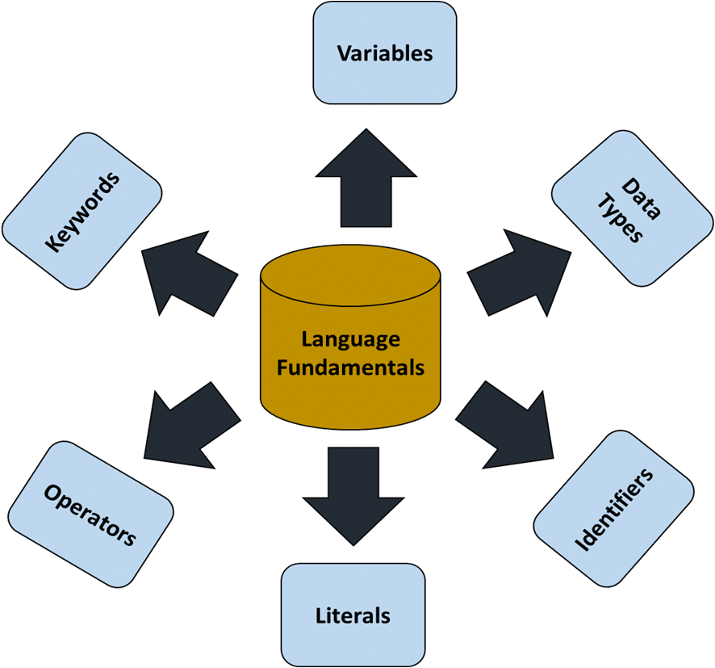

**Keywords:** - A keyword is a predefined reserved word whose meaning is fixed in the programming language.

**Type of keywords in java: -**

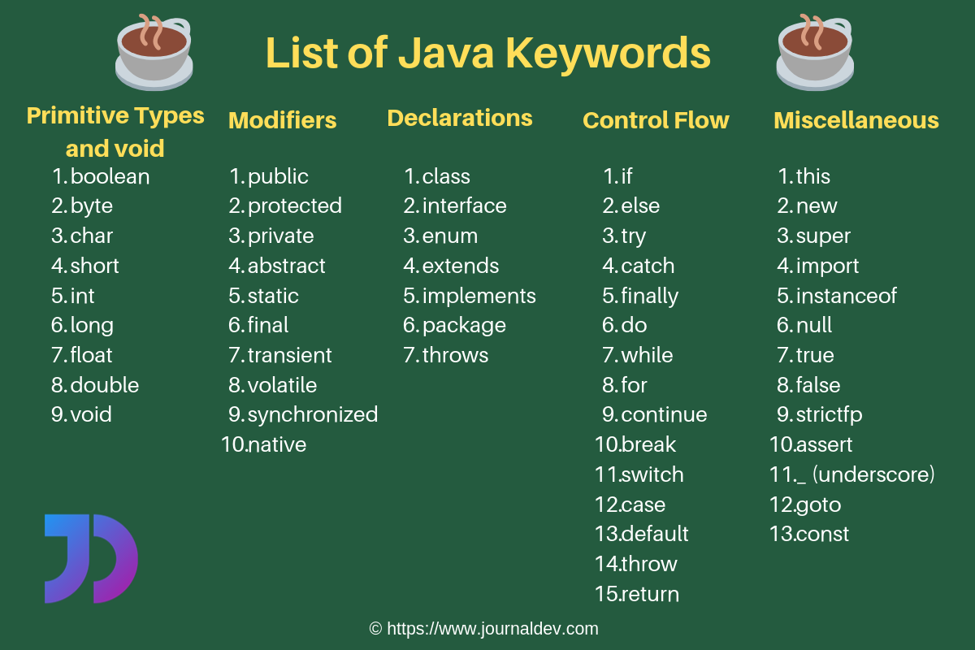

**There are approximately 52+ keywords used in java.**

*Java is a Case Sensitive language.

In java all keywords must be written in small letters of Lower Case.

**Assignment: How many keyword& Identifiers are in this program?**

**class Test{**

**public static void main(String args[]){**

**System.out.println(“hellow”);**

**}**

**}**

**Answer: Keyword – class, public , static , void.**

**Identifiers – Test, args , System , out , println .**

**Identifiy :-** (Pahchan )

**Identifiers: -** (Pahchan krane wala) Identifiers are the names of variables, methods, classes, packages, object, label and interfaces.

**Rules to declare Identifiers: -**

1. It can’t be a keyword.
2. The length of an identifier must be greater than 0 means it can’t be blank.
3. Blank Space and dot operator are not allowed.
4. In special characters only ‘_’ Underscore and ‘$’ symbols are allowed
5. It can not be start digit.

|  |  |
| --- | --- |
| Wrong | Right |
| Class int | Class Test |
| Class | Class A, class TestDetails |
| Class 0,Class Test.Details.java | My_Name@example |
| Test.Details |  |

* **Examples of legal identifiers:** age, $salary, _value, __1_value.
* **Examples of illegal identifiers:** 123abc, -salary.

**Conventions to Declare Identifiers:**

**Conventions for class identifiers:-**

**It is not mandotry. Convention ko isliye follow karate hai jis se code ki readability badati hain.**

**Conventions is guidlines**

**It is not mandorty but it should follow that increase readiblity of code**

**Jab aap convention nahi follow karoge to aap class ko kaise bhi likh doge like-tEst, test, ise naya banda confuse ho jayega jo company main kaam karega .Isliye convention ko follow kiya jaata hain.**

* If a class identifier contains single word, the 1st letter of the class-name should be in capital letters because the inbuilt classes made by Sun Microsystems have the 1st letter of their class-names in capital.

The main advantage of this convention is that the readability of the program increases.

* If a class identifier contains more than one word, then the 1st letter of each word should be capital letters.
* #Example

**public** **class** **Employee public class EmployeeDetails**

{   {

//code snippet   //code snippet

}   }

**Conventions for interface identifiers:-**

* The convention for interface identifiers is same as that of the class identifiers. Should be capital letters.

#Example

**interface** **Printable interface PrintableInter**

{   {

//code snippet } //code snippet   }

**Conventions for method identifiers:-**

* If a method identifier contains a single word, then it should be written in lower case.
* If a method identifier contains more than one word, the 1st letter of each word should be capital except the 1st word.

**class** Employee   **class** Employee

{   {

//method   //method

**void show()   void showDetails()**

{   {

//code snippet   //code snippet

}   }

}   }

**Conventions for variables identifiers or data members:**

* All the variables are written in lower case.
* variables one word small letter and more than one camel case main like method.
* All private and local variables use only lowercase letters combined with underscores.
* Variables that represent constant values use all uppercase letters and underscores between words.

#Example

**public** **class** **Employee**

{

int id;

String college_name;

float price1;

int _rn;

int $mob;

pubic static final int MAX_AGE;

}

**Conventions for package.**

All the variables are written in lower case.

#Example

**package employeeofsurya;** //name of package

**public class EmployeeDetails**

{

//code snippet

}

**Real project per kaam krana ho tab**

**Package come.androjavatech4.admin**

**Conventions for Constant identifiers:-**

* It should be in uppercase letters such as RED, YELLOW.
* If the name contains multiple words, it should be separated by an underscore ‘_’ such as MAX_PRIORITY.
* It may contain digits but not as the first letter.

#Example

**class** Employee

{

//constant

**static** **final** **int** MIN_AGE = 18;

//code snippet

}

Garbage Collector:-

Garbage collector is process of runtime unused memory destroy

How to get call garbage collector

Two types

System.gc();

Runtime.getRuntime().gc();

**Remember:-**

**Garbage collector is not gurnateed .**

**Gabage collector collector unused object and System class call gc method then jvm deleted unused object**

Finlize method:-It is object class method this method is call garbage collector before deletion/destroy object .which is eligbel for garbage collector clean up activity. lean-up activity means closing the resources associated with that object like Database,network connection.

**Memory Management:-**

There are two types of memory

Primary:-

1. RAM:-Temporary-RAM call hoti.
2. ROM:- Jo company machine ko bantati hai. Wah iska use hota hai

Secondary:-

1. Harddisk – Parmanent

Hdd

Processor -don ko maintain Ram krata hai,But sabkuch ram per chalta hain.

**How Many memory JVM?**

* Method area
* Heap area
* Stack area
* Native method Stack
* Stack area

**How many JVM is in one system?**

Jitane java install karoge utane hi jvm hote hai like-Eclipse , vscode

**Command:-** Heap size increase

Java -x 512m TestData.java

**Change Heap Size :-**

**-xms<size> set initial java heap size**

**-xmx<size>set max java heap size**

**-xss<size>set java thread stack size**

**Java -xmx 256m TestData.java**

In Java, memory management is the process of allocation and de-allocation of objects, called Memory management

**Variable: -**

**Jab variable nahi hoga let tum keyword se 20 press kiya user se input le rahe Ho. Wo value RAM mai store ho jayega but kaha store hogi wo to pata nahi .Isliye variable banaya jata hain. aur us variable ka jo address hoga wo usaki koi value hogi.**

* A variable is a name given to a memory location. It is the basic unit of storage in a program which refer the value of specific address.
* The value stored in a variable can be changed during program execution.
* A variable is only a name given to a memory location, all the operations done on the variable effects that memory location.
* In Java, all the variables must be declared before use.
* From OOPs point of view in java variables are also known as Data Members (D.M).

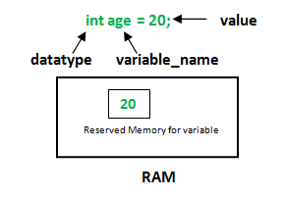

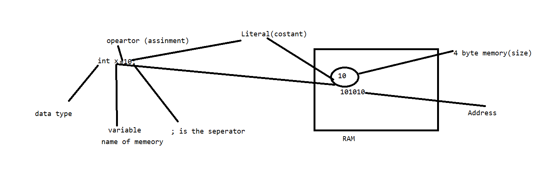

**Variable Terminology:**

**Variable declaration**

**Data type name;**

**Variable initialization**

**Variable name value;**

**Types of Variables or Data Members in java**

1. Non static variable / Instance variable / Non static data member

* **Instance variables or non-static variables are declared in a class outside any method, constructor or block.**
* As instance variables are declared in a class, these variables are created when an object of the class is created and destroyed when the object is destroyed.
* Unlike local variables, we may use access modifiers for instance variables. If we do not specify any access modifier then the default access modifier will be used.
* Initialisation of Instance Variable is not mandatory**. Its default value is 0**
* **Instance Variable can be accessed only by creating objects.**
* **Intstance variable call stadandred approach object refrecne .data member**

2. Static Variable / Class variable / Static data member

* These variables are declared similarly as instance variables, the difference is that static variables are declared using the static keyword within a class outside any method constructor or block.
* Unlike instance variables, we can only have one copy of a static variable per class irrespective of how many objects we create.
* Static variables are created at the start of program execution and destroyed automatically when execution ends.
* Initialisation of Static Variable is not mandatory. Its default value is 0
* If we access the static variable like Instance variable (through an object), the compiler will show the warning message and it won’t halt the program. The compiler will replace the object name to class name automatically.
* If we access the static variable without the class name, Compiler will automatically append the class name.
* To access static variables, we need not create an object of that class, we can simply access the variable as ***class_name.name_of_static_data_member***

3. Local variable: -

* A variable defined within a block or method or constructor is called local variable.
* These variable are created when the block in entered or the function is called and destroyed after exiting from the block or when the call returns from the function.
* The scope of these variables exists only within the block in which the variable is declared. i.e., we can access these variable only within that block.
* In java there is no concept of garbage value because java itself assign default value to the variables based on the data type.
* Local Variables must be initialized before the first use as they don’t have default value.

#Example

**Data Types**: Data type are those concept which provides following information about the variable like-type, size, range

It specifies the following things of a variable: -

1. Type of value it can hold
2. Size it will occupy in the memory
3. Range in which it can hold the data

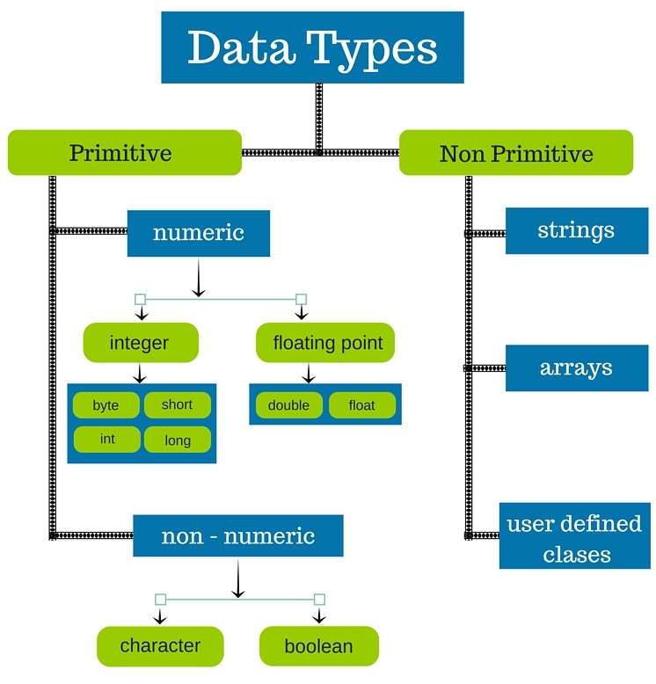

**There are two types of data types in Java:**

1. **Primitive data types:** The primitive data types include boolean, char, byte, short, int, long, float and double.
2. **Non-primitive data types:** The non-primitive data types include Classes, Interfaces, and Arrays.

**There are 8 types of primitive data types:**

* boolean data type
* byte data type
* char data type
* short data type
* int data type
* long data type
* float data type
* double data type

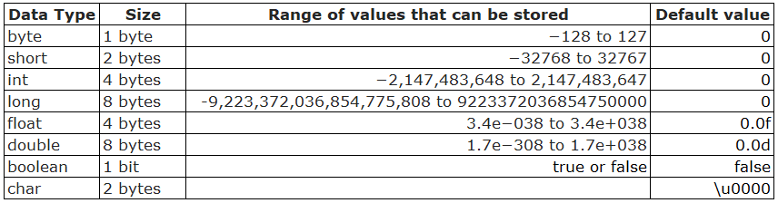

1 byte = 8 bit

* + byte:-byte ka use networking main hota hai, Socket programming main.
  + int :- arithmetic operation
  + short :-8086 ke liye banya gaya hai
  + float :-
  + double:-decimal ke liye
  + char: character ke liye hota hai
  + Boolean: true ,false ke liye use hota hainin

int x; valid hai

instance &static variable ki default value zero hoti hain ,but local varrible does not default.

**Why does not local variable default ?**

Ye calculation ke liye hota hain aur agar iski default value hogi to galat output a jayega for example-

int x=10;

int y;

int z=20;

int w=x*y+z;

sop(z);

output : zero a jayega

* **Aur instance variable ki default value isliye hoti hain.Kyuki ye client ki state ko rakhane ke liye Hota hai-Object ke kisi bhi user ke data ko sambhal ke rakhane ke liye hota hain.**
* **User defined datatype value null hoti hain.**
* **Class Hathi;**
* **Hathi h;**
* **Interface sathi;**
* **Sathi s;**
* **Enum Test;**
* **Test t;**

**\*\*Logically there are two types of data types:**

1. **Signed data type (+Ve and -Ve)**

For signed data type, the range can be calculated as -2n-1 to 2n-1-1. Where n is number of bits.

1. **Unsigned data type.(+Ve)**

#*Note: - In java there is no any concept of unsigned data type.*

* **Methods in java:-**
* **Java main class ke andar koi logic nahi likh sakate hai. Isliye inst &static variable ko do part main nahi likh sakate hain kyuki logic hamesha method & block ke andar likha jata .java ka rule.**
* **Method ka naam relevant rakhana chaiye**
* **Blank file compile ho jati hain**
* **Only class banake bhi compile kr sakate hain**
* **Only method banake compile nahi kr sakate hain. Uske liye ek class , interface, enum ek banana hoga .**
* **Why Main method make?**
* **This method entry point of the program . Main method is basically used to maintain entry point of the program.**
* **Yahi se decided hota hai program chalega . JVM bina call kiye apne aap call krta hain.**
* **Bina main method ke program compile ho jata hai but run nahi hota hain**
* **Void-Iska matlab koi bhi value return nahi karega**
* **Return.iska matalab koi bhi value return karega aur aapki marzi hain ise hold kre ya na kre**
* **Sop(a.sum();)**
* **Int t=a.sum();**
* **Sop(t);**
* **What is difference actual &formal**
* **Actual – int div(int x, int y);jahan banate hain**
* **Formal-t.div(20, 3);jahan value pass karate hain**

1. In Java Methods are also known as Member functions.
2. A **method** is a block of code which only runs when it is called.
3. Methods are used to perform certain actions, and they are also known as **functions**.
4. We use methods for the reusability of code. Once a method is defined it can be used again and again.
5. You can pass data, known as parameters, into a method.
6. From OOPs point of view a member function represents the behaviour of an object.
7. If we make a method public and static, then it acts as a global method thus can be accessed from anywhere.

**Rules Regarding Methods in Java:-**

* Before using / calling a method, we have to define it.
* We don’t have to declare a method in java

int add(); //Not Valid

* It’s valid only with the abstract keyword

abstract int add(); //Valid

**#Syntax to create a method: -**

*Modifiers + Return type + Method Name (Arguments If any)*

*{*

*Body of the method….*

*return value; (if return type is mentioned above)*

*}*

**#Syntax to call a method: -**

*Method_name(args if any);*

**We cannot create a method inside another method.

#Example

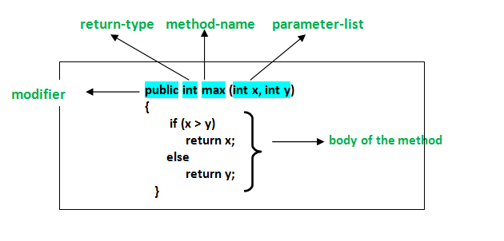

**Types of Methods:-**

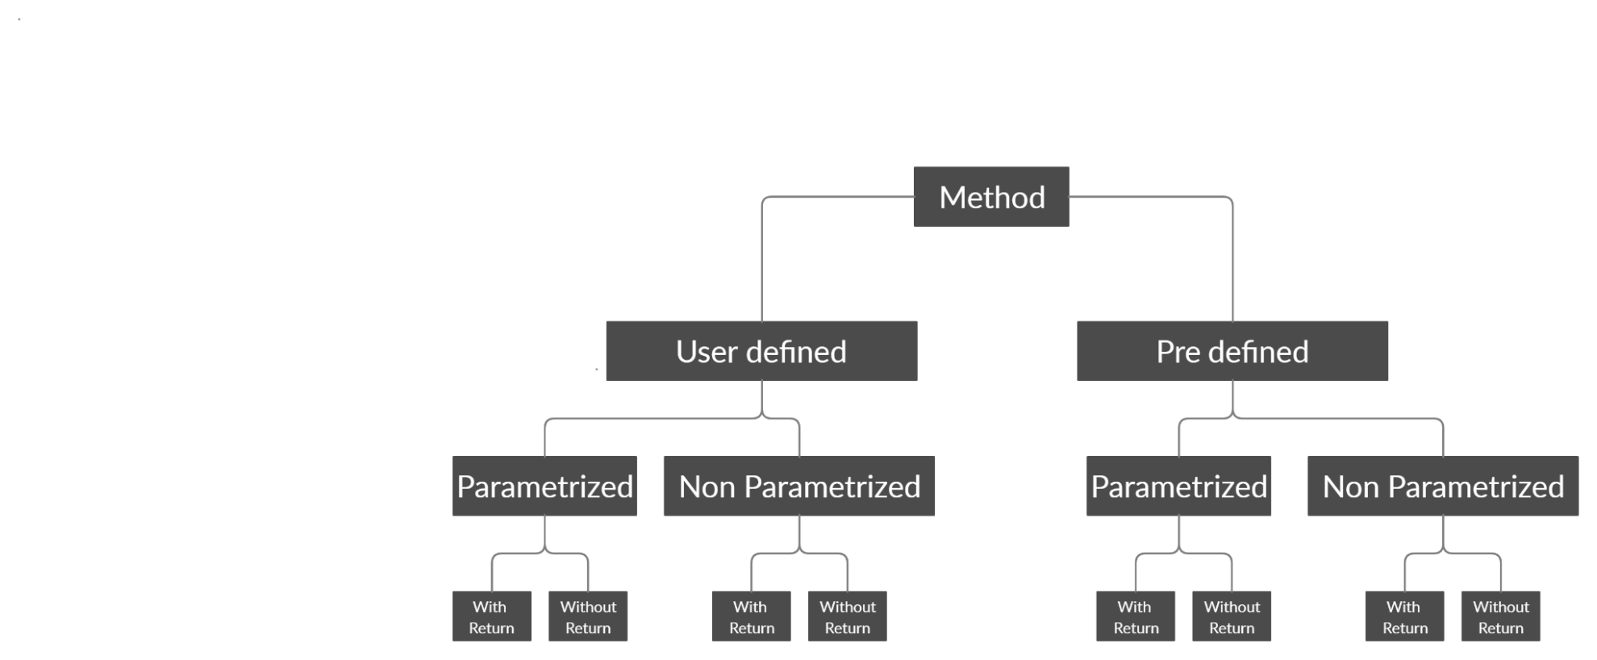

**Return type-Primitive ,Non p,void**

**Arguments if any-p,nonp**

**Modifiers-public, final, static etc.**

**Void sum(){//N.P without R**

**}**

**Void sum(){//N.P with R**

**}**

**Void sum(){//P.without R**

**}**

**Void sum(){// P with. R**

**}**

**Predefined methods**-is method main kuch na kuch logic likha rahata hai.Jisse be specific task ko perform karne ke liye hota hai.

**JVMArchitecture: 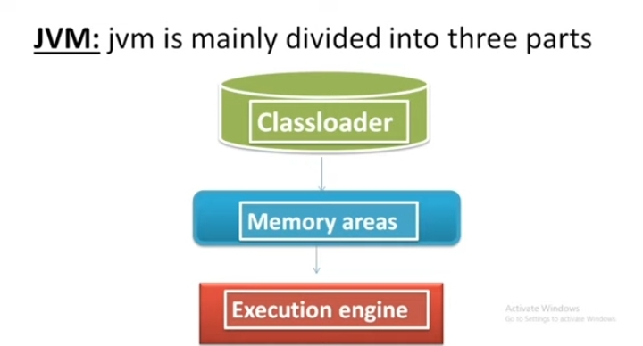**jvm mainly divided into three parts

First of all .class file go to clossloader and start loading process

Loading process done by loader in this three loader

Loader loading class in memory

• **Bootstrap ClassLoader**: Loads core Java libraries from JAVA_HOME/lib.

• **Extension ClassLoader**: Loads additional libraries from JAVA_HOME/lib/ext.

• **Application (System) ClassLoader**: Loads user-defined classes from the classpath

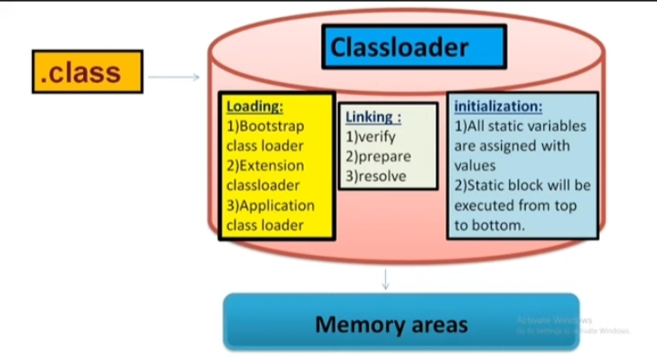

• **Verification**: Ensuring that the bytecode is valid and doesn't violate any JVM security or integrity rules.

• **Preparation**: Allocating memory for class variables and initializing them to their default values.

• **Resolution**: Resolution process symbolic name replace in original name

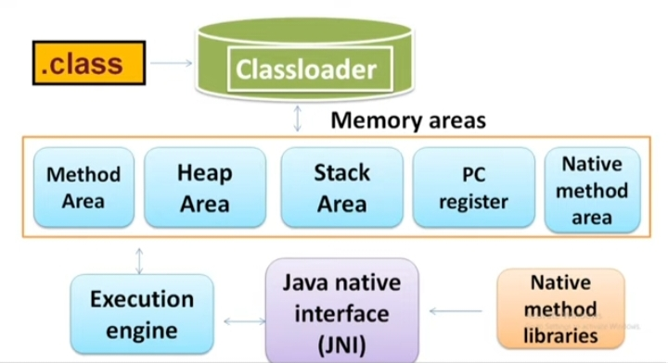

**Method area-**store static variable and static method –not thread safe

**Heap area-**object,instance , and array all stores –not thread

**Stack memory-**store local variable and pointer of object and current running method

**Pc Register:-** In Java, the **PC (Program Counter) register** stores the address of the current instruction being executed for each thread.

**Native method:-**native method store in use program

**Excution engine:-exution main component this is run program in this inside two component**

**Internpeter and jit compiler –jit when method and varrible exucte again and again then file make has itself and peroformance increase**

| **pect** | **Bubble Sort** | **Selection Sort** | **Insertion Sort** |
| --- | --- | --- | --- |

|  |  |  |  |
| --- | --- | --- | --- |
| **Approach** | Repeatedly swaps adjacent elements | Selects the smallest element | Inserts elements into a sorted sublist |

|  |  |  |  |
| --- | --- | --- | --- |
| **Time Complexity** | O(n²) (average and worst) | O(n²) (always) | O(n²) (average and worst) |

|  |  |  |  |
| --- | --- | --- | --- |
| **Best Case** | O(n) (when sorted) | O(n²) | O(n) (when sorted) |

|  |  |  |  |
| --- | --- | --- | --- |
| **Number of Swaps** | Large | Minimal | Moderate |

|  |  |  |  |
| --- | --- | --- | --- |
| **Stability** | Stable (preserves order of equal keys) | Unstable (does not preserve order) | Stable |

|  |  |  |  |
| --- | --- | --- | --- |
| **Use Case** | Simple, but inefficient | Good for datasets with few writes | Best for small or nearly sorted data |

Prdefined methods already defined logic which use to perform spcefic task.

**Object Oriented -**Object oriented programming technology or programming methodology hain .Jo real world se li gayi hain.

Object oriented programming (OOPs) is a methodology that simplifies software development and maintenance by providing some rules.

**Ques-Is technique ka naam object oriented hi kyu pad gayaa aur bhi kuch ho sakta tha?**

**Ans-**Hum software kis liye banate hai real world ki problem ki solve krne ke liye. Jab hum s/w real world ki problem ko solve krne ke liye banate hai ,to approach bhi real world ka hona chaiye.Or Sbase pahale hum yaha per objective decide karte hai ki mera Objective kya hai.Usi objective ko decide karke hum apna kaam karate hai.Isliye oops walo kuch aisa word doodah jise sabhi pe valid ho duniya koi bhi cheez ho sabke liye ek word ho jise kaam asaan ho jaye.Wo word Object hai jo duniya main koi bhi cheez hai wo object hai  **.**

**Objective-**Kisi object ke liye sochate ho for example muje ye software banana hai wahi apka objective hai**.**

You plan to achieve.

**Basic concepts of OOPs are**:

* Object
* Class
* Inheritance
* Encapsulation
* Polymorphism
* Abstraction

**Object-**The term object can be explained in so many ways

* **From real world point of view:-**
* Object is any things which exist in the real word we can see, touch, feel & imagine.
* Every real world entity is called object
* Every real world entity which physical tangible or intangible existence knows as object.
* **Every object real has the following three characteristics:**
* **1.State**
* **2.Behaviour**
* **3.Identity**
* **#Example**
* If we have a Mobile phone then its characteristics be like-
* State- Colour, Price, Dimensions, Camera, RAM, ROM etc.
* **Behaviour: -** Calling, Mailing, Messaging, Internet Surfing.
* **Identity: -** IMEI Number.
* Now we know that every object has, state, behaviour, and identity but in real world we can see that there are many objects in the real world which have same state and behaviour and this is a problem so to overcome this problem we categorize the objects. Thus we find the solution in the form of class of categorization.
* From coding point of view
* From memory point of view
* From class point of view

.

* **Java ek object oriented programming language hain. Aur object oriented programming language ye kahati hain ki jab bhi app progamming krnae jaye to uska apna objective man le. Aur usi objective man ke apna program start (orientation )kre.That is called object orientd approach hain.**
* **Real word kuch aise object object hote hain jinke same behaviour and same identity hoti hain.**

**Class or Classification:** -

* **A class is the logical categorization of similar type of object: : same type ke object ko jo uniqe name diya gaya hain wahi class hain. For example same type ke object jaise Trainee ek uniq name hain aur kai log se milkar ban hoga mana 5 log hain to unka naam, age, mobile, email , fess, Subject isme kuch cheeze same hain to jaise fees, subject to unka uniqe name hain class. Logical ka matlab jo cheez hum logical samjh rahe hain or kisi concept se proof kare jaise mere pass ek mobile hain to same type ke bahut se mobile hain .same type ka matlabe jo cheeze same thi jo same how wahi leke proof krana hain different ko ignor krna hain**
* **A class is the user define data structure.**
* **A class is user define data type.**
* **Coding point of view: is program ko dekh ke koi banda pata hi nahi laga payega ki ye program kis cheez ki liye banayaga hai. Aap kahate ho nahi hum nahi pata laga payenge but Jvm to ptaa laga lega to main kaha teek hain save(Trainee.java) krake comepile krate hain.**
* **javac Trainee.java error: class, interface, or enum expected**
* **isese pata ye chalta hain koi bhi programming main jab user apne app objective decide karata hain .(apna data likhata hain to is userdefine data ko use userdefine structure main rakho .)**
* **user define data type is liye hain kyuki non permitive data type main string , arrays and defind class hoti hain to sir ye class hain.**
* String name,mobile,email;

int age;

float fess;

void read()

{

System.out.println("rad....");

}

void chat()

{

System.out.println("chat.....");

}

void showInfo()

{

System.out.println(name);

System.out.println(mobile);

System.out.println(email)

;

System.out.println(age);

System.out.println(fess);

}

public static void main(String[] args)

{

JavaTrainee t=new JavaTrainee();

System.out.println(t);

JavaTrainee t1=new JavaTrainee();

System.out.println(t1);

JavaTrainee t2=new JavaTrainee();

System.out.println(t2);

JavaTrainee t3=new JavaTrainee();

System.out.println(t3);

JavaTrainee t4=new JavaTrainee();

System.out.println(t4);

}

* A class is combination of data member and member function.
* **A class is the blue print from an object: for real world example-aap chahate ho makan banavana. Aur aapne kya kiya uska Naksha ready krwaya but Naksha ready kya ghar ready nahi yahi hain blue print of class.**
* **A class is the way to implementing the encapsulation: encapsulation is the process of the raping data and function together. It is not 100% encapsulation. Data ek class ke andar rape(band dena guth dena ) ho chuka hain.**
* **Trainee ek capusl hain aur data and funcation alag Tablet thi.**

1. **Aisa data jispe arithimatics operation krna hain to usko primitive data leke chalte hain jispe krna hain usko non permitive lete hain.**
2. **long mobile=640849483493l ye le sakte hain but achha bhi nahi lagata hain.**

**Syntext to Create a Class In Java:-class Identifer{-[D.M]-[M.F]-Special M.F->|- Constructor|-[Initilizers]-(init block & static block)}[]- Symbol Indicates that it is optional for the Class**

* Object create krna mtlab memory alocate krna

**#Difference between Function and Member function: -**

#Ans. Function represent independent functionality of an application whereas a member function represents the behaviour of an object.

Function can be called independently whereas member function must be called on member (object)

*void morningWalk()*

*{ }*

*morningWalk(); // Function*

*Ram.morningWalk(); // M.F*

**Why we are creating the object of a class:-**

1. Because class does not have its existence in the memory until we create the object of a class.
2. To allocate memory for the instance variable.
3. To call the Non static method.

**Object-**The Object class is beneficial if you want to refer any object whose type you don't know. Notice that parent class reference variable can refer the child class object, know as upcasting.

**How many ways are used to create an object in java:-**

1. By new Keyword.
2. By *newInstance()* method.
3. By Factory Pattern.
4. By clone method.

**Syntax to creating an object in java by new Keyword:-**

*new Class Identifier( args if any); // Anonymous*

*ClassName refvar* ***=****new Class Identifier( args if any);*

*ClassName refvar;*

***r****ef****=****new Class Identifier( args if any);*

//Crating Object Using new .

class Trainee{

new Trainee();

Trainee t=new Trainee();

Trainee t;

t=new Trainee();

}

**Anonymous Object:-**

Anonymous simply means nameless. An object which has no reference is known as an anonymous object. It can be used at the time of object creation only. If you have to use an object only once, an anonymous object is a good approach.

Anonymous objetcts are those objects which have no reference .It can be used only once.

*new* Is the keyword or it is the text based operator whose main aim is to allocate memory in heap are.

**Memory Allocation in Java: -**

1. Static Memory Allocation or Compile time.

2. Dynamic Memory Allocation or Runtime.

In case of static memory allocation the user requirement and identification of memory is decided at compile time.

In case of dynamic memory allocation the user, requirement and identification of memory is decided at runtime.

**\*\*But in both cases memory is allocated at run time.**

When memory is allocated at compile time then it is referred via its name and when memory is allocated at runtime it is referred via pointer.

In Java memory allocation happens only dynamically.

**Reference Id:**

Whenever we are creating an object of a class then a unique identity is crated in memory in the form of 0101- here java Object class methods refer this id and create another id known as reference id whose syntax is-

**ClassName@HexString**

The logic of this reference id is available in Object class toString() method.

**Reference Variable: -**

Those variables which holds the reference id of an object.

*Trainee t=new Trainee();*

Here **t** is the reference variable.

Single reference id can be hold in multiple reference variables. In other words we can say that different reference variables can point the same object.

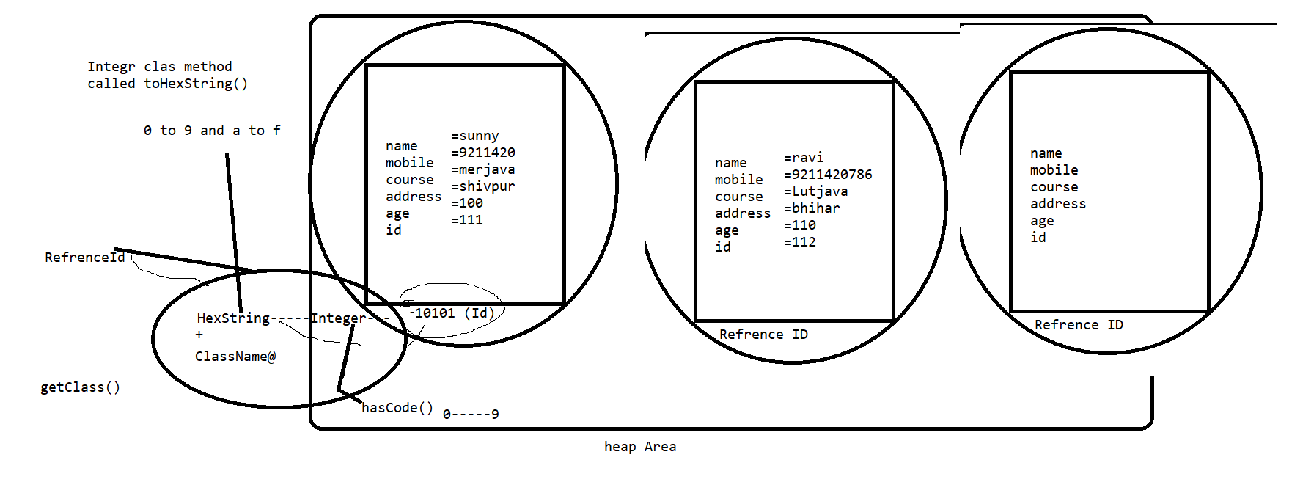

#Example

class Trainee

{

String name,mobile,course,address;

int age,id;

void showInfo()

{

System.out.println(name);

System.out.println(mobile);

System.out.println(course);

System.out.println(address);

System.out.println(age);

System.out.println(id);

}

/*

public String toString()

{

return getClass().getName()+'*'+Integer.toHexString(hashCode());

}

*/

void setData()

{

name="ravi";

mobile="79789798";

course="java";

address="grnoida";

age=23;

id=12313;

}

Trainee(String n,String m,String c,String adr,int a,int i)

{

name=n;

mobile=m;

course=c;

address=adr;

age=a;

id=i;

}

Trainee()

{

name="ravi";

mobile="79789798";

course="java";

address="grnoida";

age=23;

id=12313;

}

void setData(String n,String m,String c,String adr,int a,int i)

{

name=n;

mobile=m;

course=c;

address=adr;

age=a;

id=i;

}

void read()

{

System.out.println("trainees r reading....");

}

void chat()

{

System.out.println("trainee r chating.......");

}

public static void main(String ss[])

{

    Trainee t1=new Trainee();

    Trainee t2=new Trainee();

    t1.showInfo();

    t2.showInfo();

    Trainee t3=new Trainee("monu","242424","java","gkp",12,111);

    t3.showInfo();

    Trainee t4=new Trainee("monu","242424","java","gkp",12,111);

    t4.showInfo();

/*

Trainee t=new Trainee();

t.showInfo();

t.setData();

t.showInfo();

Trainee t1=new Trainee();

t1.setData();

t1.showInfo();

Trainee t2=new Trainee();

t2.setData("monu","242424","java","gkp",12,111);

t2.showInfo();

Trainee t12=new Trainee();

t12.setData("monu1","2142424","1java","1gkp",121,1111);

t12.showInfo();

*/

//new Trainee().name="manoj";

//Trainee t2;

//System.out.println(new Trainee().name="sunny");

//System.out.println(new Trainee().mobile="9211420");

//new Trainee().chat();

//Trainee t=new Trainee();

//System.out.println(t);

//t.chat();

//t.read();

//t.id=111;

//t.name="sunny";

//t.address="shivpur";

//t.age=100;

//t.course="merjava";

//t.mobile="9211420";

//t.showInfo();

//

//

//Trainee t1=new Trainee();

//System.out.println(t1);

//t1.id=112;

//t1.name="ravi";

//t1.address="bhihar";

//t1.age=110;

//t1.course="Lutjava";

//t1.mobile="9211420786";

//t1.showInfo();

//

//Trainee t3;

//t3=new Trainee();

//System.out.println(t3);

//t3=t;

//System.out.println(t3);

//System.out.println(t);

//t2=t1;

//t3.name="kabi";

//t.showInfo();

}

}

**How many ways to Allocate Memory -iska matlab memory main ek space dena**

* Static /compile time

1. Use
2. Requirement
3. Identification

Ye sab statically decide ho jati hain- pahale se hi decide kr lete hain

* Dynamic /runtime : on the spot decide krate hain

1. Use
2. Requirement
3. Identification

But dono case main memory allocate run time per hoti hain

Dynamically memory Allocation can be categorized in following ways-

* By new keyword
* By new Instance () method
* Factory pattern
* Clone

Run time per memory location better hota hain static memory location se- waise sabke advantages and disadvantages hote hain but better yahi hota hain. Real world example se samjte hain jaise.Hum 5 dost ka plan tha hum log agra ghumne jayenge aur hum logo ne 5 din pahale decide kiye aur usi time humane 5 ticket train ki book kr di aur 5 din ke baad hum log jab jaane ko the to do logo ko argent kaam pad gaya to do log ne mana kr diya jaane se to ticket west ho gayi . aur yahi kaam on the spot decide krate plan bana lete but decide on the spot krte to 2 seat west nahi hoti . isliye runtime memory location better hain .

In Case of C memory location : - Static memory allocation

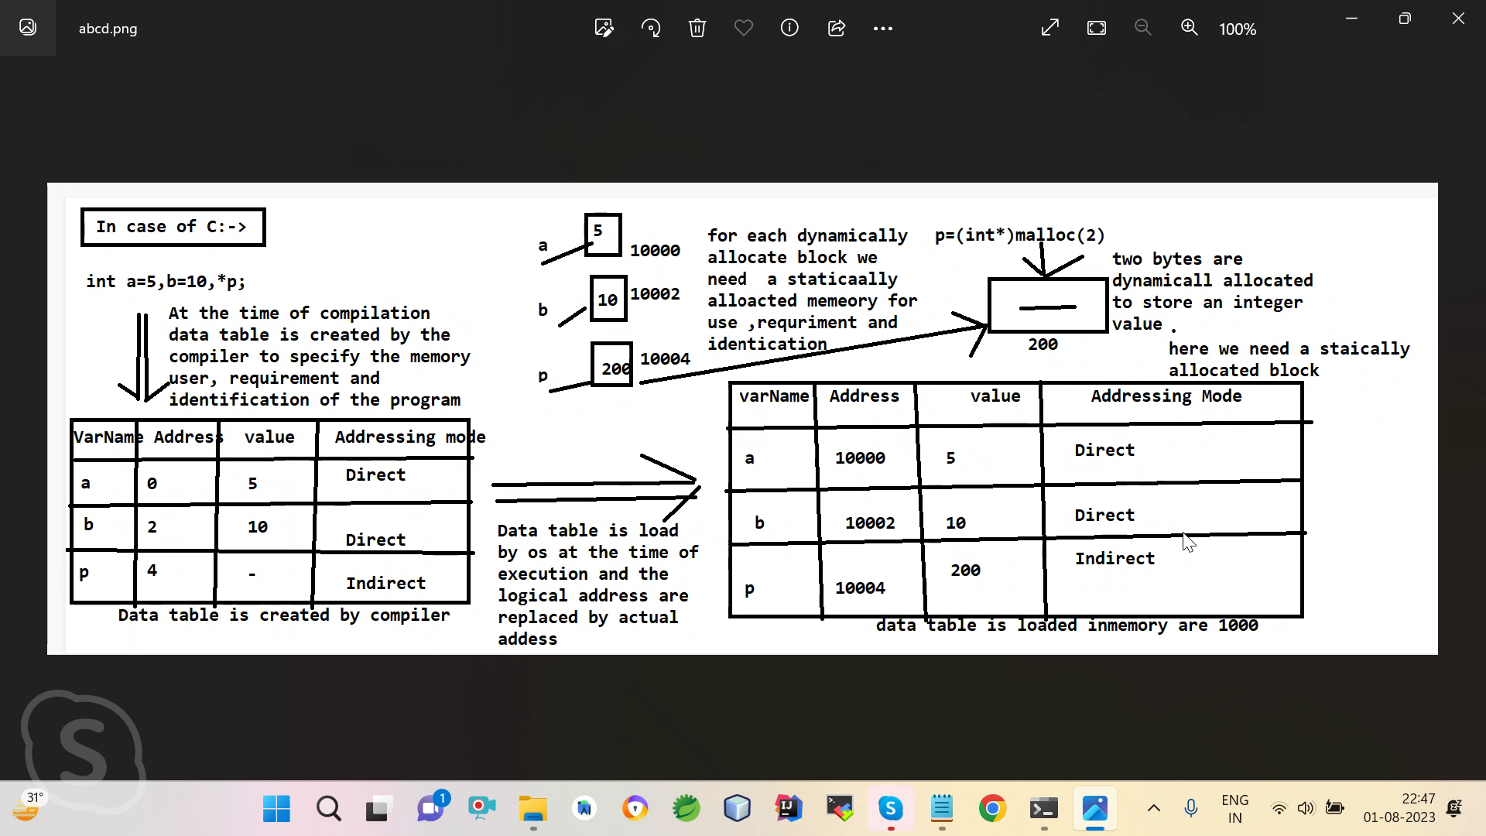

* Normal variable value hold krne ke liye hota hain.
* Pointer variable address hold krne ke liye hota hain. Dynamic memory locate krane ke liye hota hain
* C main compile time compile a data table create kr deta hain
* Run time per dusri table create hogi.is me jo data table matlab dibba bane hain compile time per utane hi dibbe run time per banege
* **Java main object kyu banate hain class ka physicale existence memory mai lane ke liye** -pahale objective sochate hain phir object ka data ,behaviour likahte hain jise user defined structre taiyar ho jata hain but uska koi physicale exitence nahi hota hain isliye object create ho jaaye **coding point of view.**
* **Syntex to Create Object In Java Using new Keyword->1. new ClassIdentifier(args if any);e.g-> new JavaTrainee();2. ClassIdentifer refVar=new ClassIdentifier(args if any);e.g->JavaTrainee t= new JavaTrainee();3. ClassIdentifer refVar; refVar=new ClassIdentifier(args if any);e.g->JavaTrainee t;t= new JavaTrainee();**
* **new keyword: ye memory create karata hain heap area mai but kitana create krna hain ye constructor batata hain.coding point of view**
* **Memory point of view :- we create object so that their physical existence can be in memory.**
* **Hum object isliye banate hain ki class ka physical exitence memory main a jaaye jaise humne new keyword kiya new javatrainee ise is class ka physical exitence memory main a gaya .**
* **class object :Perdefind class parent class hain userdefind class and predefind class . actual java main ek object name ki class hoti hain – jo har object ko service deti hain like memory allocate krna ,memory ko refer krane ki service**
* **object is predefined class in java .Object class all predefined and user defined class is super class ,which provide service to the object. Like memory allocate ,memory refer service**

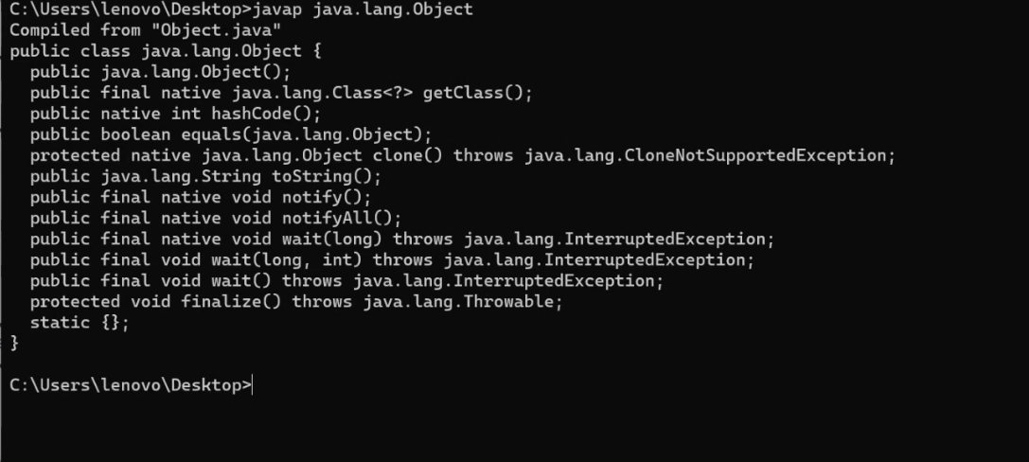

java main dyanamically memory locate hoti hain but dynamically memory locate pointer se hoti hain statically memory name allocate hoti hain but java main pointer nahi hota hain but java implicit pointer ko support krati hain

* **Ye 9 magic method hote hain . Inhe magic method isliye bola jata hain kyuki har java ke andar magically avaible hote hain**.
* **Native method are those method declaration in java but definition could be in some other language may inside the your O**/S.
* **Hashcode wo method hain jo hasing techniqe lagake pointers lagake ek native method hain jo internaly call hoti hain wo sabse pahale us particular 01 Ka memory address jo memory main area reserve hota hain us particular memory ko refer krake uska ek integer number deta hain wahi hascode hi memory ka address hota hain.**
* **For example jo adhar card banya gaya hain wo population soch kr banaya gaya hoga ki itani population aise kuch socha hoga 12 digit ka hota hain**
* **Aise kuch mobile number ka socha hoga jo 10 digit ka hota hain**
* **Hascode 0-9 jo integer number hain. integer class ke pass toHexstring method hota hain.jo 0-to9 integer number leta hain aur 0-9 and a to f mai change kr deta hain -jise hexaString bolte hain aur class se jodane ke liye ek class name ki main getclass and get name se class se jod diya jata hain name ka method hota.pura hi refernce id bola jaata hain.**
* **Refrence id:- jab bhi java ka object banate hain to uski identiy memory main taiyar hoti hain heap area main jaise hi taiyar hoti to java walo ne kya kiya Refer tarike se new id de di jise refer id bolate hain jo object class ke toString se banati hain us id ko ek variable main dal dete hain usi ko refrence variable bolte hain.Not actual address but actual tak pahucna ka address**
* **Jab object banata hain to heap arra main memory allocate ho jati hain uska kuch address hota hain jo address memory main taiyar hota hain wo dynamic hota hain ,dynamic address jo hota hain usko pointer refer krata hain but java main pointer to hota nahi hain aur jo memory ka address hota hain wo bhi muje nahi pata hota hain**
* **Java walo ne ye machanisam use kiya hashing techniqe lagayi jiski techniq ke madyam se hashcode method call kiya**
* **Jab koi object banata hain to memory main actual id taiyar hoti hain jo 01 ke form main hoti hain aur pointer se refer hoti hain but java main pointer hota nahi to java ne implicit pointer lagake us id ki reflica data hian jo actual id ki reflica hain jo heap me hoti hain aur jab use variable main hold krte hain to variable use point krega**
* **Pointer direct hota tha but refrence actual tak pahuchana tak address pointer to pointer indirect address.**
* **Java ka machanisam use actual address tak paucha degi**
* **Anymous object -reausbality nahi possible hoti hain. Ek baar hi use kr saakte hain**
* **Java ka rule hain kahi pe refrence id banati hain age uska hold kiya jata hain kisi variable main to uska type class type hota hain**
* **Test t=new Test();**
* **Object ka type ,class type ka hota hain**
* **To string method yahan override kiya gaya hain**

**class StringMethod{**

**public String toString(){**

**return getClass().getName() + "How are You" + I integer.toHexString(hashCode());**

**}**

**public static void main(String args[]){**

**StringMethod m=new StringMethod();**

**System.out.println(m);**

**}**

**2.**

class StringMethod1{

public static void main(String args[]){

StringMethod1 m=new StringMethod1();//hum kisi bhi method per hashcode method call kr sakate hain

System.out.println(m);

int i=m.hashCode();// ye integer value dega

System.out.println(i);//ye integer value print kr deta hain

String hexString= Integer.toHexString(i);//Integer class ka method to HexString method hota jo

System.out.println(hexString);//integer value ka string haxaCode main

Class c=m.getClass();//ye java main bani banayi class hain ye class naam ki class ka object return kr deta hain //method hain

String name=c.getName();//ye class ka method get Name method chala diya jata hain

System.out.println(name);

System.out.printlln(c);

System.out.println(name+'@'+hexString);

}

}

Note – same getclass , getName se hota hain

class A{

public String getN(){

return “baba”

}

}

class {

public A getA(){

return new A():

}

public static void main(String args[]){

B b=new B();

b.getA().getN();//isi ko method chinning kahate hain. Is se hum apne class ke sare method chala sakate hain

}

**Refrence variable :**

**In Java, when we create an object of any class and hold the object of that class in the same type of class, it is called a reference variable.**

**Constructor: -** A constructor is a special type of member function which have following characteristics which makes it different from other member function.

1. Its name must be same as the name of class.
2. It doesn’t has any explicit return type not even void.
3. Programmer can’t call it explicitly, it’s implicitly called when object of the class is created using *new* keyword.
4. The main purpose of constructor is to initialized data the object at the time of creation.

**If we’re not explicitly creating a constructor in this case compiler implicitly adds a default constructor.

Default constructor:-data ko default value deta hain

Three types se data initialize kr sakate ho .

1. Constructor
2. Methods
3. t.name

**what is difference between constructor and Methods?**

|  |  |
| --- | --- |
| **1.constructor must be same as the class name** | 1.Methods may or may not be same as the class name |
| 2.Constructor does not have explicit return type | 2.Methods must be return type . |
| 3.contructor is implicitly called only once when object is created | Method is called many times on one object . |
| 4.canstructor does not represented state of object but constructor initiliaze data member (object) uske data member main value dal dena | 4.Method reprensted behaviour of object |
| 5.whenever we are compelling any java program a default constructor is added by java compiler Itself when we are not adding on constructor in the program. | 5.Method is not possible |

**Why constructor name class name as same?**

**The new keyword allocates memory, but how much to allocate and for which class, that constructor tells, when the name of the constructor is not the same as the name of the class, then how will new know for whom to allocate and how much to allocate?**

**• When we do not create a constructor, the compiler adds a default constructor to the class name at compile time, whose work is to print the default value of the same class, when the constructor is not in the class name, then the compiler will give the constructor with any name. will also be a problem**

* **New keyword memory allocate krata hain but kitani allocate krani aur kis class ke liye kranei wo constructor batata hain jab constructor ka name class ke name se same nahi hoga to new ko kaise pata chalega kiske liye locate krna hain kitana krna hain**
* **Jab hum constructor nahi banate hain to compiler compile time per constructor add kr deta hain class name se but jab constructor class name se same nahi hoga to compiler kisi bhi name se constructor de dega to compiler ke liye bhi problem ho gayi**

Why does not constructor return type ?

any constructors have returntype implicit which are class type

Har constructor ka return type uske class type ka hota hain

A a=new A(); a variable main kaise hold kr

void show(){

}

Int t=a.show(); ye hold nahi kr sakate ho kyuki iska return type nahi hota

#class A{int show(){return 1;}A A(){return this;}public static void main(String ss[]){A a=new A();int p=a.show();}}

**Types of constructor: -**

1. **Parameterized**
2. **Non-Parameterized**

**Syntax to create constructor: -**

*Access Specifier ClassName(args if any)*

*{*

*}*

**Access Specifier**- public, protected, default & private

**Copy Constructor: -**

The copy constructor is a constructor which creates an object by initializing it with an object of the same class, which has been created previously. The copy constructor is used to − Initialize one object from another of the same type. Copy an object to pass it as an argument to a function.

//Program to demonstrate how copy constructor works

public class Student

{

    String name;

    int age;

    Student(String n,int a)

    {

        name=n;

        age=a;

    }

    Student(Student s)  //copy constructor

    {

    name=s.name;

    age=s.age;

    }

    void show()

    {

        System.out.println(name);

        System.out.println(age);

    }

    public static void main(String[] args)

    {

        Student s=new Student("ram",12);

        s.show();

        Student s1=new Student(s);

//      s1.name=s.name;

//      s1.age=s.age;

        //System.out.println(s1.name);

        s1.show();

    }

}

**Literals in java: -**

**from java 7:-**n Java, **literals** are fixed values that are directly written in the code to represent data. They are constant values that do not change during program execution.

### Examples:

* **Integer Literal**: 10 (represents a fixed number)
* **String Literal**: "Hello" (represents a fixed text)
* **Boolean Literal**: true or false (represents logical values)
* **Character Literal**: 'A' (represents a single character)

Literals are used to assign values directly to variables.

**1.Binary (0 and 1)---> 0b,0B2. Hexa (0 to 9 and a to f) ---> 0x, 0X3. Octa (0 to 7) ----> 04. Decimal ( 0 to 9)int x=98;int x=0b1011; or 0B1011;int x=0b10012; //errorrint x=0123;int x=01283; //errorint x=0x123abc;**int x=0x122agz; //eroor

**Binary-> 0,1 (2)Decaiml-> 0 to 9 (10)Octa-> o to 7 (8)Hex--> 0 to 9 & A to F (16)Decimal to Binary---- 96Binary to Decimal**

Constant values that are typed in the program as a part of the source code are called literals. There are 5 types of literals in java

1. Integral literals
2. Floating point literal
3. Char literal
4. String literal
5. Boolean literals

*String is a referenced type literal except this all other are primitive literals

**Rules regarding literals: -**

* All String literals are treated as String class object and these must be written in double quotes.
* By default all the integral literals are treated as int data type and floating literals are treated as double data type.
* Character literal is always to be written in single quotes.
* Boolean literals take one of the two values true OR false.

**We can specify floating point literal as float type by suffixed with f or F.**

#Example

 **Type conversion in java**

It is the process of converting one type of data in another type.

* Primitive to Primitive.
* Primitive to Object.
* Object to Primitive.

**There are two types of Type Conversion: -**

1. Type Promotion (Implicit).
2. Type Casting (Explicit).

**Type Promotion (Implicit): -**

* It is the process of converting one type of data into another type implicitly by java itself.
* **If we have data and data does found its exact match so it is implicitly promoted to its higher data type**
* **Humare compiler ko do type ki value samajh ati hain int and double operation ke type per ye max formula use krta hain.**
* **=max(int,byte,byte)=int=max(int,byte,byte,long)=long**

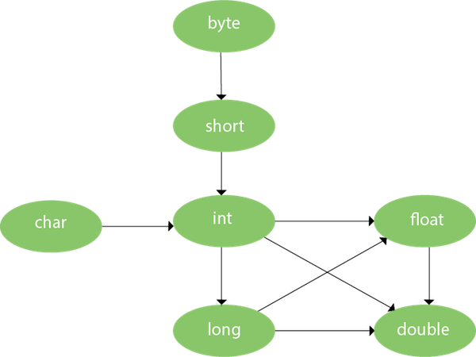

#Example

* public class Test
* {
* void show(byte b)
* {
* System.out.println("Byte="+b);
* }
* void show(short b)
* {
* System.out.println("short="+b);
* }
* void show(int b)
* {
* System.out.println("int="+b);
* }
* void show(long b)
* {
* System.out.println("long="+b);
* }
* void show(float b)
* {
* System.out.println("float="+b);
* }
* void show(double b)
* {
* System.out.println("double="+b);
* }
* public static void main(String [] args)
* {
* Test t=new Test();
* //t.show(23l);
* //t.show(23);
* t.show(23.67f);
* }
* }

**Type Casting (Explicit): -**

It is the process of converting one type of data into another type explicitly by java programmer.

**#Syntax: -**

***dataType variableName = (dataType) variableToConvert;***

//Java program to illustrate explicit type conversion

class Test

{

    public static void main(String[] args)

    {

        double d = 100.04;

        byte b=20;

        int  c=b;// type promotion

        //explicit type casting

        long l = (long)d;

//explicit type casting

        int i = (int)l;

        System.out.println("Double value "+d);

        //fractional part will  lost

        System.out.println("Long value "+l);

        //fractional part will lost

        System.out.println("Int value "+i);

    }

}

Note: - In java, compiler perform operation only on two type of data either int or double.

Note: - Whenever we perform any arithmetic operation then calculation is done on the basis of below formula:

*Max (type of first operand, type of second operand, type of third operand…)*

Note: - if data type are equals result will be in the same data type.

public class Test

{

    public static void main(String[] args)

    {

        int male=5;

        int female=2;

        float ratio=(float)male/female;

        System.out.println(ratio);

    }

}

Output :- 2.5

**Operators: -**

In java programming operators are the symbols which are used to perform the operation over operand.

*int x=10;*

*int y=20;*

*int x+y* ‘+’ is the operator and ‘x’ and ‘y’ are operands.

**Types of Operators: -**

**1. Unary Operators:** The Java unary operators require only one operand.

#Example: Increment Operator (++), Decrement Operator (--), Not Operator (!)

**2. Binary Operators:** The Java binary operators require two operands.

#Example:

* Arithmetic (+,-,*,/,%)
* Logical (&&, || , !)
* Assignment(=)
* Relational (>,<,>=,<=,!=)
* Bitwise (&,| )
* Shift (>>,<<)

**3. Ternary Operators:** The Java unary operators requires three operands.

Java has only one ternary operator which is also known as Conditional Operator

condition ? expression1 : expression2;

int max = (a > b) ? a : b;

#Example: Ternary Operator (? : )

**Operator Precedence and Associativity: -**

**Precedence of operators in Java: -** Operator precedence determines the order in which the operators in an expression are evaluated.

When various operators are used within the same statement a problem arises which is which operation should be performed first. To solve this problem there is the concept of operator precedence. Operator Precedence is a set of rules that defines the priority for all the operators present in a programming language. The operation which has an operator with the highest priority will be executed first.

*Consider the following mathematical expression 2 + 3 * 4. If we perform the operations from left to right, we get (2 + 3) * 4 = 20. However, if we follow the mathematical rule of precedence (also known as BODMAS), which states that multiplication and division should be performed before addition and subtraction, we get 2 + (3 * 4) = 14. This rule of precedence is also applicable in programming.*

**Associativity of Operators: -** If an expression has two operators with similar precedence, the expression is evaluated according to its associativity.

If we have operators which have same precedence in the same statement then we use associativity to figure out which operation should be performed first. Associativity defines whether you should go from left to right or you should go to right to left. If Associativity says that you should go left to right then operation on the left side should be performed first and then only we should move to right side.

a= 5*5/10  
If we solve the multiplication operation first then answer will be 25/10= 2.5  
If we solve the division operation first then the answer will be 5*0.5=2.5  
Out of this the first answer is correct because the given two operators have same precedence therefore we should look at the  
Associativity which is left to right.  
Therefore , a=2.5 .

**Associativity is of two types: -**

1. Left to right (grouping is done from left to right).
2. Right to left (grouping is done from right to left).

**Except postfix increment and decrement operators, all the unary operators have right to left associativity.

**Except relational and assignment operators, all the binary operators have left to right associativity.

**Operators Precedence and Associativity Table:**

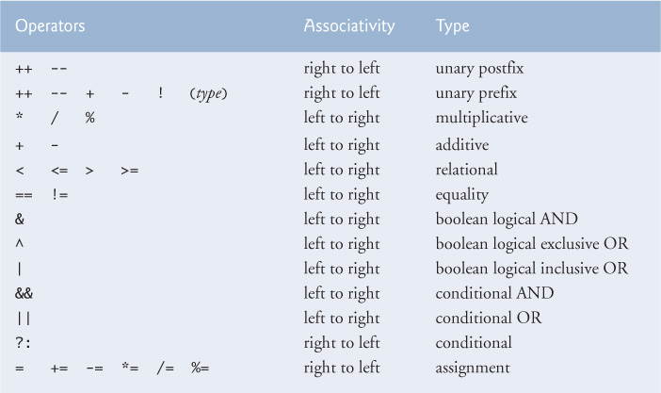

**Control Statements in java: -**

**Control Statement---> Construct1.Looping for for each while do while2.Condational IF-Boolean value jata hain**

**If else Nested If else Ladder If else (If elseif) Switch & Case**

**public class IfExample**

**{**

**public static void main(String[] args)**

**{**

**//defining an 'age' variable**

**int age=2;**

**if(age>18){**

**System.out.print("Age is greater than 18");**

**}**

**System.out.print("***");**

**System.out.print("***");**

**System.out.print("***");**

**}**

**}**

**public class IfExample**

**{**

**public static void main(String[] args)**

**{**

**//defining an 'age' variable**

**int age=20;**

**String name="baba";**

**if(age>18 && name.startWith("r"))**

**{**

**System.out.print("Age is greater than 18");**

**}**

**System.out.print("***");**

**System.out.print("***");**

**System.out.print("***");**

**}**

**}**

**Surya, 10:15 PM**

**Short Circuit Logical Operators in Java with Examples - GeeksforGeeks**

**https://www.geeksforgeeks.org**

**Surya, 10:21 PM**

**class Test**

**{**

**public static void main(String ss[])**

**{**

**int age=2;**

**if(age>18)**

**{**

**System.out.println("Age is greater than 18");**

**System.out.println("Age is greater than 18");**

**System.out.println("Age is greater than 18");**

**}**

**else**

**{**

**System.out.println("Age is greater than 2323");**

**}**

**}**

**}**

**---------------------------------**

**public class IfElseExample {**

**public static void main(String[] args) {**

**//defining a variable**

**int number=13;**

**//Check if the number is divisible by 2 or not**

**if(number%2==0){**

**System.out.println("even number");**

**}else{**

**System.out.println("odd number");**

**}**

**}**

**}**

**if(condition1){**

**//code to be executed if condition1 is true**

**}else if(condition2){**

**//code to be executed if condition2 is true**

**}**

**else if(condition3){**

**//code to be executed if condition3 is true**

**}**

**...**

**else{**

**//code to be executed if all the conditions are false**

**}**

**public class IfElseIfExample**

**{**

**public static void main(String[] args) {**

**int marks=65;**

**if(marks<50){**

**System.out.println("fail");**

**}**

**else if(marks>=50 && marks<60){**

**System.out.println("D grade");**

**}**

**else if(marks>=60 && marks<70){**

**System.out.println("C grade");**

**}**

**else if(marks>=70 && marks<80){**

**System.out.println("B grade");**

**}**

**else if(marks>=80 && marks<90){**

**System.out.println("A grade");**

**}else if(marks>=90 && marks<100){**

**System.out.println("A+ grade");**

**}else{**

**System.out.println("Invalid!");**

**}**

**}**

**}**

**public class JavaNestedIfExample2 {**

**public static void main(String[] args) {**

**//Creating two variables for age and weight**

**int age=25;**

**int weight=48;**

**//applying condition on age and weight**

**if(age>=18){**

**if(weight>50){**

**System.out.println("You are eligible to donate blood");**

**} else{**

**System.out.println("You are not eligible to donate blood");**

**}**

**} else{**

**System.out.println("Age must be greater than 18");**

**}**

**} }**

**1h 19m 39s**

**Surya, 10:31 PM**

**class Test**

**{**

**main()**

**{**

**day="sss";**

**switch(day)**

**{**

**case "sunday":**

**sdfdsfdsf**

**break;**

**case "monday":**

**aaaaaaa**

**break;**

**case "tues":**

**aaaaaaa**

**break;**

**}**

**}**Control Statements are used to control the execution flow of the program.

Java provides three types of control flow statements.

1. Decision Making statements:- decision-making statements decide which statement to execute and when.
   * if statements
   * Simple if statement
   * if-else statement
   * if-else-if ladder
   * switch statement
2. Loop statements
   * do while loop
   * while loop
   * for loop
   * for-each loop
3. Jump statements
   * break statement
   * continue statement

**There are three types of control statements:**

1. **Conditional Control Statements**

### a) If statement: It will go inside the block only if the condition is true otherwise, it will not execute the block.

if(condition){

    // statements (if Block)

    }

    //other statements

**b) If Else statement:** If the condition is true then, it will execute the If block. Otherwise, it will execute the Else block.

if(condition){

    // statements (if Block)

    }

    else{

    // statements (Else block)

    }

    //other statements

### c) If Else-If statement: if the condition is true, then it will execute the If block. Otherwise, it will execute the Else-If block. Again, if the condition is not met, then it will move to the else block.

### d)  Switch Statement: - Switch statement allows program to select one action among multiple actions during the program execution.

### In simple words, the Java switch statement executes one statement from multiple conditions.

### #Example

class WriteExample{

    public static void main(String []args){

    int a=2; int b=3; int c=4;

    if(a>b){

    System.out.print(“Institute1”);

    }

    else if(a>c){

    System.out.print(“Institute2”);

    }

    else{

    System.out.print(“AndroJava”);

    }

    }

    }

OUTPUT: - AndroJava

Switch(variable/value/expression){

    Case :

    // statements

    Case :

    // statements

    default:

    // statements

    }

1. **Looping Control Statements**

These are used to execute a block of statements multiple times. It means it executes the same code multiple times so it saves code. These are also called Iteration statements.

* Debugining line by line chalane ko kahate hain

**a) for Loop**

* It executes the code until condition is false.
* It is used when number of iterations are known.

**#Syntax**

for(initialization; condition; increment/decrement){

    //statements (For Body)

    }

**#Example: -**

class WriteExample{

    public static void main(String []args){

    int a=1;

    for(int i=0; i<2; i++){

    System.out.println(“Value of a is:”+ a); // string concatenation

    a++; // increases value by 1

    }

    }

    }

Output: Value of a is:1

Value of a is:2

**b) while Loop**

* While loop executes till the condition becomes false.
* It is used the number iterations are not known

#Syntax: -

while(condition){

    // statements

    }

#Example: -

class AndroJava {public static void main(String args[]) {

    int i = 2;

    while( i <=2 ) {

    System.out.println(“AndroJava” );

    i++;

    }

    }

    }

Output: - AndroJava

**c) do while Loop**

* When you are using for or while, then it will execute the loop body only if the condition if true.
* **In do-while loop, it will execute the loop first, then it checks the condition. So, it will execute the loop at least once.**
* It is called exit controlled loop while for & while loop are called entry controlled loop.

**#Syntax: -**

do{

    // statements

    }while(condition);

**#Example: -**

class AndroJava {public static void main(String args[]){

    int a = 2;

    do{

    System.out.println(AndroJava);

    i++;

    }while( a< =2 );

    }

    }

1. **Unconditional Control Statements/Jump Statements**  
   **a) Break Statement: -**break is a keyword. It is used within any control statements. It is used to terminate the execution of the current loop or switch statements.

**#Example: -**

class AndroJava{ // break without label

    public static void main(String args[]){

    for(int i=1;i<=4;i++){

    if(i==3) break;

    System.out.println(“AndroJava”);}

    } }

Output: -AndroJava

AndroJava

**What happens when Object is created: -**

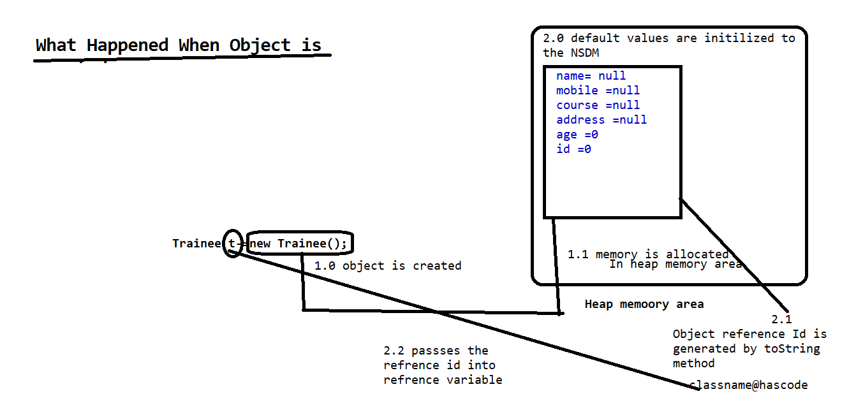

**Continue:-**  it skips the specific part of the loop and jumps to the next iteration of the loop immediately.

**Initializers: -**

An initializer is a line of code (or a block of code) placed outside any method, constructor, or other block of code. Initializers are executed whenever an instance of a class is created. Initializers are used to initialize data even before the constructor.

**Depending upon the behaviour these are of two types:** -

**1.** Init block (Non-Static Initializers) – Object Dependent

**2.** Static block (Static Initializers) – Object Independent

*Syntax to create Init block: -*

*{*

*//Business Login*

*}*

**Features of Init block: -**

1. It executes with respect to every constructor (object).
2. We can have more than one init block in a program in this case the order of execution of init block is determined by the order in which they are written means in First Come First Serve order(FCFS)
3. Init block should be created after declaration of all variables in a program.
4. Never create the same class object in init block but we can create the object of other class in init block as per our requirement.

Note: - In java init block is implicitly used by compiler to initialize every non static data member.

class A

{

int x=10;

}

//During Compilation compiler make the following changes.

class A

{

int x;

{

x=10;

}

}

**The logic of init block is automatically pasted by the compiler at the top of every constructor.

#Example: -

package oops;

public class A

{

    int x;

    static int counter;

    {

    counter++;

    System.out.println("init block1");

    }

static public void countObject()

{

System.out.println("Total number of object="+counter);

}

    A()

    {

        x=10;

        System.out.println("A cons...="+x);

    }

    A(int x)

    {

        System.out.println(x);

    }

    {

        System.out.println("init block2");

        }

    public A(int i, int j)

    {

        System.out.println(i);

        System.out.println(j);

    }

    public static void main(String[] args)

    {

        System.out.println("main block..");

        new A();

        new A(24);

        new A(44,67);

            {

            System.out.println("mai init ka jaisa hu...");

            }

            A.countObject();

    }

        {

        //x=20;

        //System.out.println("init block....="+x);

            System.out.println("init block3");

        }

}

#Example: -

package oops;

public class Employee

{

    String name;

    int age;

    Address  adr;

    Salary sa;

    int x;

    {

      adr= new Address();

    }

    {

      sa=new Salary();

    }

    Employee(String m,int a)

    {

        name=m;

        age=a;

    }

    void show()

    {

    System.out.println("Name="+name);

    System.out.println("Age="+age);

    System.out.println("Address="+adr.city +"State,"+adr.state+" Country,"+adr.country);

    System.out.println(sa.ta +" "+sa.da+" "+sa.hra);

    }

    public static void main(String[] args)

    {

        Employee e=new Employee("ram",34);

        e.show();

    }

}

**Static Keyword in Java: - Static hum jab banay jab hume lage aisa data jo sabhi object ke liye common ho to static bana de jis se memory best nahi hogi use share us datamember ko memory class loading time per class area main milati hain jo method area ka part hota hain**

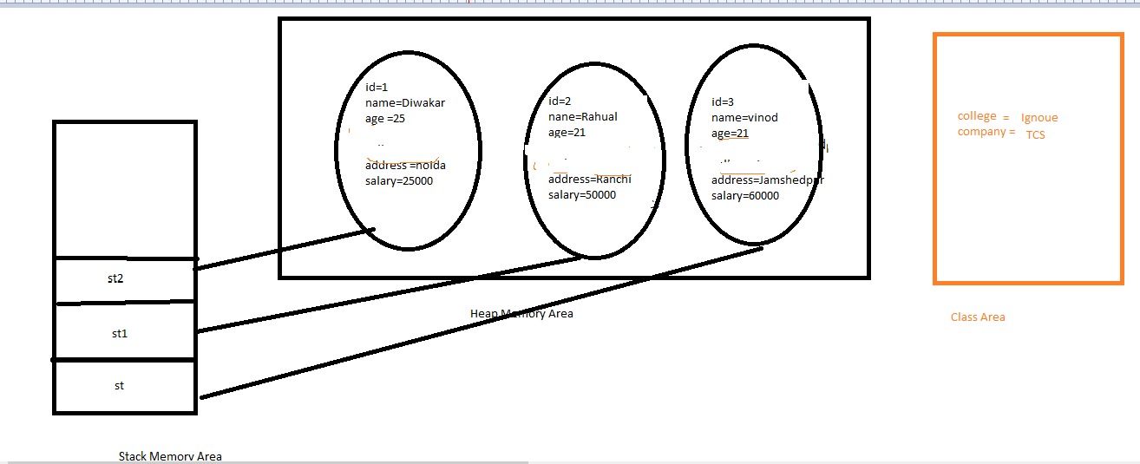

* **Ise class data member bhi bolate hain kyuki ye pure class shabhi object ke liye common hota hain isliye wo classs ki property ko batata hain**
* **Static ko ek baar memory milati hain wo sabhi object ke liye shareable hoti hain**
* **Static data member sab ke liye common hota hain class ka bhi apna state and behaviaour hota hain jo sabake liye common hota hain**

In Java, static keyword is mainly used for memory management.

**Static keyword can be used with:** -

1. Data member
2. Member function
3. Block
4. Nested class.

**Static keyword can NOT be used with:** -

1. Class
2. Constructor
3. Interface
4. Local variable.

**#Example Without static: -**

package androjava;

public class Placement {

    String companyname = "HCL";

    String collegename = "Kalinga University";

     String s_name;

     int s_id,s_age,s_sal;

    Placement(int sid,String sname,int sage,int ssal)

    {

        s_id=sid;

        s_name=sname;

        s_age=sage;

        s_sal=ssal;

    }

    void show(){

        System.out.println("\nCollege Name : "+collegename);

        System.out.println("Company Name : "+companyname);

        System.out.println("Student ID : "+s_id);

        System.out.println("Student Name : "+s_name);

        System.out.println("Student Age : "+s_age);

        System.out.println("Student Monthly Salary : "+s_sal);

    }

    public static void main(String args[])

    {

    System.out.println("*****Kalinga University Student Placement*****");

    Placement p1=new Placement(9211,"Amit",24,40000);

    Placement p2=new Placement(9233,"Sumit",25,30000);

    Placement p3=new Placement(9243,"Ronit",28,45000);

    System.out.println();

    p1.show();

    p2.show();

    p3.show();

    }

}

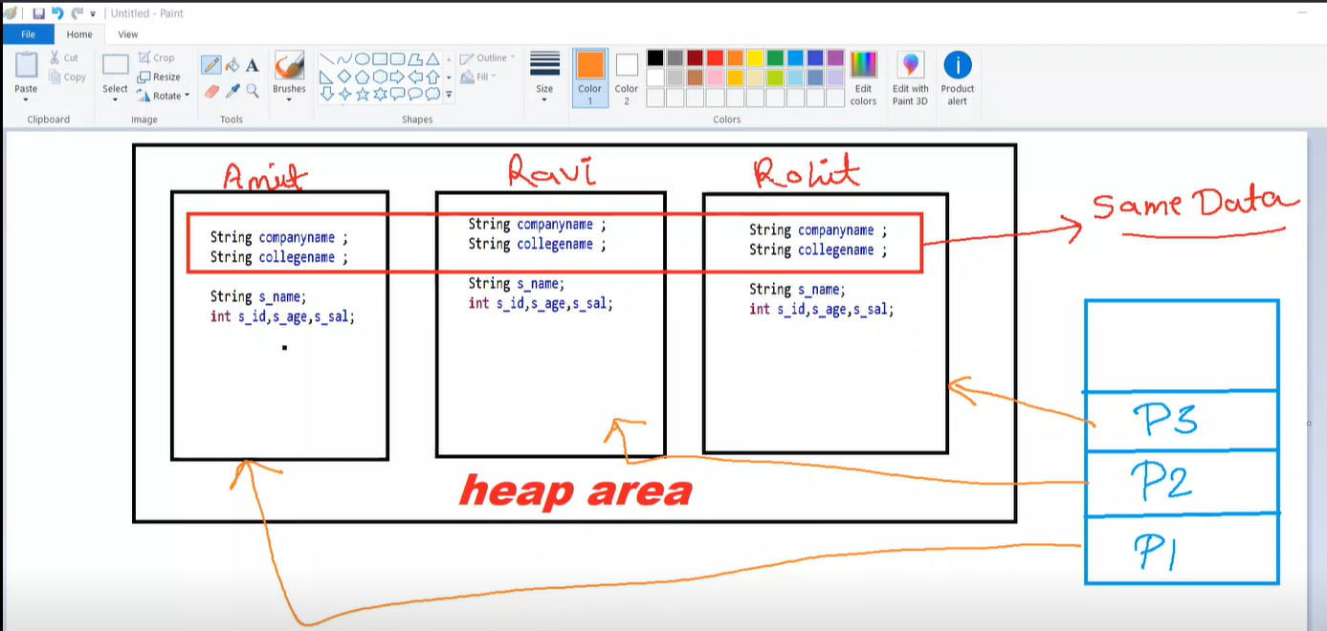

**#Example With static: -**

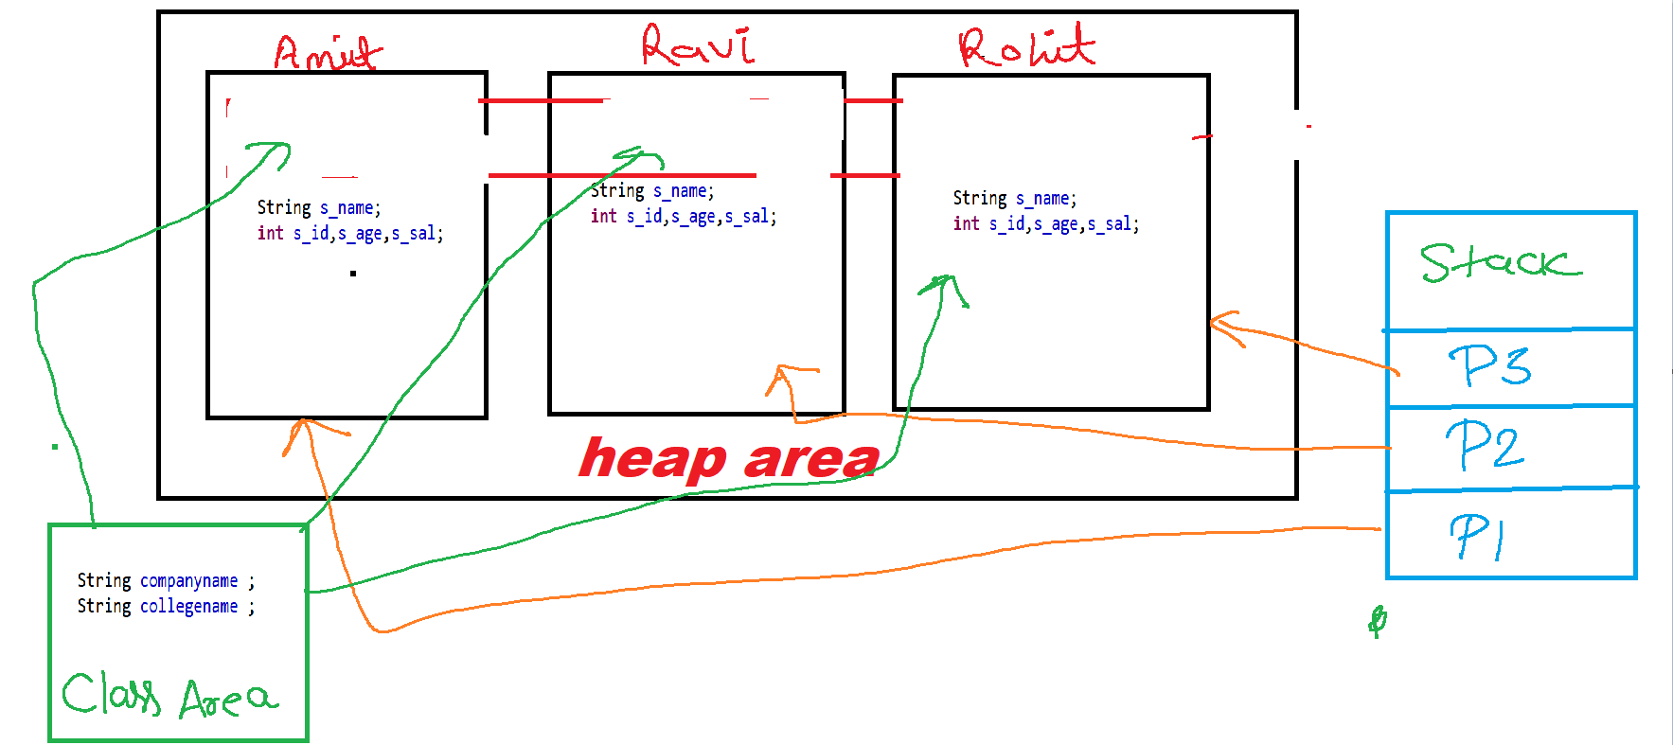

package androjava;

public class Placement {

    static String companyname = "HCL";

    static String collegename = "Kalinga University";

     String s_name;

     int s_id,s_age,s_sal;

    Placement(int sid,String sname,int sage,int ssal)

    {

        s_id=sid;

        s_name=sname;

        s_age=sage;

        s_sal=ssal;

    }

    void show(){

        System.out.println("\nCollege Name : "+collegename);

        System.out.println("Company Name : "+companyname);

        System.out.println("Student ID : "+s_id);

        System.out.println("Student Name : "+s_name);

        System.out.println("Student Age : "+s_age);

        System.out.println("Student Monthly Salary : "+s_sal);

    }

    public static void main(String args[])

    {

    System.out.println("*****Kalinga University Student Placement*****");

    Placement p1=new Placement(9211,"Amit",24,40000);

    Placement p2=new Placement(9233,"Sumit",25,30000);

    Placement p3=new Placement(9243,"Ronit",28,45000);

    System.out.println();

    p1.show();

    p2.show();

    p3.show();

        }

}

**Static Data Member and Non static Data member: -**

1. Static data member represents the property of class whereas non-static data member is representing property of object.
2. In case of static data member memory is allocated in class area at class loading time only once and this memory is shared by multiple objects. It means single copy is created in memory in case of static data member.
3. In case of non-static data member memory is allocated in each objects separately (In heap area).It means separate copy is created in each objects in case of non static data member.
4. If a data is common for all objects then make it static otherwise non static.
5. As we know that static represents the property of class that’s why the standard approach to call the static data member is with class name. and non static with object reference

**#Example how memory is shared in case of static data**

package oops;

public class B {

    static int x;

    B()

    {

        x++;

        System.out.println(x);

    }

    public static void main(String[] args)

    {

    new B();

    new B();

    new B();

    }

}

OUTPUT: -

1

2

3

**How Many ways are used to call Non static data member:-**

1. Object.Nonstatic Data member; (e.g. new A().x)
2. Object Reference. Non static Data member (e.g--- a.x)------- (Standard approach)
3. Directly Non static Data member (but only in same class non static member function and constructor ) (e.g .x)

**Above two approaches are valid in same class as well as different class.

**How Many ways are used to call static data member:-**

* 1. Object . static Data member; (e.g. new C().x)
  2. Object Reference. static Data member (e.g--- a.y)-------
  3. ClassName.Staticdatamember.(Standard approach)
  4. Directly static Data member (same class any where) (e.g .y)

**Above three approaches are valid in same class as well as different class.

**Rule: -** A non-static data member or non-static member function cannot directly access in static context (static method or static block) but vice-versa is allowed.

**Static Member Function and Non static member function:-**

1. Static Member Function represents the behaviour or functionality of class and Non static member functions representing behaviour of object.
2. Method is either static or non-static it gets memory in method area (method table).
3. As we know that static represent the behaviour of class that’s why the standard approach to call the static member function with class name and non-static with object reference

**How Many way are used to call Non static member function:-**

1. Object. Non static member function; (e.g. new A().show())
2. Object Reference. Non static member function(e.g--- a.show())------- Standard approach
3. Directly member function(but only same class non static member function and constructor ) (e.g .x)

Above two approaches are valid in same class as well as different class.

**How Many way are used to call static member function:-**

1. Object .static member function; (e.g. new C().disp())
2. Object Reference. static member function(e.g--- a.disp())
3. ClassName. static member function. Standard aproach
4. static member function(same class anywhere) (e.g .disp())

Above three (1 to 3) approaches are valid in same class as well as different class.

**Static Block: -**

1. Are those blocks which executes only once at class loading time.
2. This block is object independent.
3. It execute before main() method.
4. We can write any logic in static block which we can write in main().
5. In case of more than one static block their order of execution in FCFS.

Note: - we can’t pass the command line argument in static block this could be only possible with main method.

//Static Block

static

{

//coding…..

}

* **jo kaam mainmethod main kr sakate ho wo sabkuch is me kr sakate ho bus command line argument ko chodkr ke waaki sab kaam kr sakate ho**
* **non static data init block banake initilaze hota hain baise static data static block banake intiliaze hota hain**
* **Runtime per java Test hello hi value bhejate hain use command line argument kahate hain**
* **Command line argument is the process of passing the value from command line at runtime.**
* **Ye java main user se input se lena tarika hain jo static block se nahi kr sakate ho**

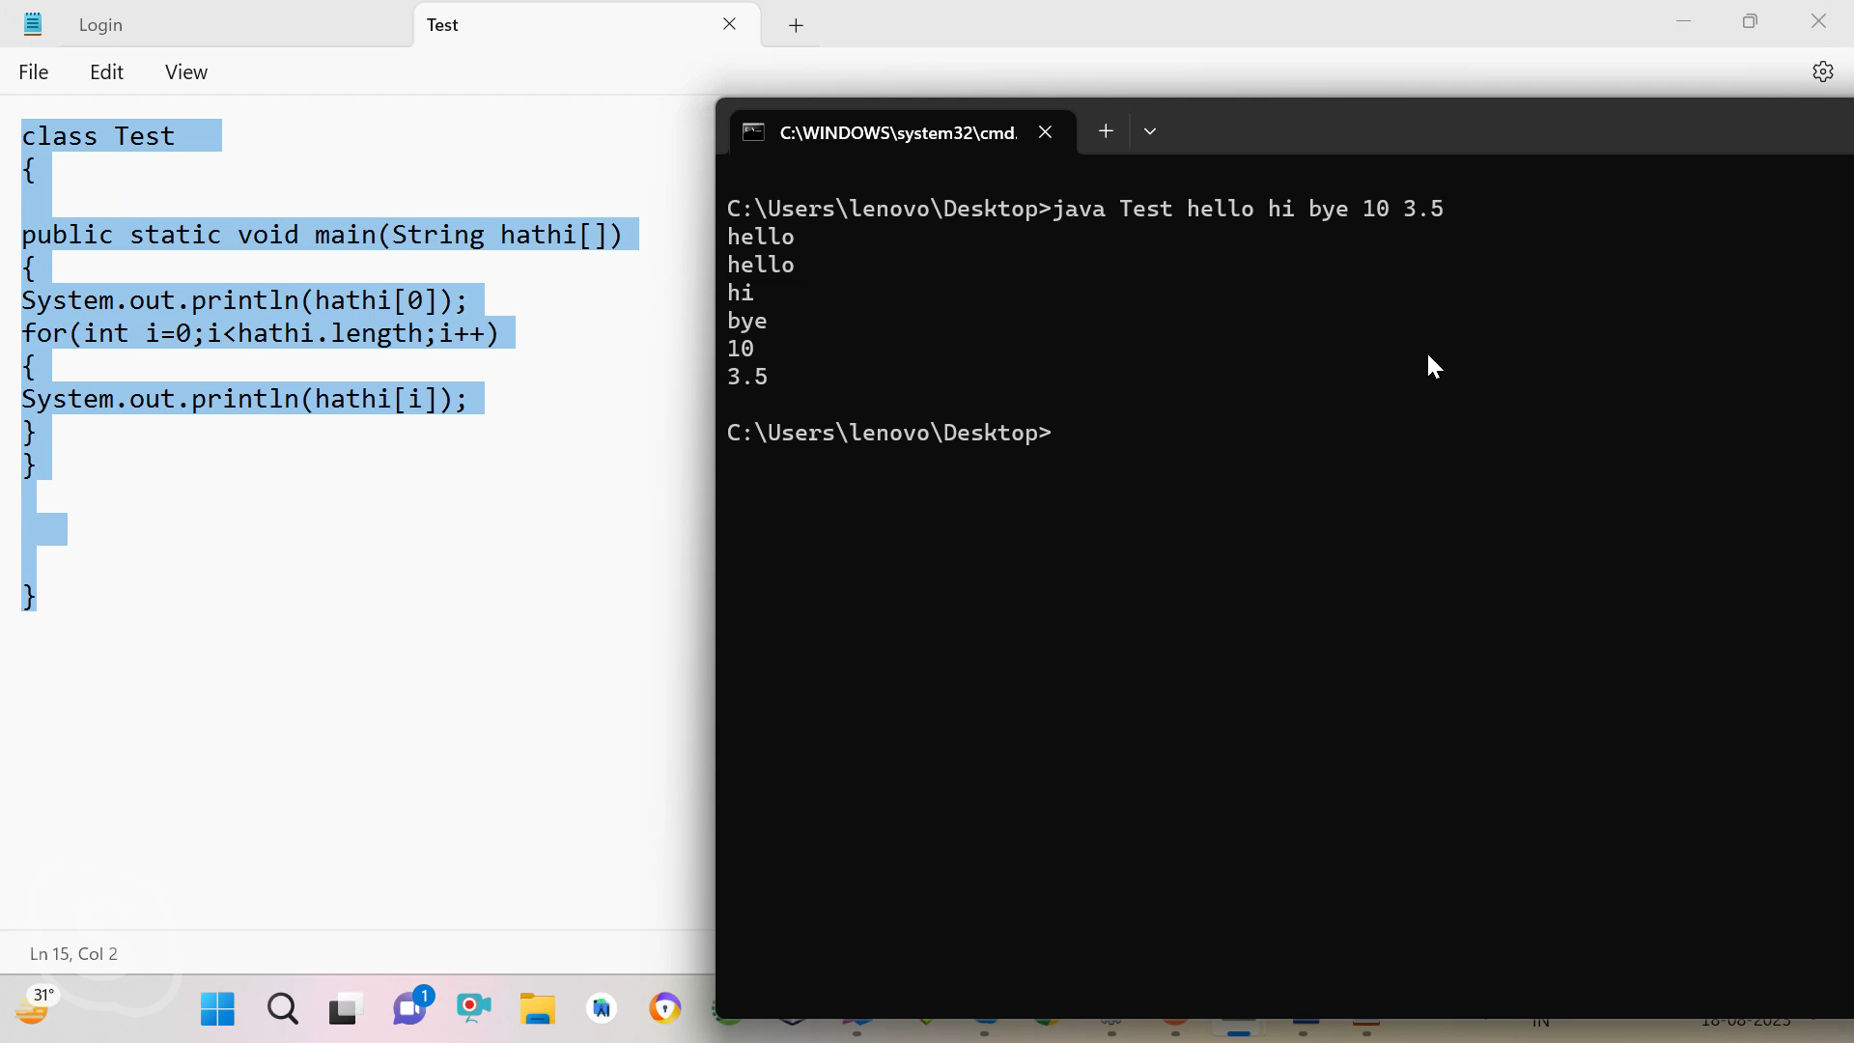

* **Wrapper Classes--- jitane bhi primitive data type ye unko object main convert krne ke liye reper class ka use kiya jaata hain reverse.**
* **Wrapper classes are those classes which providing object oriented represention of primitive data type**

**int ----Integer----class**

**float ---Floatboolean--Booleanetc**

**Autoboxing and unboxing difination-**

**MainMethod-**

**Explanation of main()**

In java main() method is the method which maintains the entry point of a java program main() is neither predefined nor user defined but it’s a contract between the user and the programming language.

Its Syntax must be like this:

public static void main(String args[])

{

}

\*\*\**We can also use some other modifiers for main like strictfp, final synchronized ,etc. but is must have public ,static, void and a string array argument*

We can change the name of the string array argument. args[] to anything[].

It is used to hold the command line arguments in the form of string values.

In java main() method is run by JVM

**Why main() method is public ?**

public is an access specifier, the members which are public can be accessed from anywhere in the program(outside class ,package). Thus is used before main() so that JVM can access and run the main() method.

**Why main() is static ?**

As we know that Non-Static Method requires instance/object of the class to access it.

But Static method can be accessed without any instance or reference of the class (object).

When JVM starts, there is no object of the class present.

Thus to make sure that JVM is able to run the main() without object it’s made static.

**Why the return type of main() is void ?**

Java main method doesn’t return anything, that’s why its return type is void.

And it was made so by the java developers because JVM doesn’t require any return value from the main() to perform any kind of operations so to keep java simple they made main() as void .

**Overloading of main()**

We can overload main() with different types of parameters.

But JVM will execute main() which have String array as an argument and the overloaded function behaves as a normal function.

classTest

{

    publicstaticvoidmain(String[] args)

    {

        System.out.println("Main Method String Array");

    }

publicstaticvoidmain(int[] args)//behave as a normal method

    {

        System.out.println("Main Method int Array");

    }

}

**Data Shadowing: -** When in a program the name of instance variable and the name of local variable are same this concept is called data shadowing.

In other words data shadowing is the process of having same name of instance and local variable in a program.

package mydata;

public class Demo

{

    int  x=10;

    void dip(int x)

    {

        //int x=20;

        System.out.println(x);

        System.out.println(x);

    }

    public static void main(String[] args) {

        Demo de=new Demo();

        de.dip(20);

    }

}

**\*\*Whenever Data Shadowing is done the preference always goes to the local data members**

package mydata;

public class Demo

{

    int x=10;

    void dip(int x,Demo de)

    {

        //int x=20;

        System.out.println(de.x);

        System.out.println(x);

    }

    public static void main(String[] args) {

        Demo de=new Demo();

        de.dip(20,de);

    }

}

**this keyword in java:**

* It is the implicit pointer
* **It is the implicit reference variable which holds the reference id of the current object.**
* **This implicit reference is available implicitly in every non static method and constructor**

**This keyword can’t be used in static context. (Static method or Block)

Whenever we are calling any non-static method and constructor in the program so by default is method and constructor have an extra argument (i.e. Object of same class) passed by java compiler its self.

Signature of this *public final this;*

**Use 1.** It is used to identify the instance variable in case of data shadowing.

**#Example: -**

//use of this in identification of instance variable in case of data shadowing

Class A

{

Void show(this)

{

}

A(this)

{

}

PSVM()

{

A a=new A(a); // Object of same class

a.show(a);   // Object of same class

A a1=new A(1); // Object of same class

a1.show(a1); // Object of same class

}

}

package mydata;

public class Demo

{

    int x=10;

    void dip(int x)

    {

        //int x=20;

        System.out.println(x);

        System.out.println(this.x);

        System.out.println("This ID="+this);

    }

    public static void main(String[] args)

    {

        Demo de=new Demo();

        System.out.println("object1 Id="+de);

        de.dip(23);

        Demo de1=new Demo();

        System.out.println("object2 Id="+de1);

        de1.dip(20);

    }

}

package mydata;

public class Demo

{

    int x=10;

    Void dip()

    {

    //int x=20; // If local variable not available.

        System.out.println(x);

        System.out.println(x);

    }

    public static void main(String[] args)

    {

Demo de=new Demo();

    de.dip();

    }

}

//Case 1:-If local variable not available…

package mydata;

public class Demo

{

    int x=10;

    void dip()

    {

          //int x=20; // If local variable not available.

        System.out.println(this.x); // this keyword id added J.C

        System.out.println(this.x);

    }

    public static void main(String[] args)

    {

        Demo de=new Demo();

de.dip();

    }

}

//Case 2:-If local variable  available…

package mydata;

public class Demo

{

    int x=10;

    void dip()

    {

          int x=20;

        System.out.println(x); // this keyword not added J.C

        System.out.println(x);

    }

    public static void main(String[] args)

    {

        Demo de=newDemo();

de.dip();

    }

}

Use 2.

This keyword is used as a method argument in order to refer the current class object.

// This keyword is used as a method argument in order to refer the current object.

package mydata;

class B

{

    static void disp(A a)

    {

        a.msg();

        System.out.println("disp");

    }

}

class A

{

    void show()

    {

        B.disp(this);

        System.out.println("show");

    }

    void msg()

    {

        System.out.println("msg");

    }

}

public class ThisTest2

{    public static void main(String[] args)

    {

        A a=new A();

        a.show();

    }

}

Use 3.

This keyword can also be used in case of method chaining.

Method chaining is the process of calling multiple methods on same object at same time.

Note:-In java every constructor have implicit return type i.e class type and it return the reference id of same class in the form of this.

class A

{

}

//Default Constructor

class A

{

A A()

{

return this;

}

}

package mydata;

public class ThisTest3

{

    ThisTest3 disp()

    {

        System.out.println("disp");

        return this;

    }

    void show()

    {

        System.out.println("show");

    }

        ThisTest3()

    {

        System.out.println("cons....");

    }

    public static void main(String[] args)

    {

        new ThisTest3().disp().show();

    }

}

Use 4.

This keyword can also be used in case of constructor chaining.

Constructor chaining is the process of calling multiple constructor in a chain on single object at same time.

Syntax to call constructor: - *this(args if any);*

*this(args if any);* statement must be the very first statement in constructor body in case of constructor chaining.

// Java program to illustrate Constructor Chaining

// within same class Using this() keyword

class Temp

{

    // default constructor 1

    // default constructor will call another constructor

    // using this keyword from same class

    Temp()

    {

        // calls constructor 2

        this(5);

        System.out.println("The Default constructor");

    }

    // parameterized constructor 2

    Temp(int x)

    {

        // calls constructor 3

        this(5, 15);

        System.out.println(x);

    }

    // parameterized constructor 3

    Temp(int x, int y)

    {

        System.out.println(x * y);

    }

    public static void main(String args[])

    {

        // invokes default constructor first

        new Temp();

    }

}

Use 5.

this keyword can also be used to call the same class methods static and non-static both.

this.show();

show();

**Use 6.**

this keyword can also be used for forward referencing .

A forward reference is a reference to a variable that has not yet been initialized. These are bad simply because, if allowed, they'd give us unexpected results. Take a look at this bit of code:

package mydata;

public class ThisTest4

{

    int x=10;

    int z=x*this.y;

    int y=20;

    ThisTest4()

    {

    System.out.println(z);

    }

    void show()

    {

        System.out.println("show");

    {

        this.show();

        System.out.println("disp");

    }

    public static void main(String[] args) {

    new ThisTest4().disp();

}

}

**This is public and final :-public means access any area but value does not change**

**Example -1**

**class ThisTest5**

**{**

**ThisTest5 disp()**

**{**

**System.out.println("disp...");**

**return new ThisTest5();**

**}**

**ThisTest5 show()**

**{**

**System.out.println("show...");**

**return new ThisTest5();**

**}**

**ThisTest5 m1()**

**{**

**System.out.println("m1..");**

**return new ThisTest5();**

**}**

**public static void main(String ss[])**

**{**

**new ThisTest5().disp().show().m1(); yah per har method object return kr raha hain aur 4 object hain jisme se teen use ho rahe hain last method m1 ka nahi use ho raha hain.**

**}**

**}**

**Example -2**

**//Method chaining**

**class ThisTest6**

**{**

**ThisTest6()**

**{**

**System.out.println("cons");//har constructor implicit current object return krta hain**

**}**

**ThisTest6 disp()**

**{**

**System.out.println("disp...");**

**return this;**

**}**

**ThisTest6 show()**

**{**

**System.out.println("show...");**

**return this;**

**}**

**void m1()**

**{**

**System.out.println("m1..");**

**}**

**public static void main(String ss[])**

**{**

**new ThisTest6().disp().show().m1(); //yaha per only ek object bana hain**

**}**

**}**

**How many classes can be in one file?**

* **There can be many classes in a file , but there can be only one public class. The class which is public must have the same class name.**
* **Java program bina main and blank file bhi compile ho jaate hain saba.  
  sabak byte code alag-2 hota hain**
* **Main method her ek class mai rakh sakate hain but rakhan nahi chaiye kyuki phir ye decide nahi ho payega konsi class ko run krwan hain ,java program class ke name se run hota hain.**
* **Main method decide entry point of java program and entry point maintain the program**
* **Main method does not predefined because main method does not defined before ,we defined ourself .It does not user defined because if user defined then he can any change. Main method is a contract programmer and programming language because java creater say that when you make program of java then you must be written main method but not any change main method.**
* **Main method is public because called public in contract.**
* **public means can accessible anywhere**
* **Main method is public because jvm access with main method .Main method**
* **Main method is static because jvm can call without object because of which memory does not west in java program**

**Who responsible main method of java?**

* **Jvm call main method of java.**
* **Jab child class inherit karati hain parent class ko ,to child class ka consntructor parent class ke only default construcotor ko pahale call karata hain ,ye implicit keyword child ki past line per add hota hain isliye ye hota hain**

java Cjava start---(Process)|-Main Subprocess (Thread)------|-Gc Subprocess (Thread)-- |-Main Subprocess (Thread)------ Its execute the Java programjava Cjava start---(Process)|-Main Subprocess (Thread)------|-Gc Subprocess (Thread)-- |-Main Subprocess (Thread)------ Its execute the Java program|----1.ClassLoading 2.Linking 3.Searching1.ClassLoading:- It is doen by class loader.a. Memory is allocated to the SDMb. Default values are assign to the SDMc. Static Blocks are executed in given OrderLoaders:-bootstrap CL (rt.jar)extension CL (jre/lib/ext)application CL (classpath)Class Loading Types->a- Static Clb- Dynamic CL

Static class loading :- isme compiler ko pahale hi pata hota hain ki kon si class memory main load hogi

Dynamic class :- isme compiler ko nahi pata hota hain kyuki isme jvm runtime per decide krta hain ki konsi class chlegi ,ye runtime per object ko dekhata hain jiska object hoga usi ko excute kr deta hain,

**Data shadowing:-**when a program the name of instance variable and local variable is called Data shadowing, In case of data shadowing goes to local always preference local variable

**this Keyword :-**this keyword is the implicit reference variable which holds the reference id of current object .

* this keyword can not be used inside static context
* this keyword is implicitly available in very non static method and constructor

**Use of this :-**

1. **It is used to identify the instance variable data shadowing**
2. **This keyword is used as a method argument in order to refer in case of the current object**
3. **This keyword is also used in case of method chaining -calling multiple method on single object**
4. **Calling multiple constructor on single object**
5. **We can call any static or non static both method via this**
6. **It is also used in case of forward a referencing**

**Class loading: -**

It is the process of storing the class specific information into memory (i.e. data member, member function, constructor etc.) this process is done by class loaders. (They are the software program).

**Type of Class Loaders: -**

1. bootstrap class loader**(rt.jar)**
2. extension class loader **(jre/lib/ext)**
3. Application class loader **(environment variable**)

**Things done at class loading time:**

* Memory is allocated to the Static Data member.
* Default values are initialized to the Static Data Member.
* Static Block are executed in given order

**Types of Class Loading:**

1. Static class loading
2. Dynamic class loading.

In case of static class loading compiler have already knowledge about loaded class but in case of dynamic class loading compiler does not have the knowledge about loaded class.

**Condition of static class loading: -**

1. When we run any class.
2. When we are creating the object of a class into another class.
3. When we are inheriting one class into another class.
4. When we call any static members of a class.

**Condition of dynamic class loading: -**

In java there is a class whose name is **Class** and this class **Class** have a static method called **forName()** which is responsible for dynamic class loading?

**Command Line Arguments: -**It is the process of passing the values from command line at run time.

In java there is a class whose name is Class. Every class is the instance of class Class.When any class statically or dynamically loaded into memory then JVM creates object of class Class for the loaded class. Then class Class object is the duplicate copy (reflected image) of specific loaded class. It is the part of reflection API.

**How many ways are there to get the object of class Class:**

1. When we call the getClass() method of object class on the target class object.

Class A

{

Public static void main(String ss[])

{

A a=new A();

Class c=a.getClass():;

}

}

1. When we load a class dynamically using the static method forName() of class Class then it return the object of class Class.

Class c=Class.forName(args[0]);

1. Directly.

Class ca=String.class; //directly

**About forName() method: -**

1. This is the static method of class Class.
2. There are mainly two uses of this method
3. To load a class dynamically
4. Return the class Class object of the loaded class.

//signature of forName()

Public static Class forName(String nameOfClass)

**About newInstance() method: -**

1. This is the non-static method of class Class whose main purpose is to create the object of any class at runtime.
2. This is another way to create the object of a class.

**Wrapper Classes: -**

* Wrapper classes are those classes which provide the facility to convert the primitive data type into object and object to primitive.
* In java there are so many wrapper classes are available for every primitive data types (java.lang)

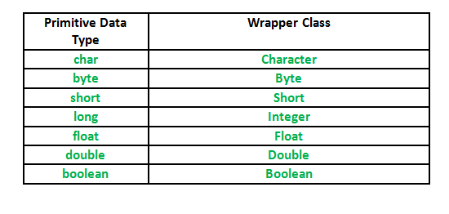

**Boxing and Unboxing in Java: -**

* The process of converting any primitive data type into object is called boxing and its reverse process is called unboxing.
* From JDK1.5 there is no requirement to convert any primitive data type into object because of the new concept of **AutoBoxing and AutoUnboxing.**

    }

Final keyword in java

In Java, the final keyword can be used while declaring an entity. Using the final keyword means that the value can’t be modified in the future.

Final keyword can be used with:

1. class
2. Method
3. Data member
4. Local variable

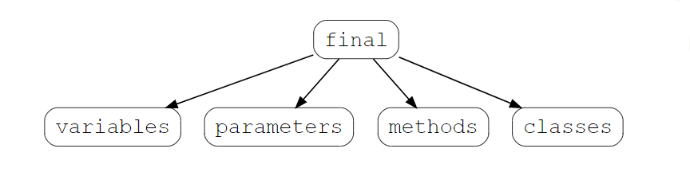

## Final variables

If a variable is declared with the final keyword, its value cannot be changed once initialized. Note that the variable does not necessarily have to be initialized at the time of declaration. If it’s declared but not yet initialized, it’s called a **blank final variable**.

Blank final variables should be initialized in constructor or init block.

// declaring a final variable

class FinalVariable {

        final int var = 50;

        var = 60 //This line would give an error

}

## Final methods

A method, declared with the final keyword, cannot​ be overridden or hidden by subclasses.

// declaring a final method

class Base{

    public final void finalMethod(){

        System.out.print("Base");

    }

}

class Derived extends Base{

    public final void finalMethod() { //Overriding the final method throws an error

        System.out.print("Derived");

    }

}

## Final classes

A class declared as a final class, cannot be subclasses it means final class can’t be inherited.

// declaring a final class

final class FinalClass {

  //...

}

class Subclass extends FinalClass{ //attempting to subclass a final class throws an error

  //...

}

## Final parameters

If you ever see the final keyword with a parameter variable, it means that the value of this variable cannot be changed anywhere in the function.

class finalParameter {

    public static void example( final int parameter ) {

      parameter = 4; //attempting to reassign a value to a parameter throws an error

**class C**

**{**

**final int x; // blank final :-jab koi instance variable bina intilize kiye final banaya jaye to use blank final variable kahate hain aur blank final variable ko constructor and init block main intilize kr sakte hain**

**static int y; // static blank only intilize static block**

**static**

**{**

**y=20;**

**}**

**C()**

**{**

**x=10;**

**}**

**}**

**Encapsulation**

* It is the process of wrapping the data member and member function into a single unit called class.
* The purpose of encapsulation is to achieve data hiding.
* And class is the way to achieve the encapsulation.
* But the normal class is not providing the 100 % implementation of encapsulation.
* **Java Bean class** providing the best implementation of encapsulation.

**Java Bean class or (POJO) Plain Old java Object: - Model, Entity**

A java bean is the general-purpose reusable piece of code that must have the following characteristics.

Any normal class said to be java bean class if it has the following characteristics: -

1. This class must be public.
2. This class must be inside package.
3. This class must have private data member.
4. This class must not be extending any specific class and implements any specific interface but must implement **serializable interface.**
5. This class must have public setter and getter method.
6. This class must have public default constructor.

**Note**: - Java bean must implement ***serializable*** interface whereas POJO may or may not.

#Example: -

package com.youtube.login;

public class Login implements java.io.Serializable

{

private String name,pass;

public void setName(String name)

{

this.name=name;

}

public String getName()

{

return name;

}

public void setPass(String pass)

{

this.pass=pass;

}

public String getPass()

{

return pass;

}

}

What is Code Reusability in java ?

**Real life example like our laptop battery is discharge the charge it and reuse it. Like Gas cylinder if empty then we refill it again .To save cost same thing coding. Without relation reusability is not possible.**

What is Software reusability?

**Reusability: reusability is a mechanism which facilitates you to reuse the fields and methods of the existing class when you create a new class. You can use the same fields and methods already defined in the previous class.**

**There are two types achieve reusability in java**

* 1. Association (Has-A relation 0 to 100 % reusability ) :-

### What is Association in Java?

Association is a relationship between two separate classes.

It is another way to achieve reusability code in java . It is provided 0 to 100 % reusability . Association as a has-a relationship between the classes. It shows how objects of two classes are associated with each other

There are many relationship in association in java

#### **1. One-to-one**

one person individual can have only one passport. This is a one-to-one relationship between the person and the passport.

#### **2. One-to-many**

Suppose, there is a Doctor and his patients. So, one doctor is associated with many patients. So this is an example of a one-to-many

#### **3. Many-to-one**

For example, there can be many books in one library So, many books are related to one library.

#### **4. Many-to-many**

1. If we talk about a teacher and student, there can be many students associated with one teacher, and also, the teacher can be related to many students.
2. So, the relationship between a teacher and student can be many-to-many.

## **[Association in Java](https://techvidvan.com/tutorials/wp-content/uploads/sites/2/2020/06/Association-in-Java.jpg)**

### Types of Java Association

There are two special forms of Association in Java. They are:  
**1.** Composition(Strong):- Concept 3:**Composition**

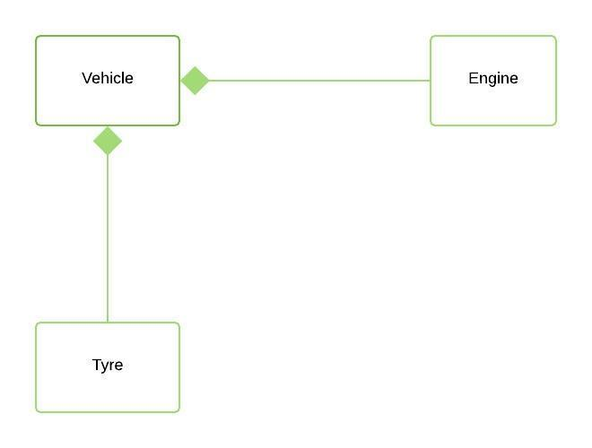

*Composition*

.

* It is the strong part of class
* In composition, both entities are dependent on each other..

**Aggregation(weak):-**

* + It represents Has-A’s relationship..
* In Aggregation,**both entries can survive individually** which means

both entities are not dependent on each other.. 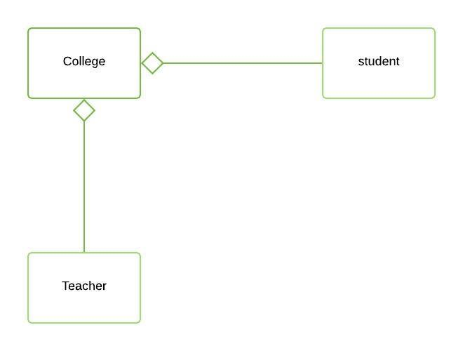

*Aggregation*

class A

{

int x=10;

void show()

{

System.out.println("show");

}

}

public class Assocation

{

public static void main(String ss[])

{

A a=new A();

a.show();

}

a)- Aggregation (Weak) :-It is weak part of the class

class A

{

int x=10;

void show()

{

System.out.println("show");

}

}

public class Assocation

{

A a1;//Aggregation

Assocation()

{

a=new A();//compostion

}

public static void main(String ss[])

{

A a=new A();

a.show();

}

}

b)- Compsotion (Strong) :-It is Strong

weak part ke liye program main method bana lo and strong part ke liye constructor bana lo

2. Inheritance (Is -A realation 100%)**Factory design pattern :-Singletn design pattern**

* **Constructor private bana de to us class ka object nahi Banega**
* **Class public bana do jise ise inherite nahi kr skate hain**

1. public final class A{static A a;private A(){}public static A getAObj(){if(a==null){a=new A();return a;} else{return a;}}}class B{public static void main(String ss[]){A a1=A.getAObj();A a2=A.getAObj();System.out.println(a1);System.out.println(a2);}}Core Java Design PatternsIn core java, there are mainly three types of design patterns, which are further divided into their sub-parts:1.**Creational Design Pattern**Factory PatternAbstract Factory PatternSingleton PatternPrototype PatternBuilder Pattern.2**. Structural Design Pattern**Adapter PatternBridge PatternComposite PatternDecorator PatternFacade PatternFlyweight PatternProxy Pattern3**. Behavioral Design Pattern**Chain Of Responsibility PatternCommand PatternInterpreter PatternIterator PatternMediator PatternMemento PatternObserver PatternState PatternStrategy PatternTemplate PatternVisitor Pattern

**https://www.javatpoint.com/factory-method-design-pattern**

**Inheritance**

It is the one of the way to achieve reusability in java

The code written in the Superclass is common to all subclasses. Child classes can directly use the parent class code.

It is a process of acquiring the properties and behaviour of Parent class (Base class/Super behaviour.

In java we use ***extends*** keyword to inherit a class.

**Advantages of Inheritance:-**

1. The purpose of inheritance is reusability.
2. To achieve run time polymorphism.
3. Method overriding.
4. Data Hiding.

#Example: -

package inheritance;

class Base  //This is the Parent / Super / Base class

{

    intx=10;

    staticinty=100;

    static void sMethod() //static method

    {

        System.out.println("Static method "+y);

    }

    voidn sMethod()  //non-static method

    {

        System.out.println("Non StaticMethod"+x);

    }

}

package inheritance;

class Base  //This is the Parent / Super / Base class

{

    int x=10;

    static int y=100;

    static void sMethod() //static method

    {

        System.out.println("Static method "+y);

    }

    void nsMethod()  //non-static method

    {

        System.out.println("Non StaticMethod"+x);

**Types of Inheritance: -**

1. Single-Level
2. Multi-Level
3. Multiple
4. Hybrid
5. Hierarchical OR Network Based Inheritance

**\*\*\* In java there is no any class created without inheritance**

* If there’s class name as A then it will extends Object class. This Object class is extended by each and every class in java. Or we can say that object class is the Parent/Super class of all the user defined and pre-defined classes.
* Object class has 9 methods known as magic method.
* Thus we can say that Single level inheritance is by default present in java.

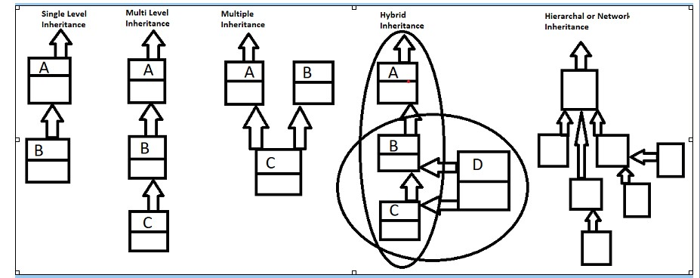

*Why java doesn’t supports Multiple Inheritance in case of class: - because it leads to data ambiguity.*

Hierarchical Inheritance a  combination of more than one type of inheritance.

It is different from the hayb rid Inheritance is the combination of any two inheritances.

Her ek class chahe wo predefined or userdefined sabako implicit object class ko inherite krti

Jdk 6 se app javap kr ke dekh sakate hain

**What is the diamond problem in Java?**

* Suppose,we find that class D is trying to inherit form class B and class C, that is not allowed in Java. It is an ambiguity that can rise as a consequence of allowing multiple inheritance. It is sometimes referred to as the deadly diamond of death

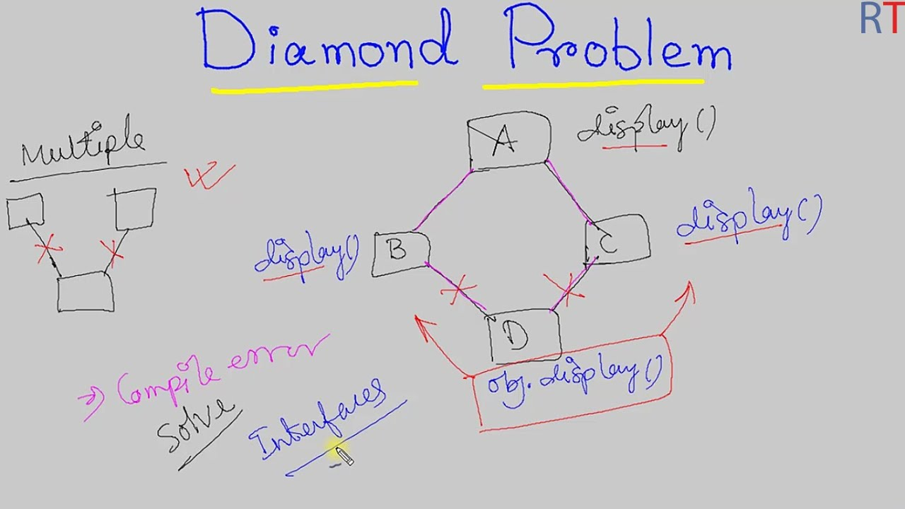

Hybrid main agat multiple level agaya to allow nahi hoga .

**Uml digram padane ke liye book khalid mugal**

[**https://ptgmedia.pearsoncmg.com/images/9780132930215/samplepages/9780132930215.pdf**](https://ptgmedia.pearsoncmg.com/images/9780132930215/samplepages/9780132930215.pdf)

**What is Data Hiding?**

* When in a program two classes (parent and Child) have data member with same then this concept is called data hiding.
* In case of data hiding always preference goes to child class data.

package reusability;

class Base

{

    int x=10;

}

public class Child extends Base

{

    int x=20;

    void show()

    {

        System.out.println(x);

        System.out.println(super.x);

    }

    public static void main(String[] args)

    {

        Child c=new Child();

        c.show();

    }

}

**Note: - Data shadowing has done is one class whereas data hiding happens in two classes.

Question:-Now the question is how to print the data of parent class.

Answer: - By creating the object of parent class or by using the ***super*** keyword.

**Super Keyword: -**The super keyword refers to superclass (parent) objects.

* It is the keyword which can be used in so many ways.
* It is used to identify the parent class data in case of data hiding.
* It is used to call the parent class method in case of method overriding.
* It is used to call the parent class constructor in case of constructor chaining.

**Note: - Super can’t be used in static context like this.**

**Up-casting and Down-Casting: -**

* In java the object of child class can be hold into the reference variable of parent class this concept is called up casting.
* But we can’t hold the object of parent into child.

Base b=new Child(); // [valid]

Child c=new Base(); // [Invalid]

Base  c=new Child(); //up casting

Child c1=(Child)c;  // down casting

**Note:-Without up casting down casting is not possible.**

**About Type:-**

1. In java every primitive variable have it’s type.**int x=10;**
2. In java every object have their type. e.g new A();
3. In java every reference variable has their type. A a;

In java any child class reference is child type and parent type too. It means child class object (reference) are tread as the parent class instance.

**Question: -** In case of Inheritance when we are creating the object of Child class parent class object are created or not? If not then how parent class data member gets memory. If yes then how?

**Answer: -** No, Object of parent class is not created. All the data of parent get memory into the child class object as shown the diagram below.

no parent class object is not created. All the parent data gets memory into child class object. We can see in the below diagram: 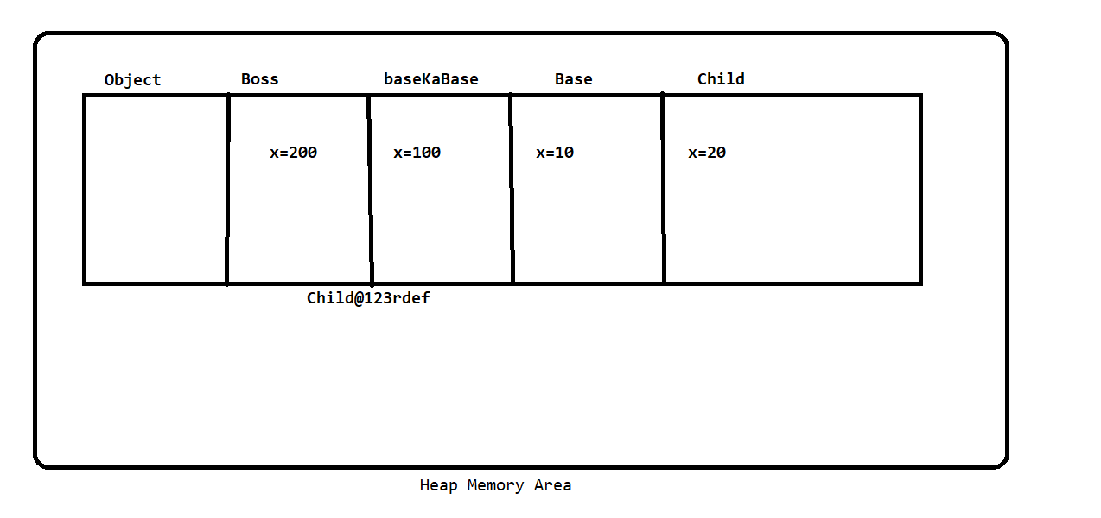

***\*\*\*Rule****: - We can call the parent class members with child reference but we can’t call the child class personal data with parent reference.(****V.V.Imp****)\*\*\**

***Instanceof: -*** The **java *instanceof* operator** is used to test whether the object is an instance of the specified type (class or subclass or interface). The *instanceof* in java is also known as type *comparison operator* because it compares the instance with type. It returns either true or false. If we apply the *instanceof* operator with any variable that has null value, it returns false.

//Example and Syntax to use instanceof operator  .

    class Sample1{

         public static void main(String args[]){

         Sample1 s=new Sample1();

         System.out.println(s instanceof  Sample1);  //true

         }

        }

package resubality;

class Boss

{

int x=200;

}

class BaseKaBase extends Boss

{

int x=100;

}

class Base extends BaseKaBase

{

    int x=10;

}

public class Child extends Base

{

    int x=20;

    void show(Base b1,BaseKaBase b2,Boss b3)//upcasting.....

    {

//      System.out.println(b1.x);

//      System.out.println(b2.x);

//      System.out.println(b3.x);

//      System.out.println(super.x);

//      System.out.println(x);

//

        System.out.println(((Base)this).x);

        System.out.println(((BaseKaBase)this).x);

        System.out.println(((Boss)this).x);

        System.out.println(x);

    }

    public static void main(String[] args)

    {

        Child c =new Child();

        //Base v=c;

        c.show(c,c,c);

        System.out.println(c instanceof Child);

        System.out.println(c instanceof BaseKaBase);

        System.out.println(c instanceof Boss);

        System.out.println(c instanceof Base);

  }

    }

* **Why the size of char in java is 2 bytes whereas in C and C++ it’s only 1 byte?**

**010101010 to 255---> 2564561 byte = 9 bit2*81 byte = 8 bita=97------>000101101bcde 1 byte = 8 bit ?In C--- ASCII--Systemchar = 1byteIn Java--- Unicode Systemchar = 2byte ?----------------------I18N**

It is because java uses Unicode system not ASCII code system.

# **Unicode System:-65536 character ,ye 16 ka p and combination world jitani bhi bhasha hain sabake code hain .Isme facility hain I18N internationlizatin jaise kisi website ko english and hindi her ek bhasha main change kr skate hain**

|  |
| --- |
| Unicode is a universal international standard character encoding that is capable of representing most of the world's written languages. |

### Why java uses Unicode System?

|  |
| --- |
| Before Unicode, there were many language standards: |
| * **ASCII** (American Standard Code for Information Interchange) for the United States. * **Jab programming ho rahi thi to dekha gaya kya kye symbol meri programming**   Ho skata hain ,English alpha bet ke hisab se and USA standred ke hisab se hamre code  System main 256 character ho sakte the  American walo ne apni natinal language English ke liye har ek informatin ko change  Krne ke liye ek decimal assign kr Rakha hain whi decimel system sky code system  Kahalta hain ye decimal number 0 se 255 hain jisme 0 se 64 numerice symbol special  Symbol ke liye hain ye banana ka fayada ye tha jab app koi character pres to uski  Koi decimal value hoti wo value app convert kr sakte hain binary main ,abhi bhi  Problem thi ki har character ki binary value alag -2 hogi jo memory main character  Ka area fix krna hain wo kaise fix kre matlab 1 byte main kitana bit space create kre  Jis isme jitane bhi 256 character a jaye aise krne ke liye binary base 2 hoto java walo  Ine dekha ki aisa konsa permutation and combination hai jisme 256 character a  Sakate hain wo hain 2 power 8 .bahut se character aise jinki decimal value ko binary  Main convert krne per 3 bit a raha to use 8 bit poora krne ke liye agar -v value hain  To 1 se start krke 0 aur jitane 8bit banal iye jata hain aur agar +V  hain to 0 start k ye kewal english hota hain  Krke 8 bit bana liya jata hain   * **KOI-8** for Russian. * **GB18030 and BIG-5** for Chinese, and so on. |

## **Problem**

|  |
| --- |
| **This caused two problems:**   * **A particular code value corresponds to different letters in the various language standards.** * **The encodings for languages with large character sets have variable length.** * **Some common characters are encoded as single bytes, other require two or more byte.** |

**Solution**

* To solve these problems, a new language standard was developed i.e., Unicode System
* In Unicode, character holds 2 byte, so java also uses 2 byte for characters.

**Lowest Value:** \u0000

**Highest Value:** \uFFFF

**Method Overriding**

*@overriding*

When in a program the parent class method name and child class method name are same this concept is called method overriding .In other words we can say that when child class rewrites the parent class method with same name and same signature so we can say that child class overrides the parent class method.

* **Ye isliye krate hain taki hum apne hisab se logic likh sake**
* **We can write our own logic**
* **Jdk 1.5 se return type se kr sakte hain but primitive na ho**

Error

class Base {void show(){System.out.println("show of Base");} }class Child extends Base{int show(){System.out.println("show of Child");return 0;}public static void main(String ss[]){Child c=new Child(); c.show();}}

//Example

class Parent {

    Void show()

    {

    }

    }

    class Child extends Parent{

    Void show()         // @overridden method

    {

    }

    }

**Rules:**

1. There must be a relation of parent and child between classes for method overriding.
2. The name of the method and its signature must be same.
3. In Case of method overriding the preference always goes to child class overridden method.
4. Static, final and private methods can’t be overridden.
5. If the method of parent class is static and child is non static then it’s not valid also it’s opposite is not valid. But if both methods are static then it’s valid. (This concept is called method hiding)
6. In Java there are 4 type of access rule
   1. Public
   2. protected
   3. default
   4. Private

**Note: This sequence is stronger sequence. But case of method overriding either same or weaker to stronger.**

**#Example**

package inheritance;

class Base {

    protected void show ()

    {

        System.out.println("this show message");

    }

}

public class Child extends Base {

    public void show ()

    {

        System.out.println("this is child message");

    }

    public static void main(String[] args) {

        Base s =  new Child();

        s.show();

    }

**\*\* From jdk 1.5 method overriding can also be done by changing the return type of the method, but the conditions below must be followed.**

**Case 1:** Both class methods must have return type of reference type

Primitive return type is not allowed.

*The classes which is used as a return type they must have relation of parent and child.

**Case 2:** Parent Class method should return parent class reference and child class method should return child class reference

The Above Case is known as **COVARIANT RETURN.**

**COVARIANT RETURN:** Before java 1.5 it’s not possible to override a method by changing its return type but from java 1.5 we can override a method by changing return type. (But this must satisfy case 1 and 2).

IF the return type of parent and child class varies then this is known as covariant return.

class A{}class B extends A{}class Base {A show(){System.out.println("show of Base");return new A();} }class Child extends Base{B show(){System.out.println("show of Child");return new B();}public static void main(String ss[]){Child c=new Child(); c.show();}}

<https://www.javatpoint.com/covariant-return-type>

class Base {Base show(){System.out.println("show of Base");return this;} }class Child extends Base{Child show(){System.out.println("show of Child");return this;}void disp(){System.out.println("Covarient Return....");}public static void main(String ss[]){Child c=new Child(); c.show().disp();}}

1. **Run time polymorphism: -** Runtime polymorphism or Dynamic Method Dispatch is a process in which a call to an overridden method is resolved at runtime rather than compile-time.

In this process, an overridden method is called through the reference variable of a superclass. The determination of the method to be called is based on the object being referred to by the reference variable.

#Example:

class Bank{

    float getRateOfInterest(){return 0;}

    }

    class SBI extends Bank{

    float getRateOfInterest(){return 8.4f;}

    }

    class ICICI extends Bank{

    float getRateOfInterest(){return 7.3f;}

    }

    class AXIS extends Bank{

    float getRateOfInterest(){return 9.7f;}

    }

    class TestPolymorphism{

    public static void main(String args[]){

    Bank b;

    b=new SBI();

    System.out.println("SBI Rate of Interest: "+b.getRateOfInterest());

    b=new ICICI();

    System.out.println("ICICI Rate of Interest: "+b.getRateOfInterest());

    b=new AXIS();

    System.out.println("AXIS Rate of Interest: "+b.getRateOfInterest());

    }

    }

**OUTPUT:-**

**SBI Rate of Interest: 8.4**

**ICICI Rate of Interest: 7.3**

**AXIS Rate of Interest: 9.7**

#Example:

class Shape{

    void draw(){System.out.println("drawing...");}

    }

    class Rectangle extends Shape{

    void draw(){System.out.println("drawing rectangle...");}

    }

    class Circle extends Shape{

    void draw(){System.out.println("drawing circle...");}

    }

    class Triangle extends Shape{

    void draw(){System.out.println("drawing triangle...");}

    }

    class TestPolymorphism2{

    public static void main(String args[]){

    Shape s;

    s=new Rectangle();

    s.draw();

    s=new Circle();

    s.draw();

    s=new Triangle();

    s.draw();

    }

    }

//Master Remote polymorphism example

package plolymorphism;

public class MaterRemote {

    void channelChange() {}

    void colorChange() {}

    void volChange() {}

}

class OperateTv{

public static void main(String[] args) throws ClassNotFoundException, InstantiationException, IllegalAccessException {

    Class c=Class.forName(args[0]);

    MaterRemote m=(MaterRemote)c.newInstance();

    m.channelChange();

    m.colorChange();

    m.volChange();

}

}

class tv1 extends MaterRemote{

    void channelChange() {

        System.out.println("channel of tv1 changed");

    }

    void colorChange() {

        System.out.println("color ovf tv1");

    }

    void volChange() {System.out.println("Vol of tv1 change");}

}

class tv2 extends MaterRemote{

    void channelChange() {

        System.out.println("channel of tv2 changed");

    }

    void colorChange() {

        System.out.println("color ovf tv2");

    }

    void volChange() {System.out.println("Vol of tv2 change");}

}

class tv3 extends MaterRemote{

    void channelChange() {

        System.out.println("channel of tv3 changed");

    }

    void colorChange() {

        System.out.println("color ovf tv3");

    }

    void volChange() {System.out.println("Vol of tv3 change");}

}

About Type-->int x;float y;Base a;new Base();Base b=new Base(); instanceOf operator

Child c=new Child(); c instanceOf Childc instanceOf Base

**Constructor overloading: -** Constructor overloading is a technique in Java in which a class can have any number of constructors that differ in parameter list. The compiler differentiates these constructors by taking into account the number of parameters in the list and their type.

//Example of constructor overloading

class Demo{

    int  value1;

    int  value2;

    /*Demo(){

     value1 = 10;

     value2 = 20;

     System.out.println("Inside 1st Constructor");

   }*/

   Demo(int a){

    value1 = a;

    System.out.println("Inside 2nd Constructor");

  }

  Demo(int a,int b){

  value1 = a;

  value2 = b;

  System.out.println("Inside 3rd Constructor");

 }

 public void display(){

    System.out.println("Value1 === "+value1);

    System.out.println("Value2 === "+value2);

}

public static void main(String args[]){

  Demo d1 = new Demo();

  Demo d2 = new Demo(30);

  Demo d3 = new Demo(30,40);

  d1.display();

  d2.display();

  d3.display();

}

}

**Class Name:-**

Class name class hoti hain java main forName uska static method hota hain

Class c =Class.forName(s[0]);

Shape c=(Shape)c.newInstance();//usi class ka method hota hain

c.areaCalcultate();

c.perimeterCalculate();

* **Jaise app koi class load krate ho humare program(jvm) main ek us class ki reflected copy taiyar ho jaati hain wo jo reflected copy hoti hain wo hogi class name class ka object**
* **Class name class ka apna koi wajood nahi bus ek ayena hain ,jaise koi class memory main load hogi us class ka memory main load hote hi us class ke liye ,class name class ke liye object banega (reflected copy)banegi,class class ki reflected copy ko uska object bolte hain**

**Class c=Class.forName([0]);**

**Yah per jo class laod hogi uski reflectd copy banegi**

* **Class class object is the reflected copy for every class**

**class A{static int x=10;static{ System.out.println("A cons...");}}class B //extends A{static{System.out.println("B con... ");}}class C {static {System.out.println("c cons...");}public static void main(String ss[]){C c=new C();Class c1=c.getClass();//class c ki reflected copy bani ye static ke liye hain System.out.println(c1);//aur yaha per uski reflected copy nikali hain is method se reflected copy C ayegi c1.getName();Class c2=C.class;System.out.println(c2);// yah se reflected copy ayegi ye bhi method hain,jvm reflected copy banata hain**

**Hamari class ki duplicate copy hain use class class se kyu represent kraya gaya hain ?**

**Aisa isliye kiya gaya kyuki class name class hain uske pass hajaro method hain,jis us class ki sari detail nikal sakate hain**

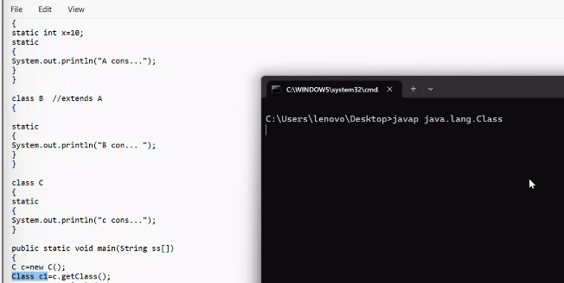

**Is command class ke sare method nikale sakate ho**

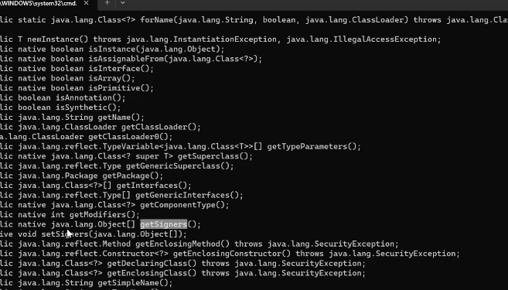

**Dynamic load krne ke liye:-**

**forName():-do kaam hote hain**

1. **kisi class ko dynamicly load krna**
2. **aur us class ki reflected copy ko return krna**
3. **newInstance runtime per object banae ke liye hain**

**class A{ static{ System.out.println("A cons...");}}class B {static{System.out.println("B con... ");}}class C {static {System.out.println("c cons...");}public static void main(String ss[]){ try{Class c=Class.forName(ss[0]);c.newInstance();System.out.println(c);}catch(Exception e){System.out.println(e);}}}**

java Cjava start---(Process)|-Main Subprocess (Thread)------|-Gc Subprocess (Thread)-- |-Main Subprocess (Thread)------ Its execute the Java program|----1.ClassLoading 2.Linking 3.Searching**Class loading: -**

It is the process of storing the class specific information into memory (i.e. data member, member function, constructor etc.) this process is done by class loaders. (They are the software program).

**Type of Class Loaders: -**

1. bootstrap class loader**(rt.jar)**
2. extension class loader **(jre/lib/ext)**
3. Application class loader **(environment variable**)

**Things done at class loading time:**

* Memory is allocated to the Static Data member.
* Default values are initialized to the Static Data Member.
* Static Block are executed in given order

**Types of Class Loading:**

1. Static class loading
2. Dynamic class loading.

In case of static class loading compiler have already knowledge about loaded class but in case of dynamic class loading compiler does not have the knowledge about loaded class.

**Condition of static class loading: -**

1. When we run any class.
2. When we are creating the object of a class into another class.
3. When we are inheriting one class into another class.
4. When we call any static members of a class.

**Condition of static class loading: -**

In java there is a class whose name is **Class** and this class **Class** have a static method called **forName()** which is responsible for dynamic class loading?

1.ClassLoading:- It is doen by class loader.a. Memory is allocated to the SDMb. Default values are assign to the SDMc. Static Blocks are executed in given OrderLoaders:-bootstrap CL (rt.jar)extension CL (jre/lib/ext)appication CL (classpath)ClassLoading Types->a- Static Cl:compiler ko pahle se pta hota hain ki konsi class load hogi class A{static int x=10;static{ System.out.println("A cons...");}}class B //extends A{static{System.out.println("B con... ");}}class C {static {System.out.println("c cons...");B b=new B();System.out.println(A.x);}public static void main(String ss[]){C c=new C();}}

b- Dynamic CL:isme nahi pata ho compiler ko pahale se ,isme run time decide hoga jvm decide krega

<https://docs.oracle.com/javase/tutorial/reflect/class/classNew.html>

Abstraction in Java

**In java abstract is a keyword which can only be used with:**

1. Methods
2. Classes

**Abstract Method:**

If you want a class to contain a particular method but you want the actual implementation of that method to be determined by child classes, you can declare the method in the parent class as an abstract.

1. The **abstract** keyword is used to declare the method as abstract.
2. You have to place the **abstract** keyword before the method name in the method declaration. E.g.,  *public void get();*
3. An abstract method contains a method signature, but no method body.
4. Instead of curly braces, an abstract method will have a semicolon (;) at the end.

Declaring a method as abstract has two consequences: -

1. The class containing it must be declared as abstract.
2. Any class inheriting the current class must either override the abstract method or declare itself as abstract.

**Abstract Class:**

A class which contains the abstract keyword in its declaration is known as an abstract class. E.g.,  *abstract class Employee{ }*

1. Abstract classes may or may not contain abstract methods, i.e., methods without a body. . E.g.,  *public void get();*
2. But, if a class has at least one abstract method, then the class must be declared abstract.
3. If a class is declared abstract, it cannot be instantiated means we can’t create object of that class.
4. To use an abstract class, you have to inherit it from another class, and also you need to define/override all the abstract method of that class in your class.

package abstracion;

// Abstract class Employee

abstract class Employee {

       private String name;

       private String address;

       private int number;

       double sal;

// abstract method ComputePay()

       public abstract double computePay(); //Abstract method

       // Remainder of class definition

    }

class Developer extends Employee{

    @Override

    public double computePay() {

        sal=49000.99;

        System.out.println("Salary of developer is "+sal);

        return sal;

    }

}

class Tester extends Employee{

    @Override

    public double computePay() {

        sal=49000.99;

        System.out.println("Salary of Tester "+sal);

        return sal;

    }

}

public class DispSal{

    public static void main(String[] args) {

        Employee dev;

        dev= new Developer();

        dev.computePay();

        dev = new Tester();

        dev.computePay();

    }

}

**Abstraction:-**

It is the process of showing the essential functionality of an object and hiding the unessential complexity.

Show functionality and hide complexity.

Show function and hide implementation.

We always achieving abstraction on function not on data.

It is the process of creating generic method.

Generic method are those method which have only declaration and it’s implantation are provided by different-2 users as per need.

**Advance:-**

To achieve runtime polymorphism.

**Implementing of abstraction:-**

* 1. **abstract class (0 to 100 %)- partially implantation of abstraction**
  2. **Interface ------(100 %)- fully implantation of abstraction.**

**abstract keyword can be applied on following things:-**

1. **Class**
2. **Method**

**Note:- abstract keyword can’t applied on data member and constructor.**

**Abstract class:-**

When we put the abstract keyword with class then class is called abstract class. we can’t create the object of abstract class.

**abstract class Test {**

**}**

Abstract class may or may not have abstract method.

**Rule:-**If any normal class extends the abstract class the normal class need to override all the abstract method of abstract class otherwise child class have to be abstract.

We can have reference variable of abstract class.

**abstract method:-**

Any method become abstract if we use the abstracts keyword with method.

abstract method do not specify a body.

We can not have abstract static ,final and private method.

Abstract class can have constructor

**Ye Runtime polymorphisam achive krne ke liye hota hain**

**Isme constructor bana skata hain agar abstract class main constructor nahi hota hai super wal rule break ho jata hain**

**Abstract class A{**

**A(){**

**Super();  
}**

**Class B extends A{  
main(){  
new A();**

**}**

**Interface.**

It is the blue print of class.

It is another way to achieve the abstraction.

It provides the fully implementation of abstraction.

It is the combination public static final data member and public abstract method.

It is the contract between two parties programmer and programming language.

**Syntax:-**

interface Identifier

{}

Rule:-

1. If a class wants to use and interface then we have to use the **implements** keyword.
2. If a class implements an interface then class need to override all the method of interface with public access specifier otherwise child class need be abstract.
3. A class can implements more than one interface simultaneously and can inherit another class also. In this case firstly we have use the extends then implements.
4. One interface can extends another interface.
5. One interface can extends more than one interface and this is called multiple inheritance
6. We can’t create the object of interface but we can have reference variable of interface.
7. Interface can’t inherit a class.
8. Class can’t inherit interface.

Isme genric method banate hain

**Interface.100% abstraction achieve**

It is the blue print of class.

It is another way to achieve the abstraction.

It provides the fully implementation of abstraction.

It is the combination public static final data member and public abstract method.

It is the contract between two parties programmer and programming language.

**Isme servalet interface uske andar 5 method hote hain unko implementation apne hisab se krte hain contract between programmer a** **nd programming**

**interface bane per jab koi class extends krati hain to uska object interface ke refrence main rakhate hain taki ye internally ho paye.**

**Yaha hota hain ye**

**Class c =class.forName([0]);**

**Servalet s=(Servalet)c.newInstance();**

**s.init();**

**s.serive();**

**Syntax:-**

interface Identifier

{}

Rule:-

1. If a class wants to use and interface then we have to use the **implements** keyword.
2. If a class implements an interface then class need to override all the method of interface with public access specifier otherwise child class need be abstract.
3. A class can implements more than one interface simultaneously and can inherit another class also. In this case firstly we have use the extends then implements.
4. One interface can extends another interface.
5. One interface can extends more than one interface and this is called multiple inheritance
6. We can’t create the object of interface but we can have reference variable of interface.
7. Interface can’t inherit a class.
8. Class can’t inherit interface.

**Implicit abstract hota hain**

**Interface ke andar static and default method bana sakate hain jdk 8 se inka use lambda expression and functional program main hota hain**

abstract interface Demo{int x=10;abstract void show();abstract void disp(); static void m1(){}default void m2(){}}abstract class A implements Demo{}class B implements Demo{public void show(){System.out.println("show of B");}public void disp(){System.out.println("disp of B");}public static void main(String ss[]){//Demo s=new Demo();Demo s;s=new B();s.show();s.disp();}}

<https://www.javatpoint.com/difference-between-abstract-class-and-interface>

* when we have requirement specification only we can use interface
* jab hume kuch implementation pata ho to hum absrtract use kre
* aisi class extends kre abstract class or implements kre interface ko to use hi concreteClass boltae hain
* wait and notifiy isliy chal jate h ain kyuki interface ke andar implicit available hote hain

## **) Multiple inheritance is not supported through class in java, but it is possible by an interface, why?**

* As we have explained in the inheritance chapter, multiple inheritance is not supported in the case of [class](https://www.javatpoint.com/object-and-class-in-java) because of ambiguity. However, it is supported in case of an interface because there is no ambiguity. It is because its implementation is provided by the implementation class. For example:

Java 8 Default Method in Interface

Since Java 8, we can have method body in interface. But we need to make it default method. Let's see an example:

*File: TestInterfaceDefault.java*

1. **interface** Drawable{
2. **void** draw();
3. **default** **void** msg(){System.out.println("default method");}
4. }
5. **class** Rectangle **implements** Drawable{
6. **public** **void** draw(){System.out.println("drawing rectangle");}
7. }
8. **class** TestInterfaceDefault{
9. **public** **static** **void** main(String args[]){
10. Drawable d=**new** Rectangle();
11. d.draw();
12. d.msg();
13. }}

[**Test it Now**](https://www.javatpoint.com/opr/test.jsp?filename=TestInterfaceDefault)

Output:

drawing rectangle

default method

Java 8 Static Method in Interface

Since Java 8, we can have static method in interface. Let's see an example:

*File: TestInterfaceStatic.java*

1. **interface** Drawable{
2. **void** draw();
3. **static** **int** cube(**int** x){**return** x*x*x;}
4. }
5. **class** Rectangle **implements** Drawable{
6. **public** **void** draw(){System.out.println("drawing rectangle");}
7. }
9. **class** TestInterfaceStatic{
10. **public** **static** **void** main(String args[]){
11. Drawable d=**new** Rectangle();
12. d.draw();
13. System.out.println(Drawable.cube(3));
14. }}

[**Test it Now**](https://www.javatpoint.com/opr/test.jsp?filename=TestInterfaceStatic)

Output:

drawing rectangle

27

# **Difference between abstract class and interface**

Abstract class and interface both are used to achieve abstraction where we can declare the abstract methods. Abstract class and interface both can't be instantiated.

But there are many differences between abstract class and interface that are given below.

|  |  |
| --- | --- |
| **Abstract class** | **Interface** |
| 1) Abstract class can **have abstract and non-abstract** methods. | Interface can have **only abstract** methods. Since Java 8, it can have **default and static methods** also. |
| 2) Abstract class **doesn't support multiple inheritance**. | Interface **supports multiple inheritance**. |
| 3) Abstract class **can have final, non-final, static and non-static variables**. | Interface has **only static and final variables**. |
| 4) Abstract class **can provide the implementation of interface**. | Interface **can't provide the implementation of abstract class**. |
| 5) The **abstract keyword** is used to declare abstract class. | The **interface keyword** is used to declare interface. |
| 6) An **abstract class** can extend another Java class and implement multiple Java interfaces. | An **interface** can extend another Java interface only. |
| 7) An **abstract class** can be extended using keyword "extends". | An **interface** can be implemented using keyword "implements". |
| 8) A Java **abstract class** can have class members like private, protected, etc. | Members of a Java interface are public by default. |
| 9)**Example:** public abstract class Shape{ public abstract void draw(); } | **Example:** public interface Drawable{ void draw(); } |

Simply, abstract class achieves partial abstraction (0 to 100%) whereas interface achieves fully abstraction (100%).

### Example of abstract class and interface in Java

Let's see a simple example where we are using interface and abstract class both.

1. //Creating interface that has 4 methods
2. **interface** A{
3. **void** a();//bydefault, public and abstract
4. **void** b();
5. **void** c();
6. **void** d();
7. }
9. //Creating abstract class that provides the implementation of one method of A interface
10. **abstract** **class** B **implements** A{
11. **public** **void** c(){System.out.println("I am C");}
12. }
14. //Creating subclass of abstract class, now we need to provide the implementation of rest of the methods
15. **class** M **extends** B{
16. **public** **void** a(){System.out.println("I am a");}
17. **public** **void** b(){System.out.println("I am b");}
18. **public** **void** d(){System.out.println("I am d");}
19. }
21. //Creating a test class that calls the methods of A interface
22. **class** Test5{
23. **public** **static** **void** main(String args[]){
24. A a=**new** M();
25. a.a();
26. a.b();
27. a.c();
28. a.d();
29. }}

[**Test it Now**](https://www.javatpoint.com/opr/test.jsp?filename=Test5)

Output:

I am a

I am b

I am c

* I am dJavac compiler object class ke jitane bhi method hain interface main utha kr rakh deta hain
* Har object class ke jitane bhi method hain interface ke andar implicit available hote hain
* Jis se run time polymorphisam achive ho sake

**Nested class :-**when we are declaring a class in the scope of another class or interface called nested class

Jab class ke andar class hota hain to use nested class kahate hain ya interface ke andar

**Kabhi aisi situation a sakati hain ki koi tumare data ko koi dusra access na kr sake to hum us class ko nested bana lena chaiye isliye hum nested class banate hain**

**Why use nested class?**

1. t is a way of **logically grouping** classes that are only used in one place.
2. It increases **encapsulation**.
3. Nested classes can lead to more **readable and maintainable code**.

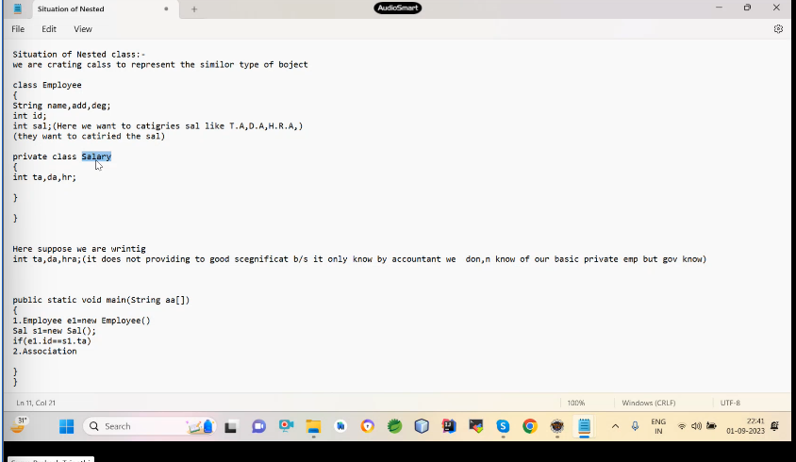

**Nested class:**

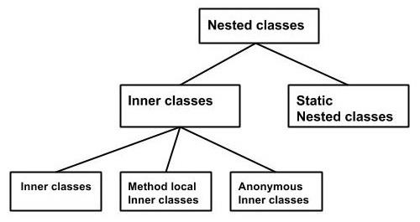

**1.static**

**2.non static**

**3.Local**

**4.Anonymous**

Ye char type ke hote hain

1. **Static Nested class** –

Ye outer wale ke kewal static ko call kr payega aur iske andar dono ho skate hain static and nonstatic .

class Outer {

staticclassInner{  
}

static Nested class:-It has the fallowing feature:-1.It is treated as a static data member of a class.2.It can have both static and non static members.3.It can access only static member of its inclosing(outer) class.4.The object of this class can be created without creating its inclosing class object.5.It can be inherite Independently.6.It can also Inherite an other class.7.It can also implements an interface.Note:-since it is treated as a static data member of a class so qualifies all those keyword that can be applied on a data member.Syntex to crate the object:-**OuterclassName.nestedclassName referenceofNestedclass=new outerclassName.nestedclassName(args if any**)

**class Outer{int x=10;static int y=20;static class Inner{public static void main(String a[]){System.out.println(y);Inner i=new Inner();Outer o=new Outer();System.out.println(o.x); }}}**

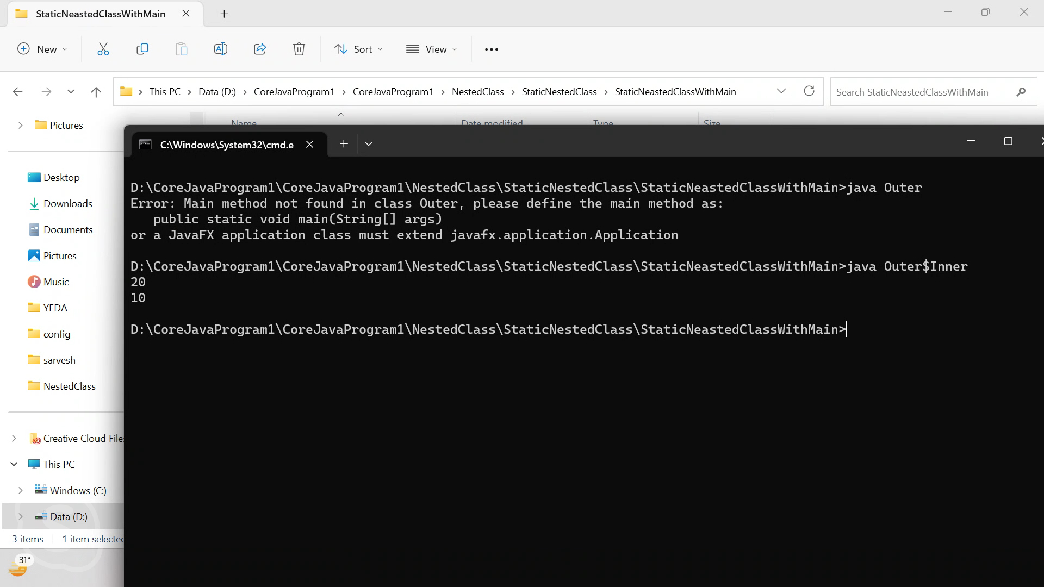

**Yaha per Inner class ke andar main method to run kre java inner class se run krna chaiye but aisa nahi hota hain kyuki ek normal class ka byte code uske class ke name se hota hain but Nested class ke inner class ka byte code Outre$Inner se hota ye compiler compile time per krata hain ais isliye krta hain taki ek normal class aur Nested class main difference ho paye aisa**

**nahi krega to jvm ko kaise pata chalega ki ye konsi class hain isliye ye Inner clalss ka name outer$inner kr deta hain compile timeper .**

**ye proof krna hain to javap outer$inner likh do byte code ka name change h** 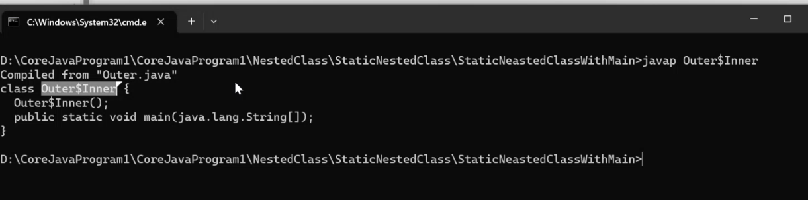**o gaya hoga**

* Kisi final variable ki value change nahi hoti hain but reflection se change kr sakate hain

1. **Non static**-

* **Isme inner class main kewal non static data hoga usi kewal access kr skega aur outer class ke static and non static dono ko call kr skata hain**

class Outer {

cl**NonStaticNested class:-**1.It is treted as a non-static data member of a class.2.It can have only non-static member.3.It can access all the members(static as well as non-static) of its inclosing class.4.The object of this class always created with the help of its inclosing class object.5.It can inherite other class.Syntex to create the object of Non-static class:-**OuterClassName refofOuter=new OuterClassName(args if any);OuterClassName.InnerClassName refofInner=ref of Outer.new InnerClassName(args if any);**Note:-In case of non-static nested class compiler make the fallowing changes in the source code.class Outer{ class Inner{}}public static void main(String aa[]){Outer o=new Outer();Outer.Inner in=o.new Inner();}}During compilation:-class Outer$Inner extends java.lang.Object{ final Outer this$0; Outer$Inner(Outer o) { this$0=0; }}class Inner{  
}

* **ye change krta hainOuter ka object inner ke constructor main bhej deta hain taki us object ka use krke inner outer ki cheezo ko acces kr sake .**

**3.Local-Nested class –**

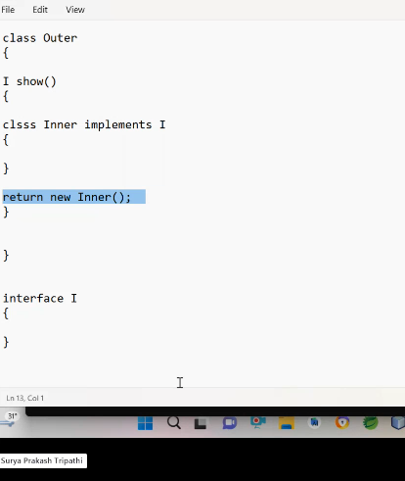

**Is parpose ke liye banayi jati hain**

**LocalNested class have fallowing characterstics:-1.It is treated as local variable.2.It can be define inside a method,cons, or block.3.It can have only non-static member.4.It can not be declear static because we can not have static local variable.5.The object of this class can not be created outside its inclosing class scope directly.6.The object of this class can not be create directly from outside its inclosing scope.7.It can implements interface. Rule:-It can access only final variable of its inclosing scope.**

**Method ke andar nested class isliye banate hain jise us method ka jo return type wo class type ka le skate hain ise us class ka object return kr skate hain aur uska use kr skate hain**

**method ya constructor ke andar bana diya jata hain**

**class outer{**

**void show(){**

**class inner{**

**}**

**4-Anonymous Nested class – banana ke liye ek abstract class ya interface lena padata hain but jadatar log interface lete hain**

**Iska koi name nahi hota hain but isko banana ke liye ek parent hona jaroori hota hain**

**Jab aap interface ko implements nahi krna chahate ho to anonymousNested class bana lo.**

**AnonimousNested class have fallowing characterstics:-1.It is treated as dataMember of a class or as local variabel.2.It does not have any name.3.It can not have static member.4.It can not be inheritate.5.It can inherite an other class or can Implements an interface.6.It is decleared and initilized in single line statement.7.only single object is created for anonymous calss;8.its object is created by jre only9.It must have a parent either a class or a interface.syntext:-Parent type refva=new Parrent(){body of anonymousclass};Prent type means class or interface.**

**Nested class ki jarorat kyu padi ?**

Jab data ke andar further data ho jaise sallery ,adress ke andar ta,da ,hra hota hain to uske liye ek seprate class bana leni chaiye . to data ko catrize krne ke liye seprate class bana lein chaiye

For example apne sallery ke liye ek seprate class bana li to sallery ek sensitive data hain jis ek employee to access kr skata but ek non employee bhi acess kr Sakata hain isliye Ise Nested class bana lena chiye jise us class ke andar hi acess kr sakoge

Nested class main jo inner class hoti hain use java class nahi bolata hain use data member bolta hain

**Situation of Nested class:-we are crating calss to represent the similor type of bojectclass Employee{String name,add,deg;int id;int sal;(Here we want to catigries sal like T.A,D.A,H.R.A,)(they want to catiried the sal)}Here suppose we are wrintigint ta,da,hra;(it does not providing to good scegnificat b/s it only know by accountant we don,n know of our basic private emp but gov know)class Salary{int ta,da,hr;}public static void main(String aa[]){1.Employee e1=new Employee()Sal s1=new Sal();if(e1.id==s1.ta)2.Association}}(Here we want to catagried this call create a new calss called sal)class Sal{int ta,da,hra;(provide good sig..)s}Non static nested class main static cheeze kyu nahi hoti hain?**

* An object of a non static inner class is associated with and instance /object of its outer class
* The entire body of a Non static inner class is Not within a static scompe and therefore you can’t have static members in there.
* Instance variables and methods in the non static inner class are relative to an instance of the enclosing class so being related t an object static won’t hold true for them
* Nested class ki dependency uske outer per hoti hain

Static nested class ki dependency uske outer class per nahi hoti hain.

What is binding?

When a member call getting their member definition is called binding.

**OR**

Connecting a member call with their member definition is called binding.

*Member means data and member functions.

//Defination

Class A{

Void method{

}

Main(){//calling

A a=new A();

a.show();

}

}

**There are two types of binding**

1. Compile time binding (earlier binding)

2. Runtime binding (late time/dynamic binding)

**Compile Time Binding:** When a member call getting their member definition at compile time this is called compile time binding. In case of compile time binding compiler does its binding on the basis of reference variable.

**Dynamic Binding:** When a member call getting their member definition at runtime this is called dynamic binding. Runtime binding is done by JVM on the basis of object type.

**\*\*\*Except non-static methods /virtual methods/instance methods all other entities are bound statically.**

**Static Binding is done in case of all the below entities:**

* Static Data Member
* Non-static data member
* Static methods
* Constructor
* Initializers
* Private methods
* Final methods
* Method call by a ***super*** keyword

**\*\*Note:** At the time of compilation assembly instructions are putted by the compiler in the byte-code in both types of binding.

**Instructions include:**

1. Invoke static: static binding to be done.
2. Invoke virtual: dynamic binding to be done.
3. Invoke special: this is also static binding but a special type of case.

Ye sub instructions byte code main compile time per likh dete hain compiler likh deta hain

class Parent{

    {

        System.out.println("Init of parent");

    }

    int x=100;

    static int s=200;

    Parent (){

        System.out.println("Dc of  parent  const...");

    }

    static void show() {

        System.out.println("Show method of Parent");

    }

    void display() {

        System.out.println("Display  method of Parent");

    }

}

public class Children  extends Parent{

int x=10;

static int s=20;

{

    System.out.println("init of child");

}

Children(){

    System.out.println("DC of Child ...");

}

void display() {

    System.out.println("Display  method of Child");

}

static void show() {

    System.out.println("Show method of Child");

}

public static void main(String[] args) {

    Parent c= new Children();

    System.out.println(c.x);

    System.out.println(c.s);

    c.show();

    c.display();

}

}

Javap -c class name -se invoke dekha jata hain- static ,and dynamic binding hoti hain

//cmd line argument dynamic binding

package suryaelectical;

class Parent{

    {

        System.out.println("Init of parent");

    }

    int x=100;

    static int s=200;

    Parent (){

        System.out.println("Dc of  parent  const...");

    }

    static void show() {

        System.out.println("Show method of Parent");

    }

    void display() {

        System.out.println("Display  method of Parent");

    }

}

public class Children  extends Parent{

int x=10;

static int s=20;

{

    System.out.println("init of child");

}

Children(){

    System.out.println("DC of Child ...");

}

void display() {

    System.out.println("Display  method of Child");

}

static void show() {

    System.out.println("Show method of Child");

}

public static void main(String[] args) {

    try {

        Class c =Class.forName(args[0]);

        Parent obj =(Parent)c.newInstance();

        System.out.println(obj.x);

        System.out.println(obj.s);

        obj.show();

        obj.display();

    } catch (Exception e) {

        e.printStackTrace();

    }

//  Parent c= new Children();

//  System.out.println(c.x);

//  System.out.println(c.s);

//  c.show();

//  c.display();

}

}

**POLYMORPHISM**

Polymorphism is made up of two words Poly and Morph

1. Poly means: Many
2. Morph means shapes.

Thus **Polymorphism** is the ability of an object to take on many forms. The most common use of **polymorphism** in OOP occurs when a parent class reference is used to refer to a child class object. Any Java object that can pass more than one IS-A test is considered to be **polymorphic**. See the image below …

Polymorphism allows us to perform a single action in different ways. In other words, polymorphism allows you to define one interface and have multiple implementations. The word “poly” means many and “morphs” means forms, So it means many forms.

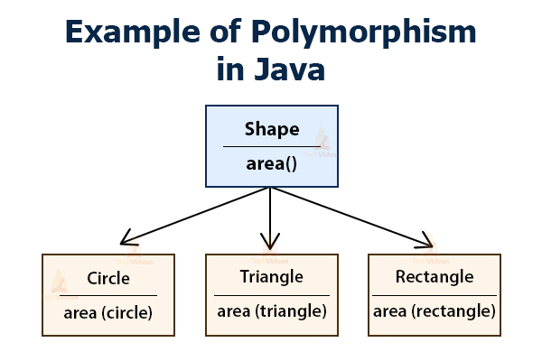

**Polymorphism is of two types: -** Compile Time Polymorphism & Runtime Polymorphism

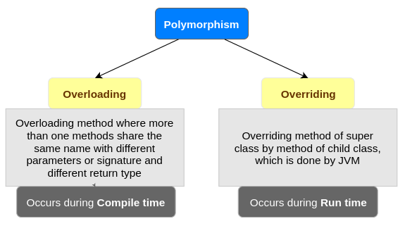

1. **Compile time polymorphism: -** Compile time polymorphism or static method dispatch is a process in which a call to an overloading method is resolved at compile time rather than at run time. In this process, we done overloading of methods which is called through the reference variable of a class here no need to superclass.

Method overloading: - If a class have multiple methods by same name but different parameters, it is known as Method Overloading.

There are two ways to overload the method in java: -

* By changing number of arguments

//Method overloading by changing number of arguments

class Calculation{

    void sum(int a,int b)

    {

       System.out.println(a+b);

    }

    void sum(int a,int b,int c){

       System.out.println(a+b+c);

     }

    public static void main(String args[]){

    Calculation obj=new Calculation();

    obj.sum(10,10,10);

    obj.sum(20,20);

    }

  }

OUTPUT:

30

40

* By changing the data type

//Method overloading by changing the parameters datatype

class Calculation{

    void sum(int a,int b){

      System.out.println(a+b);

     }

    void sum(double a,double b){

      System.out.println(a+b);

    }

    public static void main(String args[]){

    Calculation obj=new Calculation();

    obj.sum(11.5,11.5);

    obj.sum(30,20);

    }

  }

** It can also be done by changing both number of parameters and data type of parameters as shown in the above code.

**Constructor overloading: -** Constructor overloading is a technique in Java in which a class can have any number of constructors that differ in parameter list. The compiler differentiates these constructors by taking into account the number of parameters in the list and their type.

//Example of constructor overloading

class Demo{

    int  value1;

    int  value2;

    /*Demo(){

     value1 = 10;

     value2 = 20;

     System.out.println("Inside 1st Constructor");

   }*/

   Demo(int a){

    value1 = a;

    System.out.println("Inside 2nd Constructor");

  }

  Demo(int a,int b){

  value1 = a;

  value2 = b;

  System.out.println("Inside 3rd Constructor");

 }

 public void display(){

    System.out.println("Value1 === "+value1);

    System.out.println("Value2 === "+value2);

}

public static void main(String args[]){

  Demo d1 = new Demo();

  Demo d2 = new Demo(30);

  Demo d3 = new Demo(30,40);

  d1.display();

  d2.display();

  d3.display();

}

}

1. **Run time polymorphism: -** Runtime polymorphism or Dynamic Method Dispatch is a process in which a call to an overridden method is resolved at runtime rather than compile-time.

In this process, an overridden method is called through the reference variable of a superclass. The determination of the method to be called is based on the object being referred to by the reference variable.

#Example:

class Bank{

    float getRateOfInterest(){return 0;}

    }

    class SBI extends Bank{

    float getRateOfInterest(){return 8.4f;}

    }

    class ICICI extends Bank{

    float getRateOfInterest(){return 7.3f;}

    }

    class AXIS extends Bank{

    float getRateOfInterest(){return 9.7f;}

    }

    class TestPolymorphism{

    public static void main(String args[]){

    Bank b;

    b=new SBI();

    System.out.println("SBI Rate of Interest: "+b.getRateOfInterest());

    b=new ICICI();

    System.out.println("ICICI Rate of Interest: "+b.getRateOfInterest());

    b=new AXIS();

    System.out.println("AXIS Rate of Interest: "+b.getRateOfInterest());

    }

    }

**OUTPUT:-**

**SBI Rate of Interest: 8.4**

**ICICI Rate of Interest: 7.3**

**AXIS Rate of Interest: 9.7**

#Example:

class Shape{

    void draw(){System.out.println("drawing...");}

    }

    class Rectangle extends Shape{

    void draw(){System.out.println("drawing rectangle...");}

    }

    class Circle extends Shape{

    void draw(){System.out.println("drawing circle...");}

    }

    class Triangle extends Shape{

    void draw(){System.out.println("drawing triangle...");}

    }

    class TestPolymorphism2{

    public static void main(String args[]){

    Shape s;

    s=new Rectangle();

    s.draw();

    s=new Circle();

    s.draw();

    s=new Triangle();

    s.draw();

    }

    }

//Master Remote polymorphism example

package plolymorphism;

public class MaterRemote {

    void channelChange() {}

    void colorChange() {}

    void volChange() {}

}

class OperateTv{

public static void main(String[] args) throws ClassNotFoundException, InstantiationException, IllegalAccessException {

    Class c=Class.forName(args[0]);

    MaterRemote m=(MaterRemote)c.newInstance();

    m.channelChange();

    m.colorChange();

    m.volChange();

}

}

class tv1 extends MaterRemote{

    void channelChange() {

        System.out.println("channel of tv1 changed");

    }

    void colorChange() {

        System.out.println("color ovf tv1");

    }

    void volChange() {System.out.println("Vol of tv1 change");}

}

class tv2 extends MaterRemote{

    void channelChange() {

        System.out.println("channel of tv2 changed");

    }

    void colorChange() {

        System.out.println("color ovf tv2");

    }

    void volChange() {System.out.println("Vol of tv2 change");}

}

class tv3 extends MaterRemote{

    void channelChange() {

        System.out.println("channel of tv3 changed");

    }

    void colorChange() {

        System.out.println("color ovf tv3");

    }

    void volChange() {System.out.println("Vol of tv3 change");}

}

Serialization :- ye input output ka part jisme object ko network per travel krane liye use krate hain

**Marker interface :- iske pass ek bhi method nahi hota hain aur tag ke liye hota hain**

**Class emp implements Serilizeble {**

**}**

**If(e instance of Serializable ){**

**{**

**}  
else**

**{**

**}  
https://www.javatpoint.com/downcasting-with-instanceof-operator**

java Bean s class -mendotary seriliazable

pojo-may or May not

**Package :-**

**A package is the logical categorization of similar type of classes ,interfaces and sub package.**

**In java categorized their classes and interfaces in to a logical container and this container is called package.**

**Source Code---src.zip,-java walo ne source code ko package ke andar Rakha hain ,jise programmer ko serach,linking krna asan ho jati**

**CompileCode—rt.jar—ye bhi package ke andar hota hain jise compile ko serach krna asan ho jata hain,**

**Advantages :-**

1. **Linking searching first**
2. **Unique namespace**
3. **Implemention of Acessrule**

**Physically package is the folder and logically is the container .**

**Types of package**

1. **User defined-ye user defined classes ke liye hota hain**
2. **Predefined-predefined classes ke liye hota hain.**

**How to create user defined a package in java**

1. **Creating logical package –Default**

**class Package {**

**public static void main(String args[]){**

**System.out.println("Hello");**

**}**

**}**

1. **Creating physical package -folder**

**1.folder bana lo p1;**

**How to run package class in cmd:-**

There are some many steps-

**Method-1-for inside package class**

* Compile -javac classname.java
* First of all create folder package name and put byte code after that
* Run java packageName.className in outside package folder location run

When put class in side package then run javac class name but

When run the program first of all create the folder **package name and run** program Java **package.class name**

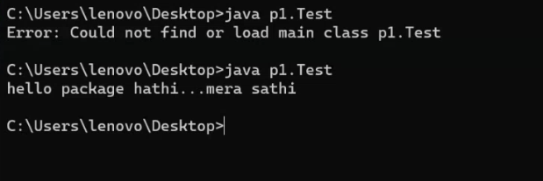

**Method-2**

* When you do not want create package folder then you can use javac –d . className.java
* In this command automatically create folder recent location and add bytecode this folder
* Run java packageName.className in outside package folder location run

**Method-3**

* Actually java –d command send the byte code your choice location
* You want create package folder your choice location then use
* Javac –d “location” className.java
* In this location create package folder

**Method-4**

* When but both location same A class import B class then compile the program javac –d .* B.java create both package folder in current location

**Method-5**

* When both class does not exist same location then which class use then set classpath
* For example –class A import in class b then class a path set in class b location after that use
* Javac –d .* B.java

**If you do not want to do this then use javac –d . classname.java then aumetically create folder**

**Javac -d : -d isliye lagate hain byte code jis folder main rakhan hain to use kre**

2.ye neeche wali command likhane per apne aap folder current directory per ban jayega

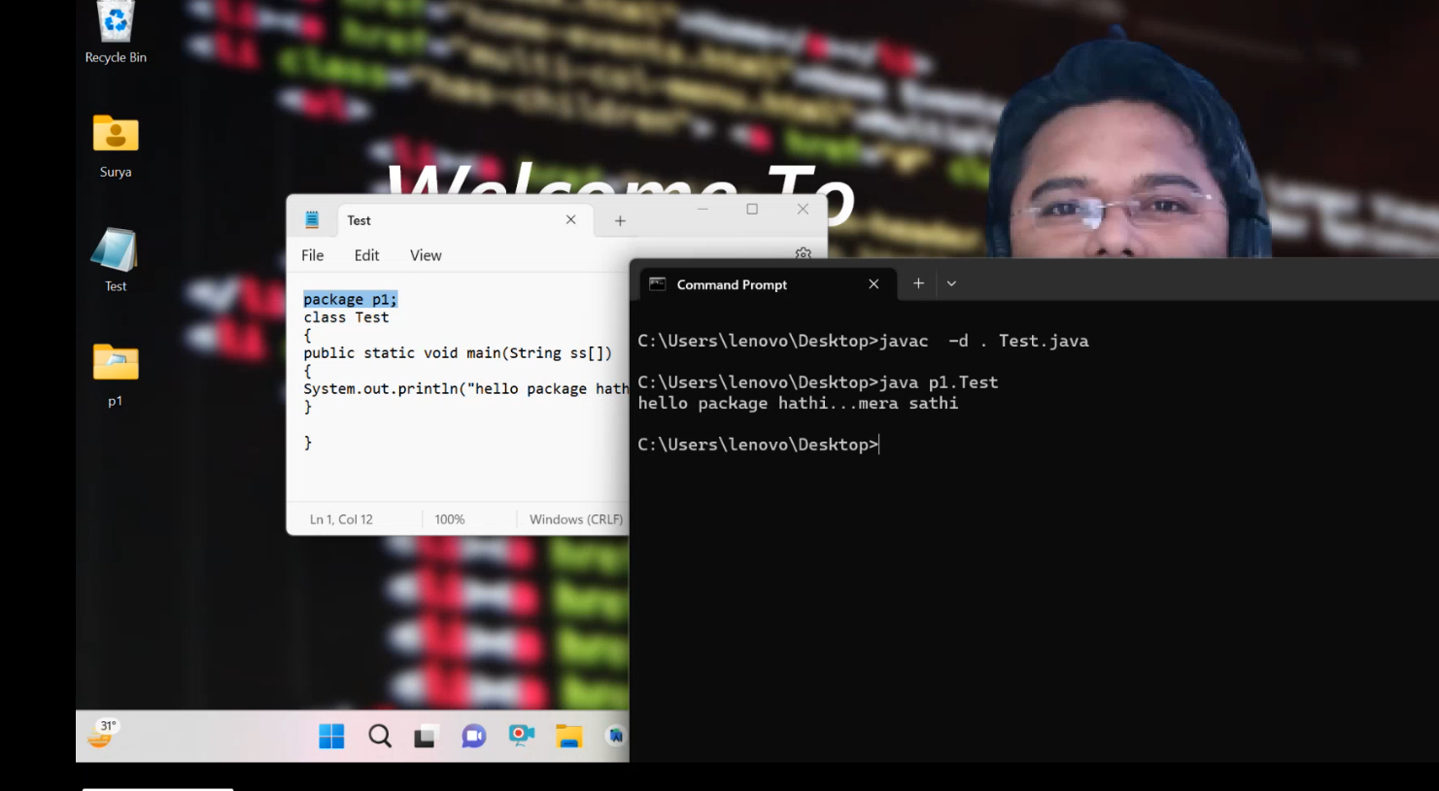

3.Jis folder main byte code dalna ho to aisa kre aur use folder ko location per ja kr run kr le

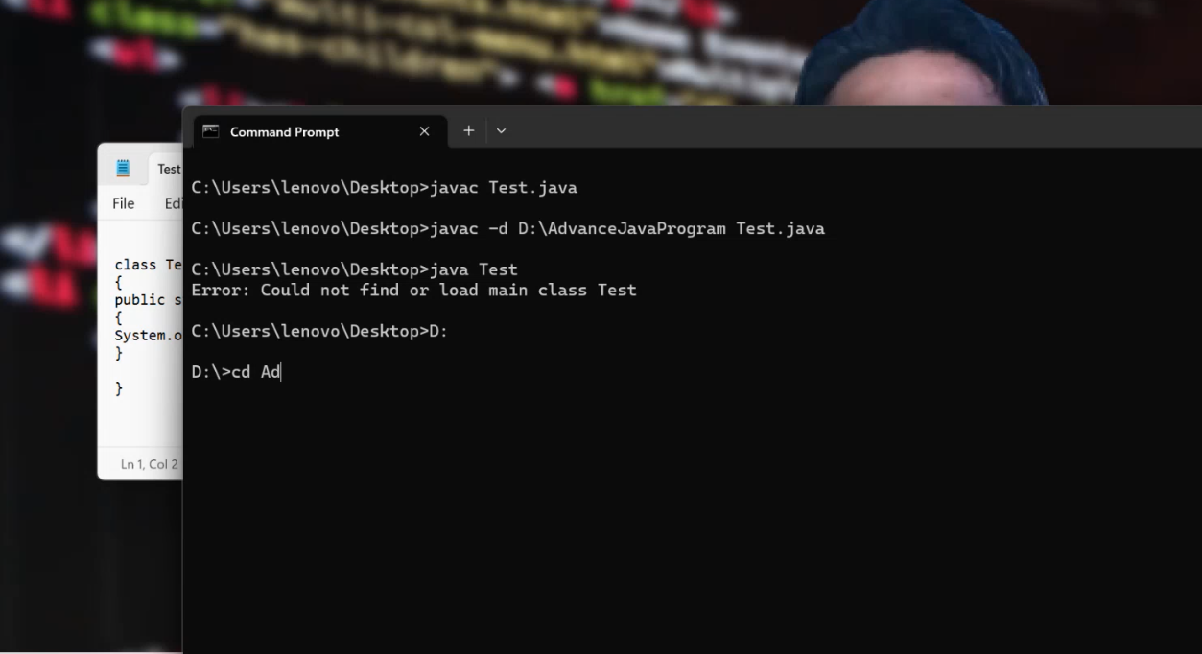

4 .isme wahi per raheke app program run kr sakate hain

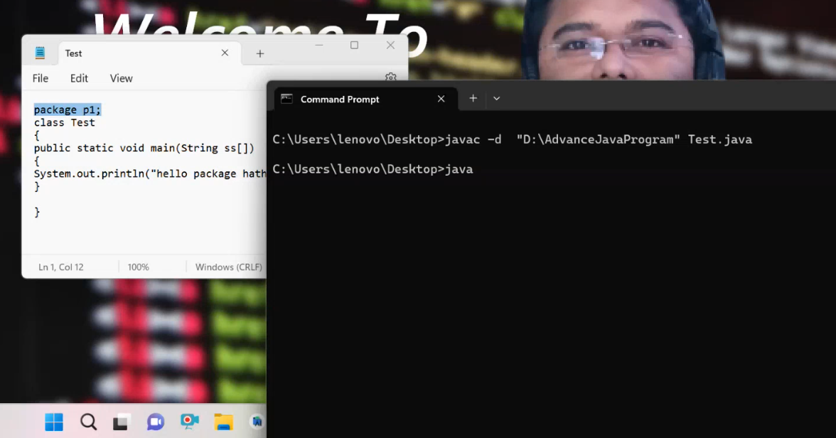

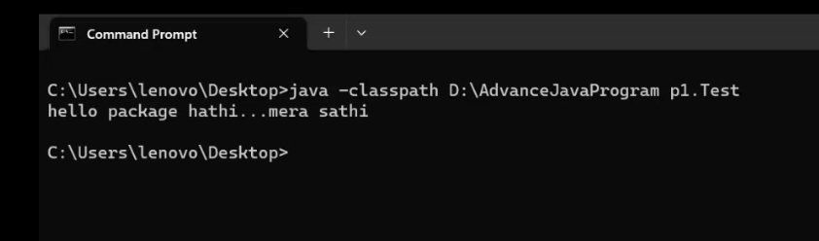

Aur class path ki jagah cp bhi likh sakate hain

C:\Users\naeem\OneDrive\Desktop\Program1\folder>javac -d C:Folder1 Package1.java

C:\Users\naeem\OneDrive\Desktop\Program1\folder>javac p3.Package1

error: Class names, 'p3.Package1', are only accepted if annotation processing is explicitly requested

1 error

C:\Users\naeem\OneDrive\Desktop\Program1\folder>java p3.Package1

Error: Could not find or load main class p3.Package1

C:\Users\naeem\OneDrive\Desktop\Program1\folder>java p3.Package1

Error: Could not find or load main class p3.Package1

C:\Users\naeem\OneDrive\Desktop\Program1\folder>java p3.Pacakge1

Error: Could not find or load main class p3.Pacakge1

C:\Users\naeem\OneDrive\Desktop\Program1\folder>cd Folder1

C:\Users\naeem\OneDrive\Desktop\Program1\folder\Folder1>java p3.Package1

Hello

C:\Users\naeem\OneDrive\Desktop\Program1\folder\Folder1>

Path vs classpath -path os walo ne banaya hain but class path java walo ne banaya hain

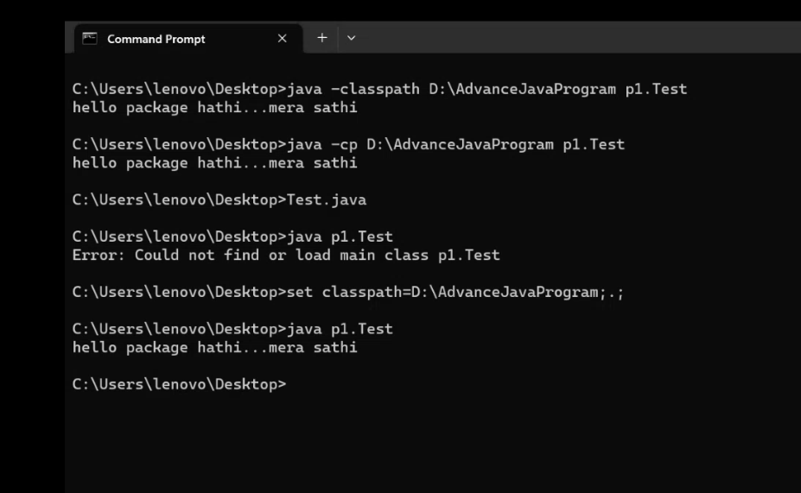

5.Ye temporary path hain set kr sakate hain;.; current location per khojane ke liye

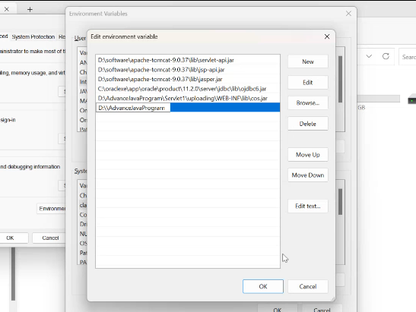

6.ye permanent path set ho gaya hain

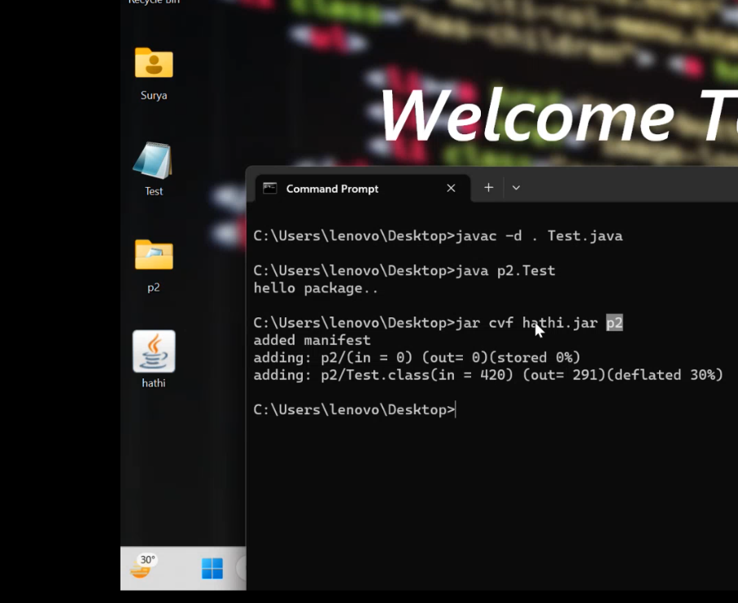

Jar bana ho to aur p2 folder delete krke hathi jar ko jre/lib/ext ke andar dal do

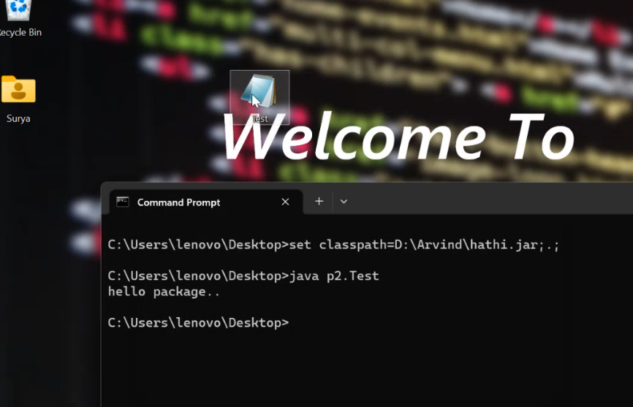

1.first tarika hain

**1.Ek package ke andar bahut classes ko rakahne ka tarika hain but ye tarika sahi nahi hain kyuki agar package ke bahar use krna hain to public class banana hain but ek file main ek hi public class ho skati hain**

**Package p1;**

**Class A**

**{**

**}T**

**Class B**

**{**

**}**

**Class C**

**{**

**}**

**Javac -d . Hathi.java**

**2.ye sahi tarika hain sabko alag -2 file main rakh do but package sabaka same kr do**

**package f1;**

**class X1{**

**}**

**package f1;**

**class X2{**

**package f1;**

**class X3{**

**}**

**}**

**f1 main hi a jayega sab**

**import hum package karate hain location batane ke liye class kaha hain.**

**1.Import**

**package A2;**

**import A1.*;**

**class Temp4 extends Temp3**

**{**

**public static void main (String args[])**

**{**

**Temp4 t4=new Temp4();**

**t4.show();**

**System.out.println(t4.x);**

**}**

**}**

**2.Without import**

**package A2;**

**//import A1.*;**

**class Temp4 extends A1.Temp3**

**{**

**public static void main (String args[])**

**{**

**Temp4 t4=new Temp4();**

**t4.show();**

**System.out.println(t4.x);**

**}**

**}**

**C:\Users\naeem\OneDrive\Desktop\Program1>javac -d . Temp4.java**

**C:\Users\naeem\OneDrive\Desktop\Program1>java A2.java**

**Error: Could not find or load main class A2.java**

**C:\Users\naeem\OneDrive\Desktop\Program1>java A2.Temp4**

**Package p1**

**10**

**C:\Users\naeem\OneDrive\Desktop\Program1>**

**Example -1- jab alag -2 folder main ho tab f2 main temp3 and f3 temp4 ho**

**C:\Users\naeem\OneDrive\Desktop\Program1\f3>set classpath=C:\Users\naeem\OneDrive\Desktop\Program1\f2;**

**C:\Users\naeem\OneDrive\Desktop\Program1\f3>javac -d . *.java**

**C:\Users\naeem\OneDrive\Desktop\Program1\f3>java A2.Temp4.java**

**Error: Could not find or load main class A2.Temp4.java**

**C:\Users\naeem\OneDrive\Desktop\Program1\f3>java A2.Temp4**

**Package p1**

**10**

**C:\Users\naeem\OneDrive\Desktop\Program1\f3>**

**Example -2 -f2 temp3 , f3 temp4 and f4 temp5 to f3 and f4 ka path set krna padega**

**poration. All rights reserved.**

**C:\Users\naeem\OneDrive\Desktop\Program1\B3>set classpath=C:\Users\naeem\OneDrive\Desktop\Program1\B1;C:\Users\naeem\OneDrive\Desktop\Program1\B2;**

**C:\Users\naeem\OneDrive\Desktop\Program1\B3>javac -d . *.java**

**Temp3.java:8: error: cannot find symbol**

**t.show();**

**^**

**symbol: variable t**

**location: class Temp3**

**Temp3.java:10: error: cannot find symbol**

**t.show();**

**^**

**symbol: variable t**

**location: class Temp3**

**2 errors**

**C:\Users\naeem\OneDrive\Desktop\Program1\B3>javac -d . *.java**

**C:\Users\naeem\OneDrive\Desktop\Program1\B3>java p3.Temp4**

**Error: Could not find or load main class p3.Temp4**

**C:\Users\naeem\OneDrive\Desktop\Program1\B3>java p3.Temp3**

**Package p1**

**Package p2**

**C:\Users\naeem\OneDrive\Desktop\Program1\B3>**

**Example- 3 – C1 main temp1 ,C2 main temp1 to konsa chalega aure C3 main temp2 hain .Jiska pahale set krege uske pahale chalega**

**C:\Users\naeem\OneDrive\Desktop\Program1\C1>javac -d . *.java**

**C:\Users\naeem\OneDrive\Desktop\Program1\C1>cd ..**

**C:\Users\naeem\OneDrive\Desktop\Program1>cd C2**

**C:\Users\naeem\OneDrive\Desktop\Program1\C2>javac -d . *.java**

**C:\Users\naeem\OneDrive\Desktop\Program1\C2>cd ..**

**C:\Users\naeem\OneDrive\Desktop\Program1>cd C3**

**C:\Users\naeem\OneDrive\Desktop\Program1\C3>set classpath=C:\Users\naeem\OneDrive\Desktop\Program1\C2;C:\Users\naeem\OneDrive\Desktop\Program1\C1;**

**C:\Users\naeem\OneDrive\Desktop\Program1\C3>javac -d . *.java**

**C:\Users\naeem\OneDrive\Desktop\Program1\C3>java p2.Temp2**

**Error: Could not find or load main class p2.Temp2**

**C:\Users\naeem\OneDrive\Desktop\Program1\C3>java p2.Temp2**

**Error: Could not find or load main class p2.Temp2**

**C:\Users\naeem\OneDrive\Desktop\Program1\C3>java p3.Temp2**

**Package p1 second**

**Package p1 second**

**C:\Users\naeem**

**Example 4- jab class same ho aur path alag ho to import kam nahi krata hain**

**package p1;**

**public class Temp1**

**{**

**public int x=10;**

**public void show()**

**{**

**System.out.println("Package p1 first");**

**}**

**}**

**package p2;**

**public class Temp1**

**{**

**public int x=10;**

**public void show()**

**{**

**System.out.println("Package p1 first");**

**}**

**}**

**package p3;**

**public class Temp2**

**{**

**public static void main(String args[]){**

**p1.Temp1 t1=new p1. Temp1();**

**t1.show();**

**p2.Temp1 t2=new p2.Temp1();**

**t2.show();**

**}**

**}**

**C:\Users\naeem\OneDrive\Desktop\Program1\D1>javac -d . *.java**

**C:\Users\naeem\OneDrive\Desktop\Program1\D1>cd ..**

**C:\Users\naeem\OneDrive\Desktop\Program1>cd D2**

**C:\Users\naeem\OneDrive\Desktop\Program1\D2>javac -d . *.java**

**C:\Users\naeem\OneDrive\Desktop\Program1\D2>cd ..**

**C:\Users\naeem\OneDrive\Desktop\Program1>cd D3**

**C:\Users\naeem\OneDrive\Desktop\Program1\D3>set classpath=C:\Users\naeem\OneDrive\Desktop\Program1\D1;C:\Users\naeem\OneDrive\Desktop\Program1\D2;**

**C:\Users\naeem\OneDrive\Desktop\Program1\D3>javac -d . *.java**

**Temp3.java:2: error: class Temp2 is public, should be declared in a file named Temp2.java**

**public class Temp2**

**^**

**1 error**

**C:\Users\naeem\OneDrive\Desktop\Program1\D3>javac -d . *.java**

**C:\Users\naeem\OneDrive\Desktop\Program1\D3>java p3.Temp2**

**5.Hume kisi class ki cheezo ko class bahar direct le ke jana hain to hum static import kr skate hain**

**Package p1 first**

**Package p1 first**

**package p1;public class Temp1{public static int x=10;public static void show(){System.out.println(x);} public void disp(){System.out.println("package p1"); }}**

**package p2;import static p1.Temp1.*;import static java.lang.System.*;//import static p1.*;//errorimport p1.*;//import java.lang.System.*;class Temp2{ public static void main (String args[]){Temp1 t1=new Temp1();t1.disp(); out.println(Temp1.x);t1.show(); out.println(x);out.println(x);show();Temp1.show();}}**

**Microsoft Corporation. All rights reserved.**

**C:\Users\naeem\OneDrive\Desktop\Program1\Static import>javac -d . *.java**

**C:\Users\naeem\OneDrive\Desktop\Program1\Static import>javac p2.Temp2**

**error: Class names, 'p2.Temp2', are only accepted if annotation processing is explicitly requested**

**1 error**

**C:\Users\naeem\OneDrive\Desktop\Program1\Static import>java p2.Temp2**

**package p1**

**10**

**10**

**10**

**10**

**10**

**10**

**C:\Users\naeem\OneDrive\Desktop\Program1\Static import>**

Access Modifiers in Java

There are two types of modifiers in Java: **access modifiers** and **non-access modifiers**.

The access modifiers in Java specifies the accessibility or scope of a field, method, constructor, or class. We can change the access level of fields, constructors, methods, and class by applying the access modifier on it.

in Java, Access modifiers help to restrict the scope of a class, constructor, variable, method, or data member. It provides security, accessibility, etc to the user depending upon the access modifier used with the element. Let us learn about Java Access Modifiers, their types, and the uses of access modifiers in this article.

There are four types of Java access modifiers:

1. **Private**: The access level of a private modifier is only within the class. It cannot be accessed from outside the class.
2. **Default**: The access level of a default modifier is only within the package. It cannot be accessed from outside the package. If you do not specify any access level, it will be the default.
3. **Protected**: The access level of a protected modifier is within the package and outside the package through child class. If you do not make the child class, it cannot be accessed from outside the package.
4. **Public**: The access level of a public modifier is everywhere. It can be accessed from within the class, outside the class, within the package and outside the package.

There are many non-access modifiers, such as static, abstract, synchronized, native, volatile, transient, etc. Here, we are going to learn the access modifiers only.

**Rule –public =protected=default within same package**

Understanding Java Access Modifiers

Let's understand the access modifiers in Java by a simple table

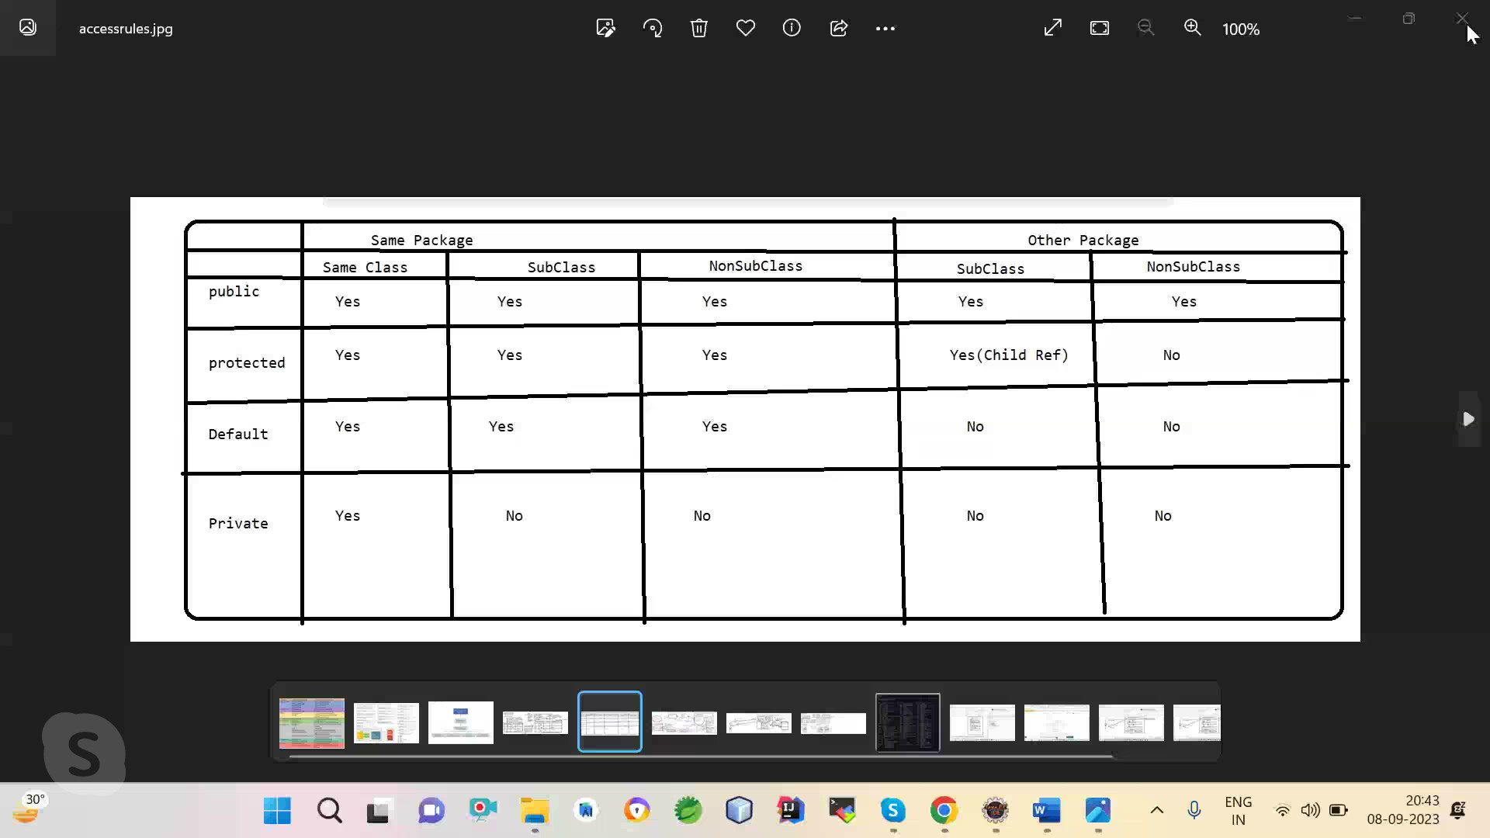

**package p1;**

**public class A{//same package same class**

**int x=10;**

**}**

**class B{//same package other(non)s w.r.t. A**

**}**

**class C extends A{//same package subclass**

**}**

**package p2;**

**class D{//other package same class**

**}**

**class E exteds D{// other package other (non) sub class**

**}**

**Protected :- class must be public and only can use inheritance and ref of child class ,if acess go out package**

**package p1;**

**public class Protect1{**

**protected int a=10;**

**protected void show(){**

**System.out.println("hello");**

**}**

**}**

**package p2;**

**import p1.*;**

**public class Protect extends Protect1 {**

**public static void main(String args[]){**

**Protect t=new Protect();**

**t.show();**

**System.out.println(t.a);**

**}**

**}**

DSA:

data ko orginzie way main rakh sake jis se kam se kam memory ,aur searching first ho

**Java Arrays:**

[Top 50 Array Interview Questions and Answers (2024) (guru99.com)](https://career.guru99.com/top-50-array-interview-questions-answers/)

Array is linear dsa .It provides facility of data in organize way or structured way ?

Int x=20;int y=23;int 30;int 40;….etc aise data agar hum rakhenge to hum kal data per operation krna hua to ye memory kaha pe store alag -2 hoge jise searching asan nahi hogi

Arrays are used to store multiple values in a single variable, instead of declaring separate variables for each value.

Array is the collection of homogeneous or similar type data in the contigueous memory or linear DSA OR Array is a variable which can hold multiple values of similar data type

Each element is differentiated by a number called index number. Index number starts with 0.use new keyword to create an array . Array take sequential memory allocation .

**Advantages of array** :

* searching first
* sequential memory allocation
* indexing maintain
* Drawback :not Hatogeneious

Syntax of Array :

int []a=new int[6];//explicit approach

int y[];

y=new int[34]

int []a=new int[]{2,3,4,5,};

int y[]={2,3,4,5};//implicit approach

**int x[]=new int[4];**

**jab array ka object banate hain to class ka object banata hain ?**

**approxi class ka**

**isme new ke baad int bana hain but constructor banata hain ,yaha per object kiska ban raha hain ?**

**jab compiler aray ka symbol dekhata hain to use pata chal jata hain ki muje approxi symbol banana hain ,approxiy class actual main exit nahi krti hain**

**is class ko banana ke liye compiler compile time per ek instruction generate kr deta hain aur run time per jvm use bana deta hain int,float,double sabake liye alag -2 genrate hogi .**

**new se memory create hogi heap area aproxi class ke liye aur usme kewal int type ka data jayega**

**Test name ki class ke array banaya hain to waha object jayenge**

**Dynamically memory loacate krani hoti iske alwa aur koi class bana nahi sakate hain (approxiy) aur koi concept nahi hain**

**x.length- approxiy class ka data member hain jo array ki length ko batata hain**

**method ke argument main array pass krate hain to use anonymous array bolate hain**

You can determine the size as:

* The number of rows: x.length = 3
* The number of columns in each row: x[0].length = 4

**String Handling**

**String-** In general String is the sequence of character or combination of character.

String is the implementation of array. **Jab bhi hum string banate hain wo memory main Array hi banata hain wo bhi character type ka .implicit aray (java) hain internal kuch aisa (“java”)**

String is the array of character data type.

int x[];

char c[]={‘j’,’a’,’v’,’a’};

‘A’,‘B’,‘C’. “ABC”

**The process of performing operation over the String (length count, con cat, replace, substring etc.) is called String handing.**

In java in order to performed string operation , java provides following classes-

1. java.lang.String
2. java.lang.StringBuffer
3. java.lang.StringBuilder
4. java.util.StringTokenizer

In java String is the represented by an object of String class.

**String class:-**

In java String is the immutable sequence (unchangeable) of character. **Imutable means hum uske object main change nahi kr sakate hain hum khud ki bhi imutable class bana sakate hain**

**Jab bhi aap koi string banata ho to String implicit array banati hain wo array blank final hota (private final char value). blank final variable wo hota jiska intilize nahi hota hain aur uski value ko ek baar intlize kr sakta hain wo bhi constructor and init block main isliye immutable hain String hain . aap khud ki immutable class bana sakate hain**

This class is internally public and final. **Iska inheritance possible nahi hota hain isliy assocication use krte hain**

This class extends object class and implements Serializable , Comparable, Char Sequence interface .

Immutable means in the one object of String we can not perform operation like- insert, delete, update etc.

**How to create the object of String class:-**

There are two ways ate used to create the object of String class.

1. without new (By String literal )------e.g **String s=”surya”;** “helllo”
2. with new e.g.  **String s=new String(“surya”);**

In java all the String literal are treated the String class object.

**Note:-** In java String , Wrapper classes , array objects can be created without new.

1. In case of without new we are creating the string object memory is allocated in String Constant pool area (part of method area). Pool areas does not allowed **duplicate** element. (It means whenever String object is created using this approach first it check the same name of string object is available or not if not then create a new memry otherwise share same memory location ). In this approach memory is optimized .pool area ka garabage collection nahi hota hain
2. In case of new keyword memory is allocated in both area (heap as well as pool area). Here duplicate element are allowed. **new se memory created hoti hain usme uski refid by default heap area ko point krta hain aur agar aap chahate ho ki pool wale ke point kre to string class ke pass ek method hota hain iturn us method ye pool wale ko point krne lagega**

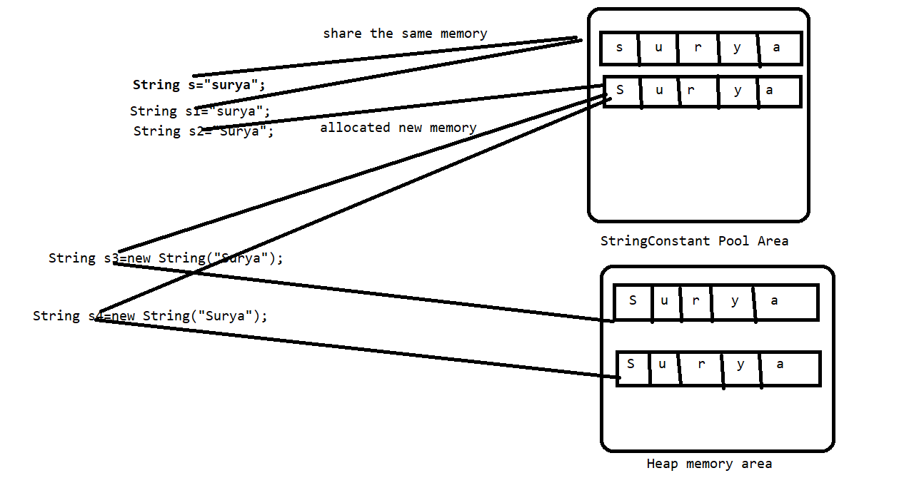

**String Comparison:-**

1. By equals() and equalsIgnoreCase() method :

Equals is the method of object class. Object class equals method is equivalent the ==operator method of String. String class equals method is override method of object class and change the behaviour It.Equals method of object class comparison between two object .jab aap kisi string ke upar equals chaloge to wo string ka equals chalega otherwise object ka .

Equals method of String class- comparison between content of two String .

1. By == operator -comparison between two reference id ofString
2. By compare To() and compareToIgnoreCase :ignore uppar and lower case of String

length Vs length()The length is an instance variable of an array in Java whereas length() is a method of String class.

The for-each loop is specifically designed to iterate over collections and arrays without needing to worry about the index or bounds. It simplifies the code when you just need to process each element without concern for how the data is structured.

**package** stringhandling;

**public** **class** TestStr1

{

**public** **static** **void** main(String[] args)

{

String s="surya";

String s1="surya";

String s2="Surya";

System.***out***.println(s.equals(s2));

System.***out***.println(s.equalsIgnoreCase(s2));

System.***out***.println(s==s2);

System.***out***.println(s.equals(s1));

System.***out***.println(s==s1);

System.***out***.println(s.hashCode());

System.***out***.println(s1.hashCode());

TestStr1 t1=**new** TestStr1();

TestStr1 t3=t1;

TestStr1 t2=**new** TestStr1();

System.***out***.println(t1.equals(t2));

System.***out***.println(t1.equals(t3));

System.***out***.println(t1==t2);

String s3=**new** String("surya");

String s4=**new** String("surya");

System.***out***.println(s3.equals(s4));

System.***out***.println(s3==s4);

String s5=s3.intern();

System.***out***.println(s==s5);

}

}

<https://www.geeksforgeeks.org/string-class-in-java/>

Java String class methods

The java.lang.String class provides many useful methods to perform operations on sequence of char values.

|  |  |  |
| --- | --- | --- |
| **No.** | **Method** | **Description** |
| 1 | [char charAt(int index)](https://www.javatpoint.com/java-string-charat) | It returns char value for the particular index |
| 2 | [int length()](https://www.javatpoint.com/java-string-length) | It returns string length |
| 3 | [static String format(String format, Object... args)](https://www.javatpoint.com/java-string-format) | It returns a formatted string. |
| 4 | [static String format(Locale l, String format, Object... args)](https://www.javatpoint.com/java-string-format) | It returns formatted string with given locale. |
| 5 | [String substring(int beginIndex)](https://www.javatpoint.com/java-string-substring) | It returns substring for given begin index. |
| 6 | [String substring(int beginIndex, int endIndex)](https://www.javatpoint.com/java-string-substring) | It returns substring for given begin index and end index. |
| 7 | [boolean contains(CharSequence s)](https://www.javatpoint.com/java-string-contains) | It returns true or false after matching the sequence of char value. |
| 8 | [static String join(CharSequence delimiter, CharSequence... elements)](https://www.javatpoint.com/java-string-join) | It returns a joined string. |
| 9 | [static String join(CharSequence delimiter, Iterable<? extends CharSequence> elements)](https://www.javatpoint.com/java-string-join) | It returns a joined string. |
| 10 | [boolean equals(Object another)](https://www.javatpoint.com/java-string-equals) | It checks the equality of string with the given object. |
| 11 | [boolean isEmpty()](https://www.javatpoint.com/java-string-isempty) | It checks if string is empty. |
| 12 | [String concat(String str)](https://www.javatpoint.com/java-string-concat) | It concatenates the specified string. |
| 13 | [String replace(char old, char new)](https://www.javatpoint.com/java-string-replace) | It replaces all occurrences of the specified char value. |
| 14 | [String replace(CharSequence old, CharSequence new)](https://www.javatpoint.com/java-string-replace) | It replaces all occurrences of the specified CharSequence. |
| 15 | [static String equalsIgnoreCase(String another)](https://www.javatpoint.com/java-string-equalsignorecase) | It compares another string. It doesn't check case. |
| 16 | [String[] split(String regex)](https://www.javatpoint.com/java-string-split) | It returns a split string matching regex. |
| 17 | [String[] split(String regex, int limit)](https://www.javatpoint.com/java-string-split) | It returns a split string matching regex and limit. |
| 18 | [String intern()](https://www.javatpoint.com/java-string-intern) | It returns an interned string. |
| 19 | [int indexOf(int ch)](https://www.javatpoint.com/java-string-indexof) | It returns the specified char value index. |
| 20 | [int indexOf(int ch, int fromIndex)](https://www.javatpoint.com/java-string-indexof) | It returns the specified char value index starting with given index. |
| 21 | [int indexOf(String substring)](https://www.javatpoint.com/java-string-indexof) | It returns the specified substring index. |
| 22 | [int indexOf(String substring, int fromIndex)](https://www.javatpoint.com/java-string-indexof) | It returns the specified substring index starting with given index. |
| 23 | [String toLowerCase()](https://www.javatpoint.com/java-string-tolowercase) | It returns a string in lowercase. |
| 24 | [String toLowerCase(Locale l)](https://www.javatpoint.com/java-string-tolowercase) | It returns a string in lowercase using specified locale. |
| 25 | [String toUpperCase()](https://www.javatpoint.com/java-string-touppercase) | It returns a string in uppercase. |
| 26 | [String toUpperCase(Locale l)](https://www.javatpoint.com/java-string-touppercase) | It returns a string in uppercase using specified locale. |
| 27 | [String trim()](https://www.javatpoint.com/java-string-trim) | It removes beginning and ending spaces of this string. |
| 28 | [static String valueOf(int value)](https://www.javatpoint.com/java-string-valueof) | It converts given type into string. It is an overloaded method. |

[www.javatpoint.com › java-string](https://r.search.yahoo.com/_ylt=Awr49_S6MghlY.wvWBFXNyoA;_ylu=Y29sbwNncTEEcG9zAzEEdnRpZAMEc2VjA3Ny/RV=2/RE=1695064891/RO=10/RU=https%3a%2f%2fwww.javatpoint.com%2fjava-string/RK=2/RS=kV9PD40bJkN7YwnqXt4naVusyi8-)

concate do tarike se kr sakte hain

1.concate method se

2.apne se dircecte + operator se : + Oprator implicity overaload hota hain

class Sample

{

public static void main(String aa[])

{

String s="ram"+"shyam";//ye khud se hain

System.out.println(s);//ramshyam

}

}

//the compiler transform this to:-

//String s=(new StringBuilder().append("ram")).apend("shyam")).toString();

class Sample1{public static void main(String aa[]){String s=50+78+"ram"+58+78;System.out.println(s);} +operator main koi value jod sakate hain

class Sample2{public static void main(String aa[]){String s="sachin";System.out.println(s);System.out.println(s.hashCode());s=s.concat("Tendulaker");System.out.println(s);System.out.println(s.hashCode());}}yah pe teen object Banega kyuki string immutable hoti hain

**String Buffer:-**

A thread-safe, mutable sequence of characters. A string buffer is like a String but can be modified.

It means in the one object of String Buffer we can do modification like- insert update etc.

String Buffer class object can be created by new keyword only.

**Commonly used constructor of String Buffer:-**

|  |
| --- |
| **StringBuffer**()  Constructs a string buffer with no characters in it and an initial capacity of 16 characters. |
| **StringBuffer**(**CharSequence** seq)  Constructs a string buffer that contains the same characters as the specified CharSequence. |
| **StringBuffer**(int capacity)  Constructs a string buffer with no characters in it and the specified initial capacity. |
| **StringBuffer**(**String** str) |

In case of default constructor of String Buffer when we are creating the object then it’s default capacity is 16 characters. and when inserted more values beyond the size of array then this array internally automatically increased with bellow formula.

**Oldlength * 2 + 2**

**Or**

Ye length kewal ek baar badayega iski capacity 16 hoti hain aur iske baad e above formula use krega but uske baad agar strng ki value 35 hui to uske baad jitani length utani capacity ho jaati hain.

**StringBuilder:-**

A mutable sequence of characters. This class provides an API compatible with StringBuffer, but with no guarantee of synchronization.

It is not a thread safe class.

**StringBuilder vs StringBuffer in Java**

| **StringBuffer Class** | **StringBuilder Class** |
| --- | --- |
| StringBuffer is present in Java. | StringBuilder was introduced in Java 5. |
| StringBuffer is synchronized. This means that multiple threads cannot call the methods of StringBuffer simultaneously. | StringBuilder is asynchronized. This means that multiple threads can call the methods of StringBuilder simultaneously. |
| Due to synchronization, StringBuffer is called a thread safe class. | Due to its asynchronous nature, StringBuilder is not a thread safe class. |
| Due to synchronization, StringBuffer is lot slower than StringBuilder. | Since there is no preliminary check for multiple threads, StringBuilder is a lot faster than StringBuffer. |

StringTokenizer in Java

1. [StringTokenizer](https://www.javatpoint.com/string-tokenizer-in-java#StringTokenizer)
2. [Methods of StringTokenizer](https://www.javatpoint.com/string-tokenizer-in-java#Methods)
3. [Example of StringTokenizer](https://www.javatpoint.com/string-tokenizer-in-java#Example)

The **java.util.StringTokenizer** class allows you to break a String into tokens. It is simple way to break a String. It is a legacy class of Java.

It doesn't provide the facility to differentiate numbers, quoted strings, identifiers etc. like StreamTokenizer class. We will discuss about the StreamTokenizer class in I/O chapter.

In the StringTokenizer class, the delimiters can be provided at the time of creation or one by one to the tokens.

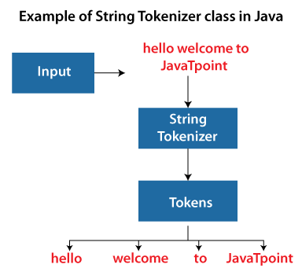

Constructors of the StringTokenizer Class

There are 3 constructors defined in the StringTokenizer class.

|  |  |
| --- | --- |
| **Constructor** | **Description** |
| StringTokenizer(String str) | It creates StringTokenizer with specified string. |
| StringTokenizer(String str, String delim) | It creates StringTokenizer with specified string and delimiter. |
| StringTokenizer(String str, String delim, boolean returnValue) | It creates StringTokenizer with specified string, delimiter and returnValue. If return value is true, delimiter characters are considered to be tokens. If it is false, delimiter characters serve to separate tokens. |

Methods of the StringTokenizer Class

The six useful methods of the StringTokenizer class are as follows:

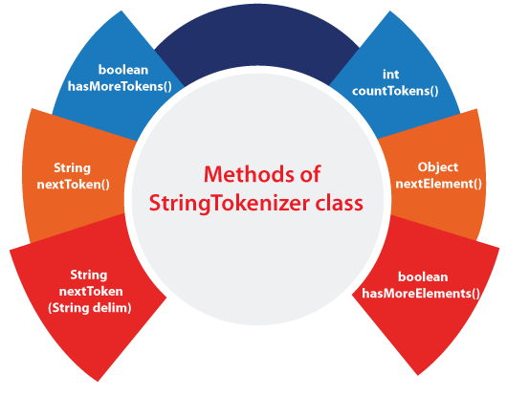

|  |  |
| --- | --- |
| **Methods** | **Description** |
| boolean hasMoreTokens() | It checks if there is more tokens available. |
| String nextToken() | It returns the next token from the StringTokenizer object. |
| String nextToken(String delim) | It returns the next token based on the delimiter. |
| boolean hasMoreElements() | It is the same as hasMoreTokens() method. |
| Object nextElement() | It is the same as nextToken() but its return type is Object. |
| int countTokens() | It returns the total number of tokens. |

**Exception:-**

It is the abnormal situation which occurs in the program at runtime due to this interrupts the normal flow of the program. And the rest of code will not be executed . In **exception handling** we learn how to handle this abnormal situation in the program.

E.g:-

Class A

{

Stamemt1….

Stamemt2….

Stamemt3….

Stamemt4….

Stamemt5….

}

Here suppose an exception is occur at statement no-3 so the rest statement will not executed but in exception handling we handle how to maintain this normal flow of the program.

**Exception Handling :-** Exception Handling is a mechanism to handle runtime errors such as ClassNotFoundException, IOException, SQLException, RemoteException, etc.

There are five keywords are used in java to handle the exception:

**1.try**

**2.catch**

**3.finally**

**4.throw**

**5.throws**

All the above are keyword but try, catch & finally are called block and throw and throws are called clause.

**Error:-** there are three type of error-

1. Syntax error
2. Logical error
3. Runtime error

Exception handling is the process of handling the runtime errors.

Exception can be handle but errors can’t be handle.

**From coding pint of view exception and error is an object is java and it is represented by a class called java. lang. Exception and java. lang. Error respectively .**

**In java java .lang package contains so many classes to represent exception and errors and they store in the hierarchical manner**

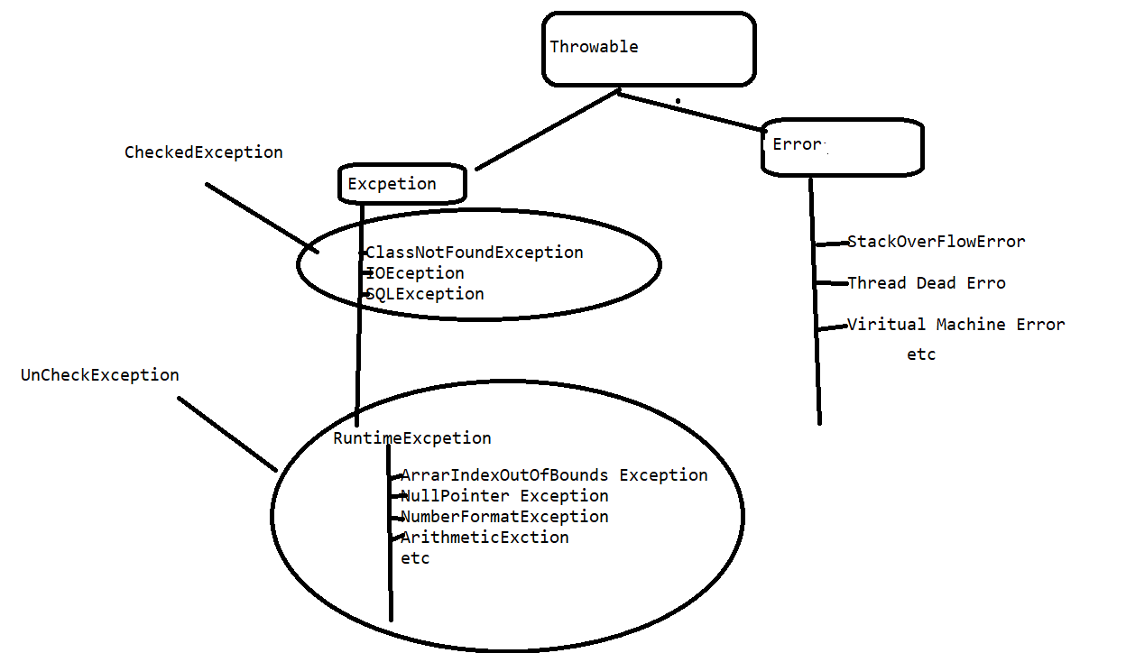

**koi bhi exception aaye humare program uske liye humare pass classes hain exception ko handle krne ke liye**

**try: isme kewal wahi statement likhe jisme exception aane ke chance ho agar hum aise nahi ,exception ayan first line main aur humne try first seconde line dono ko Rakha to exception handle hone per wo first line ko check krke bahar a jayega**

**Defination :- try block contains those set of instructions or those set of statements where exception may occurs**

**Jab hum try jis line per exception a raha tha wah per lagate hain. let ArrayOutOBoundException tha. To jvm check krega jo throwable tha usme check is exeption name ki class hain aur agar hain to jvm us class ko memory main load krega aur uske baad us class ka object banayega same reflection krega aur uske baad usko program main show kr dega humari responbility ye hoti hain us exception ko hum program main catach kr paye**

**Throwable iske part exception and error aur uske part ye hirarchay bolati hain**

**Ye kyu maintain krate hain -ye isliye karate hain taki inheritance achive kr sake**

**Jab hum koi catch nahi lagate hain to default handler jvm program ke andar dal dega but handling kr pata hain kyuki agar aisa krte to wo apne message likhate**

**{**

Java statement-.----------

}

**Try block contains those set of statement where exception may occur.**

**try must be followed by either catch or finally.**

The catch block is used to handle the uncertain condition of a try block. which handles the exception that occurs in the associated try block.

**catch**(TypeofExcption refvariable )

{

}

Single try can have multiple catch block but at a time only one catch block is executed. Because in a single try only one exception occur at a time.

Between try and catch only spaces are allowed not any statement.

Comments are allowed.

If exception occur in try then it directly to go catch means if in this try block suppose we have 10 statement and exception occur at first statement then remaining line not reachable(9 statement) .

**What Happened When Exception Occur:-**

When exception occur in try block then firstly JVM matches the it’s corresponding class in the exception hierarchy if It found the matching class then

1. load the exception class.
2. Create the object of exception class
3. Throw the exception object into corresponding catch
4. If corresponding catch is found, then exception is handling and after executing all statement of catch block the normal flow of program are maintained.
5. If corresponding catch not found, then JVM put own handler and the normal flow of program has not maintained.

1. try & catch2. Nested try catch3. multiple try catch

**Single Try With Multile Catch Block:-**

**try**

{

}

**catch(IllegalArgumentException e)**{

some code;

}

**catch(SecurityException e)**{

someCode();

}

**catch(IllegalAccessException e)**{

someCode();

}

**catch(NoSuchFieldException e)**{

someCode();

}

**Multiple Try Catch:-jab apko lage do line main exception alage-2 hain to use alag -2 try main rakhe aise nahi kroge to apne ek try main Rakha to jo first line hogi exception baad seedha catch main chal jayega .**

**Question-Ek try ke sath multiple catch kyu lagate hain jab ek catch se kaam chal Sakata hain?**

**Answer-Ek try ke sath multiple catch isliye lagate hain taki jo exception ho us type ka message de sake .**

**Aur agar aap multiple catch nahi use krna chate hain to aap switch or if lagake message print kr sakate ho.**

**catch**(Exception e)

{

**if**(e **instanceof** ArrayIndexOutOfBoundsException)

{

System.***out***.println("ArrayIndexOutOfBoundsException Issue");

}

**else** **if**(e **instanceof** NumberFormatException)

{

System.***out***.println("NumberFormatException PProbelm");

}

**else**

{

System.***out***.println("Parrent");

}

}

**Jdk 1.7 se ye concept aya hain**

**catch**(ArrayIndexOutOfBoundsException | NumberFormatException | ArithmeticException e)

{

System.***out***.println(e);

}

**try**

{

}

**catch(IllegalArgumentException e)**{

some code;

}

try{

**catch(SecurityException e)**{

someCode();

}

try

{

**catch(IllegalAccessException e)**{

someCode();

}

try{

**catch(NoSuchFieldException e)**{

someCode();

}

**try**

**{**

Java statement-.----------

}

Java block contains those set of statement where exception may occur.

try must be followed by either catch or finally.

**catch**(TypeofExcption refvariable )

{

}

Single try can have multiple catch block but at a time only one catch block is executed. Because in a single try only one exception occur at a time.

Between try and catch only spaces are allowed not any statement.

Comments are allowed.

If exception occur in try then it directly to go catch means if in this try block suppose we have 10 statement and exception occur at first statement then remaining line not reachable(9 statement) .

**Nested Try Catch:-**

**1**

**2**

**3**

**4**

**5**

**6 mana 1 se 3 main another type ka error and 4 se 6 another type ka error hain aur whole main other type ka error hain to try catch use kre**

* A try statement can be inside block of another try.
* Sometimes Condition may arise where part of block may cause one error and entire block may cause another error.So we can use in java, nested try.

**try**{

statement 1;

statement 2;

**try**{

statement 1;

statement 2;

}

**catch (Exception1 e)**{

//statements to handle the exception

}

}

**catch (Exception2 e2)**{

//statements to handle the exception

}

* When nested try blocks used, inner try block is executed first.
* Any Exception thrown in the inner try block is caught the corresponding catch block.
* If matching catch block is not found So catch block of outer block are examining until all nested try statement exhausted.
* If no matching blocks are found,So java Runtime Ennvironment handles the execution.

**Finally:-**

The finally block executes whether exception rise or not and whether exception handled or not. A finally contains all the crucial statements regardless of the exception occurs or not. In this case, the program runs fine without throwing any exception and finally block execute after the try block.

It is always executing block. Which execute every time either exception occur or not.

1. try

{

}

finally

{

}

2.try

{

}

catch()

{

}

finally

{

}

The main purpose of finally block is to write cleaup code in the program.

* 1. If exception not occurred then finally executed and rest of code will executed
  2. If exceptions occurred but not handle then finally executed. And rest code will not executed.
  3. If exception occurred and handle the finally executed and rest of code will also be executed.

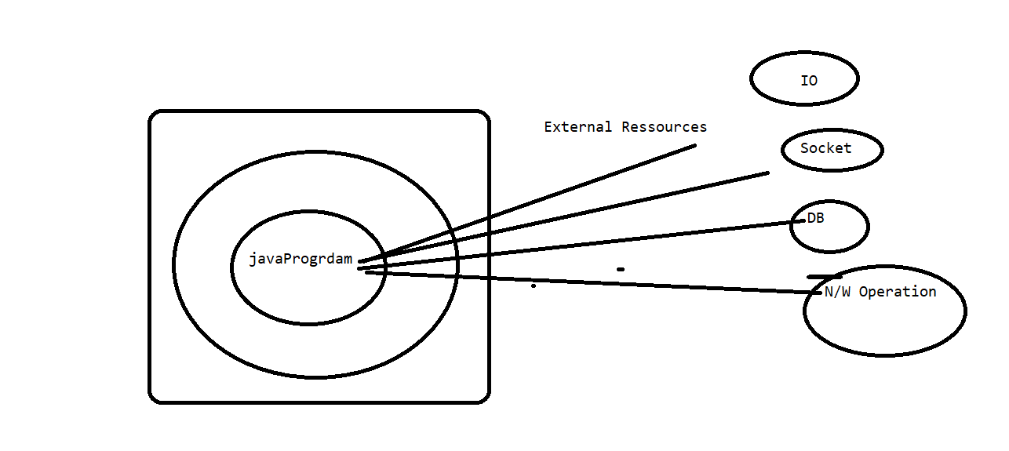

Is there any situation in which finally will not be execute.

When we explicitly terminating the program.

System.exit(0);

Can a return statement of method stop the finally.

Question-Kons sa code finally mai likhana chaiye ?

Answer-Clean up code likhana chiye

**UnChecked exception**-jab java ka program jvm ki baoundary ke andar hota hain aur jo exception aate hain to unhe unchecked exception bola jaata hain.

**Checked exception** -jab java ka program jvm ki baoundary ke bahar jata hain jais database connecte ,server se connecte hota hain to jvm complier ko forcekrta hain main handle nahi kr paunga isliye unhe checked exception bola jaata hain pahle check karega compiler uske baad jvm ki boundary ke bahar bheja jaata hain .aur inhe show throws keyword se show kr sakate h ain.database connection kr rahe suddenly light gayi ho Sakata hain wo humare code ko access kr le aur real world main atm gaye apne paise nikale process kiya but just light gayi to apka paise baad main nikal sakta tha but wha bhi isi ka use hota hain

**Checked Vs. Uncheck Exception :-**

**Partial Checked Vs. Uncheck Exception :-**

Checked exception are known by compiler at compile time and uncheck exception are known by JVM at runtime.

**Throw:-** This keyword is used to throwing an exception explicitly in the program.

The main purpose of throw keyword is used to throw an object of custom exception. It is the part of method definition

Throw new Type Of Exception ();

**Throws:**- This keyword is used to provide the indication to the end user the what type of exception may occur in the program.

public void show() throws Type of Exception

**{**

**}**

The main purpose of throw keyword is used to throw an object of custom exception. Throws is the part of method declaration

Void show()throws IOException ,A,E,N, P ek saath kitane bhi laga sakate ho

**Compiler ko checkeeeeeeeed exception kaise pata hota hain kyuki jitane bhi checked exception hote hain unke aage throws keyword laga hota hain 90% scenario main ,unchecked bhi but jadatar checked hote hain**

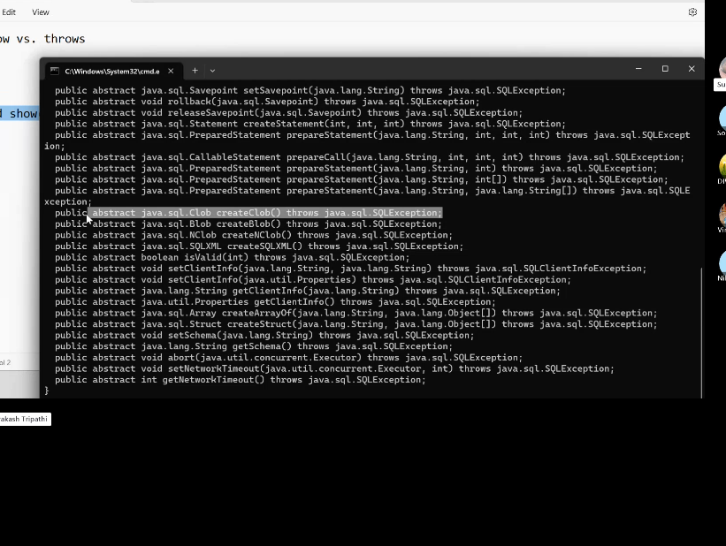

Throw new Type Of Exception ();

jab kisi program main method kea age throws exception so ho raha hai jab aap usko jis bhi method main call kroge to ya to uske aage wahi exception show kra do yap hir use jaha call kr rahe ho use try catch main Rakha do.

For example jaise class name ko class thi uska forName method exception show krta tha .jaha predefined hoga waha show krata hoga yato aap use try catch main rakhe ya phir jaha call kr us method main throw exceptin kro .

**First case** :- hume hamesha try catch main rakhan chiye jab koi exception throws ho .jaha call kre waha throws na lagaye to behatar hain kyuki agar dhoke se exception a gaya tho hadle nahi ho payega

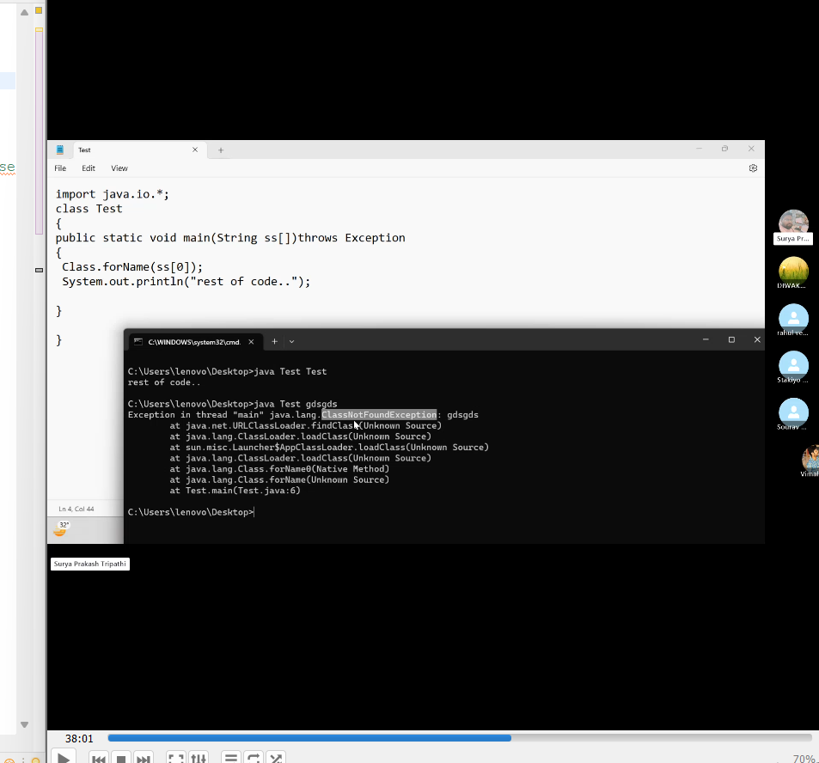

Inhone runtime per ek aur class de diye jo exit nahi kr rahi thi

**Second Case**:yaha per rest of code chal raha hain jab exception a gayi tab bhi

--------import java.io.*;class Test{public static void main(String ss[]) { try{ Class.forName(ss[0]); }catch(Exception e){System.out.println(e);}System.out.println("rest of code.."); }}

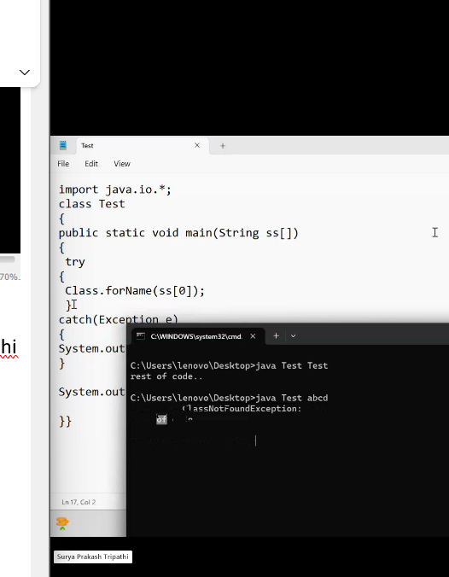

**Exception ka code kaha likhana chaiye definition main yaha jaha call kr rahe waha likhan chaiye ?**

**Exception handling always calling time per krani chaiye throws keyword se aap declation per define kr do phir jab aap call kro to aap calling main likh do.calling per hum apne hisab se kr sakate hain**

**Exception Propagation:-**

**1.**

**class UncheckedStack{**

**void m() {int x=10/0; //mana yaha per exception a gaya to yaha per exception ka code likha nahi hain to yaha se propgate hote jaha per call ho raha wah jayega but wah nahi mila to jis method ke andar call ho raha waha dekhega waha jah call ho raha hai waha dekhega aise dekhate display ke pass pahuchega aur waha likha hain to waha se handle ho jayega to exception kaha aya aur hadle kaha hua ise exception progation bola jata hain}void show() {System.out.println("show.....");m();}void display() {System.out.println("display.....");show();}public static void main(String a[]){UncheckedStack u=new UncheckedStack(); try{u.display(); }catch(Exception ne){ //System.out.println(ne);//ne.printStackTrace(); System.err.println(ne.getMessage());}System.out.println("Normal Flow...");}}unchecked excpetion ka kewal propagation hota hain**

**2.but throws keyword lagake aap checked exception bhi propgate kr sakate ho**

**import java.io.*;class checkedStack{void show()throws IOException {throw new IOException("IOProblem"); }void display()throws IOException {System.out.println("display.....");show();}public static void main(String a[]) {checkedStack u=new checkedStack();try{ u.display();}catch(Exception e){System.out.println(e);//e.printStackTrace();}System.out.println("Normal Flow...");}}jadatar exception handling banayigi wo checked exception ke liye banayi gayi hain**

**Method ko memory method area ke method table main milati hain aur calling stack area se hoti hain**

If a method have throws with it. Then we must have to follow the below rule:-

1. If we are calling a method which have throws some exception then into the called method we need to handle same exception in try and catch otherwise throws same exception with method.

Throw is used to throwing an exception explicitly where as throws is a part of method signature and it is used to provide the indication to the end use that what type of exception may occur in the program.

Throw is the part of method definition and throws is the part of method signature.

We can throws multiple exception at a time separated by comma but we can throw only one exception at a time.

We can throw any exception but generally throws are used the in case of checked exception.

**Custom Exception:-**

When we are creating own exception class as per requirement then it is called custom exception . when ever we are crating custom exception in this case we need extends some predefine exception class in our own class.

Custom exception main hume khud ka class ko bani banayi exception class ka sath inherite kr dete hain .

**An Exception is said to be fully checked if and only if all the child classes are also checked exception, otherwise it is called partially checked exception.**

**Example:**

**IOException:- fully checked exception**

**Use of Throws In case of method overriding and Constructor creation :-**

1. **If parent class method does not throwing an exception.**
   * 1. Child class overridden method can throw only unchecked exception not check exception.

Jaba parent class ka exception koi na show kre to child class ka kewal uncheked exception show kr sakta hain

class Test{void show(){}}class Demo extends Test{void show()throws java.io.IOException{}public static void main(String ss[]){ }}

1. If parent class method throwing an exception.
   1. Child class method does not throw an exception.
   2. Child class method can throws same exception.
   3. Child class method can throws child exception but **can not throws parent exception**

class Test{void show()throws java.io.IOException{}}class Demo extends Test{void show()throws Exception{}public static void main(String ss[]){ }}

4.Diffrent kra sakate hian but wo unchecked ho .checked na ho.

class Test{Test()throws java.io.IOException{}}class Demo extends Test{Demo()throws Arthimetic Exception{} public static void main(String ss[]){}}

1. In case of constructor we need to throws same exception and parent exception in child class constructor.

* Jo exception parent class ke constructor main hoga wahi child class ke constructor main hona chiye
* Aur child class main parent exception bhi kr sakate hain

class Test{Test()throws java.io.IOException{}}class Demo extends Test{Demo()throws Exception{} public static void main(String ss[]){}}

I\O

Socket

Thread

Java ka program banate samay koi additional cheeze la rahe ho unhe resources bola jata hain

Jdk 7 se try with resources ka concept aya hain

try with resources

FileInputStream fileInputStream=null;

try {

fileInputStream=new FileInputStream("sds");

fileInputStream.read();

} catch (Exception e) {

// TODO Auto-generated catch block

e.printStackTrace();

}

Ye resources hain

Nested try catch finally kr sakate hain teeno ka teen main nesting kr sakate hain

# 1.try{try{}catch(){}finally{}}catch(){try{}catch(){}finally{}}finally{try{}catch(){}finally{}}The try-with-resources statement:

* Ye wala concept use kroge to finally ka user aur close ka use nahi krna padega hain.
* Ek try ke andar multiple resources Rakha sakate hain

package com.facebook.testcases;import java.io.File;import java.io.FileNotFoundException;import java.io.PrintWriter;import java.util.Scanner;class Test { public static void main(String[] args) { try (Scanner scanner = new Scanner(new File("testRead.txt")); PrintWriter writer = new PrintWriter(new File("testWrite.txt"))) { while (scanner.hasNext()) { writer.print(scanner.nextLine()); } } catch (FileNotFoundException e) { // TODO Auto-generated catch block e.printStackTrace(); } }}

closeble interfae tab use krna chaiye jab aap khud ka resoruces banana chahate hain

package com.facebook.testcases;import java.io.Closeable;import java.io.IOException;class MyResource implements Closeable{ void show() { System.out.println("show..."); } @Override public void close() throws IOException { System.out.println("close"); } }class Test { public static void main(String[] args) { try(MyResource r=new MyResource();) { r.show(); } catch (IOException e) { // TODO Auto-generated catch block e.printStackTrace(); } }}closable autoclosable ke baare main padna hain

In Java, *try-with-resources* is a statement that ensures automatic closing of resources (like files, database connections, etc.) when they are no longer needed. Resources must implement the AutoCloseable interface. Here's a short example:

**Exception:- partially checked exception, as it's subclasses include both checked and unchecked Exceptions.**

**Throwable:- partially checked exception, as it's subclasses include both checked and uhttps://www.geeksforgeeks.org/checked-vs-unchecked-exceptions-in-java/nchecked Exceptions.**

**Parent checke ho aur child na check ho to use partially checked bola jata hain .**

**Input Output –**

**ek facility hoti hain java .**kisi source se data lana hain aur destination per data ko patk dena hain .yahi input and output hota hain.source aur destination kuch bhi ho Sakata hain

Java ka program kisi io device se directe nahi connect hota hain

**Input Output is a facility in java in which r we are reading data from source could anything like socket ,console,file etc. And writing data to the destination. Destination could be also file,console .etc.This is the io concept**

We can say that any io device does not intereact with java program

Java program ka program direct io device se nahi connect hota hain .In java main **stream** ka concept ka use krke java ke program ke connect krte hain .

Java program does not direct connect java program .So that we use stream.

C ka program ka io se direct connect hota hain



**Java ya C++ ka program io device se connect hone ke liye stream sara kyu leta hain?**

**C main pointer hota tha jo intertnet fail ho jata tha.isliye stream ka concept aaya hain.**

**Real world main bhi stream ka concept use hota hain jaise petrol tanki per ,iska use krne se efficiency first ho jaati hain**

**Jab hum internet per stream use krate hain to waha per byte ka flow hota .**

**Serilization:-**

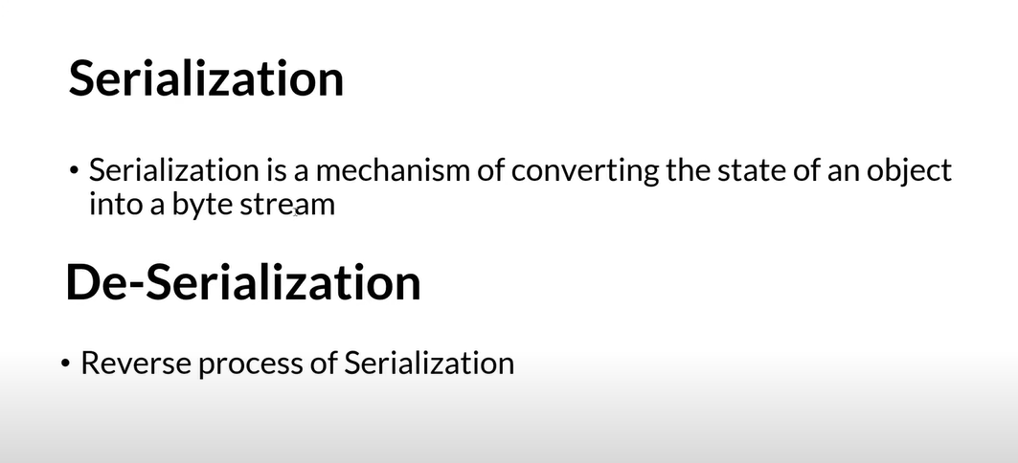

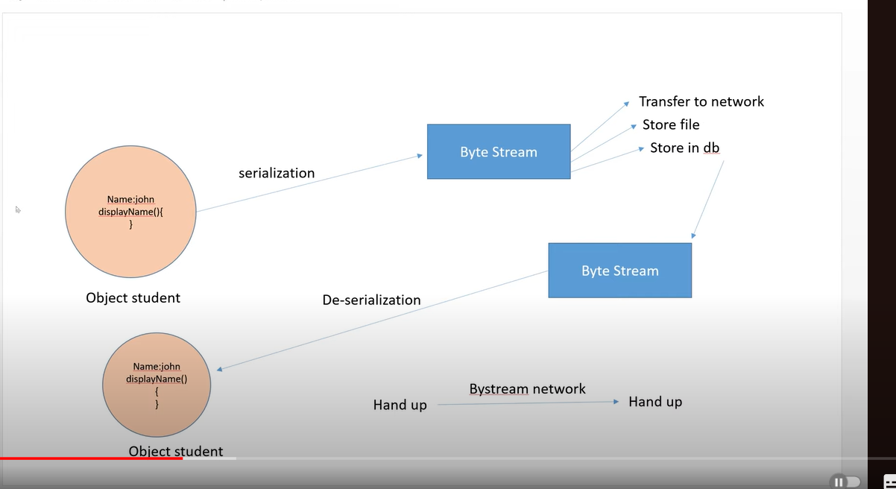

**I/O Stream:-**

Stream is the logical connection between Java program and file. In Java, stream is basically a sequence of data, which has a continuous flow between Java programs and data storage.

**ise networking main use krte hain**in java input output ek class hain jo io.package main paya jata hain**Stream (This is not a class but a concept) :->Stream is flow of data in the form of byte.There are two types of Stream name ki class de di hain.java.io:->**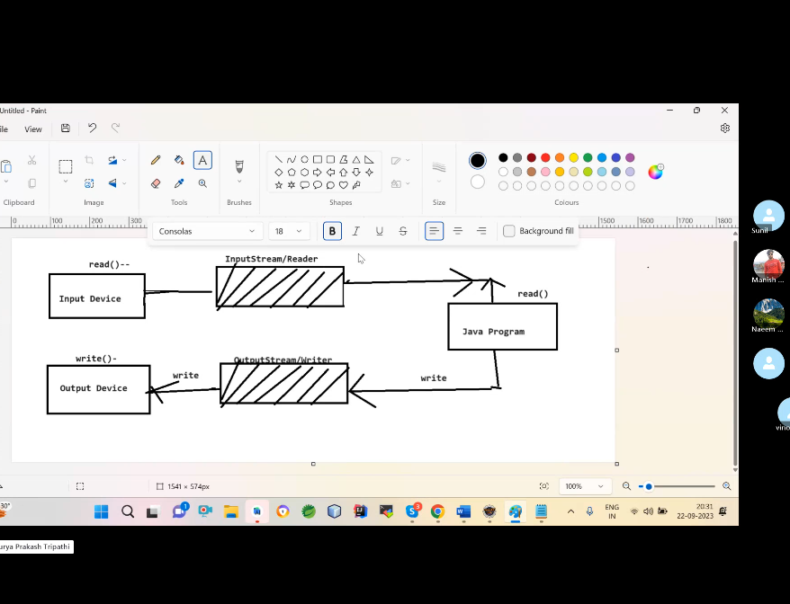

**kahi se bhi data ko read and write krna hain to muje uska stream pata hona chiye agar main read krna chahata hu to inputstream and write krna chahata hu to output stream pata hona chiye .**

**for example muje browser se data read krna hain to uska muje input stramp pata hona chaiye.nahi hogi to banana padega .**

**1. Byte Oriented (ASCII)-- 8 bit -concept hain-only main use krna to ise follow kre .desktop applicatin hain aur 8 bit ka support dena hain to hum ise use krange**

Byte stream is used to read and write a single byte (8 bits) of data.**if you want to read and write operation only egnlish language then you can use byte stream.It is support ASCII**

**a)-java.io.InputStream (read)-----> -FileInputStream -ByteArrayInputStream -BufferedInputStream -DataInputStream -SequenceInputStream -PipedInputStream -ObjectInputStream -FilterInoutStream -InfliterInputStream etc.b)-java.io.OuputStream (write) -FileOutputStream -ByteArrayOutputStream -BufferedOutputStream -DataOutputStream -PipedOutputStream -ObjectOutputStream -FilterOutoutStream -DefletorOutputStream2. Chracter Oriented (Unicode)- 16 bit-concept hain:-agar apko kisi bhi bhasha main kaam krna hain to aap character oriented use kre .china ke letter yani sabhi language ka support dena hain to use kre .**Character stream is used to read and write a single character of data.

**if you want to read and write operation any languange language then you can use byte stream.It is support Unicode System.**

**a)-java.io.Reader (read) -FileReader -CharArrayReade -BufferedReader -DataReader -SequenceReader -PipedReader -ObjectReader -FilterReader -InfliterReader etc.b)-java.io.Writer (write) -FileWriter -CharArrayWriter -BufferedWriter -DataWriter -SequenceWriter -PipedWriter -ObjectWriter -FilterWriter -InfliterWriter etc.**

**LowStream:-aisi stream jo io device se directly connect hoti hain unhe low level stream bola jata hain.**

**HighlevelStream:-iski performance ko badan eke liye high level stram padte hain.**

**Java:->jar file (rt.jar or third party jar) --->package----> class/interface---> (static,non static)method:---Inbuit Logic----> rt.jar--->io.FileInputStream---read:-FileOutputStream---write**

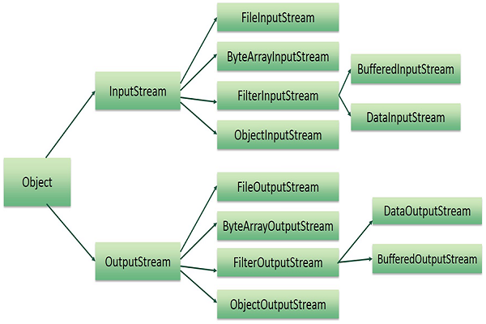

| **S. No.** | **Stream Class** | **Description** |
| --- | --- | --- |
| 1 | [**InputStream**](https://www.geeksforgeeks.org/java-io-inputstream-class-in-java/) | This is an abstract class that defines stream input. |
| 2 | [**FileInputStream**](https://www.geeksforgeeks.org/java-io-fileinputstream-class-java/) | This is used to reads from a file. |
| 3 | [**DataInputStream**](https://www.geeksforgeeks.org/java-io-datainputstream-class-java-set-1/) | It contains a method for reading java standard datatypes. |
| 4 | [**BufferedInputStream**](https://www.geeksforgeeks.org/java-io-bufferedinputstream-class-java/) | It is used for Buffered Input Stream. |
| 5 | [**PrintStream**](https://www.geeksforgeeks.org/java-io-printstream-class-java-set-1/) | This class comprises the commonly used print() and println() methods. |
| 6 | [**OutputStream**](https://www.geeksforgeeks.org/java-io-outputstream-class-java/) | This is an abstract class that describes stream output. |
| 7 | [**FileOutputStream**](https://www.geeksforgeeks.org/fileoutputstream-in-java/) | This class is used to write to a file. |
| 8 | [**DataOutputStream**](https://www.geeksforgeeks.org/dataoutputstream-in-java/) | This contains a method for writing java standard data types. |
| 9 | [**BufferedOutputStream**](https://www.geeksforgeeks.org/java-io-bufferedoutputstream-class-java/) | This is used for Buffered Output Stream. |

**Class InputStream**

* [java.lang.Object](https://docs.oracle.com/javase/8/docs/api/java/lang/Object.html)
  + java.io.InputStream
* **All Implemented Interfaces:**

[Closeable](https://docs.oracle.com/javase/8/docs/api/java/io/Closeable.html), [AutoCloseable](https://docs.oracle.com/javase/8/docs/api/java/lang/AutoCloseable.html)

**Direct Known Subclasses:**

[AudioInputStream](https://docs.oracle.com/javase/8/docs/api/javax/sound/sampled/AudioInputStream.html), [ByteArrayInputStream](https://docs.oracle.com/javase/8/docs/api/java/io/ByteArrayInputStream.html), [FileInputStream](https://docs.oracle.com/javase/8/docs/api/java/io/FileInputStream.html), [FilterInputStream](https://docs.oracle.com/javase/8/docs/api/java/io/FilterInputStream.html), [InputStream](https://docs.oracle.com/javase/8/docs/api/org/omg/CORBA/portable/InputStream.html), [ObjectInputStream](https://docs.oracle.com/javase/8/docs/api/java/io/ObjectInputStream.html), [PipedInputStream](https://docs.oracle.com/javase/8/docs/api/java/io/PipedInputStream.html), [SequenceInputStream](https://docs.oracle.com/javase/8/docs/api/java/io/SequenceInputStream.html), [StringBufferInputStream](https://docs.oracle.com/javase/8/docs/api/java/io/StringBufferInputStream.html)

public abstract class **InputStream**

extends [Object](https://docs.oracle.com/javase/8/docs/api/java/lang/Object.html)

implements [Closeable](https://docs.oracle.com/javase/8/docs/api/java/io/Closeable.html)

This abstract class is the superclass of all classes representing an input stream of bytes.

Applications that need to define a subclass of InputStream must always provide a method that returns the next byte of input.

**Since:**

JDK1.0

**See Also:**

[BufferedInputStream](https://docs.oracle.com/javase/8/docs/api/java/io/BufferedInputStream.html), [ByteArrayInputStream](https://docs.oracle.com/javase/8/docs/api/java/io/ByteArrayInputStream.html), [DataInputStream](https://docs.oracle.com/javase/8/docs/api/java/io/DataInputStream.html), [FilterInputStream](https://docs.oracle.com/javase/8/docs/api/java/io/FilterInputStream.html), [read()](https://docs.oracle.com/javase/8/docs/api/java/io/InputStream.html#read--), [OutputStream](https://docs.oracle.com/javase/8/docs/api/java/io/OutputStream.html), [PushbackInputStream](https://docs.oracle.com/javase/8/docs/api/java/io/PushbackInputStream.html)

* + ***Constructor Summary***

|  |
| --- |
| **Constructors** |
| **Constructor and Description** |
| [**InputStream**](https://docs.oracle.com/javase/8/docs/api/java/io/InputStream.html#InputStream--)() |

**Class OutputStream**

* [java.lang.Object](https://docs.oracle.com/javase/8/docs/api/java/lang/Object.html)
  + java.io.OutputStream
* **All Implemented Interfaces:**

[Closeable](https://docs.oracle.com/javase/8/docs/api/java/io/Closeable.html), [Flushable](https://docs.oracle.com/javase/8/docs/api/java/io/Flushable.html), [AutoCloseable](https://docs.oracle.com/javase/8/docs/api/java/lang/AutoCloseable.html)

**Direct Known Subclasses:**

[ByteArrayOutputStream](https://docs.oracle.com/javase/8/docs/api/java/io/ByteArrayOutputStream.html), [FileOutputStream](https://docs.oracle.com/javase/8/docs/api/java/io/FileOutputStream.html), [FilterOutputStream](https://docs.oracle.com/javase/8/docs/api/java/io/FilterOutputStream.html), [ObjectOutputStream](https://docs.oracle.com/javase/8/docs/api/java/io/ObjectOutputStream.html), [OutputStream](https://docs.oracle.com/javase/8/docs/api/org/omg/CORBA/portable/OutputStream.html), [PipedOutputStream](https://docs.oracle.com/javase/8/docs/api/java/io/PipedOutputStream.html)

public abstract class **OutputStream**

extends [Object](https://docs.oracle.com/javase/8/docs/api/java/lang/Object.html)

implements [Closeable](https://docs.oracle.com/javase/8/docs/api/java/io/Closeable.html), [Flushable](https://docs.oracle.com/javase/8/docs/api/java/io/Flushable.html)

This abstract class is the superclass of all classes representing an output stream of bytes. An output stream accepts output bytes and sends them to some sink.

Applications that need to define a subclass of OutputStream must always provide at least a method that writes one byte of output.

**Since:**

JDK1.0

**See Also:**

[BufferedOutputStream](https://docs.oracle.com/javase/8/docs/api/java/io/BufferedOutputStream.html), [ByteArrayOutputStream](https://docs.oracle.com/javase/8/docs/api/java/io/ByteArrayOutputStream.html), [DataOutputStream](https://docs.oracle.com/javase/8/docs/api/java/io/DataOutputStream.html), [FilterOutputStream](https://docs.oracle.com/javase/8/docs/api/java/io/FilterOutputStream.html), [InputStream](https://docs.oracle.com/javase/8/docs/api/java/io/InputStream.html), [write(int)](https://docs.oracle.com/javase/8/docs/api/java/io/OutputStream.html#write-int-)

* + ***Constructor Summary***

|  |
| --- |
| **Constructors** |
| **Constructor and Description** |
| [**OutputStream**](https://docs.oracle.com/javase/8/docs/api/java/io/OutputStream.html#OutputStream--)() |

**Class FileInputStream**

* [java.lang.Object](https://docs.oracle.com/javase/8/docs/api/java/lang/Object.html)
  + [java.io.InputStream](https://docs.oracle.com/javase/8/docs/api/java/io/InputStream.html)
    - java.io.FileInputStream
* **All Implemented Interfaces:**

[Closeable](https://docs.oracle.com/javase/8/docs/api/java/io/Closeable.html), [AutoCloseable](https://docs.oracle.com/javase/8/docs/api/java/lang/AutoCloseable.html)

public class **FileInputStream**

extends [InputStream](https://docs.oracle.com/javase/8/docs/api/java/io/InputStream.html)

A FileInputStream obtains input bytes from a file in a file system. What files are available depends on the host environment.

FileInputStream is meant for reading streams of raw bytes such as image data. For reading streams of characters, consider using FileReader.

**Since:**

JDK1.0

**See Also:**

[File](https://docs.oracle.com/javase/8/docs/api/java/io/File.html), [FileDescriptor](https://docs.oracle.com/javase/8/docs/api/java/io/FileDescriptor.html), [FileOutputStream](https://docs.oracle.com/javase/8/docs/api/java/io/FileOutputStream.html), [Files.newInputStream(java.nio.file.Path, java.nio.file.OpenOption...)](https://docs.oracle.com/javase/8/docs/api/java/nio/file/Files.html#newInputStream-java.nio.file.Path-java.nio.file.OpenOption...-)

* + ***Constructor Summary***

|  |
| --- |
| **Constructors** |
| **Constructor and Description** |
| [**FileInputStream**](https://docs.oracle.com/javase/8/docs/api/java/io/FileInputStream.html#FileInputStream-java.io.File-)([**File**](https://docs.oracle.com/javase/8/docs/api/java/io/File.html) file)  Creates a FileInputStream by opening a connection to an actual file, the file named by the File object file in the file system. |
| [**FileInputStream**](https://docs.oracle.com/javase/8/docs/api/java/io/FileInputStream.html#FileInputStream-java.io.FileDescriptor-)([**FileDescriptor**](https://docs.oracle.com/javase/8/docs/api/java/io/FileDescriptor.html) fdObj)  Creates a FileInputStream by using the file descriptor fdObj, which represents an existing connection to an actual file in the file system. |
| [**FileInputStream**](https://docs.oracle.com/javase/8/docs/api/java/io/FileInputStream.html#FileInputStream-java.lang.String-)([**String**](https://docs.oracle.com/javase/8/docs/api/java/lang/String.html) name)  Creates a FileInputStream by opening a connection to an actual file, the file named by the path name name in the file system. |

**Class FileOutputStream**

* [java.lang.Object](https://docs.oracle.com/javase/8/docs/api/java/lang/Object.html)
  + [java.io.OutputStream](https://docs.oracle.com/javase/8/docs/api/java/io/OutputStream.html)
    - java.io.FileOutputStream
* **All Implemented Interfaces:**

[Closeable](https://docs.oracle.com/javase/8/docs/api/java/io/Closeable.html), [Flushable](https://docs.oracle.com/javase/8/docs/api/java/io/Flushable.html), [AutoCloseable](https://docs.oracle.com/javase/8/docs/api/java/lang/AutoCloseable.html)

public class **FileOutputStream**

extends [OutputStream](https://docs.oracle.com/javase/8/docs/api/java/io/OutputStream.html)

A file output stream is an output stream for writing data to a File or to a FileDescriptor. Whether or not a file is available or may be created depends upon the underlying platform. Some platforms, in particular, allow a file to be opened for writing by only one FileOutputStream (or other file-writing object) at a time. In such situations the constructors in this class will fail if the file involved is already open.

FileOutputStream is meant for writing streams of raw bytes such as image data. For writing streams of characters, consider using FileWriter.

**Since:**

JDK1.0

**See Also:**

[File](https://docs.oracle.com/javase/8/docs/api/java/io/File.html), [FileDescriptor](https://docs.oracle.com/javase/8/docs/api/java/io/FileDescriptor.html), [FileInputStream](https://docs.oracle.com/javase/8/docs/api/java/io/FileInputStream.html), [Files.newOutputStream(java.nio.file.Path, java.nio.file.OpenOption...)](https://docs.oracle.com/javase/8/docs/api/java/nio/file/Files.html#newOutputStream-java.nio.file.Path-java.nio.file.OpenOption...-)

* + ***Constructor Summary***

|  |
| --- |
| **Constructors** |
| **Constructor and Description** |
| [**FileOutputStream**](https://docs.oracle.com/javase/8/docs/api/java/io/FileOutputStream.html#FileOutputStream-java.io.File-)([**File**](https://docs.oracle.com/javase/8/docs/api/java/io/File.html) file)  Creates a file output stream to write to the file represented by the specified File object. |
| [**FileOutputStream**](https://docs.oracle.com/javase/8/docs/api/java/io/FileOutputStream.html#FileOutputStream-java.io.File-boolean-)([**File**](https://docs.oracle.com/javase/8/docs/api/java/io/File.html) file, boolean append)  Creates a file output stream to write to the file represented by the specified File object. |
| [**FileOutputStream**](https://docs.oracle.com/javase/8/docs/api/java/io/FileOutputStream.html#FileOutputStream-java.io.FileDescriptor-)([**FileDescriptor**](https://docs.oracle.com/javase/8/docs/api/java/io/FileDescriptor.html) fdObj)  Creates a file output stream to write to the specified file descriptor, which represents an existing connection to an actual file in the file system. |
| [**FileOutputStream**](https://docs.oracle.com/javase/8/docs/api/java/io/FileOutputStream.html#FileOutputStream-java.lang.String-)([**String**](https://docs.oracle.com/javase/8/docs/api/java/lang/String.html) name)  Creates a file output stream to write to the file with the specified name. |
| [**FileOutputStream**](https://docs.oracle.com/javase/8/docs/api/java/io/FileOutputStream.html#FileOutputStream-java.lang.String-boolean-)([**String**](https://docs.oracle.com/javase/8/docs/api/java/lang/String.html) name, boolean append)  Creates a file output stream to write to the file with the specified name.  **Class ByteArrayInputStream**   * [java.lang.Object](https://docs.oracle.com/javase/8/docs/api/java/lang/Object.html)   + [java.io.InputStream](https://docs.oracle.com/javase/8/docs/api/java/io/InputStream.html)     - java.io.ByteArrayInputStream * **All Implemented Interfaces:**   [Closeable](https://docs.oracle.com/javase/8/docs/api/java/io/Closeable.html), [AutoCloseable](https://docs.oracle.com/javase/8/docs/api/java/lang/AutoCloseable.html)  public class **ByteArrayInputStream**  extends [InputStream](https://docs.oracle.com/javase/8/docs/api/java/io/InputStream.html)  A ByteArrayInputStream contains an internal buffer that contains bytes that may be read from the stream. An internal counter keeps track of the next byte to be supplied by the read method.  Closing a ByteArrayInputStream has no effect. The methods in this class can be called after the stream has been closed without generating an IOException.  **Since:**  JDK1.0  **See Also:**  [StringBufferInputStream](https://docs.oracle.com/javase/8/docs/api/java/io/StringBufferInputStream.html)   * + ***Field Summary***  |  |  | | --- | --- | | **Fields** | | | **Modifier and Type** | **Field and Description** | | protected byte[] | [**buf**](https://docs.oracle.com/javase/8/docs/api/java/io/ByteArrayInputStream.html#buf)  An array of bytes that was provided by the creator of the stream. | | protected int | [**count**](https://docs.oracle.com/javase/8/docs/api/java/io/ByteArrayInputStream.html#count)  The index one greater than the last valid character in the input stream buffer. | | protected int | [**mark**](https://docs.oracle.com/javase/8/docs/api/java/io/ByteArrayInputStream.html#mark)  The currently marked position in the stream. | | protected int | [**pos**](https://docs.oracle.com/javase/8/docs/api/java/io/ByteArrayInputStream.html#pos)  The index of the next character to read from the input stream buffer. |  * + ***Constructor Summary***  |  | | --- | | **Constructors** | | **Constructor and Description** | | [**ByteArrayInputStream**](https://docs.oracle.com/javase/8/docs/api/java/io/ByteArrayInputStream.html#ByteArrayInputStream-byte:A-)(byte[] buf)  Creates a ByteArrayInputStream so that it uses buf as its buffer array. | | [**ByteArrayInputStream**](https://docs.oracle.com/javase/8/docs/api/java/io/ByteArrayInputStream.html#ByteArrayInputStream-byte:A-int-int-)(byte[] buf, int offset, int length)  Creates ByteArrayInputStream that uses buf as its buffer array. | |

**Class ByteArrayOutputStream**

* [java.lang.Object](https://docs.oracle.com/javase/8/docs/api/java/lang/Object.html)
  + [java.io.OutputStream](https://docs.oracle.com/javase/8/docs/api/java/io/OutputStream.html)
    - java.io.ByteArrayOutputStream
* **All Implemented Interfaces:**

[Closeable](https://docs.oracle.com/javase/8/docs/api/java/io/Closeable.html), [Flushable](https://docs.oracle.com/javase/8/docs/api/java/io/Flushable.html), [AutoCloseable](https://docs.oracle.com/javase/8/docs/api/java/lang/AutoCloseable.html)

public class **ByteArrayOutputStream**

extends [OutputStream](https://docs.oracle.com/javase/8/docs/api/java/io/OutputStream.html)

This class implements an output stream in which the data is written into a byte array. The buffer automatically grows as data is written to it. The data can be retrieved using toByteArray() and toString().

Closing a ByteArrayOutputStream has no effect. The methods in this class can be called after the stream has been closed without generating an IOException.

**Since:**

JDK1.0

* + ***Field Summary***

|  |  |
| --- | --- |
| **Fields** | |
| **Modifier and Type** | **Field and Description** |
| protected byte[] | [**buf**](https://docs.oracle.com/javase/8/docs/api/java/io/ByteArrayOutputStream.html#buf)  The buffer where data is stored. |
| protected int | [**count**](https://docs.oracle.com/javase/8/docs/api/java/io/ByteArrayOutputStream.html#count)  The number of valid bytes in the buffer. |

* + ***Constructor Summary***

|  |
| --- |
| **Constructors** |
| **Constructor and Description** |
| [**ByteArrayOutputStream**](https://docs.oracle.com/javase/8/docs/api/java/io/ByteArrayOutputStream.html#ByteArrayOutputStream--)()  Creates a new byte array output stream. |
| [**ByteArrayOutputStream**](https://docs.oracle.com/javase/8/docs/api/java/io/ByteArrayOutputStream.html#ByteArrayOutputStream-int-)(int size)  Creates a new byte array output stream, with a buffer capacity of the specified size, in bytes. |

**Class BufferedInputStream**

* [java.lang.Object](https://docs.oracle.com/javase/8/docs/api/java/lang/Object.html)
  + [java.io.InputStream](https://docs.oracle.com/javase/8/docs/api/java/io/InputStream.html)
    - [java.io.FilterInputStream](https://docs.oracle.com/javase/8/docs/api/java/io/FilterInputStream.html)
      * java.io.BufferedInputStream
* **All Implemented Interfaces:**

[Closeable](https://docs.oracle.com/javase/8/docs/api/java/io/Closeable.html), [AutoCloseable](https://docs.oracle.com/javase/8/docs/api/java/lang/AutoCloseable.html)

public class **BufferedInputStream**

extends [FilterInputStream](https://docs.oracle.com/javase/8/docs/api/java/io/FilterInputStream.html)

A BufferedInputStream adds functionality to another input stream-namely, the ability to buffer the input and to support the mark and reset methods. When the BufferedInputStream is created, an internal buffer array is created. As bytes from the stream are read or skipped, the internal buffer is refilled as necessary from the contained input stream, many bytes at a time. The mark operation remembers a point in the input stream and the reset operation causes all the bytes read since the most recent mark operation to be reread before new bytes are taken from the contained input stream.

**Since:**

JDK1.0

* + ***Field Summary***

|  |  |
| --- | --- |
| **Fields** | |
| **Modifier and Type** | **Field and Description** |
| protected byte[] | [**buf**](https://docs.oracle.com/javase/8/docs/api/java/io/BufferedInputStream.html#buf)  The internal buffer array where the data is stored. |
| protected int | [**count**](https://docs.oracle.com/javase/8/docs/api/java/io/BufferedInputStream.html#count)  The index one greater than the index of the last valid byte in the buffer. |
| protected int | [**marklimit**](https://docs.oracle.com/javase/8/docs/api/java/io/BufferedInputStream.html#marklimit)  The maximum read ahead allowed after a call to the mark method before subsequent calls to the reset method fail. |
| protected int | [**markpos**](https://docs.oracle.com/javase/8/docs/api/java/io/BufferedInputStream.html#markpos)  The value of the pos field at the time the last mark method was called. |
| protected int | [**pos**](https://docs.oracle.com/javase/8/docs/api/java/io/BufferedInputStream.html#pos)  The current position in the buffer. |

* + - **Fields inherited from class java.io.**[**FilterInputStream**](https://docs.oracle.com/javase/8/docs/api/java/io/FilterInputStream.html)

[in](https://docs.oracle.com/javase/8/docs/api/java/io/FilterInputStream.html#in)

* + ***Constructor Summary***

|  |
| --- |
| **Constructors** |
| **Constructor and Description** |
| [**BufferedInputStream**](https://docs.oracle.com/javase/8/docs/api/java/io/BufferedInputStream.html#BufferedInputStream-java.io.InputStream-)([**InputStream**](https://docs.oracle.com/javase/8/docs/api/java/io/InputStream.html) in)  Creates a BufferedInputStream and saves its argument, the input stream in, for later use. |
| [**BufferedInputStream**](https://docs.oracle.com/javase/8/docs/api/java/io/BufferedInputStream.html#BufferedInputStream-java.io.InputStream-int-)([**InputStream**](https://docs.oracle.com/javase/8/docs/api/java/io/InputStream.html) in, int size)  Creates a BufferedInputStream with the specified buffer size, and saves its argument, the input stream in, for later use. |

**Class BufferedOutputStream**

* [java.lang.Object](https://docs.oracle.com/javase/8/docs/api/java/lang/Object.html)
  + [java.io.OutputStream](https://docs.oracle.com/javase/8/docs/api/java/io/OutputStream.html)
    - [java.io.FilterOutputStream](https://docs.oracle.com/javase/8/docs/api/java/io/FilterOutputStream.html)
      * java.io.BufferedOutputStream
* **All Implemented Interfaces:**

[Closeable](https://docs.oracle.com/javase/8/docs/api/java/io/Closeable.html), [Flushable](https://docs.oracle.com/javase/8/docs/api/java/io/Flushable.html), [AutoCloseable](https://docs.oracle.com/javase/8/docs/api/java/lang/AutoCloseable.html)

public class **BufferedOutputStream**

extends [FilterOutputStream](https://docs.oracle.com/javase/8/docs/api/java/io/FilterOutputStream.html)

The class implements a buffered output stream. By setting up such an output stream, an application can write bytes to the underlying output stream without necessarily causing a call to the underlying system for each byte written.

**Since:**

JDK1.0

* + ***Field Summary***

|  |  |
| --- | --- |
| **Fields** | |
| **Modifier and Type** | **Field and Description** |
| protected byte[] | [**buf**](https://docs.oracle.com/javase/8/docs/api/java/io/BufferedOutputStream.html#buf)  The internal buffer where data is stored. |
| protected int | [**count**](https://docs.oracle.com/javase/8/docs/api/java/io/BufferedOutputStream.html#count)  The number of valid bytes in the buffer. |

* + - **Fields inherited from class java.io.**[**FilterOutputStream**](https://docs.oracle.com/javase/8/docs/api/java/io/FilterOutputStream.html)

[out](https://docs.oracle.com/javase/8/docs/api/java/io/FilterOutputStream.html#out)

* + ***Constructor Summary***

|  |
| --- |
| **Constructors** |
| **Constructor and Description** |
| [**BufferedOutputStream**](https://docs.oracle.com/javase/8/docs/api/java/io/BufferedOutputStream.html#BufferedOutputStream-java.io.OutputStream-)([**OutputStream**](https://docs.oracle.com/javase/8/docs/api/java/io/OutputStream.html) out)  Creates a new buffered output stream to write data to the specified underlying output stream. |
| [**BufferedOutputStream**](https://docs.oracle.com/javase/8/docs/api/java/io/BufferedOutputStream.html#BufferedOutputStream-java.io.OutputStream-int-)([**OutputStream**](https://docs.oracle.com/javase/8/docs/api/java/io/OutputStream.html) out, int size)  Creates a new buffered output stream to write data to the specified underlying output stream with the specified buffer size. |

**FileInputStream:FileOutputStream:- ye dono ek-2 byte data leke ata hain jis se time bahut lag jata hain aur efficiency decrease ho jati hain.**

**ByteArrayInputStream:ByteArrayOutputStream:-ye dono pura byte type ka array leke ate hain read and write krene ke liye jis se fileInput and output se thoda kaam time lagata hain . ye FileInputStream and OutputStream ke comparison main achha but ye jada large array nahi rakh Sakata hain(read write nahi kr Sakata hain)**

**BufferendInputStream:BufferedOutputStream:**

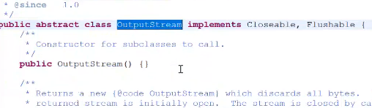

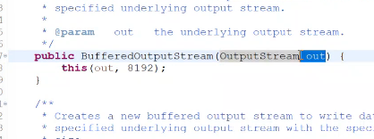

**Output stream class abstract class hain aur wo BufferedOutputStream ke method main pass hain to hum output stram ka object bana nahi sakate hain to jo output stram ko inherite kregi uska object banasakate hain aur inherite krne wali class FileOutput hain ..**

**Class DataInputStream**

* [java.lang.Object](https://docs.oracle.com/javase/8/docs/api/java/lang/Object.html)
  + [java.io.InputStream](https://docs.oracle.com/javase/8/docs/api/java/io/InputStream.html)
    - [java.io.FilterInputStream](https://docs.oracle.com/javase/8/docs/api/java/io/FilterInputStream.html)
      * java.io.DataInputStream
* **All Implemented Interfaces:**

[Closeable](https://docs.oracle.com/javase/8/docs/api/java/io/Closeable.html), [DataInput](https://docs.oracle.com/javase/8/docs/api/java/io/DataInput.html), [AutoCloseable](https://docs.oracle.com/javase/8/docs/api/java/lang/AutoCloseable.html)

public class **DataInputStream**

extends [FilterInputStream](https://docs.oracle.com/javase/8/docs/api/java/io/FilterInputStream.html)

implements [DataInput](https://docs.oracle.com/javase/8/docs/api/java/io/DataInput.html)

A data input stream lets an application read primitive Java data types from an underlying input stream in a machine-independent way. An application uses a data output stream to write data that can later be read by a data input stream.

DataInputStream is not necessarily safe for multithreaded access. Thread safety is optional and is the responsibility of users of methods in this class.

**Since:**

JDK1.0

**See Also:**

[DataOutputStream](https://docs.oracle.com/javase/8/docs/api/java/io/DataOutputStream.html)

* + ***Field Summary***
    - **Fields inherited from class java.io.**[**FilterInputStream**](https://docs.oracle.com/javase/8/docs/api/java/io/FilterInputStream.html)

[in](https://docs.oracle.com/javase/8/docs/api/java/io/FilterInputStream.html#in)

* + ***Constructor Summary***

|  |
| --- |
| **Constructors** |
| **Constructor and Description** |
| [**DataInputStream**](https://docs.oracle.com/javase/8/docs/api/java/io/DataInputStream.html#DataInputStream-java.io.InputStream-)([**InputStream**](https://docs.oracle.com/javase/8/docs/api/java/io/InputStream.html) in)  Creates a DataInputStream that uses the specified underlying InputStream. |

* + ***Method Summary***

**Class DataOutputStream**

* [java.lang.Object](https://docs.oracle.com/javase/8/docs/api/java/lang/Object.html)
  + [java.io.OutputStream](https://docs.oracle.com/javase/8/docs/api/java/io/OutputStream.html)
    - [java.io.FilterOutputStream](https://docs.oracle.com/javase/8/docs/api/java/io/FilterOutputStream.html)
      * java.io.DataOutputStream
* **All Implemented Interfaces:**

[Closeable](https://docs.oracle.com/javase/8/docs/api/java/io/Closeable.html), [DataOutput](https://docs.oracle.com/javase/8/docs/api/java/io/DataOutput.html), [Flushable](https://docs.oracle.com/javase/8/docs/api/java/io/Flushable.html), [AutoCloseable](https://docs.oracle.com/javase/8/docs/api/java/lang/AutoCloseable.html)

public class **DataOutputStream**

extends [FilterOutputStream](https://docs.oracle.com/javase/8/docs/api/java/io/FilterOutputStream.html)

implements [DataOutput](https://docs.oracle.com/javase/8/docs/api/java/io/DataOutput.html)

A data output stream lets an application write primitive Java data types to an output stream in a portable way. An application can then use a data input stream to read the data back in.

**Since:**

JDK1.0

**See Also:**

[DataInputStream](https://docs.oracle.com/javase/8/docs/api/java/io/DataInputStream.html)

* + ***Field Summary***

|  |  |
| --- | --- |
| **Fields** | |
| **Modifier and Type** | **Field and Description** |
| protected int | [**written**](https://docs.oracle.com/javase/8/docs/api/java/io/DataOutputStream.html#written)  The number of bytes written to the data output stream so far. |

* + - **Fields inherited from class java.io.**[**FilterOutputStream**](https://docs.oracle.com/javase/8/docs/api/java/io/FilterOutputStream.html)

[out](https://docs.oracle.com/javase/8/docs/api/java/io/FilterOutputStream.html#out)

* + ***Constructor Summary***

|  |
| --- |
| **Constructors** |
| **Constructor and Description** |
| [**DataOutputStream**](https://docs.oracle.com/javase/8/docs/api/java/io/DataOutputStream.html#DataOutputStream-java.io.OutputStream-)([**OutputStream**](https://docs.oracle.com/javase/8/docs/api/java/io/OutputStream.html) out)  Creates a new data output stream to write data to the specified underlying output stream. |

***User se input lene ke kayi saare tarike hain jaise datainput,buffer,file etc.***

***\*\*\*\*\*Java main only System name ki class hain. jo kisi bhi input output se direct deal kr sakati hain jo java lang package main payi jaati hain.yahi wahi class hain jo humare opration system ko information rakati hain. System kewal ek class hain jo keyword aur console ki sari information ko sambhal ke rakati hain dusre word main kahe to ye humare oprating system ki information ko sambhal ke rakhati hain***

***Jaise ki apko pata hain agar apko keyword se kuch read krna hain aur console per output dekhan hain to console aur keyword ke kuch program hain jo humare opration system per chal rahe honge .System class wo class hoti hain jo keyword aur console ki saari information ko sambhal ke rakhati hain***

***Kyword se kuch read krana hain aur console per kuch output dekhan hain to iske liye program humare opration system ke pass honge***

***System class final hoti hain aur uska constructor private hota hain iska matlab usko koi call nahi kr Sakata hain ye direct computet se deal krati hain***

***Jaha kahi aap system laga doge to wo memory main laod hogi aur uska static block chalega aur us static block ke andar natives library hain to unhe call krega***

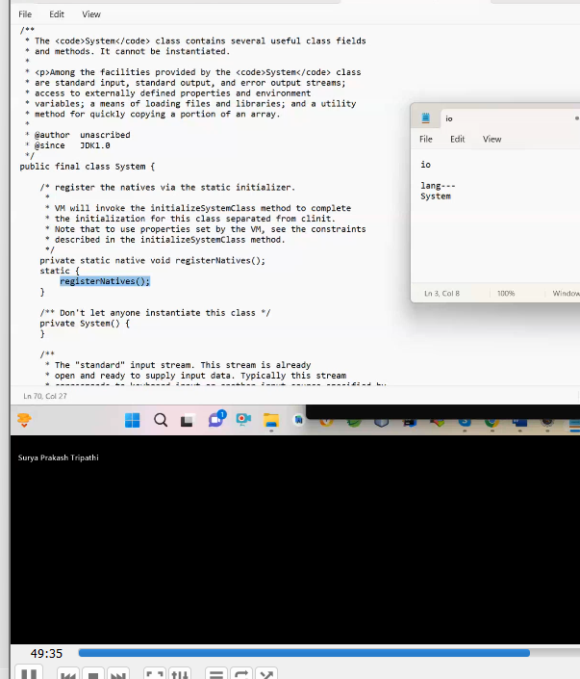

***Jaise aap ne System class likha waise uska static block chala aur static block ne oprating system ki native libaray ko call kiya aur uske baad keyword ka wo program jo input read kr Sakata hain wo apne pass sambhal ke rakh liya***

**For example main aap se kahu aapko ek software banana hain ye pata lagana hain ki mere system main kitane file kitane folder hain to aap file class use krenge to**

**\*\*\*\*Similarly main aap se kahu keyword ka program chaiye jo input se deal kran eke liye hain aur output ka program chiaye jo console per dekhata hain.to muje wo program keyword se deal krne wala and cosole per deal krne wala program muje lana padega but main la Sakata hu kyuki wo opration system ke andar hain aur muje pata hain oprating system se direct interact kewal system class krati hain wo muje pata hain wo program input output ka hoga to muje input output use kran padega**

**\*\*\*to isliye input output ko system class import karati hain khud use karati hain**

**Import java.io.*;**

**class System{**

**public static final InputStream(child class hide hain wo nahi pata hain) in=null;//ye do variable hain**

**\*\*\*jaise aap system likhoge waise system memory main load hoga aur uska register native chalega aur wo keyword ka wo program jo humare oprating system main pada wo leke ayega aur** in*** variable main dal dega aur uska type InputStram type ka but inputStram to abstract class hain to inputstram jo class inherit kregi uska object Banega but wo class java walo ne chipa kr rakhi hain aur wahi class reflaction ke throw( ***in =null but reflection se ho jata hain**)jo keyword ka program ka logic** in ***main pass kr deti hain.**

**public static final PrintStram(Parent class OutputStream) out=null;;**

CharacterStream:-

PrintWriter ka println()method Unicode ko support krta hain

PrintStram ka println()Assci ko support krta hain aur ye exception show krta hain

System class:-

**Socket Programming OrNetworking:-**

**System ka addres hota hain IP address for example humara address jaha hum rahate hain waise hi computer ka addres hota hain**

**Networking is the process of connecting more than one node eachother**

**Machine ko ek saath connect krna networking kahalata hain**

**Network:- net ka matlab jaal ek aisa jaal jo charo taraf fela hua ho network**

**Networking kyu krate hain ?**

**Ye isliye krate hain taaki information share kr sake apna dusre ko aur dusre ka apne ke saath.**

**Ek network ko stabilize krne ke liye _**

**H/w—Router -ye network ki capblitity ko badata hain**

**S/w—programing**

**Media-cable optical fiber -wire**

**S/w---java🡪program---ise network main jab use krate hain to ise socket program bolate hain**

**IpAddress-ye computer ka addrss hota for example apko network se computer main data ko bhejna to lekin aapko kis computer main bhejan to uske liye aapko us computer ka addres chaiye jis IP addres kahate hain**

**Har ek computer ka uniqe addres ko Ip addres bola jaata h ain**

**Mac-Ip addres se pahale ye manufacturing ke time per diya jaata hain ye bhi uniq hota hain**

**Ipconfig ye command hoti hain Ip address ko pata krne ka.**

**Port-aapne koi information Ipadress ke jariye se bheji but usko cleient kaise recive krega usi ko port number bola jaata h ain**

**Real word se joda jaaye to Ipaddres mere ghar ka number and port number main**

**Programming to IPaddres ka computer ka hota hain aur port number kisi bhi programa ka Unieq hota hain**

**Protocol:Rule Regulataion communication jaise main hello bheja ye hain rule regulation .**

**Socket-It is the combination of IP address ,port number and Protocol**

**ServerSocket ek class hoti hain jo java.net.package main payi jaati hain**

**Java main aisa bola gaya hain agar aapko server ka program bana hain to ServerSocket class use kre aur agar apko client ka program banana hain to Socket class ka user kre**

**Socket ek aisa buffer hota hain jo client side aur sever side dono side hota hain we can say that common buffer -read write krna ho agar apko network per data ko to socket use krna padega**

**Server:-**

**ServerSocket sk=new ServerSocket(10);**

**System.out.println(“sever has started wating for client request”);**

**Socket s=sk.accept();**

**System.out.println(s);**

**Jaise aap server program run krenge waise hi sop wala print hoga but abhi accept method nahi chalega aur uske baad jab aap client wale ko run krenge to uska jo object hain wo server ke accept method ko call krega aur accept method socket ka object return krke de dega**

**Matalb socket common buffer to jo dono ke liye hoti hain input aur output network per statblize krnke liye hoti hain**

**Aur uske baad jab socket ka object return ho jayega to hum server and client se input and output de denge aur jo bhi input and output de denge sever and client se dono ka input and output socket ke object main jayega .**

**Matlab ye hain agar do logo kisi common data ko share krna chahate hain to same copy chaiye .**

**Client:-**

**ServerSocket sk=new ServerSocket(10)**

**UDP bases classes : ye jo below hain .ye network package main payi jaati hain aur packet ke form main data ko bhejegi.**

**1.DatagramSocket classThe DatagramSocket class represents a connection-less socket for sending and receiving datagram packets. Datagram is basically an information but there is no gurantee of its content, arrival or arrival time. The DatagramSocket and DatagramPacket classes are used for connection-less socket programming. 1.DatagramPacket class:The DatagramPacket is message that can be sent or received. If you send multiple packet, it may arrive in any order. Moreover, packet delivery is not guaranteed.Commonly used methods of InetAddress class:• public static InetAddress getByName(String host) throws UnknownHostException: it returns the IP of the given host.• public static InetAddress getLocalHost() throws UnknownHostException: it returns the LocalHost IP and name.• public String getHostName(): it returns the host name of the IP address.• public String getHostAddress(): it returns the IP address in string format. public static InetAddress[] getAllByName(String name) throws UnknownHostException; Commonly used methods of InetAddress class:• public static InetAddress getByName(String host) throws UnknownHostException: it returns the IP of the given host.• public static InetAddress getLocalHost() throws UnknownHostException: it returns the LocalHost IP and name.• public String getHostName(): it returns the host name of the IP address.• public String getHostAddress(): it returns the IP address in string format. public static InetAddress[] getAllByName(String name) throws UnknownHostException;UDP Bases Classes:-1.Datagram SocketCons:-public DatagramSocket(int port)[server-side]public DatagramSocket()[client-side]method:-public void send(DatagramPacket dp)public void recive(DatagramPacket dp)2.Datagram Packetcons:-public DatagramPacket(byte data[],int length,InetAddress address,int hostport)[for sending]public DatagramPacket(byte data[],int length)[for reciving]method:-public byte[] getData()URL class:The URL class represents a URL. URL is an acronym for Uniform Resource Locator. It points to a resource on the World Wide Web. A URL contains many informations: • Protocol: In this case, http is the protocol.• Server name or IP Address: • Port Number: It is an optional attribute.**

**URL class:The URL class represents a URL. URL is an acronym for Uniform Resource Locator. It points to a resource on the World Wide Web. A URL contains many informations: • Protocol: In this case, http is the protocol.• Server name or IP Address: • Port Number: It is an optional attribute. Commonly used methods of URL class:• public String getProtocol(): it returns the protocol of the URL.• public String getHost(): it returns the host name of the URL.• public String getPort(): it returns the Port Number of the URL.• public String getFile(): it returns the file name of the**

**Commonly used methods of URL class:• public String getProtocol(): it returns the protocol of the URL.• public String getHost(): it returns the host name of the URL.• public String getPort(): it returns the Port Number of the URL.• public String getFile(): it returns the file name of the**

**Utility class validation ke liye banayi gayi hain validation kya kya ho skate hain**

**Name blank na ho**

**2 baar password dalane per account block ho jaye**

**Minimum and maximum**

**private** **static** **final** String ***EMAIL_PATTERN*** =

"^[_A-Za-z0-9-\\+]+(\\.[_A-Za-z0-9-]+)*@"

+ "[A-Za-z0-9-]+(\\.[A-Za-z0-9]+)*(\\.[A-Za-z]{2,})$";

**Aur sabake liye regular expression hota hain jaise email ke liye ke liye**

**Java .util main pattern name and matches name ki class hoti hain jo pattern class pattern check krtata hain aur matcher class match krta hain pattrenko**

**Hain.**

**public** **static** **boolean** validateEmail(String email) {

*pattern* = Pattern.*compile*(***EMAIL_PATTERN***);//compile method pattern class ka object return kr dega

*matcher* = *pattern*.matcher(email);//aur ab jis email ko match krna hain wo kaam matcher krta hain ab matcher return ho jayega

**return** *matcher*.matches();//matcher class ka method matches ye matches krta hain jo user se liya email aur jo string main wo match krega to true return krega nahi to false return kr dega .

}

**public** **static** **boolean** validateMaxMobile(String mobile) {

**if** (mobile != **null** && mobile.length() > 10) {//jo bhi string doge uski length greater than 0 hain to true nahi to false

**return** **true**;

}

**return** **false**;

}

**public** **static** **boolean** validateMinMobile(String mobile)//null nahi hona chiye

{

**if** (mobile != **null** && mobile.length() < 10) {

**return** **true**;

}

**return** **false**;

}

**MultiThreading :**-is process of executing multiple thread simultaneously at a time

Other word multiple task ko ek saath parrlele chalana multitask kahalata hain

Thread:-Thread is process inside process .It is light weight process.

Or smallest unit process.

SingleTask: only one task execute at a time example –cmd

Agar single task main input jada a gaye to time jada lagega isliye multitasking ayi

MultiTasking :-multiple task execute at a time ek concept ka name hain usko acive krnke ke do tarike hote hain -isme input task jada honge to kaam kam lagega

* Process
* Thread

1. MultiProcess :process based multitasking multiprocess kahalati hain
2. MultiThread:-thread based multitasking multithreading kahalti hain

Hum oprating system ke andar multitasking krate hain but uske andar schedule tachniq use krate hain first come first serve -iska matlab jo pahale aya wo pahale chalega .

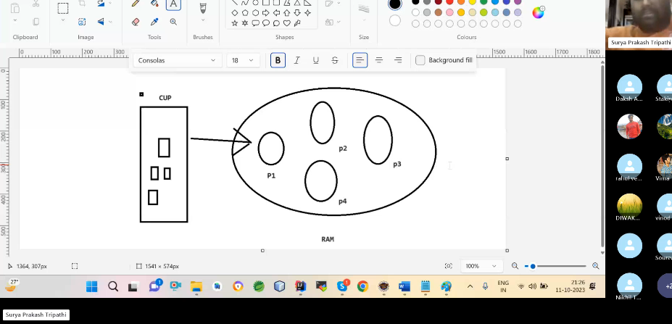

Cpu, oprating ko use krne ke liye aisa multitasking sabase pahale ki gayi kyuki ek samaye aisa hota hain apne kuchm kaam krwaya oprating system se tu kuch smaye aisa hoga jise aap use ke sake real world se app ek saath multiple task kr sakate ho

**\*\*\*\*\*\*\*Multiprocess ko only oprating system use krta hain bhi sahi nahi tha kyuki suppose kro aap ne ek saath 1thousands process chala diya to oprating system ko context switching krni padegi 1 thousands ke liye jis time jada laga jayega aur agar hum process ke andar process kr de to utna time nahi lagega**

**Multithread:-thread ka use applicationg software use krta h ain jais apne koi app banaya to uske andar process kai chal rahe honge unke andar to unko kaam jaldi kr sake**

**java Class(enter) JVM Start (Process)---PID|| ||main G.c(Thread) (Thread)||ClassLoading|Linking|SearchNote:- In Java All the Java program are by default running on a seperate thread that is called main thread.It means java by default using thread concept.If you want create your own thread then we have to use the Thread class. Thread class found in java.lang package.1.Inheritance. (by extends)2.Assocaication (by object create)---- (Runnable) How many Ways are used to creat MultiThreading Program:-1. By Inheeritance of Thread class.2. By Creating the Object of Thread class. (By Runnable)3. By Lamda Expression or Annonymous nested class .advantages:-**

**1**) You **can perform many operations together, so it saves time**.

2) Threads are **independent**, so it doesn't affect other thread

**You are correct: the main thread is essential for starting any other threads in a Java program. Without the main thread, there would be no entry point for the program to execute, which means no other threads can be created or started.**

### Key Points:

* **Main Thread as Entry Point**: The main thread is the starting point of any Java application. Without it, the JVM does not execute any code.
* **Other Threads Require Main Thread**: To create and start other threads, the main thread must first be running.

### Example:

Here’s a simple example to illustrate this point:

java

Copy code

class MyThread extends Thread {

MyThread(String name) {

super(name);

}

@Override

public void run() {

System.out.println(Thread.currentThread().getName() + " is running.");

}

}

public class MainThreadExample {

public static void main(String[] args) {

// Main thread starts here

MyThread t1 = new MyThread("Thread-1");

MyThread t2 = new MyThread("Thread-2");

// Start the other threads

t1.start();

t2.start();

// Main thread finishes

System.out.println("Main thread is finishing.");

}

}s

### Explanation:

* The main() method is where execution starts. It creates instances of MyThread and starts them.
* Without the main method and main thread, the JVM wouldn’t know what to execute.

### Conclusion:

* **You cannot run other threads without the main thread**. The main thread is required to initiate the program and manage other threads. Once started, other threads can run concurrently, but the initial execution must begin with the main thread.

## **Main Thread in Java**

Whenever we run a Java program, main thread is created automatically. This thread is responsible for execution of java program. Java runtime searches for main method to execute and create a main thread based on it. If we're creating multiple threads then all child threads will be spawned from main thread. This main thread is the first thread to be created and is generally the last thread and it is used to perform shut down tasks.

**Whenever we run java program,main thread is created automatically.which is responsible for execution of java program.**

**It is default periorty is 5.**

## **How to Control Main Thread?**

The main thread is created by the JVM automatically when a program starts. But you can control a Main thread by using different Thread methods and techniques.

The following are some of the methods for controlling the Main thread.

* [sleep() Method](https://www.tutorialspoint.com/java/lang/thread_sleep_millis.htm)
* [join() Method](https://www.tutorialspoint.com/java/lang/thread_join.htm)
* [interrupt() Method](https://www.tutorialspoint.com/java/lang/thread_interrupt.htm)

## **Example of Java Main Thread**

In this example, we're showing a simple one thread program where we're not declaring any thread and checking the thread name in the program execution.

package com.tutorialspoint;

public class TestThread {

public void printName() {

System.out.println("Thread Name: " + Thread.currentThread().getName());

System.out.println("Thread Priority: " +Thread.currentThread().getPriority());

}

public static void main(String args[]) {

TestThread thread = new TestThread();

thread.printName();

}

}

#### **Output**

Thread Name: main

Thread Priority: 5

**1. Inheritance:-step 1-: Create a clas that Inheritance the Thread class stpe 2:- then Override run method of Thread class(Runnable) Stpe 3:- Write the our task i run method.Stpe 4:- Create the Our Child class object .Stpe 5:- set the Name of Thread if requred (setName(), supser)Step 6:- Then Call start method of thread on child object .Stspe 7:- thred will created and excuted the run method ****Native method ki oprating system deta hain but declare java main hoti hain.**

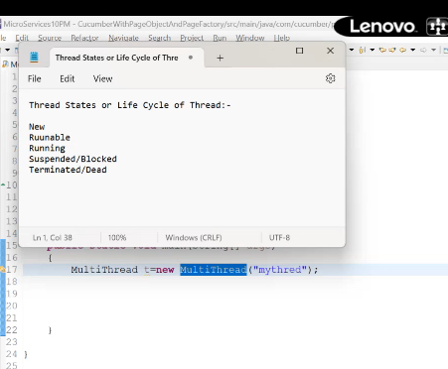**jab thread banata hain to kai states se hoke gujrata hain to unhe thread ki life cycle bolate hain ye sab states hain**

## **Sleep()**

The [Sleep () method](https://www.javatpoint.com/sleep()-method) is related to the Thread class that is used to stop the execution of the current Thread for few seconds. The Sleep () method takes the sleeping time in milliseconds. The monitor's ownership is not lost when we use the Sleep () method and start the execution again from where it stops. In simple words, the Sleep() method is responsible for sending the current Thread into the "Non Runnable" state.

**Cycle of thread :-**

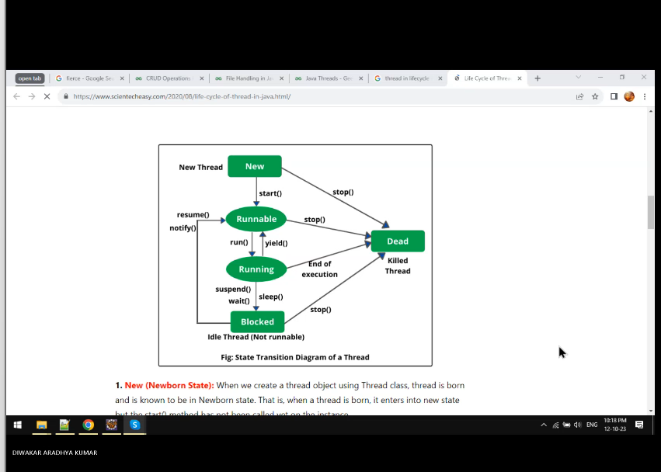

**When join method ,sleep method and wait method call then thread is blocked state and join method complete task which thread join and automatically move runnable state and scheduler decide then work is running state and inside the run work is complete then dead state or exit state and sleep method current ly running thread stop of excuttion for few seconds and after that few seconde complete automatically move in runnable state and scheduler schudel and thread is running state**

* Jab thread ko object banata hain to iska matlabe ye nahi ki thread chal gaya
* Let aapne 4 thread banadiye jaise aap 4 thread banake start kr doge to memory rakhane ke liye memory main ek pool maintain hota h ain jise runnable pool kahate hain
* Jaise aap thread ke upar start method chalato to thread runabale state main a jata hain aur koi thread runnable state main to iska matlabe ye nahi wo active state main hain
* Suppose aapne 4 thread chalaye to jab unpar start method chaloge to waha per pool maintain hoga wo runnable state main a jayega .runnable state main jvm ek pool maintain krta hain jise hum runnable pool kahate hain
* **********Jab thread ka object banata hain to thread new state main hota hain aur new state main ek hi baar aur jab us per start maithod chalate hain to runnable state main chla jata hain but ye bhi state passive state h ain
* Jab thread ko scheduler thread ko schedule krega to thread active state main a jati hain. Jise running state bolate hain
* Jab run method ke andar ka task excute ho jata h ain tothread dead ho or complete ho jati hain
* Runnable state main thread start method ke complete hone per ati hian iske alwa bhi thread runnable state main jab thread sleep ho gayi or suspende mode mai chli gayi ho
* By defulat thread asynchroniouse way main chlati hain kyuki jab aapp thread ko chlate ho to ye nahi pata hota konsa thread pahlae chlage agar aapko aisa krna hain to apko synchronous krna padega
* Run method ke chlagne per thread excute hogi aur uske baad complete hone per wo dead ho jayegi but thread run ho raha tha aap ne suspend or sleep chla diya to wo non runnable state main chla jayega .aur non runnable poole hota hain wa per ek se jada thread ho sakate hain.
* Aur non runnable se jab aap bulaoge to pahle wo runnable main jayegi aur uske baad scheduler decide krega isko chalana hain ki nahi.
* ****start method ke andar run method ko call kiya gaya hain isliye hum start method chalate hain to to run method chalta hain .

when we create an object of our thread class and call a start method on it.The thread goes to passive state or runnable state and at the same time create a runnable pool to maintain the memory for the thread.So how the thread goes to passive state to active state.The thread will go to active state when the thread schedular schedule the thread. And assign the cpucycle to the thread.**when does the thread goes to the dead state?**The thread goes to dead state only when the program or work is completed inside the run method.And once the thread is dead it cannot be called again.when we call the sleep or wait method in our thread the thread goes to non runnable state or blockedstage.After completing the time of sleep or waiting statge thread again goes to runnaable stage.There are two types of pool:-1)Runnable 2)Non-Runnable

\*\*\*\*\*\*\*\***kya run method ko hum khud call kr sakate hain ?**

but run method ko khud call kroge to waha normal method ki tarah behave kregea

**thread is a seprate path of execution -thread ka path stack memory area main se taiyar hota aur stack ko maintain krnke liye start method ka chalna must hain.**

jab hum thread ko name na dekhe call krega to thread khud name de dega .

**public** **class** Test3 **extends** Thread

{

**public** **void** run()

{

**for**(**int** i=1;i<=10;i++)

{

System.***out***.println(i);

**try** {

Thread.*sleep*(1000);

} **catch** (InterruptedException e) {

// **TODO** Auto-generated catch block

e.printStackTrace();

}

}

}

**public** **static** **void** main(String[] args)

{

Test3 t=**new** Test3();

t.setName("one");

t.start();

Test3 t1=**new** Test3();

t1.setName("two");

t1.start();

}

}

Output -1

1

2

2

… isme kya ho rahi 1 thread chala uske baad wo sleep hua uske baad two chla usne 1 kiya aise aage ka process hain.

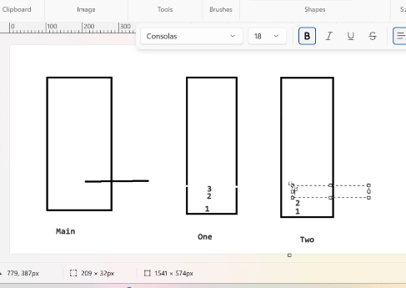

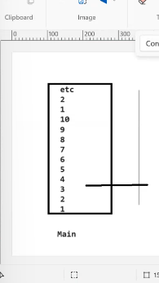

//only one thread

**package** com.multithreading;

**public** **class** Test4 **extends** Thread

{

**public** **void** run()

{

**for**(**int** i=1;i<=10;i++)

{

System.***out***.println(i);

**try** {

Thread.*sleep*(1000);

} **catch** (InterruptedException e) {

// **TODO** Auto-generated catch block

e.printStackTrace();

}

}

}

**public** **static** **void** main(String[] args)

{

Test3 t=**new** Test3();

t.setName("one");

t.run();

Test3 t1=**new** Test3();

t1.setName("two");

t1.run();

}

}

**Kya hum thread ko do baar start kr sakate hain ?**

**No,agar aisa kroge to illegeal state dekheyega aisa isliye dikhayega kyuki ye state ka part nahi hain.**

**#######Thread ko extend krke thrad ka program banana sahi nahi mana jata hain kyuki inherite krne se thread ke saare feature extend class ke pass hota hain but jo jaroot hain wo bhi aur jo nahi hain wo bhi .**

class Thread extends Object implements Runnable{Runnable r;Thread(){r=this;}Thread(Runnable r){this.r=r;}public void run(){}public void start(){r.run();}}

**\*\*\*\*hum agar kisi bhi thrad ko priority jada de denge to usko time jad legega**

**\*\*join method jab kis ko joint krega to for example usne thread banko join kiya hain thrad two main to thread two one ko chance dega uske complete hone ke baad wo chalega..**

**Join Method:-**Join method **currently** excuting thread ko suspend krke jo join hain usko maouka deta hain.aur jab tak ye join thread complete nahi ho jaate hain tab tak wo current thread kam nahi krta hain.

**Join method is used to suspend the executing currently thread and given the chance the join thread until or unless the join thread will not completely the task the currently executing thread.**

**Join is the overloaded method .**

**How many types of thread ?**

**There are a lot of thread in java ,deamon ,main,thread,**

**How to order of execution thread in java ?**

**Asynchroneous manner main hota hain**

**Who is responsible order of execution ?**

Scheduler which is aviable in jvm.and jvm scheduler is mapped os system scheduler because thread is decided excute in os shedluler

**Deamon Thread :-**

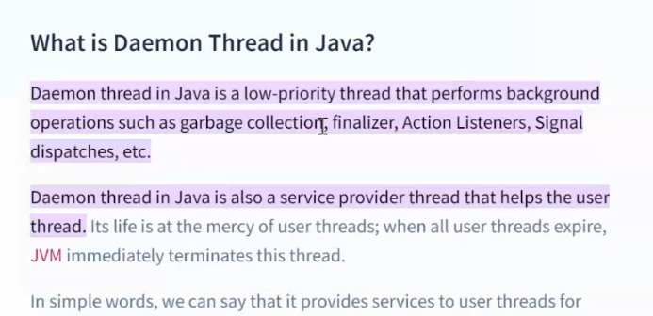

* deamon thread ko serveice provedier thread bolate hain kyuki ye background main service provide krta hain.It is lower periorty thread
* koi bhi child thread deamon thrad jab banati hain jab uske upar setDeamon method call krate hain.
* Isko aisa isliye banaya jata hain taki kisi ko beck ground main service provide krna chahate hain to isko use kr le jaise aap for example main chahate hu online shoppin main main apne item ko track krna chahate hu unko timeng ko
* Garbage collector thread bhi ek deamon thrad hota hain kyuki wo main ko service deta hain jo unused memory unko se free kra deta hain.
* Is deamon method Thread.currentThread().isDeamon()) chala de to pata la jayega ki thread deamon hain nahi
* Starte ke pahle thread deamon baneyenge baad main banayegne to illegal statement dikhayega.
* Deamon thread ki jo life wo jis thread main banoge to use per depend krene lagegi jaise aap jab thread banoge to child class ke upper set method channa hota hain aapne kya ki ek thread banayi main method se alage jisko aapne 10 baar chalaye aur aapn main ko 5 baar chalaya agar thread ke main ke andar setDemaon chaloge to aab demon bhi 5 baar chlegi
* <https://www.geeksforgeeks.org/daemon-thread-java/>

**Shutdown thread in java**:_

* koi bhi user defind thread shutdown thrad tab kahalati hain jab hum use jvm ke sath register kr dete hain bina start kiye
* hum jvm ke sath kaise register krenge to uske liye humare pass runtime class hoti hain
* Runtime class jvm ke instance ko represente krti hain agar is class ka hume object mil jaye to hum uski ek copy mil jayegi
* Jab hum runtime class ka getRuntime method ko call krte hain to wo hume us class ka object return krke deta hain
* Hum shut down thread kyu banate hain isliye banate hain jo user defined thrad banayi this uska jo method hain agar apne start nahi kiya aur shutdown ke andart pass kr diya to shutdown thread usko ek baar chala dega jvm ke shutdown hone se pahale .

**Task Scheduling :-**

* ye apne dekha hoga jaise apka recharge khatam hone ko hota hain to do ya teen din pahle message a jata hain aur apne kisi ko enroll kiya ho etc.waha per task scheduling use hoti hain
* **Task scheduling in Java** refers to the process of executing tasks at specific intervals or after a certain delay, usually using threads or timers. It is commonly used in scenarios where you want to run periodic or delayed tasks, such as in background services, scheduled maintenance, or time-based triggers.
* 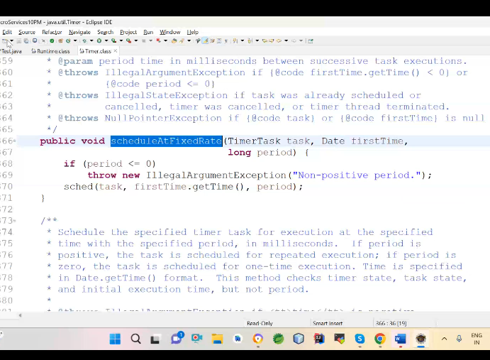

**Synchronization :-**

* In java by default all the thread executing in asynchronization manner any thread can be execute any moment of time but
* some times you wants execute thread in sequetinal manner so process of executing in thread sequenceintil manner is nothing but synchronization
* Synchronization is a process of multiple thread executing in the sequencetial manner
* Synchronization do tarike se ho sakta hain thread se and process but hum thread base pad rahe hain

**Why use Synchronization**?

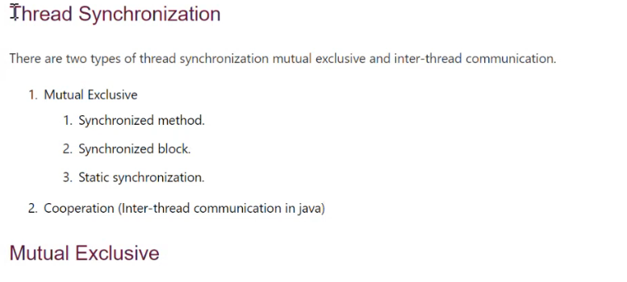

* Real world ke example se mana main tiket kr raha tha aur main jab ticket book kr raha tha bahut se log aur bhi kr rahe honge but main process start kiya jaise hi to dusre ne bhi start kr diya ,ho but main details bagera dal diya aur account se paise cut na tha but main network problem thi aur dusre ne mere se do second pahale start kiya tha aur usne ticket book aur payment kr diya to aur ticket mara ho gaya jab **hum Asynchronizetion banayenge kyuki** thread poora to complete hogan ahi dusra bhi ho jayega but agar hum synchronize kr denge to ek pura process hone ke baad hi dusra start hoga is ko interference bolate hain . ye write per hoti hain ye read per nahi hoti hain
* **Synchronization concept locking se banaya gaya hain ye isi per base hota hain**
* 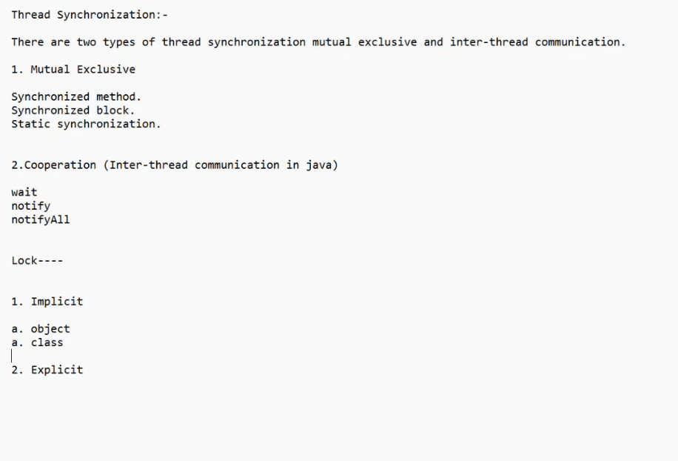

**The synchronization is mainly used to**To prevent thread interference.To prevent consistency problem.

**Shared problem, railway reservation, procudere consumer problem**

**There are two types of thread synchronization mutual exclusive and inter-thread communication.**

**Mutual Exclusive:**

* **ye tab hota hain more than thread sequential manner main chlana chahate hain but kon pahle chalega no guranti but jo bhi chalega poora chalga**
* Mutual Exclusive helps keep threads from interfering with one another while sharing data. It can be achieved by using the following three ways:
* In this more than one thread create in java program but in this threads excuted sequential manner but one threads interfare another thread
* Synchronized method-in this method put synchronized keyword non static method in this more than thread excute sequential manner but one theread interfare another thread
* Static synchronization-if we want to interfare then use static keyword but in this thread excute sequential manner but it is not decided which thread excute first but whatevevr thread excute first then complete excute second

-synchronization block- **you wants to create a portion of method as synchronized in this secnerio we go for synchronized block**

**Locking :-**

* synchronization lock per based hota hain aur lock ek monitor variable hota hain jise oprating system main mutex bolate hain iske do tarike hote hain
* implicit and explicit
* java main jitane bhi object banate hain unke saathe ek lock taiyar hota hain aur class ke sath bhi taiyar hota hain
* **synchronization ka lock do tarike se milta hain**

1. **Object per :-** Synchronized method.

* lock resources per depend krta hain resurces agar synchronized non static hota hain to lock ki checking current object per hoti hain
* for example apne 3 thread banaye aur ek method ek table name ki class banayi aur uska method synchronized kr diya to jo thread table method ko call krege to wo method synchronize hoga to wo method puchega ki tumare pass lock hain wo kahega hain to wo usko pura chala degi but ye nahi clear hain ki hain kon threaed chalega kyuki thread chalna schedular decide krta hain.
* Jab do object banoage to wah per drawback hain suppose apne 4 thread banaye aur usme do do ko same object de diya hain to waha per interferenc ki problem a jayegi

1. **Class per:-** Static synchronization lock checking current object

* Jab humne 4 thread banaye aur usme do object same de diya aur do ko same to waha per interference ki problem a jaati hain jaise first third aur four ko interfere kr Sakata hain aur second bhi isliye hum waha per check ing object wajah class krte hain but uske liye hume method synchronized static banana padata hain

**Synchronization Bloc**k :-synchronization block is used protion of method

**What is difference between Synchronization Block and Method?**

**When we are creating synchronized method the hole method is synchronized but sometimes if you wants to create a portion of method as synchronized in this secnerio we go for synchronized block**

[**https://www.geeksforgeeks.org/method-block-synchronization-java/**](https://www.geeksforgeeks.org/method-block-synchronization-java/)

2.**Cooperation (Inter-thread communication in java**):isme 100% guranite hot kisko pahle chalane hain pura chalana hain .Thread priority in Java allows higher-priority threads to be favored for execution, potentially improving the responsiveness of critical tasks by giving them more frequent access to CPU resources. However, it does not guarantee execution order, as actual behavior depends on the thread scheduler's implementation.

When we say that higher-priority threads have a "better chance of execution," it means that the thread scheduler is more likely to select those threads to run before lower-priority threads. However, this does not guarantee that they will always run first.

* **Wait:** wait method currently executing thread ko suspend kr deta hain aur chance deta hain another thread ko aur lock,cpu ko bhi release kr ke jaata hain isliye jata hain taki koi dusra uska use kr sake . aur tab tak use main nahi ayega jab tak usko dusra thread notify na kre. Aur jo lock hota hain wo Boolean flag value hoti hain wo true or flase ka kaam krtaa hain.
* Aur jo kaam is samay wait aur notify krta hian wo phale suspend aur resume method krta tha
* Susped aur resume main dead lock problem a skati thi isliye wo deprecated ho gaya.jab aap kisi thread ke upper apne suspend method chalaya wo lock ko bhi le jata tha suspend poole main leke baith jata tha aur cpu ko release kr deta tha but wo jab tak louck nahi deta tha jab tak usi lock ko koi dusri thread usi object per resume method ko na chalati thi
* Aur main deiffrenece ki baat kre to wait ko kisi bhi object ki zaroort hi nahi hain kyuki use object ke andar hi rakh diya gaya hain
* Wait method object class main isliye rekhe gaye kyuki jab aap wait method ko chalate ho to wo lock ,cpu ko realse kr deta hain aur jis thread per chalega usko suspend kr dega but supend method only cpu release krega lock ko pool main leke bithega aur jab tak usi object per koi thread na a jaye
* For example 4,5 thread banaye ho aapne suspend laga diya to waha per dead lock ki problem a sakate hain
* **Difference between Sleep and Wait method in Java1. Class belongs : The wait() method belongs to java.lang.Object class, thus can be called on any Object. The sleep() method belongs to java.lang.Thread class, thus can be called on Threads.2. Context : The wait() method can only be called from Synchronized context i.e. using synchronized block or synchronized method. The sleep() method can be called from any context.3. Locking : The wait() method releases the lock on an object and gives others chance to execute. The sleep() method does not releases the lock of an object for specified time or until interrupt.4. Wake up condition : A waiting thread can be awake by notify() or notifyAll() method. A sleeping can be awaked by interrupt or time expires.5. Execution : Each object has each wait() method for inter-communication between threads. The sleep() method is static method belonging to Thread class. There is a common mistake to write t.sleep(1000) because sleep() is a class method and will pause the current running thread not t.**
* [**https://javahungry.blogspot.com/2015/11/5-difference-between-sleep-and-wait-with-example.html**](https://javahungry.blogspot.com/2015/11/5-difference-between-sleep-and-wait-with-example.html)
* **notify:** In the case of the [multiThreading](https://www.geeksforgeeks.org/multithreading-in-java/), notify() method sends the notification to only one thread among the multiple waiting threads which are waiting for the send lock
* **notifyAll :-** While notifyAll() methods in the same context send notifications to all waiting threads instead of a single thread.

Lock----1. Implicit

* a. class
* b.object2. Explicit
* DeadLock:-

class DeadLock { String s=new String(); void show() { synchronized(this) { for(int i=1;i<=5;i++) System.out.println(i+": statemet of SHOW method........"+" "+Thread.currentThread().getName()); synchronized(s) { for(int i=5;i<=10;i++) System.out.println(i+": statemet of SHOW method........"+" "+Thread.currentThread().getName()); } } }void disp() { synchronized(s) { for(int i=1;i<=5;i++) System.out.println(i+": statemet of DISP method........"+" "+Thread.currentThread().getName()); synchronized(this) { for(int i=5;i<=10;i++) System.out.println(i+": statemet of DISP method........"+" "+Thread.currentThread().getName()); } //catch(Exception e){} } }}class LockThread1 extends Thread{DeadLock dl;LockThread1(DeadLock dl1){ dl=dl1;} public void run() { dl.show(); }}class LockThread2 extends Thread{DeadLock dl;public LockThread2(DeadLock dl2){ dl=dl2;} public void run() { dl.disp(); }}class DeadLockTest{public static void main(String args[]){System.out.println("main is started....");DeadLock dl=new DeadLock();LockThread1 dt1=new LockThread1(dl);LockThread2 dt2=new LockThread2(dl);dt1.start();dt2.start();System.out.println("End of the main Thread");}}

**Interrupt :-**ye method sleep condition main thread ko running condition main lata hain.aur us thread per interrupted method chalata hain agar intruppted hua hoga to true print krega warna false print krega.

If any thread is in sleeping or waiting state (i.e. sleep() or wait() is invoked), calling the interrupt() method on the thread, breaks out the sleeping or waiting state throwing InterruptedException. If the thread is not in the sleeping or waiting state, calling the interrupt() method performs normal behaviour and doesn't interrupt the thread but sets the interrupt flag to true. Let's first see the methods provided by the Thread class for thread interruption.

**The 3 methods provided by the Thread class for interrupting a thread**

* **public void interrupt()**
* **public static boolean interrupted()**
* **public boolean isInterrupted()**

**Thread Local:**- Thrad Local is thread specific class it is genral parpose class jis class ka ek object memory main buffer banata hain jaha per data ko set get and remove krna hain thread ke data ko to use kr le.

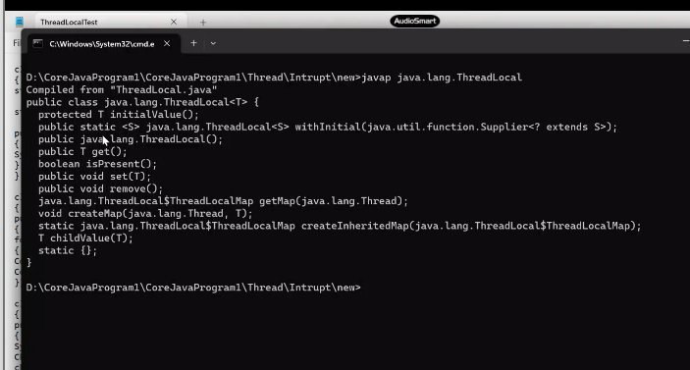

<https://www.geeksforgeeks.org/java-util-concurrent-package/>

jab hum explicit lock lete hain to ye concurrency se ho pata hain ye class hain .agar apko kahi bhi explicit lock lena chahate hain to ise se le skate hain.

**Thread group class** :-a thread group represents set of threads. Har thread ka ek group hota hain

Let's see a code to group multiple threads.

1. ThreadGroup tg1 = **new** ThreadGroup("Group A");
2. Thread t1 = **new** Thread(tg1,**new** MyRunnable(),"one");
3. Thread t2 = **new** Thread(tg1,**new** MyRunnable(),"two");
4. Thread t3 = **new** Thread(tg1,**new** MyRunnable(),"three");

**Why thread group make ?**

Thread ko common work krna ho to thread group banate hain.

**System--- ThreadGroup||main---ThreadGroup||main---Thread**

**Concurrency :-**

* synchronization main kuch problem thi usi problem ko solve krne ke liye ke concurrency ko use kiya gay hain
* jab hum kisi bhi resource ko sysnchronization kr dete hain wo resource lock ho jata hain wo resource tab tak luck rahata hain jab tak koi bhi thread jo usko use kr rahi hain jis se uska proformance grade hota hain uski efficiency acchi nahi hoti hain
* jab humne kisi bhi resource ko synchronize bana diya hain to wo sequentialy access hogi
* aur isme hum particular lock ke liye try nahi kr sakate the
* aur normal hum lock ke liye time nahi de sakate the

<https://www.javatpoint.com/executor-framework-java>

**Excutor framework** :-alag task-2 performe krne ke liye alag thread banana hota hain jo java main recomanded nahi hota hain kyuki is se perfomarance issu a jata hain

To alag -2 task ko perform krna ke liye hum pool bana lenge sab thread ke liye

**Thread pool** – ek pool hota hain jo bahut saare create thread ke dwara kiya jata hain different -2 task ko perform krne ke liye usme apko alag -2 thread ko start nahi krna hota isi concept ko excutor frame work kahate hain

<https://medium.com/javarevisited/a-complete-guide-on-executorservice-in-java-67528f1a535b>

<https://jenkov.com/tutorials/java-concurrency/volatile.html>

**Volatile keyword in java:-** inconsistency problem ko resolve krne ke liye use k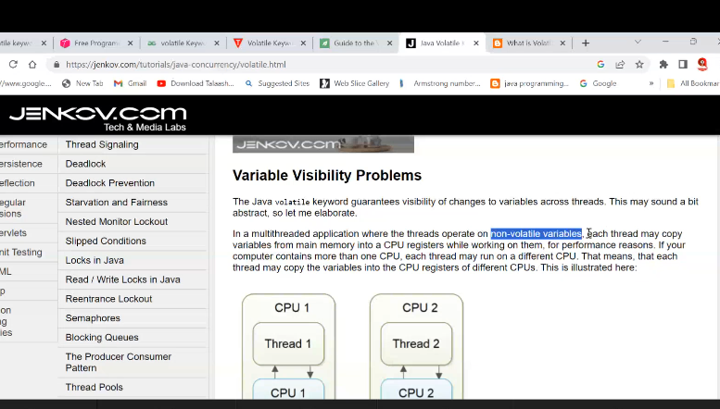iya jata hain

**Presentation Logic PL / ui: cui,graphical user interface guiBusiness Logic BLDatabase Logic DLGUI:AWT,SWINGSTEPS TO CREATE GUI APPLICATION:1.IMPORT java.awt package2. create a container (frame)3. identify the coponents that you want to add on frame4. create object of identified components5. set the size of frame6. set the layout for frame7. add the component created in step 48. make the frame visiblebusiness logic nhi hoga abhi**

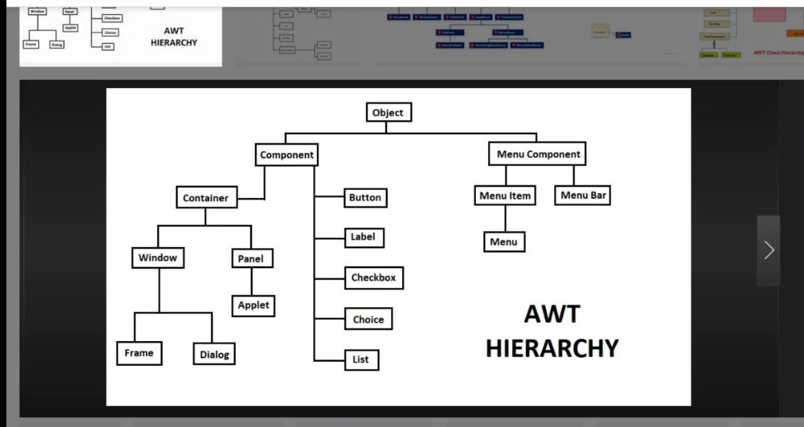

**Layout :It is a interface .it is used replace setbounds because set bounds is length method then used interface layout.**

**Constructor of FlowLayout:-1. public FlowLayout() Constructs a new FlowLayout with a centered alignment and a default 5-unit horizontal and vertical gap.2. public FlowLayout(int align) FlowLayout.LEFT, FlowLayout.RIGHT, FlowLayout.CENTER,3. public FlowLayout(int align,int hgap,int vgap)Implementing class of LayoutMager is:-1.java.awt.FlowLayout2.java.awt.BorderLayout3.java.awt.GridLayout4.java.awt.CardLayout5.java.awt.GridBagLayout6.javax.swing.BoxLayout7.javax.swing.GroupLayout8.javax.swing.ScrollPaneLayout9.javax.swing.SpringLayoutjava.awt.event :- ghatana ghatit ho**

**jdk1.2--->Evenet-Handling---> ModelEvent-Daligate :-jdk 1.2 teen ka hona jaroori hain koi bhi event hone ke liye (500)CRRegister--1. Source---- Componenet2. Listener ----Interface (call-backmethod)2. Register Between Source and Listsner (method)Event-Class Listner-Interface callbackmethod1.ActionEvent-----ActionListener. actionPerformed(ActionEvent e)2.MouseEvent------MouseListener.3.MouseWheelEnent-MouseWheelListener.4.KeyEvent--------KeyListener.5.ItemEvent-------ItemListener.6.TextEvent-------TextListsrer.7.AdjustmentEvent-AdjustmentListsrer.8.WindowEvent-----WindowListener.9.ComponentEvent--ComponentListener.10.ContainerEvent-ContainerListener.11.FocusEvent-----FocusListener.addActionListener();addMouseListener();addActionListener();SourceListenerRegister between source and listenerEvent based Gui application banana ke step :**

1. create gui application
2. create listener class :-button per click action event ho to uske liye action event ek class hoti hain aur action listener name se interface hota hain usi ko implements krke hum banayenge class listener interaface ko implement krne wali class listner class kahaliti hain and har listener ke pass call back method hota hain .wo action ko perform krne ke liye hota hain

**istener class 4tarike se bana sakate hain**

* **same class listener**
* **other class listener**
* **anonymous listener**
* **adapter listener**

1. listener class override kregi call back method aur business logic likho
2. Registertion krna hain hota hain class Button{ActionListener al;public void addActionListener(ActionLsitener al){this.al=al;click();}public void click(){ActionEvent e=new ActionEvent(this);al.actionPerformed(e);}}class ActionEvent{Button b;ActionEvent(Button b){this.b=b;}public Object getSource(){return b;}}interface ActionLisnener{public void actionPerformed(ActionEvent e);}

**AWT platform dependent hota hain kuch kamiya thi jiske baad swing aya hain aur heavy weighted bhi hote hain aur pair to pair link hota hain awt ka ek button underlaying oprating system se link hain aur app jis oprating system pe hoge to wo uska look change ho jata hain kyuki oprating system per dependent rahata hain**

**Swing dependent hota hain aur close ka option diya hain aur nahi doge to wo close kroge to dekhega but awt main nahi hota hain swing concept 1.2 main aya hain**

**\*\*\*\*\*\*Graphics main designing hoti hain aap circle ,line draw kr sakate hain**

**Do tarike hote hain inherite kr ke and association krke**

JMenu,JmenuBar,JMenuIteam

JTable

ListSelectionListner

ListList

JScrollPane

DefaultMutableTreeNode

JSlider

JColorChooser

JFileChooser

JCombobox

JOtionPane

JTabbedPane

JFrame

JButton

JChecobox

JDatabase is a software program where we store the data in an organised form.we can store data in two form 1)primary storage.2)Secondary storage.primary storage like Object where we store our data but this data are store temporary and it is destroyed when the program is finished.Secondary storage like cloud,rdbms,dbms,odbms,what is sql?It is a structured query language which is use to write query for storing the data in RDBMS in the form of raw colums form.Radio

DBMS:-input output stream not touple

RDBMS:-structered form data orginzed

**NoSql:-**unstructered data ke liye use krate for example -live chat krna ,twitter twite krna hi

**MySql:**-structred form data rakhan ho

DDL-create,alter,drop,rename,truncate;//auto commitDML-insert,update,delete,modifiy;DCL-grant,revoke;TCL-commit,rollback,savepoint;DQL-selectQus-How can create a table from an other tableans-create table emp2 select * from epm2;Qus1-How to create a table-ans-create table emp56(name varchar2(20),id number(10));/Qus2-How to add a value in table-ans-insert into emp56 values('ram','45');/Qus3-add values multiple-ans-insert into emp56 values('&name',&age);the we to provide //Qus4-how to fetch the data from databaseans-select * from emp23;/Qus5-how to get description of databaseans-desc emp23;/Qus6-for delete a table-ans-drop table emp12;/Qus-delete from emp12 where id=222;/Qus7-for update table-ans-update emp12 set id='111' where name='aaa';/Qus-0-How to create userans-create user surya1 identified by surya1;/Qus-01-How to create grantprivalage-ans-grant create session,create table to surya;/Qus-02-How to create grantprivalage as admin-ans-grant dba to surya;/Qus-03-How to revoke the privalage from user as dba;ans-revoke dba from surya;/Qus-03-How to revoke the privalage from user as cretesession;ans-revoke create session,create table from pp;/Qus-How to provide the quota to usersans-alter user ram default tablespace users quota 10m on users;/qus-connect to sys dbaans-coon / as sysdba;qus-how to lock the uses;ans-alter user hr identified by hr account lock; qus-how to unlock the uses;ans-alter user hr identified by hr account unlock;/qus-how to connect;ans-conn hr/hr;qus-to show all the object of hr;ans-select * from tab;ans-How to count the number of rows int the table;ans-select count(*) from employees;qus-if we want that all the data is then what we have to do;ans-set autocommit on then write the quary;qus-if data is insert and it is not save then we what we have t do;ans-commit;qus-if we want to loss the data;ans-rollback;Qus-How to login in sqlpluse from run...ans-sqlplusw / as sysdbatruncate table emp21;/drop table student;create table student(id int primary key auto_increment, name varchar(30) not null, address varchar(50));alter table student add column (mobile varchar(15) unique);select * from subject;update student set mobile = '32444' where id= 4;insert into student (name,address,mobile) values('ravi','Bhiar','124423'),('ravi','Bhiar','124423');create table subject (sub_id int(10),subject_name varchar(30), foreign key (sub_id) references student(id));insert into subject values(sub_id,subject_name),(1,'Science'),(1,'English'),(2,'Math'),(3,'Hindi');select s.name,s.id,sb.subject_name from student s,subject sbwhere s.id= sb.sub_id ;select s.name,s.id,sb.subject_name from student s join subject sbwhere s.id= sb.sub_id ;SELECT COUNT(DISTINCT Country) FROM details;SELECT DISTINCT Country FROM details;SELECT Count * AS DistinctCountries FROM (SELECT DISTINCT Country FROM details);SELECT CustomerName, id, SALARY FROM details GROUP BY CustomerName;SELECT * FROM details WHERE NOT Country='Germany';SELECT id, CustomerName, ContactName, Address FROM Details WHERE Address IS NOT NULL;SELECT CustomerName, ContactName, Address FROM details WHERE Address IS NULL;UPDATE Details SET CustomerName = 'Alfred Schmidt', City= 'Frankfurt' WHERE ID = 11;SELECT MIN(Salary) AS LowestSalary FROM Details;SELECT MAX(Salary) AS LowestSalary FROM Details;SELECT COUNT(Salary) FROM Details;SELECT AVG(Salary) FROM Details;SELECT * FROM Details WHERE CustomerName LIKE 'a%';SELECT * FROM Details WHERE Country IN ('India', 'Germany', 'UK');SELECT * FROM Details WHERE Salary NOT BETWEEN 1000 AND 5000;SELECT ID AS CustomerID, CustomerName AS Name FROM Details;Create table Orders(OrderId int(10), ID varchar(40), OrderDate DATE NOT NULL);insert into Orders value(10308, 2 ,'2006-09-18');insert into Orders value(10309, 5 ,'1996-09-19');insert into Orders value(10310, 8 ,'1998-09-20');insert into Orders value(10311, 11 ,'2003-09-21');select * from orders;SELECT details.id, Orders.OrderID, Details.CustomerName, Orders.OrderDate FROM OrdersINNER JOIN Details ON Orders.ID=Details.ID;SELECT Details.ID, Details.CustomerName, Orders.IDFROM Details LEFT JOIN Orders ON Details.ID = Orders.ID ORDER BY Details.id;SELECT Details.ID, Details.CustomerName, Orders.IDFROM Details LEFT JOIN Orders ON Details.ID = Orders.ID ORDER BY Details.CustomerName;SELECT Orders.ID, orders.orderdate FROM Orders RIGHT JOIN Details ON Orders.ID = Details.IDORDER BY Orders.OrderID;/*SELECT * FROM Details FULL JOIN Orders ON details.id=orders.id; non supported*/select * from details;select * from orders;SELECT * FROM DetailsLEFT JOIN orders ON details.id = orders.idUNION ALLSELECT * FROM DetailsRIGHT JOIN orders ON details.id = orders.id;SELECT COUNT(ID), City FROM DetailsGROUP BY CityHAVING COUNT(ID) <= 2;create table department (id int primary key auto_increment,name varchar (50),marks int (10),department_id int(10));insert into department (name,marks,department_id) values('Ali',78,100),('Zain',70,101),('Nasir',56,100),('Yasir',80,101),('Bilal',60,100),('Altamsh',80,100),('Danish',90,101),('Fahad',55,102),('Aliya',88,102),('Tahira',68,104),('Usama',55,104),('Wajiha',88,102);select * from department;select name,id,marks,department_id from departmentgroup by(department_id)having min(marks);select name,id,marks,department_id from departmentgroup by(department_id)having marks > 60 ;select * from department;alter table department add column (batch_id varchar(10)); /* for adding command /alter table department drop batch_id; /* for droping any coulmn /alter table department rename as department; /* for changing table name /update department set batch_id = 'TEL' where id=12; /* for updating /create table Example (id int (10),name varchar (50));drop table Example ;insert into Example(id,name) values(1,'A'),(2,'B'),(2,'C');select * from example;create table Account_info (account_no int (50) , name varchar(50), amount int(50) );insert into Account_info values(8,'pooja',2400);select * from Account_info;delete from Account_info where aacount_no = 6;commit;rollback to poojaMyprocedureMyprocedure;insert into Account_info values(4,'Arif',5000);savepoint preetam;insert into Account_info values(5,'pooja',50000);savepoint pooja;insert into Account_info values(6,'Danish',3000);savepoint Dansish;drop table Account_info;rollback to Zia;

Data ka structured form main rakhane ke liye normalization concept aya tha.

hota hain to servlet ka object banata hain aur usi time servletconfig ka object banata hain

**Collection Framework:-**

1. It is used to achieve the Data Structure functionality in java.
2. Data Structure is the concept which facilities us to store the in organized manger.
3. It was introduced in JDK1.2.
4. **Before jdk1.2 we also achieve the data structure functionality, but they are not a framework now they are called legacy collection.like vector ,hashset**
5. Collection represent group of object known as element, the object could be homogenous or heterogeneous.
6. Why collection – so that we can further perform some operation on that – maximum, short , mail.
7. **Difference between collection(array list) and array – array is collection of homogenous type of data but collection have homogenous as well as heterogeneous. Once we are creating the array it’s size became fixed and we can not dynamically increase and decrease the size of array where as in collection framework it is possible. We can crate the array by both ways without new and with new but in case collection we are only using new keyword.**

**int []=new int[10];**

**Student []=new Student[10];**

**Object []=new Object[10000];**

**API**:- set of inbuilt libraries or predefined functionality in any language. Whose from is varies from language to language. In c and C++ it is in the form header file and in java it is in the form of classes interfaces and package.

**Framework** :- It is set of API which work on the predefined algorithm and targeted to specific domain. Framework made the task easy.

**Java walo ne ds achive krne ke bani banayi cheeze de hain use hi framework kahate hain**

**App object type ka array bana skate ho lekin us me dal sakate ho sabkuch but nikale ne main dikkat hogi pata hi nahi hoga konsa data nikalana hain**

**Framework Specific domains.**

Collection---------------------------------------------------D.S

JDBC----------------------------------------------------------Database connectivity

JEE------------------------------------------------------------WebApp & Enterprise App

Struts----------------------------------------------------------MVC

Hibernate……………………………………………………………..ORM

Spring……………………………………………………………………AOP & IOC etc.

**Advantage**:- It is use the simplify the development and maintenance of application software. Framework never wrong output because it is already tested.

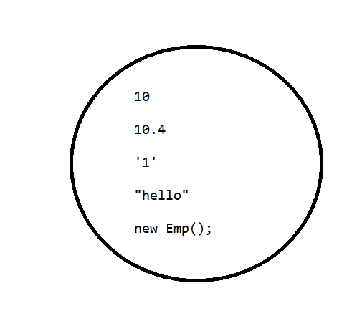

All the collection framework API are found in **java. util.** package.

Depending on behaviour collection API’s are categorised in so may parts.

1. **List**
2. **Set**
3. **Queue**
4. **Map**

**From coding point of view collection is the interface and collections is the class.**

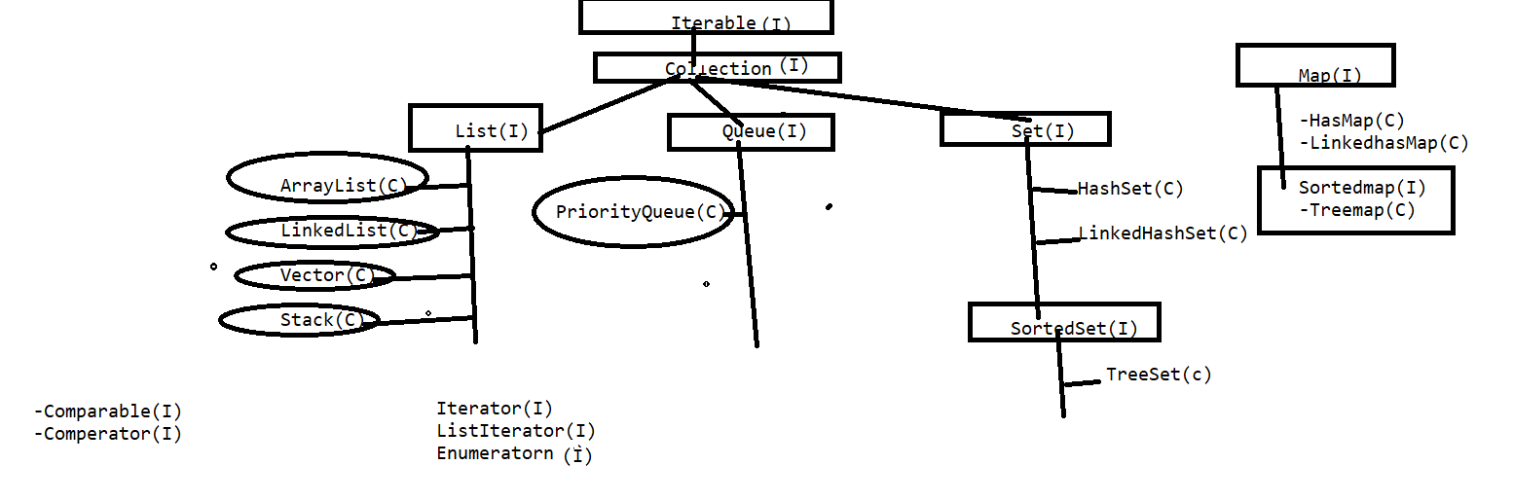

* **Map is the part of collection framework not is the part of collection because it is not inherit collection .It is the nonlinear ds it has another behaviour which keep data key value pair**
* **List main indexing maintain hoti hain aur yaha per duplicate elements rakh sakate ho**
* **Set main duplicate elements allow nahi hote hain aur koi order nahi hota hain**
* **Queue fifo mainer main elements sambhal ke rakhata hain**
* **Map data ko key value pair main rakhata hain**
* **Agar kisi collection se data nikalana hain to waha iterator ,listiterator,enumeration kaam ata hain**
* **Comparable and comperator data ko sort krne ke liye use kiya jata hain**
* **Heirerchy banana ka fayada ye hota hain jis reusbillity and runtime polymorphisam achieve hota hain**
* **Collections ek class hoti hain aur collection ek interface hota hain**

Methods of Collection Interface :-

public abstract int size();

public abstract boolean isEmpty();

public abstract boolean contains(java.lang.Object);

public abstract java.util.Iterator<E> iterator();

public abstract java.lang.Object[] toArray();

public abstract <T> T[] toArray(T[]);

public abstract boolean add(E);

public abstract boolean remove(java.lang.Object);

public abstract boolean containsAll(java.util.Collection<?>);

public abstract boolean addAll(java.util.Collection<? extends E>);

public abstract boolean removeAll(java.util.Collection<?>);

public boolean removeIf(java.util.function.Predicate<? super E>);

public abstract boolean retainAll(java.util.Collection<?>);

public abstract void clear();

public abstract boolean equals(java.lang.Object);

public abstract int hashCode();

public java.util.Spliterator<E> spliterator();

public java.util.stream.Stream<E> stream();

public java.util.stream.Stream<E> parallelStream();

**Note: collection ke andar aane wale method ko banaya to collection walo ne but iski implemention wo different -2 collection apne hisab se krte hain jaise set alag tarike se and list alag tarike se etc**

**Collection Interface:-**

The root interface in the *collection hierarchy*. A collection represents a group of objects, known as its *elements*. Some collections allow duplicate elements and others do not.

**List interface**:-

It is the child interface of collection which does allowed the duplicate elements and have also features of index.

And also maintain the insertion order of elements.

**Implementation(concrete classes ) of List interface:-**

1. Array List
2. LinkedList
3. Vector

**Array List:-** It is the concreate class of List interface , an object of this class is responsible to create a dynamic resizable array in **memory with initial capacity is 10.**

**Koi class kisi class ko inherite kre ya kisi interface ko implement kre usi ko concreate class bolate hain**

**Arraylist ko print krne per id ana chiye tha but data a jata hain kyuki isne to string ko override krke Rakha hota hain**

**Generic ka matlab hota hain angular bracket ke andar hota hain type safety ke liye use kiya jata hain**

**Iski intial capacity 10 hoti hain chahe aap ek element hi dala apne aap 1o capacity ho jayegi but agar aap cahate ho jitane elements hain utani hi size rahe to aap uske upper method trimToSize chala do**

**Child class object class ko inherite krke banayigi hai hum jab add krte hain arraylist main to wo object type ka parameter leta hain chahe int,float le ye sab aur child ka object parent ke refrence main ja Sakata hain yahi reason hain in sab ka type casting ho jati hain**

**Arraylist ka default size 10 hota hain aur 1o se jada element add krte ho to wo to actual value ka 50 %increase ho jata hain aise hota jab yaha 50 % increase hota hain to garbage collection old array ke valu ko copy krke ek naya array create kr deta hain**

Constructor of array list:-

|  |
| --- |
| **ArrayList**()  Constructs an empty list with an initial capacity of ten. |
| **ArrayList**(**Collection**<? extends **E**> c)  Constructs a list containing the elements of the specified collection, in the order they are returned by the collection's iterator. |
| **ArrayList**(int initialCapacity)  Constructs an empty list with the specified initial capacity. |

As we know that the initial capacity of arraylist is 10 when we added some more values beyond the size of array so default it increase the 50 % of actual size.

**How to Traverse the Element of Collection:-**

1. For loop
2. For Each
3. Iterator
4. List Iterator

**Iterator**:- It is an interface whose implementation are provided by different-2 collection as per requirement. An implementing class object of this interface is responsible to traverse the element in forward direction only.

Koi bhi collection ho use forward dirction main le jane ka kaam krta hain iske pass by default iterator pointer ko concept ho ta hain jiski value by default -1 hoti hain

**Itrrator ka method next do kaam krta hain :-**

**1.intrator pointer ko aage le jana**

**2.jaha itrator pointer hai us position ki value ko get krna**

**How to get the object of Iterator:-**

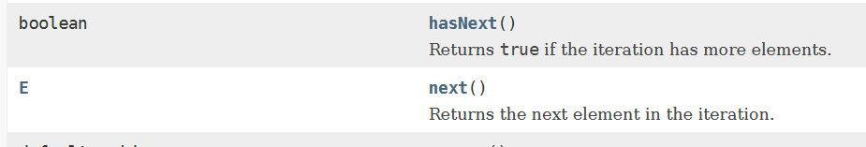

Iterator i=arraylist.iterator();

Methods of Iterator:-

1. public Object next();
2. public boolean hasNext();//Boolean return krta hain agar iske aage koi element hai to true dega otherwise return krega ;
3. public void remove()

**How Iterator works internally**

Iterator internally uses the concept of iterator pointer to traverse the elements.

By default the pointer position is just first index(-Ve) . next method iterator is use to traverse the iterator pointer to next Index and return same value where iterator pointer is available. hash Next() method is used to check the collection data or not of yes the return true otherwise return false.

**List Iterator:-**

It is the Child interface of Iterator whose implementation are only provide by List interface . And It’s implementing class object of this interface is responsible to traverse the elements in **both direction (forward and backword).**

**Iterator ke threw aap kisi bhi collection ko traverse kr sakate ho but list itrator se kewal list interface ki implement class ke hi travers ho sakate hain**

**Vector:-**

It is a also a implementing class of List whose one object is responsible to crate a dynamic resizable array. This is legacy class and synchronized also.

|  |
| --- |
| **Vector**()  Constructs an empty vector so that its internal data array has size 10 and its standard capacity increment is zero. |
| **Vector**(**Collection**<? extends **E**> c)  Constructs a vector containing the elements of the specified collection, in the order they are returned by the collection's iterator. |
| **Vector**(int initialCapacity)  Constructs an empty vector with the specified initial capacity and with its capacity increment equal to zero. |
| **Vector**(int initialCapacity, int capacityIncrement)  Constructs an empty vector with the specified initial capacity and capacity increment. |

**Difference between Array List and Vector: -**

1. vector is a legacy class which was available science beginning of java but array list was introduce int jdk1.2 as part of collection framework.
2. Vector is synchronised and array list is not synchronized.
3. We can have synchronized as Array List but can not have unsynchronized as Vector **Note:- Synchronized methods are access sequentially in multithreading environment but non Synchronized method can be access simultaneously in multithreading environment , it means vector is thread safe and array list not. But vector is slower than array list. In Collections class we have a method called synchronised List by which we can make array List as synchronised .**
4. **Once we added more value beyond the size of array list then array list recreated and by default it increases the 50 % of actual size. But in case of vector it increase the double of actual size.**
5. We can provide the incremental factor in vector but not in array list.
6. Vector can use iterator, list iterator and enumeration to traverse the element but Array List can only use iterator, list iterator.

**Linked List:-** It is the concreate class of list interface an object of this class is responsible to creating doubly linked list in memory apart from doubly linked list this class also provide the implementation of Queue and Stack.

A **Linked List** is a data structure where each element (called a node) contains data and a link to the next element. It allows easy insertion and removal of elements without shifting other elements.

**Ek aisa list jo ek dusre se link ho banda hua**

**Linked list main node hota hain aur node main data and next hota hain isi ko node bola jata hain aur first node ko head and last node ko tail bola jata hain**

**Constructors: public LinkedList(); public LinkedList(Collection c); Methods: public Object getFirst(); public Object getLast(); public Object removeFirst(); public Object removeLast(); public void addFirst(Object element); public void addLast(Object element); public void push(Object element); public Object pop(); public Object peek();**

### How the LinkedList works

The LinkedList stores its items in "containers." The list has a link to the first container and each container has a link to the next container in the list. To add an element to the list, the element is placed into a new container and that container is linked to one of the other containers in the list.

**What is Concurrent Modification ?**  
  
When one or more thread is iterating over the collection, in between, one thread changes the structure of the collection (either adding the element to the collection or by deleting the element in the collection or by updating the value at particular position in the collection) is known as Concurrent Modification  
  
**Difference between Fail Fast iterator and Fail Safe iterator**  
  
**Fail fast Iterator**  
  
Fail fast iterator while iterating through the collection , instantly throws Concurrent Modification Exception if there is structural modification  of the collection . Thus, in the face of concurrent modification, the iterator fails quickly and cleanly, rather than risking arbitrary, non-deterministic behavior at an undetermined time in the future.

Fail-fast iterator can throw ConcurrentModificationException in two scenarios :-

*Single Threaded Environment*  
  
After the creation of the iterator , structure is modified at any time by any method other than iterator's own remove method.  
   
*Multiple Threaded Environment*  
  
 If one thread is modifying the structure of the collection while other thread is iterating over it .

According to  [Oracle docs](http://docs.oracle.com/javase/7/docs/api/java/util/HashMap.html) , **the fail-fast behavior of an iterator cannot be guaranteed** as it is, generally speaking, impossible to make any hard guarantees in the presence of unsynchronized concurrent modification. Fail-fast iterators throw ConcurrentModificationException on a best-effort basis. Therefore, it would be wrong to write a program that depended on this exception for its correctness:**the fail-fast behavior of iterators should be used only to detect bugs.**  
  
  
**Interviewer : How  Fail  Fast Iterator  come to know that the internal structure is modified ?**  
Iterator read internal data structure (object array) directly . The internal data structure(i.e object array) should not be modified while iterating through the collection. To ensure this it maintains an internal  flag *"mods" .*Iterator checks the *"mods" flag* whenever it gets the next value (using hasNext() method and next() method). Value of *mods* flag changes whenever there is an structural modification. Thus indicating iterator to throw ConcurrentModificationException.

**Fail Safe Iterator :**  
  
Fail Safe Iterator makes copy of the internal data structure (object array) and iterates over the copied data structure.Any structural modification done to the iterator affects the copied data structure.  So , original data structure remains  structurally unchanged .Hence , no ConcurrentModificationException throws by the fail safe iterator.  
  
Two  issues associated with Fail Safe Iterator are :  
  
1. Overhead of maintaining the copied data structure i.e memory.  
  
2.  Fail safe iterator does not guarantee that the data being read is the data currently in the original data structure.  
  
According to [Oracle docs](http://docs.oracle.com/javase/7/docs/api/java/util/concurrent/CopyOnWriteArrayList.html) , fail safe iterator is ordinarily too costly, but may be more efficient than alternatives when traversal operations vastly outnumber mutations, and is useful when you cannot or don’t want to synchronize traversals, yet need to preclude interference among concurrent threads. The "snapshot" style iterator method uses a reference to the state of the array at the point that the iterator was created. This **array never changes during the lifetime of the iterator, so interference is impossible and the iterator is guaranteed not to throw ConcurrentModificationException**.The iterator will not reflect additions, removals, or changes to the list since the iterator was created. Element-changing operations on iterators themselves (remove(), set(), and add()) are not supported. These methods throw UnsupportedOperationException.

# **5 Difference Between ArrayList And LinkedList In Java With Example**

Ad by Valueimpression

One of the start up [java interview questions](https://javahungry.blogspot.co.uk/2013/06/top-25-most-frequently-asked-core-java.html) on Collections topic is difference between ArrayList and LinkedList , interviewer may also ask  to write examples . We already discussed some other  basic interview questions like [difference between array and arraylist](https://javahungry.blogspot.com/2015/03/difference-between-array-and-arraylist-in-java-example.html) , [difference between arraylist and vector](https://javahungry.blogspot.ca/2013/12/difference-between-arraylist-and-vector-in-java-collection-interview-question.html) . In this post difference between arraylist and linkedlist , apart from the differences , we will also discuss the similarities , examples and when to prefer arraylist over linkedlist.  
  
**Difference between ArrayList and LinkedList in Java**<https://www.codingninjas.com/studio/library/difference-between-arraylist--linkedlist-that-everyone-should-know>

**1. Implementation :**ArrayList is the resizable array implementation of list interface , while LinkedList is the Doubly-linked list implementation of the list interface.  
  
  
**2. Performance  :**Performance of ArrayList and LinkedList depends on the type of operation  
  
a. get(int index) or search operation :  ArrayList get(int index) operation runs in constant time i.e O(1)  while LinkedList get(int index) operation run time is O(n) .  
  
The reason behind ArrayList being faster than LinkedList is that ArrayList uses index based system for its elements as it internally uses array data structure , on the other hand ,  
LinkedList does not provide index based access for its elements as it iterates either from the beginning or end (whichever is closer) to retrieve the node at the specified element index.  
  
b. insert() or add(Object) operation :  Insertions in LinkedList are generally fast as compare to ArrayList.  
  
In LinkedList adding or insertion is O(1) operation . While in ArrayList, if array is full i.e worst case,  there is extra cost of  resizing array and copying elements to the new array , which makes runtime of add operation in ArrayList O(n) , otherwise it is O(1) .  
  
c. remove(int) operation :  Remove operation in LinkedList is generally same as ArrayList i.e. O(n).  
In LinkedList , there are two overloaded remove methods. one is remove() without any parameter which removes the head of the list and runs in constant time O(1) .  
The other overloaded remove method in LinkedList is remove(int) or remove(Object) which removes the Object or int passed as parameter . This method traverses the LinkedList until it found the Object and unlink it from the original list . Hence this method run time is O(n).  
  
While in ArrayList remove(int) method involves copying elements from old array to new updated array , hence its run time is O(n).  
  
**3.  Reverse  Iterator :**LinkedList can be iterated in reverse direction using descendingIterator() while there is no descendingIterator() in ArrayList , so we need to write our own code to iterate over the ArrayList in reverse direction.  
  
**4. Initial Capacity :**If the constructor  is not overloaded , then ArrayList creates an empty list of initial capacity 10 , while LinkedList  only constructs the empty list without any initial capacity.  
  
**5. Memory Overhead :**Memory overhead in LinkedList is more as compared to ArrayList as node in LinkedList needs to maintain the addresses of next and previous node. While in ArrayList  each index only holds the actual object(data).

**When to Use ArrayList and LinkedList :**  
In real world applications , you will more frequently use ArrayList than LinkedList. But in a very specific situations LinkedList can be preferred.  
1. ArrayList is preferred when there are more get(int) or search operations need to be performed as every search operation runtime is O(1).  
  
2. If application requires more insert(int) , delete(int) operations then the get(int) operations then LinkedList is preferred as they do not need to maintain back and forth like arraylist  to preserve continues indices.

Legacy Classes & Interfaces:-

1. Vector (C)
2. Stack (C)
3. Hash Table (C)
4. Enumeration (C)

Stack class:-

Java Stack

The **stack** is a linear data structure that is used to store the collection of objects. It is based on **Last-In-First-Out** (LIFO). [Java collection](https://www.javatpoint.com/collections-in-java) framework provides many interfaces and classes to store the collection of objects. One of them is the **Stack class** that provides different operations such as push, pop, search, etc.

In this section, we will discuss the **Java Stack class**, its **methods,** and **implement** the stack data structure in a [Java program](https://www.javatpoint.com/java-programs). But before moving to the Java Stack class have a quick view of how the stack works.

The stack data structure has the two most important operations that are **push** and **pop**. The push operation inserts an element into the stack and pop operation removes an element from the top of the stack. Let's see how they work on stack.

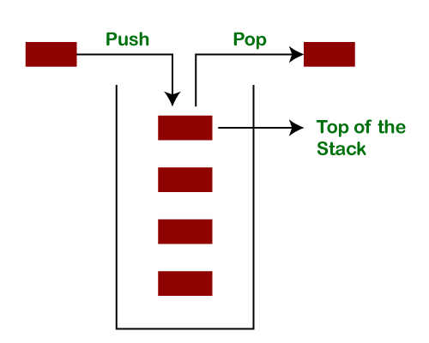

Let's push 20, 13, 89, 90, 11, 45, 18, respectively into the stack.

ADVERTISEMENT

ADVERTISING

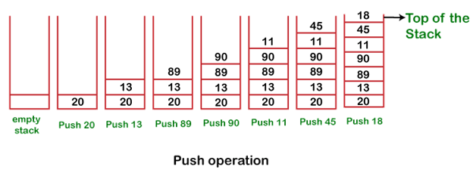

Let's remove (pop) 18, 45, and 11 from the stack.

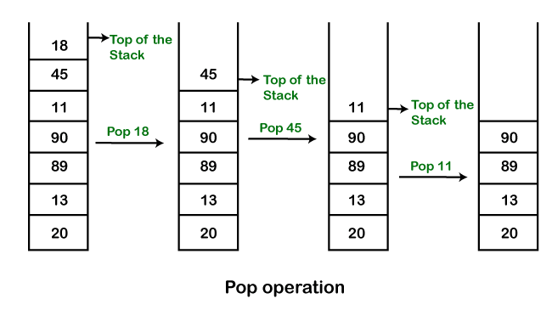

**Empty Stack:** If the stack has no element is known as an **empty stack**. When the stack is empty the value of the top variable is -1.

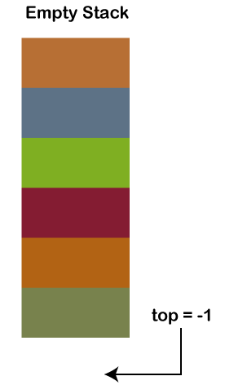

When we push an element into the stack the top is **increased by 1**. In the following figure,

* Push 12, top=0
* Push 6, top=1
* Push 9, top=2

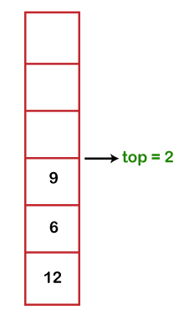

When we pop an element from the stack the value of top is **decreased by 1**. In the following figure, we have popped 9.

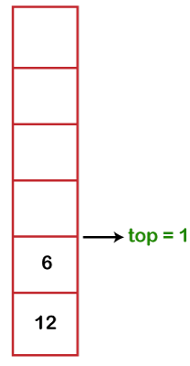

The following table shows the different values of the top.

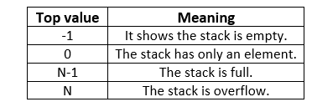

Java Stack Class

In Java, **Stack** is a class that falls under the Collection framework that extends the **Vector** class. It also implements interfaces **List, Collection, Iterable, Cloneable, Serializable.** It represents the LIFO stack of objects. Before using the Stack class, we must import the java.util package. The stack class arranged in the Collections framework hierarchy, as shown below.

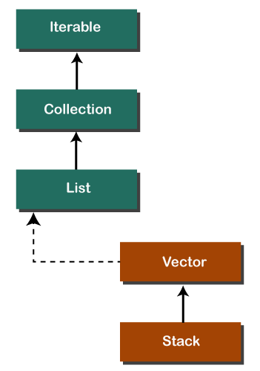

Stack Class Constructor

The Stack class contains only the **default constructor** that creates an empty stack.

1. **public** Stack()

Creating a Stack

If we want to create a stack, first, import the java.util package and create an object of the Stack class.

1. Stack stk = **new** Stack();

Or

1. Stack<type> stk = **new** Stack<>();

Where type denotes the type of stack like Integer, String, etc.

Methods of the Stack Class

We can perform push, pop, peek and search operation on the stack. The Java Stack class provides mainly five methods to perform these operations. Along with this, it also provides all the methods of the [Java Vector class](https://www.javatpoint.com/java-vector).

|  |  |  |
| --- | --- | --- |
| **Method** | **Modifier and Type** | **Method Description** |
| [empty()](https://www.javatpoint.com/java-stack#empty) | boolean | The method checks the stack is empty or not. |
| [push(E item)](https://www.javatpoint.com/java-stack#push) | E | The method pushes (insert) an element onto the top of the stack. |
| [pop()](https://www.javatpoint.com/java-stack#pop) | E | The method removes an element from the top of the stack and returns the same element as the value of that function. |
| [peek()](https://www.javatpoint.com/java-stack#peek) | E | The method looks at the top element of the stack without removing it. |
| [search(Object o)](https://www.javatpoint.com/java-stack#search) | int | The method searches the specified object and returns the position of the object. |

Stack Class empty() Method

The **empty()** method of the Stack class check the stack is empty or not. If the stack is empty, it returns true, else returns false. We can also use the [isEmpty() method of the Vector class](https://www.javatpoint.com/java-vector-isempty-method).

**Syntax**

1. **public** **boolean** empty()

**Returns:** The method returns true if the stack is empty, else returns false.

In the following example, we have created an instance of the Stack class. After that, we have invoked the empty() method two times. The first time it returns **true** because we have not pushed any element into the stack. After that, we have pushed elements into the stack. Again we have invoked the empty() method that returns **false** because the stack is not empty.

**StackEmptyMethodExample.java**

1. **import** java.util.Stack;
2. **public** **class** StackEmptyMethodExample
3. {
4. **public** **static** **void** main(String[] args)
5. {
6. //creating an instance of Stack class
7. Stack<Integer> stk= **new** Stack<>();
8. // checking stack is empty or not
9. **boolean** result = stk.empty();
10. System.out.println("Is the stack empty? " + result);
11. // pushing elements into stack
12. stk.push(78);
13. stk.push(113);
14. stk.push(90);
15. stk.push(120);
16. //prints elements of the stack
17. System.out.println("Elements in Stack: " + stk);
18. result = stk.empty();
19. System.out.println("Is the stack empty? " + result);
20. }
21. }

**Output:**

Is the stack empty? true

Elements in Stack: [78, 113, 90, 120]

Is the stack empty? false

Stack Class push() Method

The method inserts an item onto the top of the stack. It works the same as the method [addElement(item) method](https://www.javatpoint.com/java-vector-addelement-method) of the Vector class. It passes a parameter **item** to be pushed into the stack.

**Syntax**

1. **public** E push(E item)

**Parameter:** An item to be pushed onto the top of the stack.

**Returns:** The method returns the argument that we have passed as a parameter.

Stack Class pop() Method

The method removes an object at the top of the stack and returns the same object. It throws **EmptyStackException** if the stack is empty.

**Syntax**

1. **public** E pop()

**Returns:** It returns an object that is at the top of the stack.

**Set interface:-**

**It is the interface which does not have any extra method it only changes the behaviour of add method in such a way that it does not allowed duplicate element. And not maintaining order as well.**

**Implementation of Set interface: -**

**1. Hash Set**

**2. Linked Hash Set**

**Map Interface:-**

**It is the part of collection framework but not a collection(because of it does not extends collection interface).**

**It store the data in the form of key and value pair.**

**Internally map interface uses the Entry interrace**

hashMap:-isme key value pair main data store hota hain ,aur isme key uniqe honi chaiye but value ho same bhi ho sakti hain **key set ke form main store hoti hain aur value arraylist (collections)form main store hoti hain**

**key and value pair ko entry set kahate hain aur entry ek interface hota hain, jo nested interface hota hain jo map ke andar hota hain, map interface ka entery ka koi akela ashtitva nahi hota hain**

**key and value ka pair ka ek entry kahalta hain ,entry map interface ka ka ek nested interface hota hain map key and value pair ko store krne ke liye entry interface ka sahara leta hain**

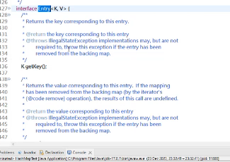

**Isliye isko akele nahi likh sakate hain jab bhi hum entry ko likhenge to Map.entry likhanege**

**Hashmap ka object banata hain to 16 size ki table banati hain yahi bhi**

**LinkedHashMap :-insertion maintain krta hain but uniqu value hold krta hain**

Points to remember

* Java HashMap contains values based on the key.
* Java HashMap contains only unique keys.
* Java HashMap may have one null key and multiple null values.
* Java HashMap is non synchronized.
* Java HashMap maintains no order.
* The initial default capacity of Java HashMap class is 16 with a load factor of 0.75.

Hierarchy of HashMap class

As shown in the above figure, HashMap class extends AbstractMap class and implements Map interface.

HashMap class declaration

Let's see the declaration for java.util.HashMap class.

1. **public** **class** HashMap<K,V> **extends** AbstractMap<K,V> **implements** Map<K,V>, Cloneable, Serializable

HashMap class Parameters

Let's see the Parameters for java.util.HashMap class.

* **K**: It is the type of keys maintained by this map.
* **V**: It is the type of mapped values.

Constructors of Java HashMap class

|  |  |
| --- | --- |
| **Constructor** | **Description** |
| HashMap() | It is used to construct a default HashMap. |
| HashMap(Map<? extends K,? extends V> m) | It is used to initialize the hash map by using the elements of the given Map object m. |
| HashMap(int capacity) | It is used to initializes the capacity of the hash map to the given integer value, capacity. |
| HashMap(int capacity, float loadFactor) | It is used to initialize both the capacity and load factor of the hash map by using its arguments. |

Methods of Java HashMap class

|  |  |
| --- | --- |
| **Method** | **Description** |
| void clear() | It is used to remove all of the mappings from this map. |
| boolean isEmpty() | It is used to return true if this map contains no key-value mappings. |
| Object clone() | It is used to return a shallow copy of this HashMap instance: the keys and values themselves are not cloned. |
| Set entrySet() | It is used to return a collection view of the mappings contained in this map. |
| Set keySet() | It is used to return a set view of the keys contained in this map. |
| V put(Object key, Object value) | It is used to insert an entry in the map. |
| void putAll(Map map) | It is used to insert the specified map in the map. |
| V putIfAbsent(K key, V value) | It inserts the specified value with the specified key in the map only if it is not already specified. |
| V remove(Object key) | It is used to delete an entry for the specified key. |
| boolean remove(Object key, Object value) | It removes the specified values with the associated specified keys from the map. |
| V compute(K key, BiFunction<? super K,? super V,? extends V> remappingFunction) | It is used to compute a mapping for the specified key and its current mapped value (or null if there is no current mapping). |
| V computeIfAbsent(K key, Function<? super K,? extends V> mappingFunction) | It is used to compute its value using the given mapping function, if the specified key is not already associated with a value (or is mapped to null), and enters it into this map unless null. |
| V computeIfPresent(K key, BiFunction<? super K,? super V,? extends V> remappingFunction) | It is used to compute a new mapping given the key and its current mapped value if the value for the specified key is present and non-null. |
| boolean containsValue(Object value) | This method returns true if some value equal to the value exists within the map, else return false. |
| boolean containsKey(Object key) | This method returns true if some key equal to the key exists within the map, else return false. |
| boolean equals(Object o) | It is used to compare the specified Object with the Map. |
| void forEach(BiConsumer<? super K,? super V> action) | It performs the given action for each entry in the map until all entries have been processed or the action throws an exception. |
| V get(Object key) | This method returns the object that contains the value associated with the key. |
| V getOrDefault(Object key, V defaultValue) | It returns the value to which the specified key is mapped, or defaultValue if the map contains no mapping for the key. |
| boolean isEmpty() | This method returns true if the map is empty; returns false if it contains at least one key. |
| V merge(K key, V value, BiFunction<? super V,? super V,? extends V> remappingFunction) | If the specified key is not already associated with a value or is associated with null, associates it with the given non-null value. |
| V replace(K key, V value) | It replaces the specified value for a specified key. |
| boolean replace(K key, V oldValue, V newValue) | It replaces the old value with the new value for a specified key. |
| void replaceAll(BiFunction<? super K,? super V,? extends V> function) | It replaces each entry's value with the result of invoking the given function on that entry until all entries have been processed or the function throws an exception. |
| Collection<V> values() | It returns a collection view of the values contained in the map. |
| int size() | This method returns the number of entries in the map. |

Java HashMap Example

Java LinkedHashSet Class

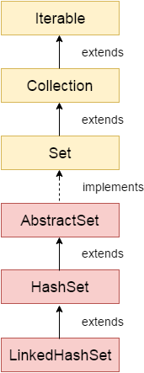

Java LinkedHashSet class is a Hashtable and Linked list implementation of the Set interface. It inherits the HashSet class and implements the Set interface.

The important points about the Java LinkedHashSet class are:

ADVERTISEMENT

* Java LinkedHashSet class contains unique elements only like HashSet.
* Java LinkedHashSet class provides all optional set operations and permits null elements.
* Java LinkedHashSet class is non-synchronized.
* Java LinkedHashSet class maintains insertion order.

Note: Keeping the insertion order in the LinkedHashset has some additional costs, both in terms of extra memory and extra CPU cycles. Therefore, if it is not required to maintain the insertion order, go for the lighter-weight HashMap or the HashSet instead.

Hierarchy of LinkedHashSet class

The LinkedHashSet class extends the HashSet class, which implements the Set interface. The Set interface inherits Collection and Iterable interfaces in hierarchical order.

LinkedHashSet Class Declaration

Let's see the declaration for java.util.LinkedHashSet class.

PauseNext

Unmute

Current TimeÂ 0:49

/

DurationÂ 18:10

Loaded: 10.27%

Â

Fullscreen

1. **public** **class** LinkedHashSet<E> **extends** HashSet<E> **implements** Set<E>, Cloneable, Serializable

Constructors of Java LinkedHashSet Class

|  |  |
| --- | --- |
| **Constructor** | **Description** |
| HashSet() | It is used to construct a default HashSet. |
| HashSet(Collection c) | It is used to initialize the hash set by using the elements of the collection c. |
| LinkedHashSet(int capacity) | It is used to initialize the capacity of the linked hash set to the given integer value capacity. |
| LinkedHashSet(int capacity, float fillRatio) | It is used to initialize both the capacity and the fill ratio (also called load capacity) of the hash set from its argument. |

Java LinkedHashSet Example

Let's see a simple example of the Java LinkedHashSet class. Here you can notice that the elements iterate in insertion order.

**FileName:** LinkedHashSet1.java

1. **import** java.util.*;
2. **class** LinkedHashSet1{
3. **public** **static** **void** main(String args[]){
4. //Creating HashSet and adding elements
5. LinkedHashSet<String> set=**new** LinkedHashSet();
6. set.add("One");
7. set.add("Two");
8. set.add("Three");
9. set.add("Four");
10. set.add("Five");
11. Iterator<String> i=set.iterator();
12. **while**(i.hasNext())
13. {
14. System.out.println(i.next());
15. }
16. }
17. }

**Output:**

One

Two

Three

Four

Five

**public int size(); public boolean isEmpty(); public Object put(Object key, Object value); public Object get(Object key); public boolean containsKey(Object key); public boolean containsValue(Object value); public Object remove(Object key); public void putAll(Map m); public void clear(); public Set keySet(); public Collection values(); public Set entrySet(); public HashMap(); public HashMap(Map m); public HashMap(int no.Of Buckets); public HashMap(int no.Of Buckets,float loadFactor);**

**Set interface:-**

**It is the interface which does not have any extra method it only changes the behaviour of add method in such a way that it does not allowed duplicate element. And not maintaining order as well.**

**Implementation of Set interface: -**

* 1. **Hash Set:-iske object memory main ek hashtable create hota hain wo hashtable hashmap ka object hota hain**
  2. **Hashset internally hashmap ka object create krta hain**
  3. 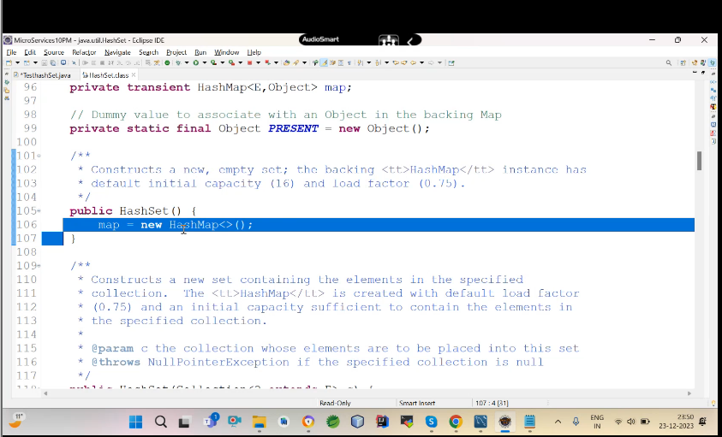
  4. **Hash set interanally hashmap ka object banata hain but hashmap main key value pair main data jata hain but hashset main nahi jata hain to iska reason ye hain hashmap ke object key main element jata hain aur value main dumi object jata hain**
  5. 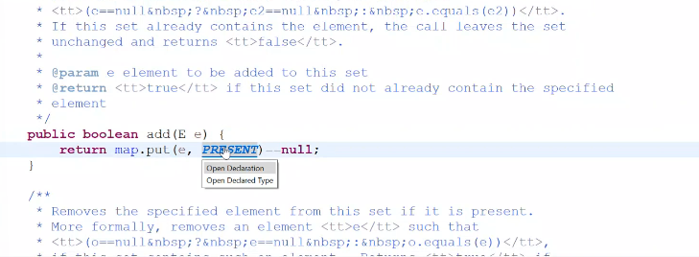
  6. 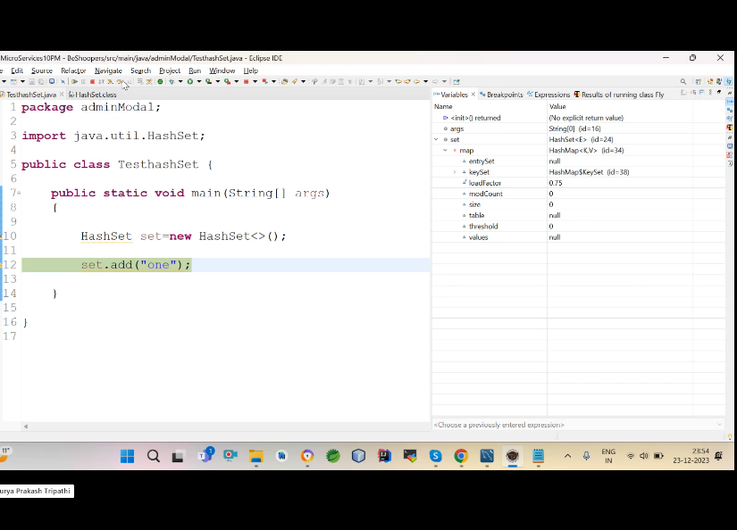
  7. **Abhi yaha per koi value adde nahi hui hain**
  8. 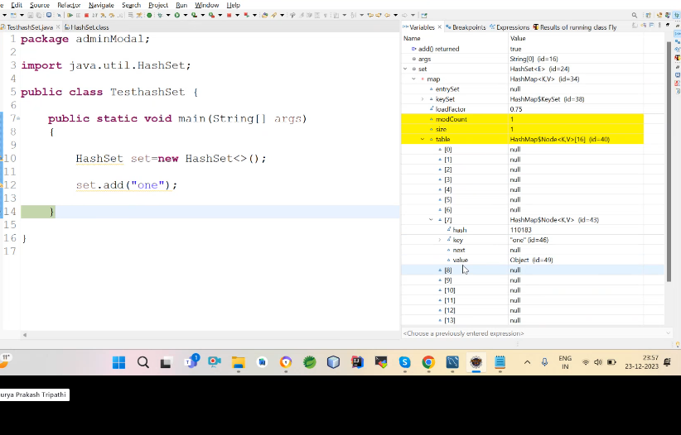
  9. **Jais hi aap value add krte hain waise hi ek 16 size ki table banati hain jo hashset ka instance hota hain**

**Set interanally memory main ek logical table banati hain**

**Hashtable bhi ek class hoti hain jo legacy collection main payi jati hain jo kaam hashmap krti hain wo same kaam hashtable krti hain**

**9.No dubplicasy-hashset ke andar jab koi value add honi jaati hain to us index ka bucket elements nikala jata hain -bucket array of linked list hota hain**

**Actually main kahani ye hoti hain jab hum hashset banate hain to hashmap ka object banta hain aur hashmap internally ,jab hum add chalate hain to add put ko chalata hain put node (node ek class hoti h ain)ka use krta h hain element ko maintain krne ke liye -ye jo neeche diya gaya hain ye 4 value leta hain jise HashMap$Node kahate hain l -hashmap ka nested class hota hain HashMap$Node jo neeche diya gaya hain**

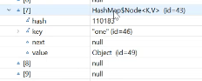

**Bucket nikalne ka ek formula hota hain hum janate hain ki jab koi value kahi bhi add hone jata hain uski ek hashcode value hotia hain jaise is program main one add hone jar aha hain jo one hain wo ek object hain aur uski hashcode value hogi kuch**

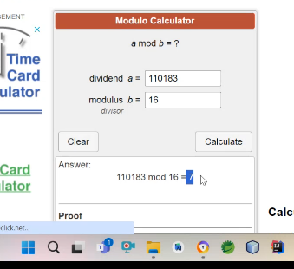

**Memory main internally kya hota hain jab bhi koi element koi add hone jata hain to apna bucket index nikalta hain agar uska bucket index per koi value pahle se add nahi hain to wo value add ho jayegi agar hogi to wo nahi add hoga**

**Ye aise hota hain add method interanally contain ko call krta hain aur contain equals ko call krta hain ye dekhta hain agar ye object bucket main pada to nahi agar pada nahi hoga to true return krega otherwise false return krega**

**Yaha per do step ka process hota hain**

**1.pahle bucket index nikalna -bucket index nikalne ke liye total number of hashcode ko total number of buckets se divide kr diya jata hain bucket nikal ata hain**

**2.existence check krna -aur uske baad existence check krta hain**

**Isme 4 cheez hain key main value jayegi aur hash-hashcode hoga ,next-null hoga aur value main dumi object hoga**

**Kya 16 se jada element dalenge to kya hoga ?**

**16 se jada element dalne per kuch nahi hoga ha agar 12 se jada elment daloge to jise threshold value kahate hain to wo 16 ka 75% increase krega -default load factor -0.75 and default threshold value 12**

**Agar hum 13 valud add krege to 32 buckets ho jayenge aur threshold value 24 ho jayegi aur yaha per ye nahi hain ki jo object index for example 4 per add hua wo usi per add ho ye nahi ho Sakata hain change bhi ho Sakata hain**

**Hum apna load factor and threshold rakh sakate hain apne hisab se**

**No order maintain -hashcode and buckets ko madulare kiya jata hain aur us per jo index ata hain to wahi us element ka index ho jata hain**

**User defind class ke liye hume String tostring method ko ovvride kr lena chiey jis wo id nahi print krega**

**HashCollision:-jab object ki hash value same ho jati hain to hashcollision hota hain**

**\*\*\*\*\*Sorted set main order maintain hota hain**

**TreeSet:-** sorted set ki implmentd class hoti hain tree set

Isme asceding order hota hain ye maintain hota hain

* Tree set ek baar main ek type ki value leta hain aisa isliye hota hain kyuki ye logic comparable or compartor both se uthata hain
* By default comparable ye ek interface hota hain se uthata hain aur comparable ke pass ek method hota hain compare to usi main sorting ka code hota
* Treeset internally ek binary search tree banata hain-isme left ,right and root hota hain
* **Isme wahi object add ho sakate hain jo comparable interface ko implement kre**
* 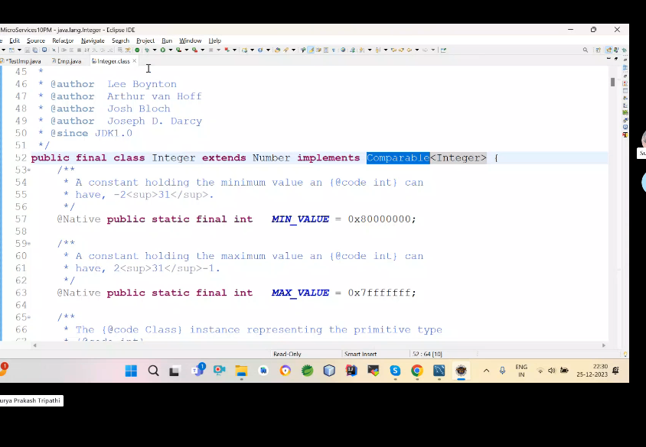
* **What is difference between compartor and comparable**

1. **Compartor ke liye sorting ki ek alag class banani padti hain but comparable main ek hi class hoti hain**
2. **Compartor util main paya jata hain but comparable lang man paya jata hain**
3. **Compartor main equals method bhi hain ek compare to but compare main equals method override nahi krte hain kyuki ye direct hi override ho chuka hota hain wo object class ka method hota hain aur object class use override krti hain pahle se**
4. **Comprable Interface:-**
5. Class ke andar define property ko defince krta hain ki ye ab is tarike se sort hoga . comparable and comprator dono order main sorting kr sakate hao but collections(sort) se kewal ascending order main sorting hoti hain
6. 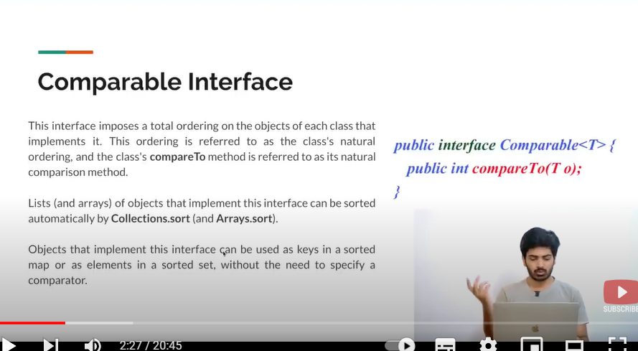
7. 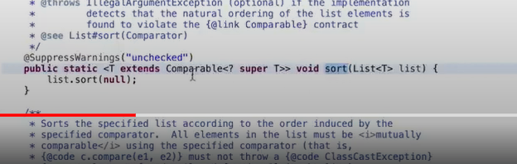
8. **Koi bhi class camprator interface ko implements kr rahi hogi to hum usi ki list pass kr sakte hain sort main ?**
9. public static <T> void sort([List](https://docs.oracle.com/javase/8/docs/api/java/util/List.html)<T> list,
10. [Comparator](https://docs.oracle.com/javase/8/docs/api/java/util/Comparator.html)<? super T> c)
11. public static <T extends [Comparable](https://docs.oracle.com/javase/8/docs/api/java/lang/Comparable.html)<? super T>> void sort([List](https://docs.oracle.com/javase/8/docs/api/java/util/List.html)<T> list)

**java.util.ConcurrentModificationException:**-ek hi time per collection se data nikal rahe ho aur add kr rahe ho to ye issue ata hain is ki **hum fail fast bolate hain**

**why:-**

**let apne ek arraylist banaya aur jab aap arraylist main item add krte ho wo internally array banata hain jis structure bolate hain aur structure create hota hain aur uske baad aap us structure ko itrate krte ho to waha per ek another process chalata hain aur aap usi main aap add krte ho to apka original structure modified hota hain tab ye exception a jati hain**

**kyuki ye iterator time per iterator method ek flag value generate krta hain usi wajah se hota hain**

**Interviewer : How  Fail  Fast Iterator  come to know that the internal structure is modified ?**  
Iterator read internal data structure (object array) directly . The internal data structure(i.e object array) should not be modified while iterating through the collection. To ensure this it maintains an internal  flag *"mods" .*Iterator checks the *"mods" flag* whenever it gets the next value (using hasNext() method and next() method). Value of *mods* flag changes whenever there is an structural modification. Thus indicating iterator to throw ConcurrentModificationException.

**Is door krne ke liye copyonArrayList use kiya jata hain ye uski copy bana deta hain**

**Aise hi hashmap ke saath hota hain**